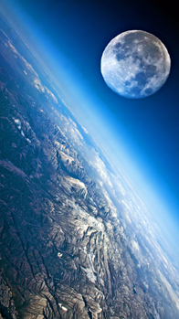[**VISUAL PHYSICS ONLINE**](http://www.physics.usyd.edu.au/teach_res/hsp/sp/spHome.htm)

**MODULE 5**

**ADVANCED MECHANICS**

**GRAVITATIONAL FIELD:**

**MOTION OF PLANETS AND SATELLITES**

|  |
| --- |
| **SATELLITES**: **Orbital motion** of object of mass *m* about a massive object of mass *M* (*m* << *M* assume *M* stationary w.r.t *m*) with an orbital radius *r*, orbital speed  and period *T*  Gravitational force (magnitude)  Centripetal force (magnitude)  Orbital speed  circular orbit  Angular momentum  Gravitational potential energy  Kinetic energy  circular orbit  Total energy  circular orbit  Conservation of energy  **How the planets move around the Sun: Kepler’s Laws**  **1st Law**: A planet describes an **ellipse** with the Sun at one focus. The distance from the Sun to the planet varies as the planet orbits the Sun. So, if we take *r* to be average distance between the Sun and the planet then *r* represents the length of the semi-major axis of the ellipse and is usually represented by the symbol *a*.  **2nd Law**: Each planet moves so that an imaginary line drawn from the Sun to the planet sweeps out equal areas in equal periods of time. This law results from the Law of Conservation of Angular Momentum  where  is the component of the velocity of the planet perpendicular to the radius vector. This velocity is the tangential velocity or orbital velocity.  **3rd Law:**    **Escape velocity** |

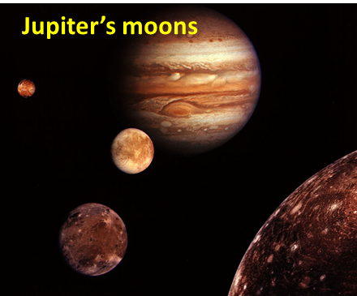A **satellite** is an object that orbits a much more massive object. **Natural satellites** include the planets orbiting the Sun, the moons of Jupiter, and the Moon about the Earth.

An **artificial satellite** is an object put into **orbit** from the Earth’s surface using a spacecraft such a rocket or a space shuttle. Satellites are used for many applications and include military and civilian Earth observation satellites, communications satellites, navigation satellites, weather satellites, and research satellites. Space stations and human spacecraft in orbit are also satellites.

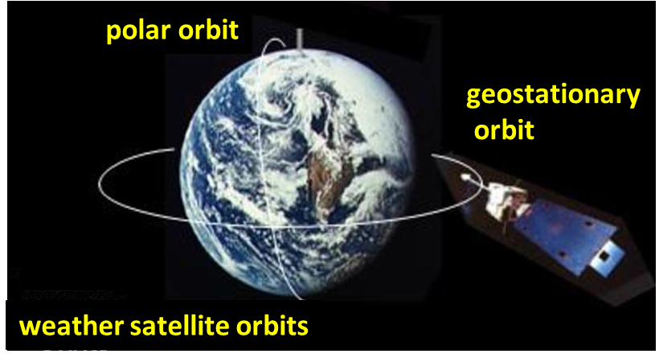

Satellites are placed in one of several different types of orbit depending on the nature of their mission. Two common orbit types are a **Low Earth Orbit** (**LEO**) and a **Geostationary Orbit** (**GEO**).

**Low Earth Orbit** (**LEO**) occur at a radius of between 200 and 2000 km above the Earth’s surface with periods varying from 60 to 90 minutes. The space shuttle uses this type of orbit (200-250 km). LEOs have the smallest field of view and frequent coverage of specific or varied locations on the Earth’s surface. Orbits less than 400 km are difficult to maintain due to atmospheric drag and subsequent **orbital decay**. They are used mainly for military applications, Earth observation, weather monitoring and shuttle missions. Except for the lunar flights of the Apollo program, all human spaceflights have taken place in LEO. The altitude record for a human spaceflight in LEO was Gemini 11 with an apogee of 1,374 km. All manned space stations and most artificial satellites, have been in LEO.

**Orbital decay** is the reduction in the height of an object's orbit over time due to the drag of the atmosphere on the object. All satellites in low Earth orbits are subject to some degree of atmospheric drag that will eventually decay their orbit and limit their lifetimes. Even at 1000 km, as ‘thin’ as the atmosphere is, it is still sufficiently dense to slow the satellite down gradually.

A **Geostationary Orbit** (**GEO**) is a circular orbit in the Earth's equatorial plane, any point on which revolves about the Earth in the same direction and with the same period as the Earth's rotation. Geostationary orbits are useful because they cause a satellite to appear stationary with respect to a fixed point on the rotating Earth. As a result, an antenna can point in a fixed direction and maintain a link with the satellite. The satellite orbits in the direction of the Earth's rotation, at an altitude of approximately 35,786 km above ground. This altitude is significant because it produces an orbital period equal to the Earth's period of rotation, known as the **sidereal day**. These orbits allow for the tracking of stationary points on Earth and have the largest field of view. Applications include communications, mass-media and weather monitoring.

**Web investigation** – artificial satellite orbits

<http://en.wikipedia.org/wiki/Satellite>

<http://en.wikipedia.org/wiki/Low_Earth_orbit>

<http://en.wikipedia.org/wiki/Geostationary_orbit>

[Review: Circular Motion](http://www.physics.usyd.edu.au/teach_res/hsp/sp/mod5/m5UCM.pdf)

**CIRCULAR ORBITAL MOTION**

We will assume that a satellite moves in a **circular path** around the Earth. To place an object into a stable Earth orbit at a given radius, the launch must give it both an initial vertical and horizontal component of velocity, relative to the Earth’s surface. The rocket will eventually turn so that it is travelling horizontal to the Earth’s surface. At this radius, the force of gravity provides the acceleration needed to keep the object moving in a circle, but a particular orbital velocity is also required to keep the object in a stable orbit (figure 2). To calculate that velocity, known as the orbital velocity , we equate expressions for centripetal force  and gravitational force  as follows:

 **centripetal force**

 **Gravitational force**



**Orbital velocity of a satellite around orbiting the Earth in a circular path**

(3)  circular orbit

Note that the velocity of a satellite as it orbits around the Earth in a circle only depends on:

* Mass of the Earth 
* Radius of the orbit 

It is clear from this formula that altitude is the only variable that determines the orbital velocity required for a specific orbit. Further, the greater the radius of that orbit, the lower that orbital velocity .

The orbital velocity of a satellite around other planets is simply

(4)  **orbital velocity about any planet**

**The orbital motion of the Moon about the Earth**

We can calculate the orbital velocity  of the Moon orbiting the Earth using the equation 3 for the orbital velocity or knowing the period *T* of rotation of the Moon around the Earth is 27.3217 days.

The Moon’s orbital velocity of was calculated to be 1.02 km.s-1. The Moon’s orbit is not quite circular and the speed is only approximately constant. The orbital speed of the of the Moon varies from 0.970 to 1.022 km.s-1. So, our simple models gave numerical results which compare very favorably with the measured values for the orbital speed of the Moon.

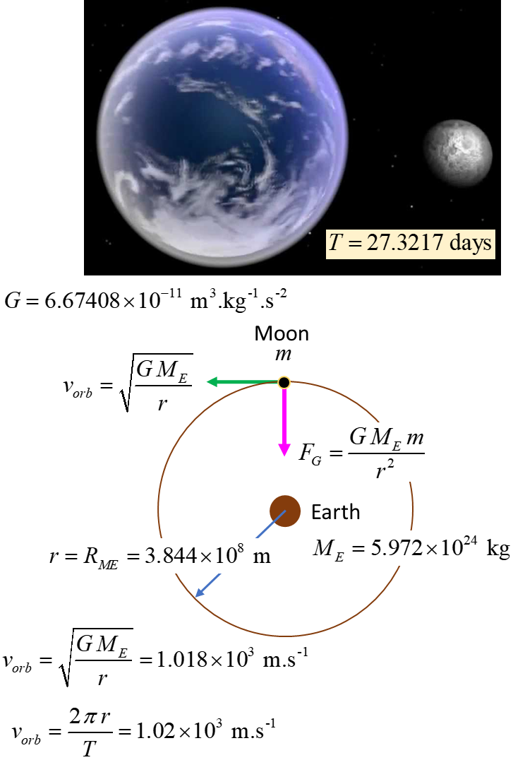

**How do the planets move ?**

**Kepler’s Laws of Motion**

One of the most important questions historically in Physics was how the planets move. Many historians consider the field of Physics to date from the work of Newton, and the motion of the planets was the main problem Newton set out to solve. In the process of doing this, he not only introduced his laws of motion and discovered the law of gravity, he also developed differential and integral calculus.

Today, the same laws that govern the motion of planets, are used by scientists to put satellites into orbit around the Earth and to send spacecraft through the solar system.

How the planets move is determined by gravitational forces. The forces of gravity are the only forces applied to the planets. The gravitational forces between the planets are very small compared with the force due to the Sun since the mass of the planets are much less than the Sun's mass. Each planet moves almost the way the gravitational force of the Sun alone dictates, as though the other planets did not exist.

The motion of a planet is governed **by Newton’s Law of Universal Gravitation**

(5) 

where *G* is the Universal Gravitational Constant, *M*S is the mass of the Sun, *m* is the mass of the planet and *r* is the distance from the Sun to the planet.

*G* = 6.67×10-11 N.m2.kg2

*M*S = 2.0×1030 kg

Historically, the laws of planetary motion were discovered by the outstanding German astronomer **Johannes Kepler** (1571-1630) based on almost 20 years of processing astronomical data, before Newton and without the aid of the law of gravitation.

**Kepler's Laws of Planetary Motion**

1. The path of each planet around the Sun is an **ellipse** with the Sun at one focus.
2. Each planet moves so that all imaginary lines drawn from the Sun to the planet sweeps out **equal areas** in equal periods of time.
3. The ratio of the squares of the periods of revolution of planets is equal to the ratio of the cubes of their orbital radii (mean distance from the Sun or length of **semi-major axis**, *a*)

(6) 

## Kepler’s First Law

**A planet describes an ellipse with the Sun at one focus**. But what kind of an ellipse do planets describe? It turns out they are very close to circles. The path of the planet nearest the Sun, Mercury, differs most from a circle, but even in this case, the longest diameter is only 2% greater than the shortest one. Bodies other than the planets, for example, comets move around the Sun in greatly flattened ellipses.

Since the Sun is located at one of the foci and not the centre, the distance from the planet to the Sun changes more noticeably. The point nearest the Sun is called the **perihelion** and the farthest point from the Sun is the **aphelion**. Half the distance from the perihelion to the aphelion is known as the **semi-major radius**, *a*. The other radius of the ellipse is the **semi-minor radius**, *b*.

The equation of an ellipse is

(7)  **ellipse**

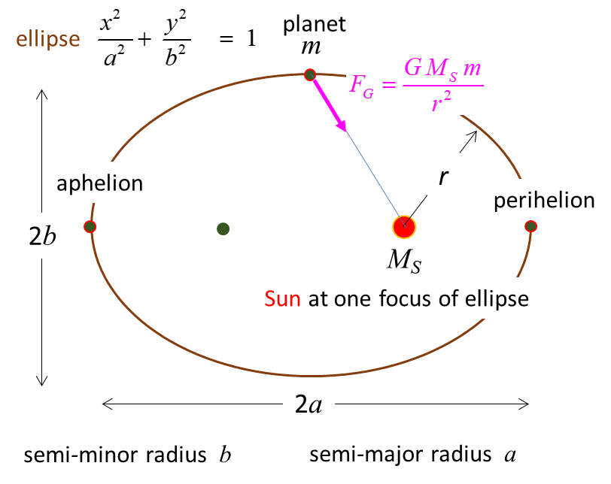

Fig. 3. The path of a planet around the Sun is an **ellipse**.

## Kepler's Second Law

Each planet moves so that an imaginary line drawn from the Sun to the planet sweeps out equal areas in equal periods of time.

In a small time interval  the line draw from the Sun to the planet P turns through an angle .

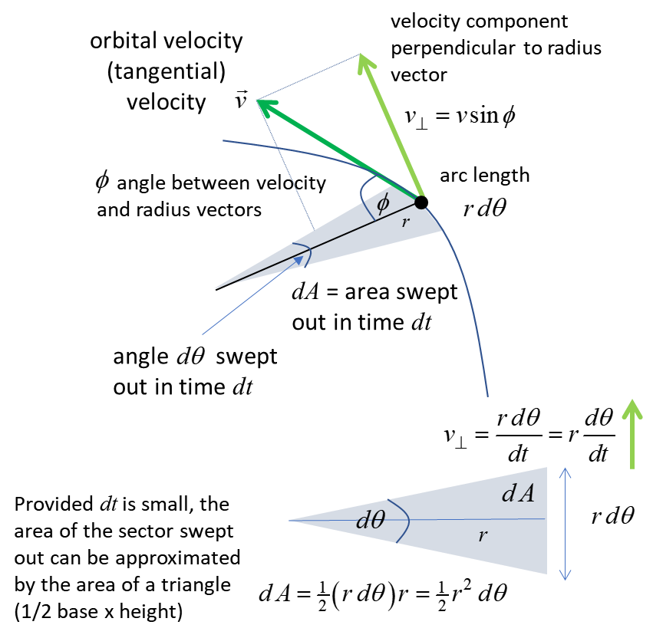

Therefore, the area of the sector swept out can be approximated as the area of a triangle given by



The area  has the same value at all points along the orbit.

When the planet is close to the Sun, *r* is small and  is large: when the planet is far from the sun, r is large and  is small.

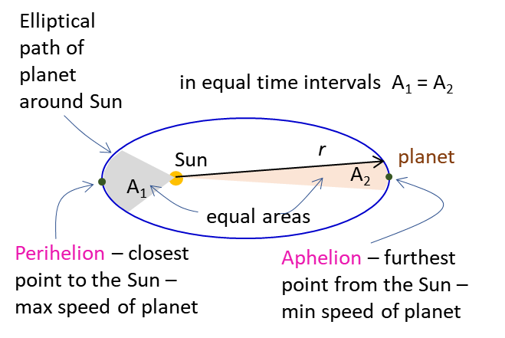

Fig. 4. A planet moves so that an imaginary line drawn from the Sun to the planet sweeps out equal areas in equal periods of time.

Kepler’s Second law follows from Newton’s laws. The component of the orbital velocity  perpendicular to the radius vector  is . The displacement along the direction of  during the time interval  is the arc length , so



Combining



gives



The magnitude of the angular momentum is



Hence,



No external torques act on the system, hence, the angular momentum *L* must be a constant (law of conservation of angular momentum) and this means that the area swept out per unit time is also a constant, which is simply Kepler’s 2nd law.

"Equal areas in equal times" means the rate at which area is swept out on the orbit  is constant.

## Kepler's Third Law

For a planet orbiting the Sun with a radius *r*, the centripetal force results from the gravitational attraction between the planet and the Sun

Centripetal force = Gravitational force



For rotational motion, we know that



So,



**Kepler’s 3rd Law**

Figure 5 shows a computer simulation for the motion of a planet around the Sun. The dots represent the positions of the planet at equal time intervals. Near the aphelion, the dots are closely spaced indicating a small speed while at the perihelion the dots are widely spaced indicating a large speed for the planet.

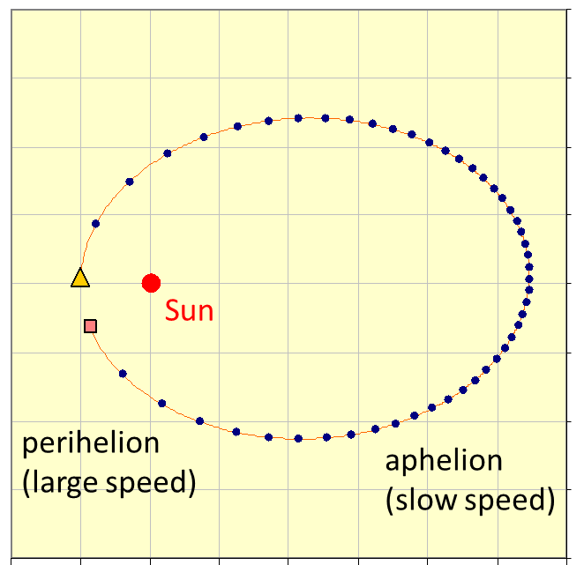

Fig. 5. Computer simulation of the motion of a planet around the Sun.

[Predict Observe Exercise – Motion of planets around a star](http://www.physics.usyd.edu.au/teach_res/hsp/u5/ag_kepler1.htm)

**ENERGY CONSIDERATIONS**

Consider a satellite of mass *m* orbiting a massive object of mass

*M* (*m* << *M* assume *M* stationary w.r.t *m*) with an average orbital radius *r*, orbital speed  and period *T*.

The net force acting on the satellite is the gravitational force



The gravitational force is responsible for the orbit, thus the gravitational force corresponds to the centripetal force



Hence the average orbital speed is

 circular orbit

The gravitational potential of the satellite system is



and its kinetic energy is

 circular orbit

The total energy of the system is

 circular orbit

Conservation of energy 

For a satellite in a circular orbit, the radius of orbit and the orbital velocity (tangential) are both constants. In an elliptical orbit, both the radius and orbital velocity change during the orbit of the satellite. However, the angular momentum *L* of the satellite remains constant

 

So, if the radius increases, the orbital velocity decreases or if the radius decreases, then the orbital velocity increases. By carefully examining figure 5, you will observe that when the satellite is at the aphelion position, the satellite is at the greatest distance from the massive object and its speed is a minimum. When the satellite is at the perihelion position, the position closest to the massive object and smallest radius, the speed is a maximum.

|  |
| --- |
| **Example**  A satellite of mass 2500 kg is in a low orbit trajectory at an altitude of 1000 km above the Earth’s surface. The satellite must be moved to a higher trajectory with an altitude of 2000 m.  Calculate for both orbits: the acceleration due to gravity (gravitational field strength), orbital speeds, periods, kinetic energies, gravitational potential energies and total energies.  How can this be achieved?  What energy must be used to shift the satellite into the higher orbit?        **Solution**  *Problem: type / visualize / how to approach ? / scientific annotated diagram / what do you know ?*  Acceleration due to gravity (gravitational field strength)    Orbit #1 *g* = 7.33 m.s-2  Orbit #2 *g* = 5.69 m.s-2  Acceleration due to gravity decreases with increasing altitude.  The orbital velocities of the satellite    Orbit #1  = 7.35 m.s-1  Orbit #2  = 6.90 m.s-1  Orbital velocity decreases with increasing altitude.  The period of the satellite orbits    Orbit #1 *T* = 6.30x103 s = 1.75 h  Orbit #2  = 7.62x103 s = 2.12 h  Period increases with increasing altitude.  Kinetic energies of the satellite    Orbit #1  = 6.76x1010 J  Orbit #2  = 5.95x1010 J  KE decreases with increasing altitude.  Gravitational potential energies of the satellite    Orbit #1  = - 1.35x1011 J  Orbit #2  = - 1.19x1011 J  GPE increases with increasing altitude.  Total energies of the satellite    Orbit #1  = - 6.76x1010 J  Orbit #2  = - 5.95x1010 J  total energy increases with increasing altitude.  **The total energy being negative means that the satellite is bound to the Earth.**  The energy (work) required to move the satellite from orbit #1 to orbit #2 is the difference in the total energies between the two orbits  work *W* = *E*2 – *E*1 = ( - 5.95x1010 + 6.76x1010 ) J  *W* = 0.81x1010 J  This energy for the work required to shift the orbit must come from the fuel that is burnt by the satellite’s rockets. |

[VISUAL PHYSICS ONLINE](http://www.physics.usyd.edu.au/teach_res/hsp/sp/spHome.htm)

http://www.physics.usyd.edu.au/teach_res/hsp/sp/spHome.htm

If you have any feedback, comments, suggestions or corrections please email Ian Cooper

ian.cooper@sydney.edu.au

Ian Cooper School of Physics University of Sydney