[**VISUAL PHYSICS ONLINE**](http://www.physics.usyd.edu.au/teach_res/hsp/sp/spHome.htm)

**MODULE 5**

**ADVANCED MECHANICS**

**PROJECTILE MOTION**

The simplest type of motion in a gravitational field is called **projectile motion**. As an object of mass *m* moves near the surface of the Earth we will assume the only force acting on the object is the gravitational force *FG*. The motion of an object can be considered as two independent components for its motion:

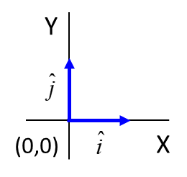

Frame of reference:

Horizontal motion with zero acceleration, *ax* = 0, horizontal velocity *vx* = constant

Vertical motion with a constant acceleration *ay* = -*g* = - 9.81 m.s-2

(vertically up is taken as the positive direction)

The magnitude of the force *FG* on an object of mass *m* in the Earth’s gravitational field is

(1) 

where *G* is the Universal Gravitational Constant, *ME* is the mass of the Earth, *RE* is the radius of the Earth, *r* is the distance from the Earth’s centre to the object and *h* is the distance of the object above the Earth’s surface. Just above the Earth’s surface *h* << *RE*, therefore (*RE* + *h*) ≈ *RE*. Therefore, we can assume the gravitational force is constant and acts in direction vertically towards the surface

(2) 

From Newton’s Second law, *FG* = *m**ay* = -*mg*, we can conclude that near the Earth’s surface, the acceleration due to gravity is constant

(3)  up is positive direction

The acceleration  due to gravity does not depend upon the mass , therefore, when two objects of different sizes and masses are dropped from rest and the same height they will hit the ground at the same time as they fall at the same rate. In our real world, this does not happen because of resistive forces acting on objects as they fall.

|  |
| --- |
| **Maths Extra**  The gravitational potential energy is given by    Consider raising an object of mass m near the surface without increasing its kinetic energy. As a consequence, work must be done on the object to increase the potential energy of the object / Earth system.  Initial position  Final position  Work done = Increase in Gravitational Potential Energy |

Figure 1 shows the positions three objects dropped from rest at equal time intervals. The objects have different shapes and masses while the third object is initially projected horizontally. All three objects fall at the same rate such that the horizontal acceleration is zero, *ax* = 0 and the vertical acceleration is constant, *ay* = -*g*. The horizontal velocity is constant while the magnitude of the vertical velocity continually increases as it falls.

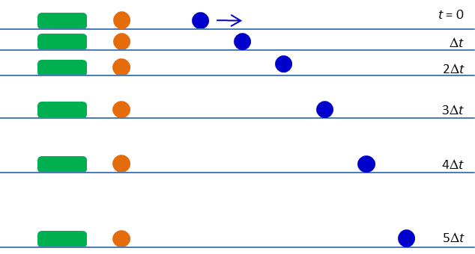

Fig. 1. Three different objects fall at the same rate.

The horizontal direction is taken as the +X-axis and the vertical direction is taken as the +Y-axis. A convenient choice for assigning a positive or negative sense to a component of a vector directed along one of the axes is:

Consider an object projected with an initial velocity  (magnitude *u* and direction  w.r.t X-axis). Then the components of the initial velocity are:



To perform all calculations on projectile motion to predict any displacements (*x*, *y*), velocities (*v­x*, *vy*) at any time *t* we can use the following equations for uniform accelerated motion

(4) 

The equation can also be expressed



Note: there is **no** unique set of symbols for displacement, velocity or acceleration. The most common symbols for initial velocity are initial velocity .

Figure 2 shows the **parabolic trajectory** travelled by an object that was launch with an initial velocity . The horizontal velocity remains constant at all times during the flight of the object. As the object moves up its vertical velocity decreases at a steady rate until it reaches its maximum height where its vertical velocity becomes zero. Then the object falls down with its vertical velocity increasing at a steady rate. When the object returns to its launch height its vertical velocity is equal in magnitude to its initial vertical velocity but its direction is opposite. At all times in the flight the acceleration and force acting on the object are directed vertically down.

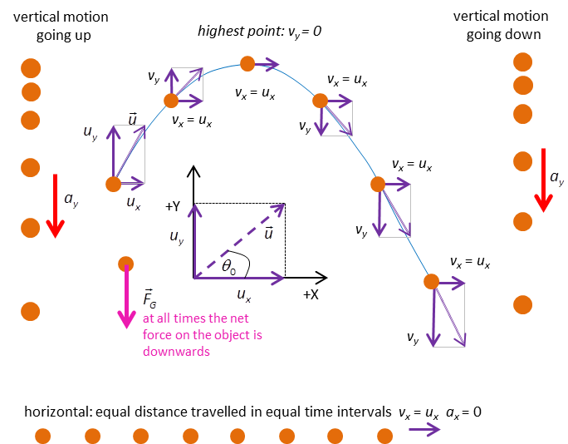

Fig. 2. The parabolic trajectory of an object when the net force acting on it is the gravitational force.

|  |
| --- |
| **Exercise 1**  From the graphs estimate the initial launch velocity  (magnitude and direction). Check your estimate of  by calculating: (a) the time for the projectile to reach its maximum height, (b) the range of the projectile (the value of *x* when *y*= 0), (c) the velocity  (magnitude and direction) when *y* = 0. Check your answers with the information provided by the graphs. |

Figure 3 shows the trajectory of a projectile fired with a constant magnitude for its initial velocity but at different angles. Note: from figure 3 that the **maximum range** of a projectile occurs when the launch angle is **45o**. For angles lower or greater than 45o the range is less. This implies that two launch angles will give the same range.



Fig. 3. Trajectories of a projectile launched at different angles, but with the same magnitude for the initial velocity.

|  |
| --- |
| **Exercise 2**  From the information provided in figure 3 estimate the magnitude of the initial velocity. Check your answer by doing further calculations to confirm your answers from the graph. |

Figure 4 shows the trajectory of a projectile launched at 45o w.r.t. the horizontal for a range of initial velocities.



Fig. 4. Trajectories of a projectile launched at 45o w.r.t the horizontal, but with different launch speeds.

|  |
| --- |
| **Exercise 3**  What would be the result of increasing and increasing the launch speed? As the launch speed gets bigger and bigger, can we still take *g* as a constant? Explain. |

|  |
| --- |
| **Example 1**  A volcano that is 3300 m above sea level erupts and sends rock fragments hurting into the sea 9.4 km away. If the fragments were ejected at an angle of 35o, what was their initial speed?    **Solution**  *Identify / setup*  *v*0 = ? m.s-1  θ = 35o  *x*0 = 0 *y*0 = 0  *x* = 9400 m *y* = -3300 m  *a*x = 0 *a*y = -9.8 m.s-2  *v*0x = *v*0cosθ *v*0y = *v*0sinθ  Equation for uniformly accelerated motion    *Execute*  X motion Y Motion    Eliminate *t* to find equation for *v*0    *Evaluate*  The rocks in a volcanic explosion can be thrown out at enormous speeds. |

|  |
| --- |
| **Example 2**  In the Blackhawk landslide in California, a mass of rock and mud fell 460 m down a mountain and then travelled 8 km across a level plain on a cushion of compressed air. Assume that the mud dropped with the free-fall acceleration due to gravity and then slide horizontally with constant deceleration. (a) How long did it take the mud to drop 460 m? (b) How fast was it travelling when it reached the bottom? (c) How long did the mud take to slide the 8 km horizontally?  **Solution**  Free fall  *a* = *g* = 9.8 m.s-2 *v*o = 0 *s* = 460 m  time to fall vertically, *t* = ? s  velocity at bottom of mountain, *v* = ? m.s-1  Since *a* = constant  (a) *s* = *v*o *t*+ ½ *a t*2 ⇒ *t* = √ (2*s* / *a*) = √{(2)(460)/9.8} s = 9.7 s  (b) *v* = *v*o + *a t* ⇒ *v* = 0 + (9.8)(9.7) m.s-1 = 95 m.s-1  (c)  Sliding to a stop  *v*o = 95 m.s-1 *s* = 8x103 m *v* = 0 *a* = ? m.s-2  time to slide to a stop, *t* = ? s  Since *a* = constant  *v*2 = *v*o2 + 2 *a s* ⇒ 0 *a* = (*v*2 – *v*o2)/(2*s*) ⇒  *a* = (- 952 / 16×103) m.s-2 = - 0.56 m.s-2  *v* = *v*o + *a t* ⇒ *t* = - *v*o / *a* = - 95 / (-0.56) s = 170 s |

**Galileo’s Analysis of Projectile Motion**

Our understanding of projectile motion owes a great debt to Galileo, who in his work entitled “Dialogues Concerning Two New Sciences”, presented his classic analysis of such motion. Galileo argued that projectile motion was a compound motion made up of a horizontal and a vertical motion. The horizontal motion had a steady speed in a fixed direction, while the vertical motion was one of downwards acceleration. Using a geometric argument, Galileo went on to show that the path of a particle undergoing such motion was a parabola. In his work, Galileo admits that his assumptions and results are only approximations to the real world. He admits that due to resistance of the medium, for instance, a projectile’s horizontal motion cannot be truly constant in speed. He states quite clearly that the path of the projectile will not be exactly parabolic. He argues, however, that his approximations can be shown by experiment to be close enough to the real world to be of very real use in the analysis of such motion. In doing this, he became perhaps the first scientist to demonstrate this modern scientific attitude. His approach was certainly very different from that of the ancient Greek geometers, who were only interested in exact results.

**Studying Projectile Motion**

Consider a ball projected from ground level with an initial velocity . Sometime later the ball hits the ground. Knowing the initial velocity of the ball, it is possible to predict the maximum height reached by the ball and its range (horizontal distance the ball travelled from when it was launched to its landing point). table.

*What calculations are necessary for our predictions?*

*What would a physicist do?*

The first step is always to visualize the physics situation and think about how you might solve the problem. For example, image you are looking at the flight of a golf ball and know that the motion is described by the equations of uniform motion.

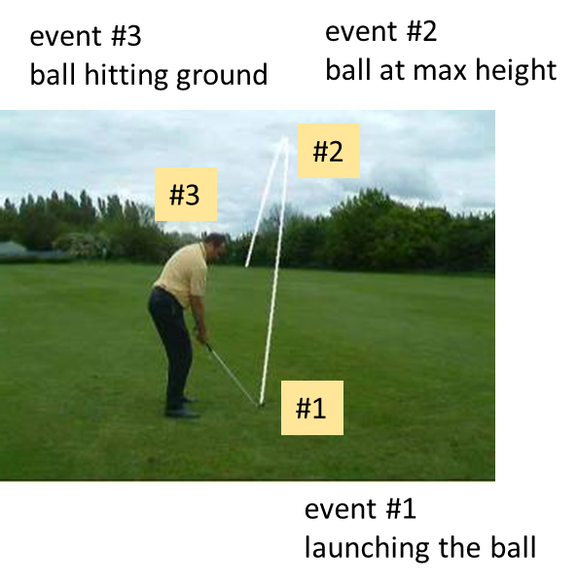

Draw an animated scientific diagram of the physical situation. The diagram should include known and unknown physical quantities. In this example, we can identify three separate events: #1 launching the ball; #2 ball reaches its maximum height and #3 the instant before the ball hits the ground. Using subscripts in an easy way to keep track of the parameters. If you want to improve your physics, you need to good at using appropriate symbols and subscripts.

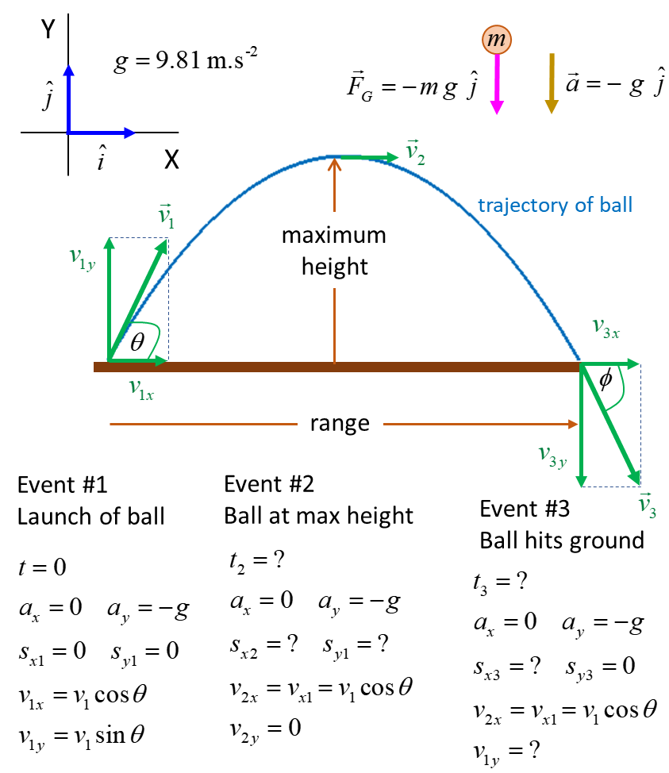

The equations for **uniform accelerated motion** are



These equations need to be applied to the X motion and Y motion separately and by using subscript we can identify the times for our three events.

**Event #1** launching the ball



Note: The horizontal acceleration is zero , therefore, the horizontal velocity is constant.

**Event #2** ball reaches its maximum height (vertical velocity of ball is zero)



Time to reach maximum height 



Maximum height 



Horizontal displacement at maximum height 



**Event #3** instant before ball hits ground (vertical displacement of ball is zero)



Time just before impact with ground 



Note: It takes twice the time to hit the ground as it takes for the ball to reach its maximum height 

Range of ball just before it hits the ground 



Note: The range is twice the distance from the launch position to the horizontal position of the maximum height .

The maximum range occurs when the launch angle is 45o .

Velocity of the ball just before impact 





Note: the magnitudes of the initial velocity at launch and the velocity at impact with the ground are equal. The horizontal components are equal and the vertical components have equal magnitudes are in opposite directions.

|  |
| --- |
| **Exercise 4**  A ball was launched from ground level with a speed of 3.24 m.s-1 at an angle of 60o w.r.t to the horizontal. Calculate:   * Maximum height the reached by the ball. * Time for the ball to reach its maximum height. * Horizontal displacement of the ball at its maximum height position. * The acceleration of the ball (vector) at its maximum height. * The time of flight. * The horizontal range of the ball. * The impact velocity of the ball with the ground.   **Check your answers by studying the graphs below.** |

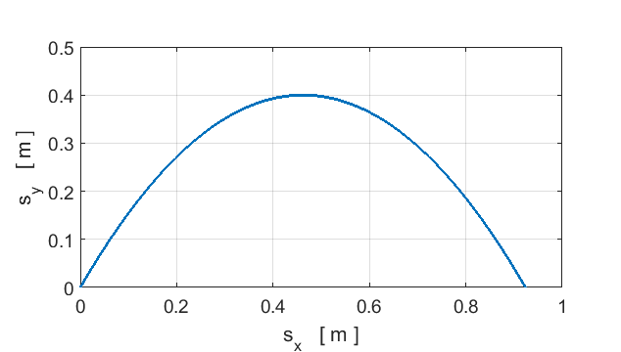

Trajectory of the Ball.

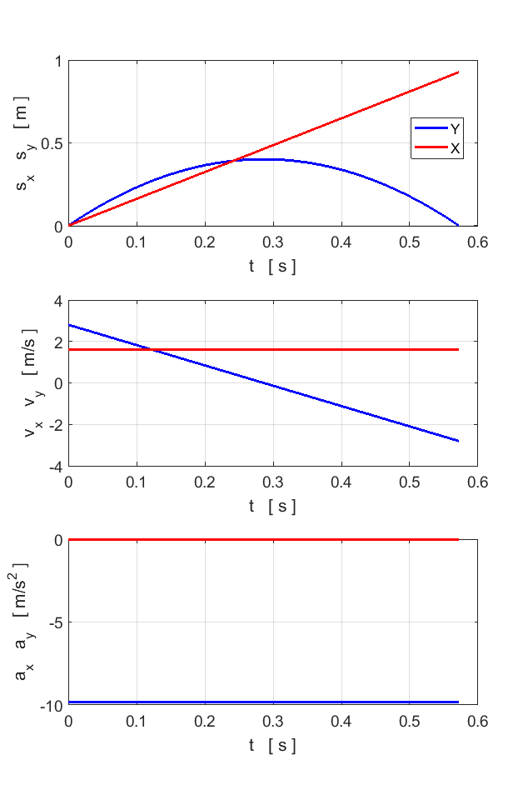

Graphical representation of the ball in flight.

You must do the experiment on the Video Analysis of the Flight of a golf Ball. The experiment is best done in class at your school in a group of three. However, the experiment can also be done individually as no equipment is necessary other than pen, paper, graph paper, ruler and calculator. The measurement are best recorded in a spreadsheet to save time and effort.

[EXPERIMENT 533: PROJECTILE MOTION](http://www.physics.usyd.edu.au/teach_res/hsp/sp/mod5/expt533.pdf)

[VISUAL PHYSICS ONLINE](http://www.physics.usyd.edu.au/teach_res/hsp/sp/spHome.htm)

http://www.physics.usyd.edu.au/teach_res/hsp/sp/spHome.htm

If you have any feedback, comments, suggestions or corrections please email Ian Cooper

ian.cooper@sydney.edu.au

Ian Cooper School of Physics University of Sydney