

[**VISUAL PHYSICS ONLINE**](http://www.physics.usyd.edu.au/teach_res/hsp/sp/spHome.htm)

**MODULE 5**

**ADVANCED MECHANICS**

**UNIFORM CIRCULAR MOTION**

|  |
| --- |
| Equation of a circle  Angular displacement  [rad]  Angular speed  [rad.s-1]  Tangential velocity  [m.s-1]  (direction: tangent to circle)  Centripetal acceleration  [m.s-2]  (direction: towards centre of circle / perpendicular to circle)  A force must be applied to an object to give it circular motion. This net force is called the centripetal force.    (direction: towards centre of circle / perpendicular to circle)  Period *T* [s] time for 1 revolution  Frequency *f*  [Hz] revolutions per seconds  Angular frequency (speed)  [rad.s-1] |

Uniform circular motion is circular motion with a uniform orbital speed. As an example of circular motion, imagine you have a rock tied to a string and are whirling it around your head in a horizontal plane. Because the path of the rock is in a horizontal plane, as shown in the diagram, gravity plays no part in its motion. The Greek, Aristotle, considered that circular motion was a perfect and natural motion, but it is far from it. If you were to let go of the string, the rock would fly off at a tangent to the circle - a demonstration of Newton's First Law of Motion (an object continues in uniform motion in a straight line unless acted upon by a force). In the case of our rock, the force keeping it within a circular path is the tension in the string, and it is always directed back towards the hand at the centre of the circle. Without that force the rock will travel in a straight line (figure 1).

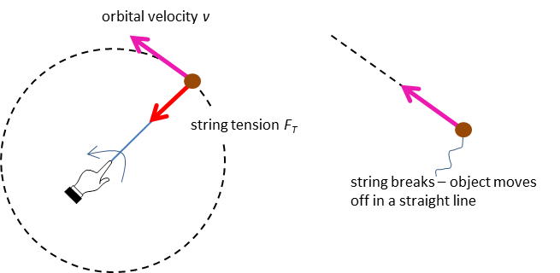

Fig. 1. A force acting towards the centre of a circle is necessary for an object to rotate in a circular path.

If the magnitude of the velocity is constant but its direction is changing, then the velocity must be changing, so, the rock is accelerating. A force is required to accelerate the rock and as stated above, this force is the tension in the string. This centre seeking force is called the **centripetal force** . The term centripetal force is only a **label** attached to real physical forces such as tension, gravitation or friction. On force diagrams, you should show the real physical forces acting and not the label centripetal force.

The same is true of a spacecraft in orbit around the Earth, or any object in circular motion - some force is needed to keep it moving in a circle or accelerate it and that force is directed towards the centre of the circle. In the case of the spacecraft, it is the gravitational attraction between the Earth and the spacecraft that acts to maintain the circular motion and keep it in orbit. The Moon obits around the Earth and the Earth around the Sun because of the gravitational force like the satellite shown in figure 2.

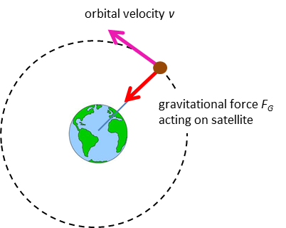

Fig.2. A satellite is acted upon by the gravitation force between the Earth and the satellite. The centripetal force is the gravitational force.

An object is shown in figure 3 moving between two points (1) and (2) on a horizontal circle. Its velocity has changed from  to . The magnitude of the velocity is always the same, but the direction has changed. Since velocities are vector quantities we need to use vector mathematics to work out the average change in velocity , as shown in figure 3. In this example, the direction of the average change in velocity is towards the centre of the circle. This is always the case and thus true for instantaneous acceleration. This acceleration is called the **centripetal acceleration** .



Fig. 3. The direction of the change in velocity (and acceleration) is directed towards the centre of the circle.

For a mass , moving at a speed , in uniform circular motion of radius , the **net force**  acting on is called the **centripetal force**  and its magnitude is given by equation 1

(1)  **centripetal force**

This centripetal force is responsible for the change in direction of the object as its speed is constant. The resulting acceleration due to the change in direction is the centripetal acceleration  and its magnitude is given by equation 2. The direction of the centripetal force and centripetal acceleration is towards the centre of the circle (centripetal means ‘centre seeking’).

(2)  **centripetal acceleration**

[**WARNING**: the equations given in the Physics Stage 6 Syllabus for the centripetal force and centripetal acceleration are **absolutely incorrect**]

It is important to understand that centripetal force is not a new force that starts acting on something when it moves in a circle. It is the sum of all forces acting on the object. This total force results from all the other forces on the object. When the rock in the example above is whirled in a vertical circle (instead of horizontal), gravity interacts with the tension in the string to produce the net force which we call centripetal force. Centripetal force is always the net force.

[Predict / Observe / Explain: Circular Motion](http://www.physics.usyd.edu.au/teach_res/hsp/u5/ag_circular1.htm)

|  |
| --- |
| **Mathematical Analysis of Uniform Circular Motion**  You do not need this depth of treatment for any examination. However, by understanding of the mathematics, you will gain a much deeper insight into circular motion. Richard Feynman one of the greatest physicists and teachers of the20th century, said that leaning was a creative process and one of the best approaches to learning physics was to start with first principles.  Image result for richard feynman  Our object is simply moving in a circle with a constant speed. So, we start with the equation of a circle and what we know about describing a moving object: time, displacement, velocity and acceleration.    The **position** of the object can be given as    As the object moves with uniform circular motion at a radius , it sweeps out an angle  in a time interval . When , the **instantaneous angular speed**  is  **angular speed** [rad.s-1]    The arc length  is the distance the objects moves in the time interval . The instantaneous tangential velocity  of the object is ()  **tangential velocity** [m.s-1]  This velocity is called the **tangential velocity**  since at any instant the direction of the velocity vector is tangential to the circle.    The components of the position of the object at any instant are    The components of the tangential velocity  at any instant are    The magnitude of the velocity  is      The components of the centripetal acceleration  at any instant are    The magnitude of the centripetal acceleration  is    The direction of the centripetal acceleration is always directed towards the centre of the circle since      Note: A force must be applied to an object to give it circular motion. This net force is called the centripetal force. |

|  |
| --- |
| **Example**  A 1200 kg car rounds a circular bend of radius 45.0 m. If the coefficient of static friction between the tyres and the road is 0.820. Calculate the greatest speed at which the car can safely negotiate the bend without skidding. What would be the trajectory of the car if it entered the bend with a greater speed?  **Solution**  [Review: Types of forces (friction)](http://www.physics.usyd.edu.au/teach_res/hsp/sp/mod2/m2_FM.pdf)    The static friction force  provides the centripetal force required for the car to move in the circular path.    The faster the car moves, the greater the frictional force required to the car to keep moving along its circular path. The maximum speed corresponds to the maximum value of the static friction    Note: the max speed is independent of the mass of the car. The same maximum speed applies to a motor bike or a heavy truck.    If the car entered the bend at a speed greater than 19 m.s-1, the friction would not be sufficient for the car to continue moving in a circular path and hence the car would move in a straighter path – a curve of greater radius. This is why so many collisions resulting in death occur when a car enters a corner too fast. |

Many roads have banked (tilted) bends. The same type of banking occurs on some racetracks. The banking is directed towards the centre of the bend. This is by design for safety reasons. On a banked curve, the normal force exerted by the road contributes to the required centripetal force so that the car can negotiate the curve even when there is zero friction between the road and tyres.

|  |
| --- |
| **Example**  Consider a 1200 kg car rounding a banked curve which has a radius of 65.0 m. Determine the banking angle of the curve if the car travels around the curve at 25.0 m.s-1 without the aid of friction.  **Solution**    For the car to move in a circular path, there must be a force acting on it in the +X direction towards the centre of the circle.  Forces in Y direction    Forces in X direction    Centripetal force    Note:  Banking angle is independent on the mass of the vehicle.  Banking angle increases with increasing speed.  Banking angle decreases with increasing radius of the turn. |

|  |
| --- |
| **Example**  A person with a mass of 70 kg is driving a car with a mass of 1000 kg at 20 m.s-1 over the crest of a round shaped hill of radius 100 m. Determine the normal force acting on the car and the normal force acting on the driver. What is the centripetal acceleration of the driver and the car?  If the car is driven too fast, the it can become airborne at the top of the hill. What is the maximum speed at which the car travel over the hill without becoming airborne?  **Solution**  Visualize the problem    Assume the same radius for the motion of the car and driver are the same speed.  Car      Driver      The driver and car will have the same centripetal acceleration towards the centre of curvature of the hill    Travelling too fast and becoming airborne  The normal force becomes zero as the car leaves the ground.      Note: Using unit vector notation makes it easier to keep track of the directions and magnitudes of vector quantities.  Note: If you travel over a bump too fast, the car will become airborne. It does not matter how good a driver you are, when the car leaves the ground you have no control of the car’s movement – this has resulted in many ***fatal*** accidents. |

**Period, frequency, angular frequency (speed)**

Consider an object executing uniform circular motion with a radius *r* and speed *v*. The time for one complete revolution is known as the **period** *T*. The distance travelled by the object in one period is simply the circumference of the circle . The **orbit speed** , period  and radius  are connected by the equations



|  |
| --- |
| **Example**  Image a spider sitting halfway between the rotational axis and the outer edge of a turntable. When the turntable has a rotational speed of 20 rpm, the spider has a speed of 25 mm.s-1.  What will be the rotational speed and tangential speeds of another spider sitting on the outer edge?  What are the periods for the two spiders?  What is the radius of the turntable?  **Solution**  Visualize the problem / how to approach the problem? / annotated scientific diagram    All parts of the turntable have the same rotational speed (angular speed or angular velocity) and hence the same period.      Alternatively, for the period:  20 rpm = 20 revolutions in 60 seconds  1 revolution in 3 seconds  *T* = 3.00 s  Tangential speed    Radius of turntable *R* |

|  |
| --- |
| **Example**  A ball of mass *m* is rotated at a constant speed *v* in a vertical circle of radius *r*. Find the tension in the string at positions A and B  **Solution**    We know that a force equal to the centripetal force is needed to hold the ball in its circular orbit.  When the ball is at point A, the centripetal force is the sum of the string tension and the gravitational force (weight of ball).    Note: The tension in the string becomes zero when . Under that condition, the gravitational attraction required for uniform circular motion means that the centripetal acceleration  is simply equal to the gravitational acceleration *g*:  When the ball is at point B, the centripetal force on the ball still must be    and the must be equal to the net force acting on the ball at this point    Note: The centripetal force at point B is larger than at point A since it must support the weight of the ball and act so that the ball moves in its circular path. |

**Energy**

Have you wondered why the Earth just keeps going around the Sun year after a year, in fact for many billions of years the Earth has been orbiting the Sun. The Earth is attracted to the Sun by the gravitational force acting between the Earth and the Sun, but the Earth does not lose energy, it just keeps orbiting the Sun.

**Why is it so?**

The gravitational force acts as the centripetal force responsible for the uniform circular motion of the Earth around the Sun (actually, the motion of the Earth is only approximately circular, and its speed does vary slightly in its orbit). The centripetal force always acts towards the centre of the circle, but at each instant the displacement of the Earth is at right angles to the centripetal force. Hence, zero work is done by the gravitational force and there is zero change in potential  or kinetic energies  of the Earth in its orbit and the total energy  is constant. So, the Earth can just keep orbiting.

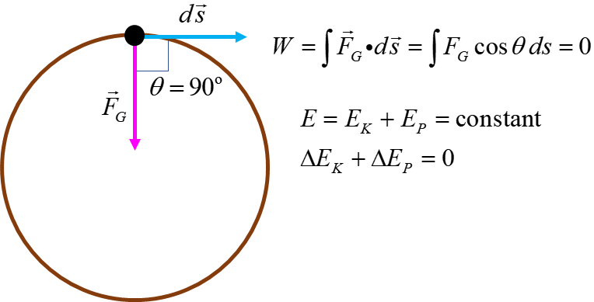

Note: The equation for angular speed given in the Physics Stage 6 Syllabus is . This expression should always be written as . This is another example of the incompetence of the people who put the Syllabus together.

[VISUAL PHYSICS ONLINE](http://www.physics.usyd.edu.au/teach_res/hsp/sp/spHome.htm)

http://www.physics.usyd.edu.au/teach_res/hsp/sp/spHome.htm

If you have any feedback, comments, suggestions or corrections please email Ian Cooper

ian.cooper@sydney.edu.au

Ian Cooper School of Physics University of Sydney