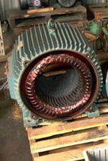[**VISUAL PHYSICS ONLINE**](http://www.physics.usyd.edu.au/teach_res/hsp/sp/spHome.htm)

**MODULE 6**

**ELECTROMAGNETISM**

**AC INDUCTION MOTORS**

|  |
| --- |
| **AC INDUCTION MOTOR**  **Stator**: stationary groups of coils together with a steel core form an electromagnet that is used to produce a **rotating magnetic field**.  **Rotor**: rotating coil.  An alternating current is supplied to the stator that generates an alternating magnetic field. The rotor coils are subjected to the **alternating magnetic flux** due to the stator coils. The result is a current is **induced** in the coils of the rotor. A magnetic force is applied to the rotor coils due to the interaction of the induced current in the rotor and the changing magnetic field due to the stator current. This magnetic force results in a **torque** applied to the rotor causing it to spin. So, we have an electric motor where electrical energy is converted into mechanical energy.  **Advantages**: avoids problem with wear (no brushes); electrical arcing (sparking) across split ring commutators of DC motors; simple & rugged construction; low cost and minimum maintenance; high reliability; efficient; no extra starting motor. |

**PRINCIPLE OF AN AC INDUCTION MOTOR**

**Advantages of an AC induction motors compared with a DC motor**

Avoids problem with wear (no brushes); no electrical arcing (sparking) across split ring commutators as in DC motors; simple & rugged construction; low cost and minimum maintenance; high reliability; efficient; no extra starting motor.

**AC induction motors**

There are two main components of an AC induction motor.

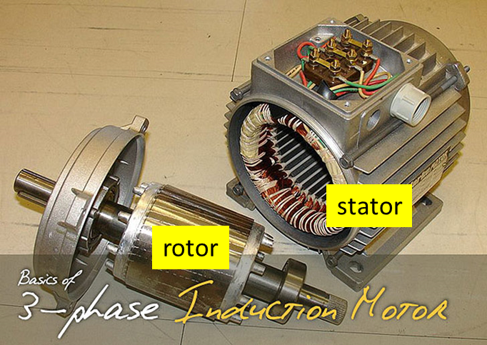

**Stator**: groups of coils together with a steel core form an electromagnet that produces a rotating magnetic field.

**Rotor**: rotating coils often in the form of a squirrel cage (stacks of steel laminations with evenly spaced conductor bars around the circumference).

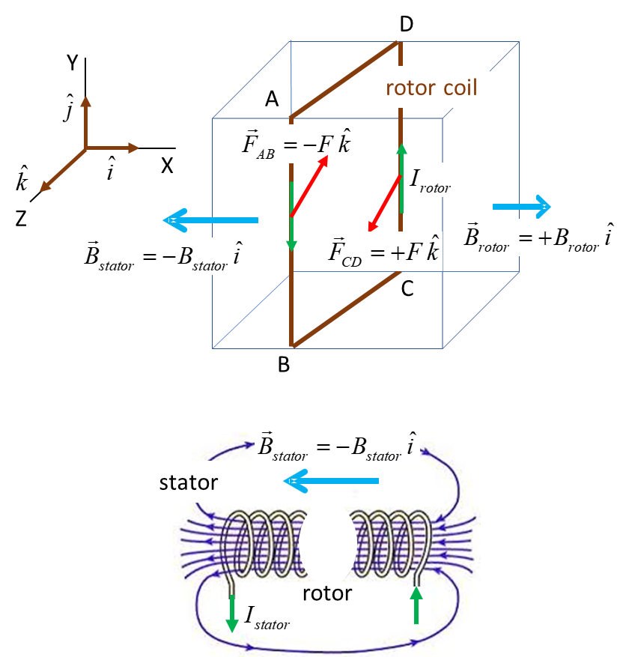

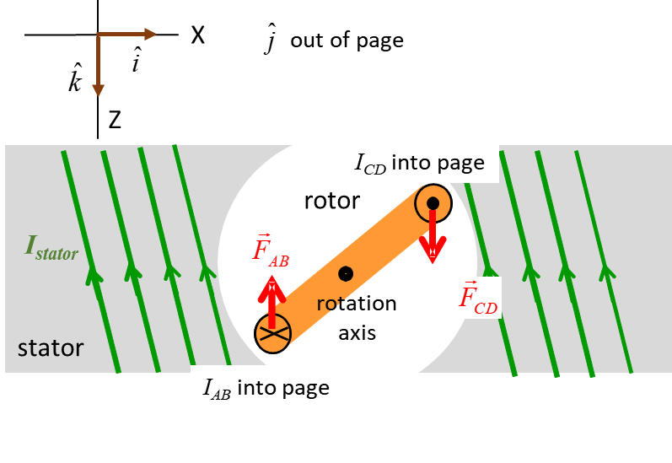

Fig. 1. Schematic diagram of an AC induction motor. Real practical AC induction motors are much more complex than shown.

For a simplified AC induction motor shown in figure 1, the stator (stationary electromagnet) is composed of a set of coil like in a solenoid. Consider the time in which the current in the coils of the stator is increasing. The stator current generates a magnetic field (direction given by the right-hand screw rule as applied to a solenoid). Since the stator current is increasing, the magnetic field of the stator is also increasing. So, the coils of the rotor are subjected to a changing magnetic flux due to the magnetic field of the stator and a current  is induced in to the rotor coils. The direction of the rotor current must produce its own magnetic field which opposes the increasing magnetic field of the stator (Lenz’s Law).

So,

 

and the current must be in a clockwise sense as shown in figure 1. The rotor current carrying conductors will experience a magnetic force  in the magnetic field generated by the stator current . The magnetic force acting on the coils of the rotor causes it to turn. The direction of the force on the conductor segments AB and DC are



Thus, a torque is exerted on the rotor coils causing in to spin to produce an electrical motor where electrical energy is converted into mechanical energy.

**Stator produces a rotating magnetic field**



An AC induction motor must achieve a rotating magnetic field to continue to exert a continuous applied torque on the rotor (armature) coils. This is achieved by having extra coils for the stator to produce the rotating magnetic field .

The rotor is often made as a squirrel cage to give many current loops to increase the torque acting on it.

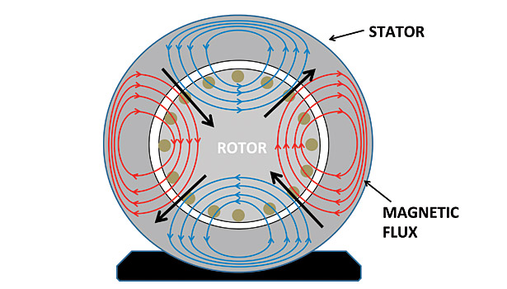

Fig.2. The magnetic fields due to the current through the stator any one instant. After a time equal to a half-period, the magnetic fields shown in red and blue are reversed, so that a rotating magnetic field is generated by the stator.

[Explain that Stuff: Induction Motors](http://www.explainthatstuff.com/induction-motors.html)

|  |
| --- |
| **Exercise 1**   1. What is a DC motor? Describe its main features. 2. What is an AC motor? Describe its main features. 3. Compare the advantages and disadvantages between DC and AC motors. 4. Which statement correctly describes an AC induction motor? 5. An AC or DC motor in which torque is produced by the interaction of a rotating magnetic field in the stator with induced magnetic fields of the induced current in the rotor. 6. An AC only motor in which torque is produced by the interaction of a rotating magnetic field in the stator with induced magnetic fields of the induced current in the rotor. 7. An AC or DC motor in which torque is produced by the interaction of a rotating magnetic field in the stator with induced magnetic fields of the supplied current in the rotor. 8. An AC only motor in which torque is produced by the interaction of a rotating magnetic field in the stator with induced magnetic fields of the supplied current in the rotor. 9. Which statement about an AC motor is correct?   (i) It has slip rings and carbon brushes.  (ii) It has slip rings but no carbon brushes.  (iii) It has a split ring commutator and carbon brushes.  (iv) It has a split ring commutator but no carbon brushes.   1. Which statement about split rings and slip rings is correct?   (i) Neither are commutators.  (ii) Only split rings are commutators.  (iii) Only slip rings are commutators.  (iv) Both are commutators  [Explain that Stuff: Induction Motors](http://www.explainthatstuff.com/induction-motors.html) |

|  |
| --- |
| **Exercise 2**  (a)  Explain the physical principles of how an AC motor operators using the diagrams as a basis for your answer.  (b)  Consider the design shown for an induction motor. Explain the operation of this motor and any advantages or disadvantages with the design.    **Solution**  (a)  An AC only motor in which torque is produced by the interaction of a rotating magnetic field in the stator with induced magnetic fields of the induced current in the rotor.  (b)  As the magnet is rotated – changing magnetic flux through metal disk – induced currents – oppose motion of disk – S pole induced at top of disk – disk attracted to magnet – disk rotates.  This is not an efficient induction motor – lots of energy need to rotate “heavy” magnet. |

[View PHYSCIPS Electric motors and generators](http://www.animations.physics.unsw.edu.au/jw/electricmotors.html)

[VISUAL PHYSICS ONLINE](http://www.physics.usyd.edu.au/teach_res/hsp/sp/spHome.htm)

If you have any feedback, comments, suggestions or corrections please email Ian Cooper

ian.cooper@sydney.edu.au