[**VISUAL PHYSICS ONLINE**](http://www.physics.usyd.edu.au/teach_res/hsp/sp/spHome.htm)

**MODULE 6 ELECTROMAGNETISM**



**MAGNETIC FIELDS AND CURRENTS**

|  |
| --- |
| **A frame of reference**  Image result for clip art personObserver  Origin O(0, 0, 0) Cartesian coordinate axes  (X, Y, Z)  Unit vectors  Specify the units  Note: the magnitude of a vector is always a positive number.  **Newton’s 2nd Law**  **Motor Effect**: a conductor carrying a current in a magnetic field will experience a force    where *θ* is the angle between the conductor (current) and the direction of the B-field.  **Right-hand palm rule** determines the direction of the force on a moving charge or the current in a magnetic field    Magnetic force between two parallel straight conductors    Two parallel conductors carrying currents in the **same** direction are **attracted** to each other.  Two parallel conductors carrying currents in **opposite** directions are **repelled** to each other. |

There are magnetic forces on moving charged particles. But, a moving charge corresponds to an electric current. Therefore, a conductor carrying a current in a magnetic field will experience a force. It is the force on a conductor carrying a current that is responsible for the rotational motion of an electric motor, the vibration of a membrane in a loudspeaker and the deflection of a needle in an analogue electrical meter. This is often called the **motor effect**.

Consider a straight conductor of length *L* carrying a current  in a uniform B-field of strength *B*. Then, the conductor will experience a force . The direction of the force is determined by the right-hand palm rule and its magnitude is given by equation 1

1. 

where *θ* is the angle between the conductor (current) and the direction of the B-field as shown in figure 1.



Fig. 1. The direction of the force on a current is determined by right-hand palm rule.

The principle of a force on a current in a magnetic field is illustrated in how a **loudspeaker** works. An audio signal is connected to the wire leads of a speaker which are connected to a coil that is attached to the speaker cone. The speaker cone is mounted so that it is free to vibrate back and forth. A permanent magnet is aligned with the coil in such a way that when a current passes through the coil, the force on the conductor can move the speaker cone in or out.

 When an alternating current of the audio signal is connected to the coil, the force on the conductor alternates at the frequency of the audio signal. The speaker cone vibrates producing a series of compressions and rarefactions of the adjacent air, thus producing the sound wave with frequencies and intensities to give a reproduction of the electrical signal and the original sound signal. The main features of a loudspeaker are shown in figure 2.

Fig. 2. Loudspeaker. When a AC current passes through the coil, an alternating force moves the speaker back and forth to produce the sound wave. An any instant, the direction of the force on the speaker can be determined from the right-hand palm rule.



**Magnetic force between two parallel current carrying conductors**

A conductor carrying a current has a magnetic field surrounding it. A conductor carrying a current in a magnetic field experience a force. Hence, two current parallel carrying conductors will exert a force on each other. Figure 3 shows the force *F*21 acting on conducting 2 (current *I*2) due to the magnetic field surrounding conductor 1 (current *I*1). The direction of the force is given by the right-hand palm rule. When the currents are in the same direction, the conductors are attracted to each other.

When the currents are in opposite directions, the conductors repel each other as shown in figure 4.

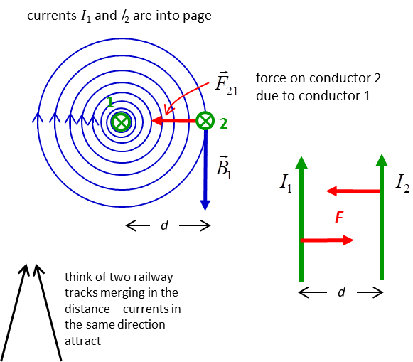

Fig. 3. Two parallel conductors carrying currents in the same direction are attracted to each other.



Fig. 4. Two parallel conductors carrying currents in opposite directions are repelled to each other.

At the location of conductor 2, the B-field from conductor 1 is



The magnitude of the force on conductor 2 in this B-field is





Hence, we can conclude, that the force per unit length between two parallel conductors is

(2)  

|  |
| --- |
| **Example**  There are two parallel horizontal conductors. The first conductor has a current of 100 A. The second conductor lies 350 mm directly below the first conductor. The second conductor has a mass of 0.150 g.m-1. What is the minimum current through the second conductor so that it does not fall due to gravity? What are the directions of the currents?  **Solution**  How to approach the problem  Draw a diagram of the situation: labelled with known and unknown quantities  Type of problem: force between parallel conductors  Magnetic force  Weight  For the conductor 2 to be balanced, the gravitational force must equal the magnetic force and the conductors must attract each other. Therefore, the currents *I*1 and *I*2 must be in the same direction.    Gravitational force  Magnetic force  Forces balance to support 2nd conductor    We can rearrange to find the current *I*2 |

[View online video 1](https://www.youtube.com/watch?v=nfSJ62mzKyY)

[View online video 2](https://www.youtube.com/watch?v=s94suB5uLWw)

[VISUAL PHYSICS ONLINE](http://www.physics.usyd.edu.au/teach_res/hsp/sp/spHome.htm)

<http://www.physics.usyd.edu.au/teach_res/hsp/sp/spHome.htm>

If you have any feedback, comments, suggestions or corrections please email:

Ian Cooper School of Physics University of Sydney

ian.cooper@sydney.edu.au