[**VISUAL PHYSICS ONLINE**](http://www.physics.usyd.edu.au/teach_res/hsp/sp/spHome.htm)

**MODULE 6 ELECTROMAGNETISM**

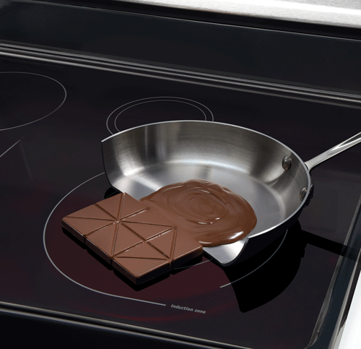

**ELECTROMAMAGNETIC INDUCTION**

**EDDY CURRENTS**

|  |
| --- |
| **Eddy currents**: A changing magnetic flux can induce a current in a conductor. Sometimes the changing magnetic flux induces circulating current known as **eddy currents**. |

A changing magnetic flux can induce a current in a conductor. Sometimes the changing magnetic flux induces circulating current known as **eddy currents**.

Eddy currents have a heating effect upon the conductor (ohmic heating ). This heating effect is put to good use in induction cooktops, but this heating effect contributes to an energy loss in transformers.

When you try to pull a strip of copper or aluminium through the poles of a magnet, you feel a retarding force. As you move the conductor through the magnetic field of the magnet, a changing flux is produced. This results in circulating eddy currents in the metal strip. The induced force on the metal strip opposes its motion (Lenz’s law).



Fig.1. Metal sheet pulled through a magnetic field experiences a drag force. This drag force opposes the motion of the metal through the B-field. The direction of the induced current can be determined using the right-hand palm rule.

If you drop a permanent magnet through a vertical plastic tube, the magnet will fall freely with an acceleration *g.* But, if it falls through a vertical copper pipe eddy currents are established around the circumference of the pipe. The faster the magnet falls the greater the induced eddy currents and the greater the opposing force to slow the magnet down. So, the magnet falls very slowly through the copper pipe, speeding up, slowing down repeatedly as it drifts down the tube. Try sliding a magnet down a sheet of aluminium – you will notice this effect.

Eddy currents can be used in **electromagnetic breaking**. A large electromagnet is located over the wheels of a vehicle. When the electromagnet is switched on, large eddy currents are induced in the metal wheels and the magnetic force provides a drag force on wheels to stop the vehicle.



Fig. 2. As an element of the metal enters the magnetic field, circular current loops are induced. The force on these current loops in such that it opposes the motion of the metal.



Fig. 3. As an element of the metal exits from the magnetic field, circular current loops are induced. The force on these current loops in such that it opposes the motion of the metal.



Fig. 4. As the metal wheel rotates, the section of the wheel within the B-field region will experience a drag force that can be used to stop the rotation. This is the mechanism used for brakes in vehicles using an electromagnetic induction braking system.

**Eddy currents are used to dampen unwanted oscillations**. For example, very sensitive mechanical balances would oscillate up and down about its equilibrium position when a mass was placed on the scales if not for the damping produced by eddy currents.

**Eddy currents are usually unwanted because of their heating.**

Eddy currents induced in the armature of a motor, generator or transformer can produce a considerable heating effect (ohmic heating ). This degrades their performance because energy is lost as thermal energy.

Theses thermal energy losses can be reduced by using conductive slabs that are laminated (small strips glued together). This separates the conductive strips by an insulator, hence, the eddy currents are confined to individual strips which dramatically reduces the heating effect.



Fig. 5. Laminations reduce the magnitude of eddy currents. This reduces the ohmic heating of the metal core.

Also, if the conductor has cuts made in it, again the eddy currents are weaker reducing the heating effect and also reducing the magnetic drag force acting on the conductor.



Fig. 6. Copper sheets falling through the poles of a magnet.

**Induction cooktops** are becoming more popular. The cooktop does not get hot. No heat is transferred from the cooktop to the saucepan. A coil in the cooktop induces eddy currents in the base of a saucepan. The eddy currents in the metal base produce the heating effect (). Induction cooktops are more energy efficient and quicker than traditional cooktops. The magnetic properties of a steel vessel concentrate the induced current in a thin layer near its surface. This makes the heating effect stronger. In non-magnetic materials like aluminium, the B-field field penetrates too far, and the induced current encounters little resistance in the metal. Practical induction cookers are designed for ferromagnetic saucepans or frypans that will stick to a magnet.



Fig. 6. Induction heating of a saucepan.

[VISUAL PHYSICS ONLINE](http://www.physics.usyd.edu.au/teach_res/hsp/sp/spHome.htm)

<http://www.physics.usyd.edu.au/teach_res/hsp/sp/spHome.htm>

If you have any feedback, comments, suggestions or corrections please email:

Ian Cooper School of Physics University of Sydney

ian.cooper@sydney.edu.au