[**VISUAL PHYSICS ONLINE**](http://www.physics.usyd.edu.au/teach_res/hsp/sp/spHome.htm)

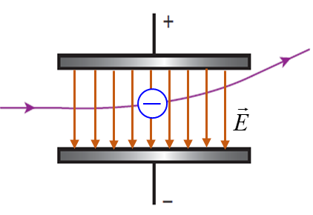

**MODULE 6**

**ELECTROMAGNETISM**

**PARTICLE MOTION IN UNIFORM GRAVITATIONAL and ELECTRIC FIELDS**

|  |
| --- |
| **A frame of reference**  Image result for clip art personObserver  Origin O(0, 0, 0) Cartesian coordinate axes  (X, Y, Z)  Unit vectors  Specify the units  Define zero point for  potential energy and  electric potential  Note: the magnitude of a vector is always a positive number.  **Newton’s 2nd Law**  **Electric force**  **Motion of a particle with a uniform acceleration**          **Motion the XY plane with uniform acceleration**  Apply the equation for uniform acceleration to the X Motion and Y Motion separately          **Energies**  Kinetic energy  Electric potential energy and electric potential (uniform electric field)    Work    Total energy  Conservation of energy |

*Physics is a* ***beautiful*** *subject*. The same laws, principles and equations can often be applied to describe and predict the behaviour of a wide range of physical phenomena. As an example, we will examine the motion of a particle in a uniform gravitational field and the motion of charged particles in uniform electric fields and find that the exactly same laws and equations can be applied to both situations.

**Motion in a uniform gravitational field**

Near the surface of the Earth, to a good approximation the gravitational force  acting on a particle of mass *m* is constant (uniform). We will investigate the motion of a particle launched from the Origin with an initial velocity  in the uniform gravitational field near the surface. We can predict the velocity , displacement and energies  of the particle at any future time *t*.

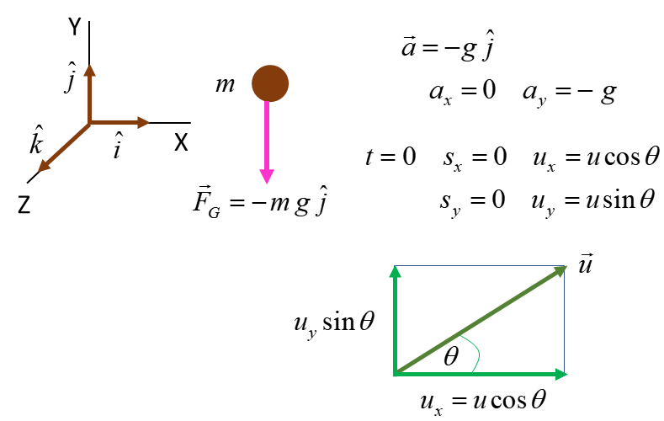

Fig. 1. Frame of reference and force acting on a particle in a uniform gravitational field.

Using Newton’s 2nd Law, the acceleration of the particle is constant, because the force acting on the particle is constant



Note: The acceleration of the particle is independent of the particle’s mass.

The motion of the particle is described by the equations of uniform accelerated motion which are applied to the motion in the X and Y directions



 initial conditions

 Graph *vy* vs *t* is a straight line

 Graph *sy* vs *t* is a parabola



 average velocity



 kinetic energy

 gravitational potential energy

 total energy

 work done by gravitational force



 conservation of energy

|  |
| --- |
| **1 Predict Observe Explain Exercise**  A particle of mass 10 kg is launched with an initial velocity of 10 m.s-1 at an angle of 75o w.r.t. the horizontal.  Calculate the time, velocity, position, kinetic energy, potential energy and total energy of the particle at the Origin, when it reaches its maximum height and when it returns to its launch height. Predict the shape of the graphs for:  Trajectory (*sx* vs *sy*)  Time graphs  Mark on the graphs, when the particle reaches its maximum height and returns to its launch height.  **Solution**  Use the graphs shown below to check your calculations and predicted graphs. |

**Motion of charged particles in uniform electric fields**

**How do electric charges move in a uniform electric field?**

To get started in answering this question, we will investigate the motion of an electron and a proton in a uniform electric field. The electric field between two oppositely charged parallel plates is approximately a uniform field. As an example, the potential difference between the plates is set at 1000 V and the plate separation is 20 mm. An electron and a proton are released from rest at points mid-way between the two plates. The zero position for the potential energies of the two charges and the potential is at the mid-point between the plates where the two charges are released. The physical situation is shown in figure 2.

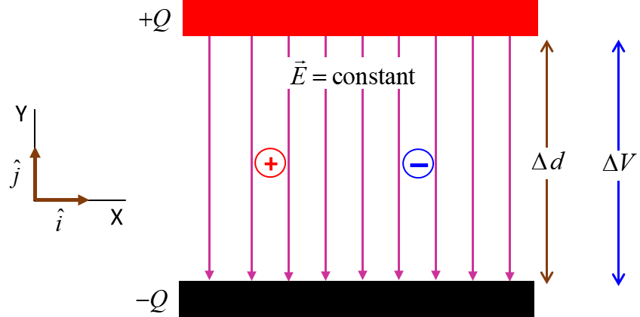

Fig.2. Motion of charged particles in a uniform electric field.

|  |
| --- |
| **2 Predict Observe Explain Exercise**  **Predict** the following after each charged particle has moved a distance of 5.0 mm from their initial release positions.   1. The location of each charge. 2. Is the force (magnitude) on the electron less than, equal to or greater than the force on the proton? 3. Is the acceleration (magnitude) on the electron less than, equal to or greater than the acceleration of the proton? 4. The time interval for the electron to travel 5.0 mm is less than, equal to or greater than the time interval for the proton to travel 5.0 mm? 5. Is the work done on the electron by the electric force less than, equal to or greater than the work done on the proton? 6. Is the kinetic energy of the electron less than, equal to or greater than the kinetic energy of the proton? 7. Is the momentum of the electron less than, equal to or greater than the momentum of the proton? 8. Has the potential of the electron decreased, stay the same or increased? Has the potential of the proton decreased, stay the same or increased? 9. Is the potential energy of the electron-field less than, equal to or greater than the potential energy of the proton-field?   Verify each of your predictions by calculating each quantity. Compare your predictions with the numerical results and resolve any discrepancies.  **Solution**  Visualize the motion of the two charges: The electron will move towards the positive plate as it is attracted to the positive plate and be repelled from the negative plate. The opposite is true for the proton, it will move towards the negative plate.  Annotated diagram including frame of reference  1 Since the charged particles start from rest, they will move in a direction parallel to the electric field lines. So, the distance travelled corresponds to the vertical displacements of the two charges.  Initial position of electron  Final position of electron  Initial position of proton  Final position of proton  2 The electric force on a charged particle in an electric field is    The magnitudes of the charges on the electron and proton are equal, therefore the magnitudes of the forces on each charged particle are equal.      Electric force on electron and proton    Electron  Proton  3 The acceleration of a particle is given by Newton’s Second Law    The mass of the proton is much greater than the mass of the electron. So, the electron’s acceleration is much greater than the acceleration of the proton.    Electron  Proton  4 The acceleration of the electron is greater than the acceleration of the proton. So, the electron will gain speed more quickly and cover a given distance in a shorter time interval than the proton.  Uniform acceleration  Electron    Proton    5 Work  The same work is done on the electron and the proton by the electric force since the magnitude of the displacements are the same.  Electron    Proton    6 The initial kinetic energies of the electron and proton are both zero, hence,  The final kinetic energies will be the same since the same amount of work is done on the electron and proton.  Electron    alternative calculation  Proton    alternative calculation  7 Momentum    Electron    Proton    8 Potential  The potential is a linear function of distance for a constant electric field. The potential difference between the plates is 1000 V, therefore the potential of the positive plate is +500 V and the potential of the negative plate is -500 V. The potential at *y* = 5.0 mm is *V* = 250 V and the potential at *y* = - 5.0 mm is *V* = -250 V. An electron in an electric field moves from a region of lower potential to higher potential. A proton moves from the higher potential region to a lower potential region.  9 Potential energy  The changes in potential energy of the electron and the proton are the equal since the work done on the charges is the same.    Alternatively, energy must be conserved. As the kinetic energy of the electron or proton increases then the potential energy must decrease such that |

We will now consider the [2D] motion of a positive charged particle in a uniform electric field. The electric field is assumed to be uniform in the region between two oppositely charged parallel plates. The potential difference between the two plates is  and the plate separation distance is . So, the uniform electric field between the plates is

 uniform electric field

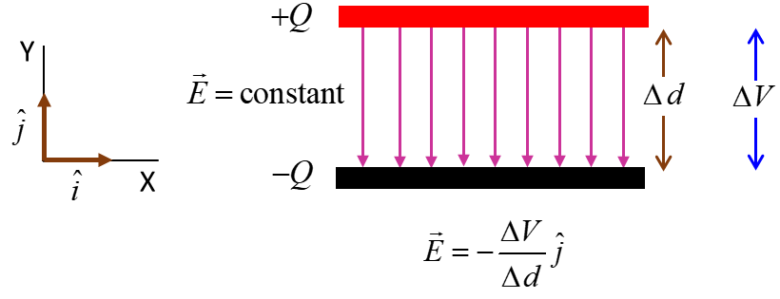

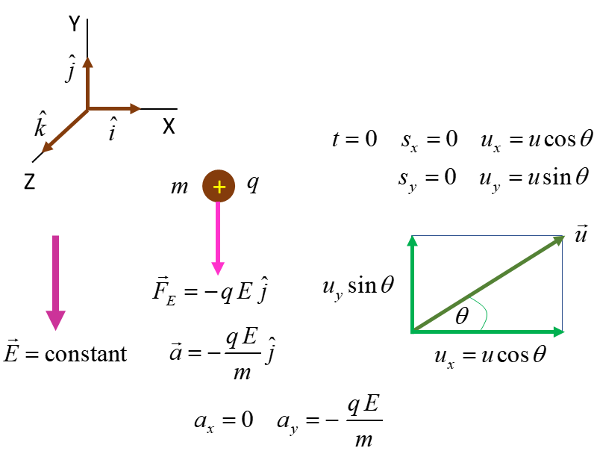

Fig. 3. Projectile motion if a charged particle in a uniform electric field.

The equations describing the motion of a charged particle in a uniform electric field are identical as those describing the motion of an object in the uniform gravitational field near the Earth’s surface as given above, except the acceleration of the charged particle is



For the motion of the charged particle we can also define the very important terms – potential and potential difference . The potential and potential difference between two points is related to the difference in potential energy of the electric field and charge.

Electric force acting on charge 

The only force acting on the particle is the electric force. So, the net work done by the electric force is the work done by the electric force which results in the increase in kinetic energy when the charged particle is projected into the uniform electric field. The electric force is a conservative force, therefore, the increase in kinetic energy results in a corresponding decrease in the potential system of the system (particle and charge).

The initial position of the charged particles is taken as the Origin O(0,0) and is the reference point where the potential energy and potential are both zero, .

Electric field 

Electric force 

Work done on particle 

Potential energy 

Potential 

Kinetic energy



|  |
| --- |
| **2 Predict Explain Observe Example**  A particle of mass 10.0 kg and charge 1.0 mC is launched with an initial velocity of 10.0 m.s-1 at an angle of 75o w.r.t. the horizontal in a uniform electric field 1.0x105 V.m-1.  Calculate the time, velocity, position, kinetic energy, potential energy and total energy of the particle at the Origin, when it reaches its position of maximum vertical displacement and when it vertical displacement is again zero. Predict the shape of the graphs for:    Trajectory (*sx* vs *sy*)  Time graphs  Mark on the graphs, when the particle reaches its maximum height and returns to its launch height.  **Solution**    The initial velocity and acceleration values are identical to those given in **Example 1**. Therefore, the numerical values and graphs are identical to the results presented in **Example 1**.  In **Example 1**, the acceleration of the particle is independent of the mass – if you launched another particle with the same initial conditions, but with different mass, then all the graphs and numerical values would be the same. This is **not true** for our particle launched in a uniform electric field. The acceleration does dependent upon the particle’s mass.  Another important difference between the motion of particles in gravitational fields or electric fields is:   * The gravitational force is always attractive – a particle under the action of only the gravitational force will move from a point of high potential energy towards points of lower potential energy. * The electric force can be **attractive** or **repulsive**. A positive charge will move from a higher potential point to a lower potential point by the action of the electric force. However, a negative charge will move from a lower potential point to a higher potential point by the action of the electric force.   Consider the case where the vertical acceleration has a magnitude of 5.0 m.s-2 instead of 10 m.s-2. This could be for the projectile motion of an object on a different planet or the motion of a charged particle in an electric field. Using the results for **Example 1**, how do the trajectory and time to reach maximum height change with the reduced vertical acceleration?    Compare the two sets of results for the vertical acceleration of 5.0 m.s-2 and 10.0 m.s-2. |

|  |
| --- |
| **3 Example**  A beam of electrons moving in the +X direction with an initial veloicty  enters a region of uniform elctric field  directed in the +Y direction generated by a pair of oppositely charged parallel plates (parallel plate capacitor) which has a length  in the X direction.  Determine the path of the electron when it is moving through the uniform electric field. What is the vertical distance  the electron will be deflected when passing through the uniform electric field.  Descibe the path of the elctron beam after leaving the uniform electric field. The electron beam hits a screen located at a distance  from the end of the parallel plate capacitor. What is the vertical deflection  of the electron beam from its original trajectory when it strikes the screen?  **Solution**  [Watch Video](https://www.youtube.com/watch?v=XSXKk_A3xUM) (concentrate on the motion of charged particles through a uniform electric field).  [Review motion with a uniform acceleration](http://www.physics.usyd.edu.au/teach_res/hsp/sp/mod1/m1_aconstant.pdf)  [Review [2D] motion in a plane](http://www.physics.usyd.edu.au/teach_res/hsp/sp/mod1/m1_plane.pdf)  Think about how to approach the problem by visulaizing the physical situation.  Draw an annoated scientifc diagram.  State the known and unknown physical quantities.  State the equations that you will need.  State the physical principles and concepts needed to solve the problem.  This is a long (difficult ???) problem, but if think about breaking the problem into four smaller problems, then you will find that it is not such a difficult problem.  The problem can be solved using the equations for uniform accelerated motion resolved into the X direction and the Y direction.  uniform accelerated motion    **X motion through capacitor (uniform electric field region)**  Initial conditions    Transit time    **Y motion through capacitor (uniform electric field region)**  Force acting on electron and its acceleration    Initial conditions    Time at which electron leaves electric field region    Vertical velocity of electron leaving electric field    Vertical displacement of electron leaving electric field    **X motion field free region**  Initial conditions    Time for electron to travel from capacitor to screen    **Y motion field free region**  Initial conditions    Vertical displacment for position of electron striking screen    The vertical deflection  of the electron on the screen is proportional to the electric field strength between the plates. In cathode ray tubes used in television sets of the past, the path of the electrons through the tube to the screen could be controlled by changing the electric field between the plates of the capacitors. |

[VISUAL PHYSICS ONLINE](http://www.physics.usyd.edu.au/teach_res/hsp/sp/spHome.htm)

http://www.physics.usyd.edu.au/teach_res/hsp/sp/spHome.htm

If you have any feedback, comments, suggestions or corrections please email:

ian.cooper@sydney.edu.au