[**VISUAL PHYSICS ONLINE**](http://www.physics.usyd.edu.au/teach_res/hsp/sp/spHome.htm)

**MODULE 6 ELECTROMAGNETISM**

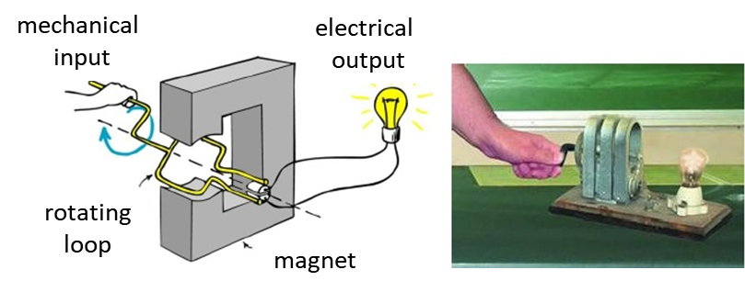

**ELECTRIC GENERATORS**

|  |
| --- |
| **Magnetic flux**  constant over area  **Faraday’s law of electromagnetic induction**  An induced current can be established in a circuit if there is a changing magnetic field. So, a current can be established without a battery by the mechanical action of moving a conductor in a magnetic field to produce changes in magnetic flux.  induced emf  induced current  **Lenz’s Law** is a consequence of the law of conservation of energy. The induced emf and induced current are in the direction that opposes the change that produced them.  **Electrical generator** mechanical energy  electrical energy  Sources of mechanical energy include steam turbines, gas turbines, water turbines, internal combustion engines and even hand cranks. The first electromagnetic generator, the Faraday disk, was built in 1831 by British scientist Michael Faraday. Generators provide nearly most of the power for electric power grids.  A simple generator AC generator has a pair of slip rings as the commutator connected to the brushes.    A simple generator DC generator has a single slip-split ring commutator.    Rotating coil generator |

**Generators are used to convert mechanical energy (rotation) into electrical energy.**

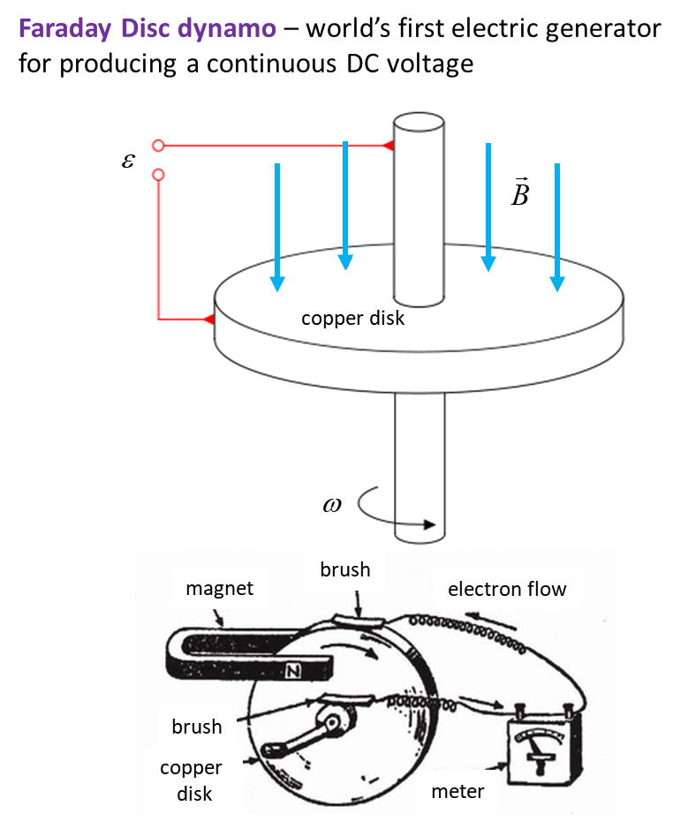

A simple generator consists of a loop of wire that is made to rotate in a uniform magnetic field. The force causing the rotation is applied externally. As the loop is turned the magnetic flux through it changes, thus creating a **motionally induced current**.

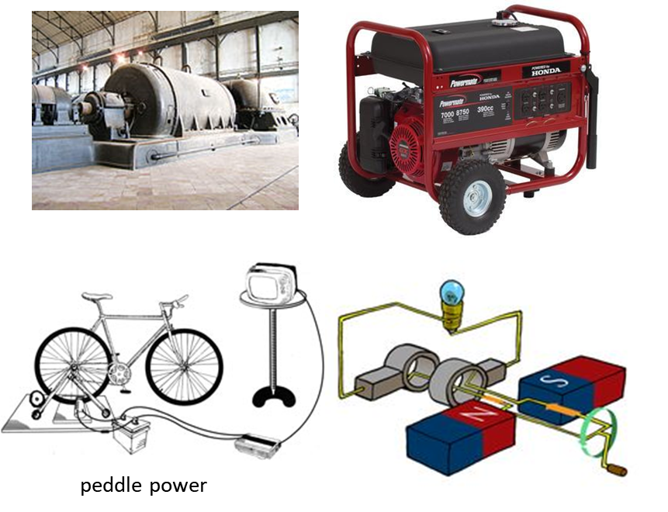

In figure 1, as the loop turns, the point marked D spends half its time to the left of point E and the other half to the right of E. While D is to the left of E, the current flows in the direction CDEF (right-hand palm rule). When the loop is in the vertical direction, with D directly above E the angle between the magnetic field and the normal to the loop is zero, so zero current is flowing. During the rest of the revolution, D is to the right of E the current flows in the direction FEDC. Thus, the direction on which the current flows around the loop is reversed for half of each revolution.



Fig. 1. A simple generator AC generator with a pair of slip-rings as the commutator.

As always with rotary devices (motors and generators) special arrangements must be made to connect the rotating components to a fixed external circuit. In figure 1, each end of the rotating loop is attached to a metal hoop called a **slip ring**. The slip rings turn with the loop, but as they turn they rub against two electrical **brush contacts**. The brushes are fixed and carry the current produced in the rotating loop into the external circuit. This arrangement ensures that the direction of the current supplied to the external circuit will also be reversed for each half of a revolution. This is an **AC generator**. This is different with the kind of DC current (direct current) produced by a battery in which the current direction is constant.

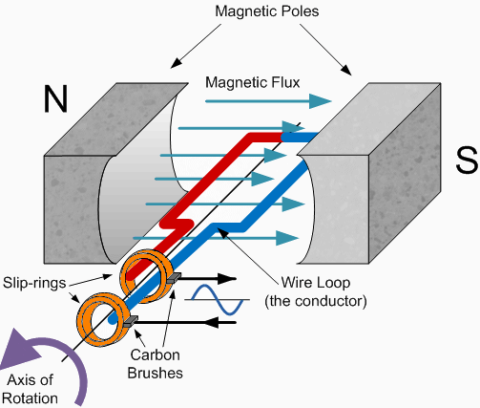

**Generator parameters**

Number of winding of coil *N*

Rotation speed *ω*  [rad.s-1]

Rotation frequency *f* = *ω* / 2π [Hz]

Period of rotation *T =* 1 / *f* = 2π/*ω*  [s]

Angle between magnetic field and normal to the area of the coil

 [rad]

Magnetic flux (constant magnetic field) [T.m2]



Induced emf



Figure 2 shows a series of diagrams explaining how the emf is induced by a rotating coil in a uniform magnetic field that points out of the page.



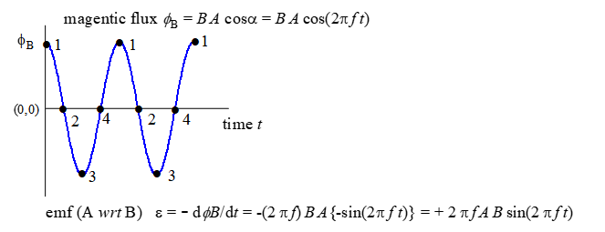

Fig. 2a Rotating coil in magnetic field produces an emf. As the coil rotates, an AC emf is induced.

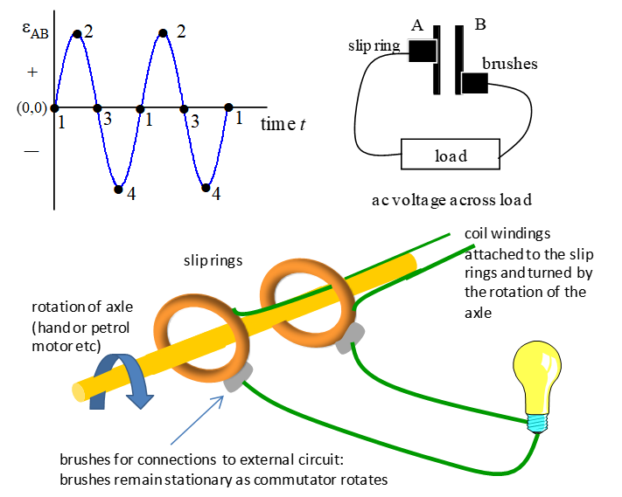

Fig. 2b. Brushes are used to make the connections between the generator and external circuit. For a AC generator, a **pair of slip rings** are used.

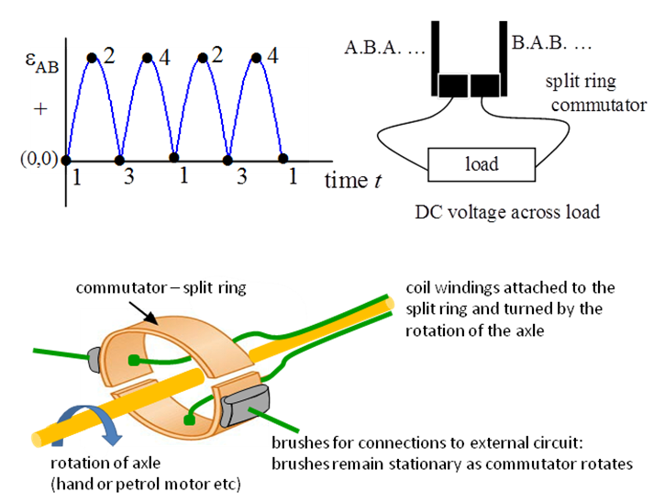

Fig. 2c. Brushes are used to make the connections between the generator and external circuit. For a DC generator, a **single split ring commutator**. is used.

**Advantages and disadvantages of AC and DC generators**

* AC easier to transform (increase or decrease voltage) using transformers than DC.
* AC high voltage transmission – smaller currents – smaller heating losses.
* AC voltages emits electromagnetic radiation which can interfere with electrical / electronic equipment.
* AC produces eddy currents which lowers power output.
* DC not does induced voltages in nearby electrical devices or wires.
* DC generators less reliable due to sparking (causes electrical interference) and wear across the split ring commutator.

**Counter torque in a generator**

Principle of conservation of energy  more mechanical input needed to produce greater electrical output.

Generator not connected to an external circuit  emf exists at the terminals  no current flows  little effort required to rotate armature  zero current  zero counter torque

Generator connected to an external circuit  emf exists at the terminals  induced current flows in coils of armature  current carrying coil in a magnetic field  torque experience by coil which opposes the rotation  counter torque

Greater current drawn from generator  greater counter torque  greater applied torque to keep generator turning.

|  |
| --- |
| **Example**  A coil of resistance 50.0 has 320 turns is placed around a solenoid used as an electromagnet. The cross-sectional area of the solenoid is 0.080 m2 and when switched on, the magnetic field is 0.800 T. When the electromagnet is switched off, the magnetic field drops to zero in 3.00 ms. Sketch three graphs for the time variation of the electromagnetic magnetic field of the solenoid, the induced emf and the induced current. After you have completed your calculations, add scales to your plots. From this information, what quantities can we estimate?  **Solution**  Visualize the physical situation  THINK – how do we approach the problem (ISEE)  Draw an annotated diagram  When the electromagnet is switched off, there is a change in the magnetic field. So, the magnetic flux through the surrounding coil changes and an induced current in the coil will be established.      The negative sign determines the direction of the induced emf and induced current. Lenz’s law states that the induced emf and induced current oppose the initial change.  The magnetic field of the electromagnet decreases. By Lenz’s Law, the induced current will try to keep the magnetic field from decreasing. So, the induced current must produce a magnetic field in the same direction as the original magnetic field of the electromagnet as shown in the diagram above. |

[VISUAL PHYSICS ONLINE](http://www.physics.usyd.edu.au/teach_res/hsp/sp/spHome.htm)

<http://www.physics.usyd.edu.au/teach_res/hsp/sp/spHome.htm>

If you have any feedback, comments, suggestions or corrections please email:

Ian Cooper School of Physics University of Sydney

ian.cooper@sydney.edu.au