[**VISUAL PHYSICS ONLINE**](http://www.physics.usyd.edu.au/teach_res/hsp/sp/spHome.htm)

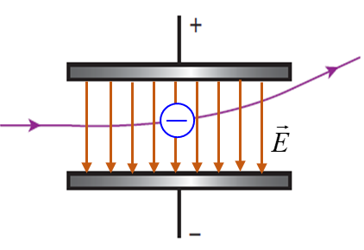

**MODULE 6**

**ELECTROMAGNETISM**

**MOTION OF CHARGED PARTICLES IN MAGNETIC FIELDS**

|  |
| --- |
| **A frame of reference**  Image result for clip art personObserver  Origin O(0, 0, 0) Cartesian coordinate axes  (X, Y, Z)  Unit vectors  Specify the units  Note: the magnitude of a vector is always a positive number.  **Newton’s 2nd Law**  **Magnetic force on a moving charge**    **Right-hand palm rule** determines the direction of the force on a moving charge in a magnetic field    **Circular motion**  A charge moving at right angles to a **uniform magnetic field** will move in a circular orbit.  Magnetic force  Centripetal force    Radius of circular path  Since the magnetic force acts at right angles to the direction of motion of the charge, zero work is done on the charge and the change in its kinetic energy is zero. So, the charged particle will move with a constant speed. The magnetic force always acts towards the centre of a circle. Hence the charged particle will execute uniform circular motion. |

Experiments show that moving electric charges are deflected in magnetic fields. Hence, moving electric charges experience forces in magnetic fields and they are accelerated. The magnetic force on a stationary charge is zero. A force experienced by a charge in motion in a magnetic field does not change its speed or kinetic energy, the acceleration produces only a change in direction of motion since the direction of the force is perpendicular to the velocity of the charge.

The direction of the force on a moving charge can be found by using the **right-hand palm rule**. Using only the right hand: the **fingers** point along the direction of the B-field; the **thumb** points in the direction in which ***positive*** charges would move (if a negative is moving to the left, then the thumb must point to the right); the face of the **palm** gives the direction of the force on the charged particle. Applications of the right-hand palm rule are illustrated in the following figures.



Fig. 1. The right- hand palm rule.



Fig. 2. The direction of the force on a charged particle is determined by the right-hand palm rule.

Magnetic forces on charged particles have important implications from the functioning of electronic devices to phenomena in astrophysics and plasma physics.

A bar magnet can be used to deflect an electron beam in a cathode ray tube as shown in figure 3.



Fig. 3. The direction of the force on an electron beam in a cathode ray tube is given by the right-hand palm rule.

From such deflections as shown in figure 3, the magnetic force  is found to depend upon the B-field , the charge *q* and the velocity of the charge  as given by equation 1

(1) 

The angle *θ* is measured between the directions of the velocity and the magnetic field. The component of the velocity perpendicular to the B-field is 

When using the right-hand palm rule, the **thumb** must point in the direction along  for a positive charge. If the motion of the charge particle is along the direction of the B-field () then the magnetic force on the charge is zero since *θ* = 0 and sin*θ* = 0.

The S.I. unit for the B-field is called the **tesla** [ T ], in honour of Nikola Tesla who made important contributions to electrical energy generation.

|  |
| --- |
| **Example**  An electron beam travels through a cathode ray tube. A south pole of a bar magnet is placed above the beam causing the beam to be deflected. The magnitude of the B-field at the location of the electron beam is 0.0875 T. The beam of electrons has been accelerated by a voltage of 6.65 kV. What is the magnitude of the force acting on the electrons and which way is the beam deflected?  **Solution**  How to approach the problem: [ISEE](http://www.physics.usyd.edu.au/teach_res/jp/hsp/u0/t0_372.pdf)  Category: work done on charge by a potential difference    Force on a charged particle in a B-field    direction of force right-hand palm rule  Diagram  Sketch the physical situation  Choose a [3D] set of axes for the direction of *B*, *v* and *F*  Summary of given information  Summary of unknown information  Solve the problem  Evaluate your answers    magnitude electron charge *q* = 1.602x10-19 C  electron mass *me* = 9.101x10-31 kg  accelerating voltage: V = 6.65 kV = 6.65x103 V  B-field: *B* = 0. 875 T  *FB* = ? N  *v* = ? m.s-1  From the diagram using the right-hand palm rule, the electron beam is deflected towards the **right**.  The work done by the accelerating voltage increases the kinetic energy of the electrons, therefore, we can calculate the speed of the electrons in the beam.        A moving charge in a magnetic field experience a force |

**CIRCULAR MOTION IN A MAGNETIC FIELD**

Consider a charged particle entering a region of uniform magnetic field with its velocity perpendicular to the B-field. The magnitude of the force on the charged particle is given by equation 1 and the direction of the force is perpendicular to both the B-field and the velocity (right-hand palm rule). The result is that the magnetic force corresponds to a centripetal force. So, the charge will move in a circular arc with the acceleration of the charged particle directed to the centre of the circle (figure 4).



Fig. 4. Charged particle entering a uniform B-field. Diagrams not too scale

Magnetic force 

Centripetal force 



Radius of circular path 

The radius *R* for the circular motion is proportional to the momentum (*mv*) of the charged particle and inversely proportional to both the charge *q* and B-field *B*.

Since the magnetic force acts at right angles to the direction of motion of the charge, zero work is done on the charge and the change in its kinetic energy is zero. So, the charged particle will move with a constant speed. The magnetic force always acts towards the centre of a circle. Hence, the charged particle will execute uniform circular motion.

A **mass spectrometer** can separate charged particles of nearly equal mass by passing them into a uniform magnetic field. Since the masses are different, their radii of curvature are also slightly different.

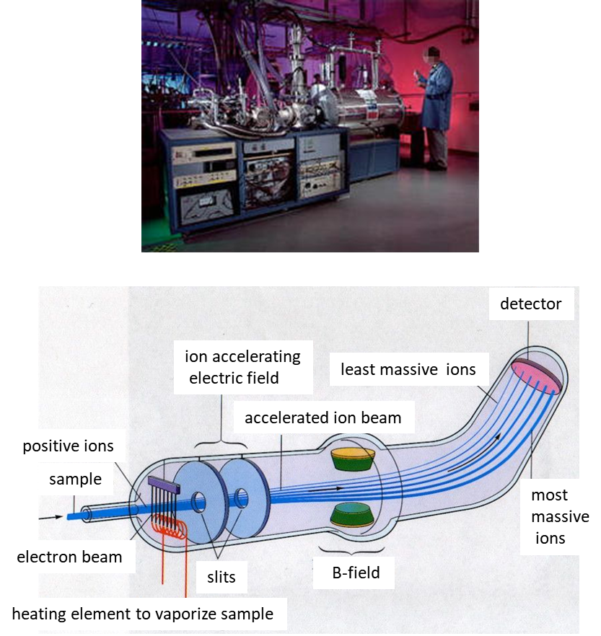

Fig. 5. Mass spectrometer.

**VAN ALLEN RADIATION BELTS**

The Earth has a magnetic field surrounding it. The field lines are like a huge bar magnet. The south pole of the magnet is located near the geographical north pole and the north magnetic pole near the south geographical pole as shown in figure 6.

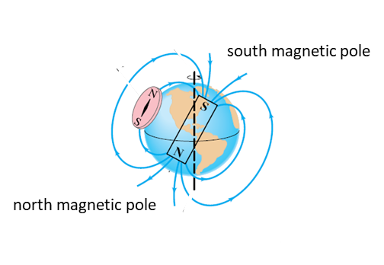

Fig. 6. The Earth is surrounded by a magnetic field.

Particles from outer space strike the Earth’s surface. Most of these particles are from the solar wind which consists of particles streaming out from the Sun. Some of these charged particles are trapped by the Earth’s magnetic field and spiral around the magnetic field lines as they move in a helical path towards one of the Earth’s poles (charged particles moving in a B-field experience a magnetic force). As the charged particles approach a pole, the magnetic field increases as the B-field lines are more closely spaced. This increasing B-field causes the charged particles to reverse their direction of motion and hence are reflected. The polar regions act like magnetic mirrors.

Thus, the charged particles are trapped and accumulate, bouncing back and forth between the polar regions (figure 7).

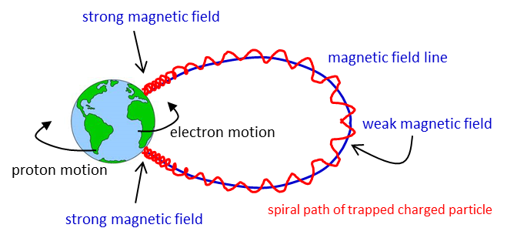

Fig. 7. Magnetic bottle. When a charged particle moves in a B-field which is strong at both ends and weak in the middle, the charged particle becomes trapped and moves back and forth spiralling around the B-field lines.

They form two **Van Allen belts**. An inner belt for the motion of protons (~ 3000 km above sea level) and an outer belt for the electrons (~ 15 000 km above sea level) as shown in figure 8. In 1958, James Van Allen discovered these belts from the data obtained from the satellite Explorer 1.

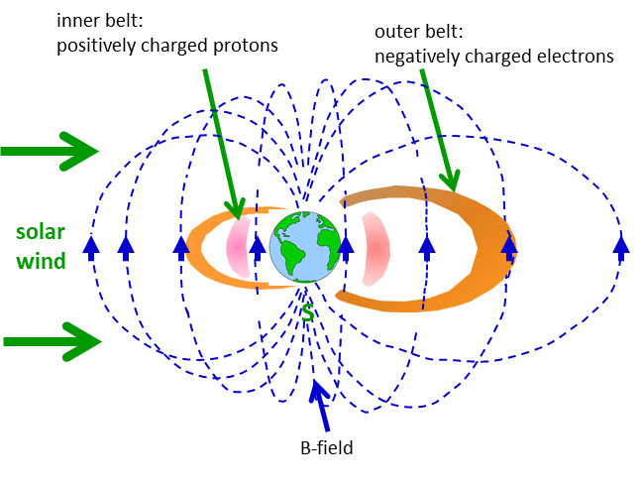

Fig. 8. Van Allen belts. Electrons (outer belts) and protons (inner belts) are trapped in the Earth’s magnetic field and spiral around the B-field lines between the north and south poles.

Spectacular light shows known as **auroras** are often seen near the polar regions. The auroras originate in the high altitudes of the atmosphere (the thermosphere) where the trapped energetic charged particles collide with atmospheric atoms. The atoms are excited to higher energy states. The excited atoms then lose their excess energy by emitting electromagnetic radiation mainly in the visible part of the spectrum as shown in figure 9.

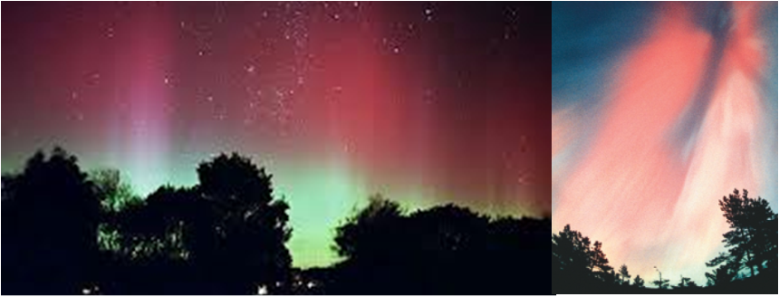

Fig. 9. Spectacular light shows known as auroras are often seen in the higher latitudes. The southern and northern lights are the result of collisions between gaseous particles in the Earth's atmosphere with charged particles released from the Sun's atmosphere. Variations in colour are due to the type of gas particles that are colliding. The most common auroral colour, a pale yellowish-green, is produced by oxygen molecules located about 100 km above the earth. Rare, all-red auroras are produced by high-altitude oxygen, at heights of up to300 km. Nitrogen produces blue or purplish-red aurora.

**VELOCITY SELECTOR**

Often it is important to select charged particles that have a certain velocity. This can be achieved in a velocity selector where the charged particles enter a region of uniform electric field  and magnetic field that are mutually perpendicular to each other . Only at a certain speed *v* will the electric and magnetic forces acting on a charge are balanced and the particle can pass through the region of uniform fields without any deflection as shown in figure 10.

electric force on charge 

magnetic force on charge 





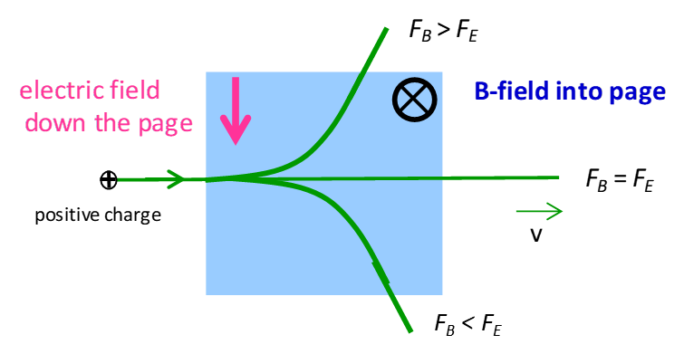

Fig. 10. Positive charges with different velocities entering a velocity selector, a region of uniform electric and magnetic fields with .

|  |
| --- |
| **Example**  An electron and a proton enter a uniform magnetic field of strength 5.00 mT with a velocity of 8.00x105 m.s-1. Calculate the radius of the circular orbits and the directions of motion of both charged particles. Before you do the numerical calculation, **predict** which orbit will have the greatest orbit. Justify your answer.  **Solution**  The magnitude of the force on the electron is equal to the magnitude of the force on the proton. The mass of the proton is much greater than the mass of the electron. So, the acceleration of the electron is much greater than the acceleration of the proton. Therefore, the electron will move in a circular orbit with a much smaller radius than the proton.  Magnetic force  Centripetal force    Radius of circular path  Both particles will move in a circle with a constant speed. |

[VISUAL PHYSICS ONLINE](http://www.physics.usyd.edu.au/teach_res/hsp/sp/spHome.htm)

http://www.physics.usyd.edu.au/teach_res/hsp/sp/spHome.htm

If you have any feedback, comments, suggestions or corrections please email:

Ian Cooper School of Physics University of Sydney

ian.cooper@sydney.edu.au