[**VISUAL PHYSICS ONLINE**](http://www.physics.usyd.edu.au/teach_res/hsp/sp/spHome.htm)

**MODULE 6 ELECTROMAGNETISM**

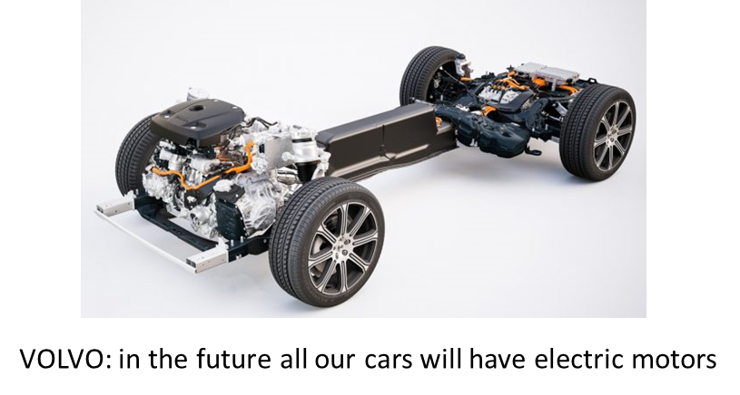

**ELECTRIC MOTORS**

|  |
| --- |
| **Force *F* on a current element**  **Torque**  **Torque on a current loop**  **Galvanometer** is the basic component of analogue meters (ammeters, voltmeters). The rotation angle of a conductive loop is proportional to the loop’s current.  **DC Motor** electrical energy  mechanical energy  The current through a coil experiences a torque to produce the rotating motion of the motor’s armature. An induced emf called the back emf is established in the rotating coil to oppose the emf of the motor’s energy source. When the back emf is equal to the supply emf, then the motor can rotate at a constant speed. The current in the motor is reversed each half-revolution by means of stationary contacts on the axle (shaft). The rotating coil is connected to the external energy supply via a split ring commutator in a simple DC motor by stationary brushes (sliding contacts)    A **motor** and a **generator** are the same device with the input and output reversed.  Motor electrical energy  mechanical energy  Generator mechanical energy  electrical energy  The electrical device running an electric car is a motor / generator combination. |

[View PHYSCIPS Electric motors and generators](http://www.animations.physics.unsw.edu.au/jw/electricmotors.html)

**TORQUE**

Clearly, a force is required to make an object start rotating about an axis. However, both the direction of the force and where it is applied are important. For example, consider the action of opening a door. If you push at the hinge, you will never open the door. To take into account the direction of the force and its point of application, we define the **torque** as given by equation 1 and illustrated in figure 1

(1)  [ N.m ]

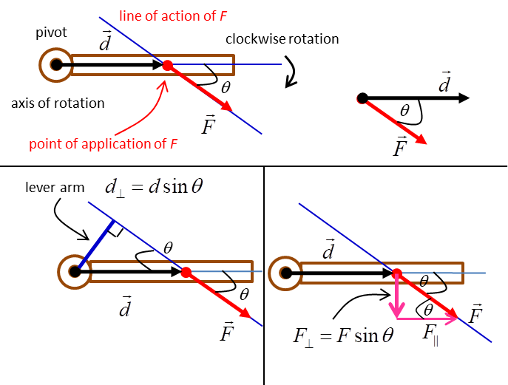

Fig. 1. The torque acting on a beam.

It is important to identify the line of action of the force, the point of application of the force and the pivot point or axis of rotation.  is the angle between the vectors for the force and displacement . The displacement  is the vector pointing from the pivot point to the point of application of the force. The perpendicular distance  from the line of action to the pivot point is called the lever arm. is the component of the force acting at right angles to the displacement vector .

To gain a better understanding of an equation, it is often a good idea to make a graphical representation as shown in figure 2 for equation 1.

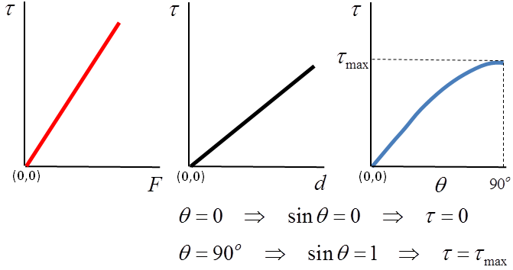

Fig. 2. Graphical representation of the equation.

**TORQUE ON A CURRENT LOOP**

A conductor loop in a magnetic field experiences a torque due to the magnetic force acting on the current. This is the **motor effect**. It has important applications such as the mechanism of a galvanometer found in analogue ammeters and voltmeters and most importantly in electric DC motors.

To understand the physics of the torque acting on a current loop you must be able to visualize vectors pointing in three dimensions (x, y, z). This can be difficult and it is often difficult to draw two-dimensional pictures of a three-dimensional situation or understand them. So, it is a good idea to make an aid to help visualize the vectors. You should make the aid as shown in figure 3. It should be used when studying this topic. It is quick and easy to make, and it is often a good idea to make one during an examination if you have a question on motors or generators. Simply take an A4 size piece of paper and draw a large rectangle on it. Label each corner with A, B, C and D. Draw a set of arrows from A to B, B to C, C to D and D to A to give the direction of the current in the loop.

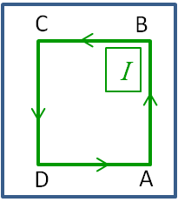

Fig. 2. An aid you should make to help you visualize the vectors when a coil is placed into a magnetic field.

Consider a coil labelled ABCD with a current *I* placed into a uniform magnetic field . The dimensions of the rectangular coil are length *a* and width *b*. The area of the coil is *A* = *ab*. The orientation of the coil can be given by the vector which points in a direction away from the coil and perpendicular to the plane of the coil (right hand screw rule). Each side of the loop will experience a force because of the current in the magnetic field. The direction of the forces is determined by the right-hand palm rule (figure 3). Remember to use the aid to help determine the directions of each force.

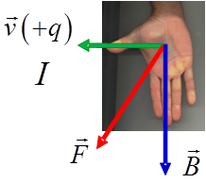

Fig. 3.

Right hand palm rule.

Figure 4 shows a rectangular coil carrying a current *I* in a uniform magnetic field.

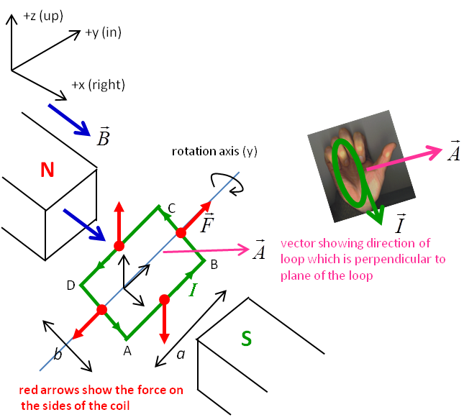

Fig. 4. A current carrying coil in a uniform magnetic field will experience a torque. Use the aid to help visualize the directions of all the vectors.

The direction of the force on each side of the coil are:

*F*AB - z direction (down page)

*F*BC + y direction (into page)

*F*CD + z direction (up page)

*F*AD - y direction (out of page)

Only the forces *F*AB and *F*CB act to cause the rotation of the coil in the magnetic field. The force *F* on a current element of length *L* in a magnetic field *B* is given by

(2) 

Therefore, the magnitude of the forces *F*AB and *F*CB are

(3) 

This pair of forces exert a **torque** on the coil which is known as a **couple**.

To calculate the torque it is best to view the coil in the xz plane showing only the side AD as shown in figure 5.



Fig. 5. Forces acting on the current loop to produce the torque.

The torque on a current element is given by equation 1. Therefore, the torques on the sides AB, CD and the net torque on the loop are:







Area of loop 

Coil often has many windings, for N turns:

Net torque on loop



(4) 

**GALVANOMETERS**

The basic component of analogue meters (ammeters, voltameters) is the **galvanometer**. A galvanometer has a coil suspended in a magnetic field. Attached to the coil is a spring and a pointer. The pointer indicates on a dial the deflection of the coil when a current passes through it. The larger the current through the coil then the larger the torque experienced by the coil. The coil and the attached pointer will rotate only to the point where the torque due to the magnetic field balances the torque exerted by the spring. Figure 6 shows a schematic diagram of a galvanometer with a rectangular coil in a uniform magnetic field produced by a permanent magnet.

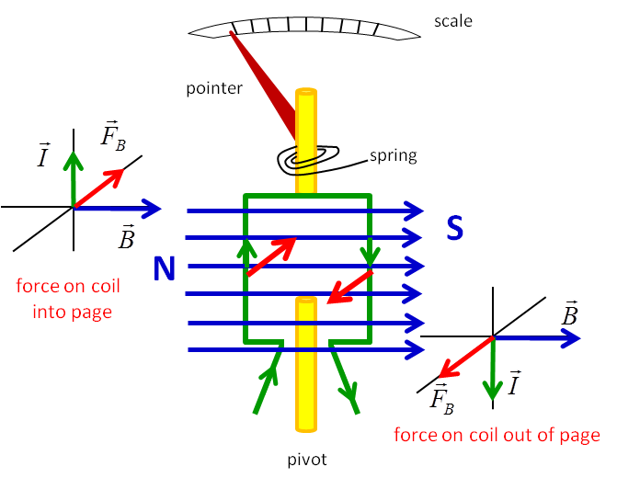

Fig. 6. Galvanometer (right hand palm rule gives the direction of the force on each current element).

In real galvanometers, curved magnetic pole pieces are used to concentrate the magnetic field and the galvanometer coil is wrapped around a cylindrical iron core. In this arrangement, the angle through which the coil is deflected is proportional to the current (figure 7).

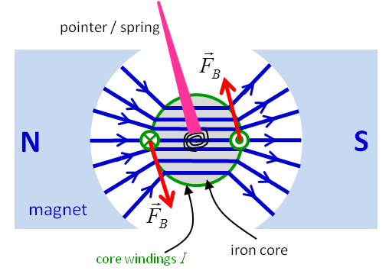

Fig. 7 Galvanometer coil wrapped around an iron curve. The magnetic field is concentrated by having curved pole pieces.

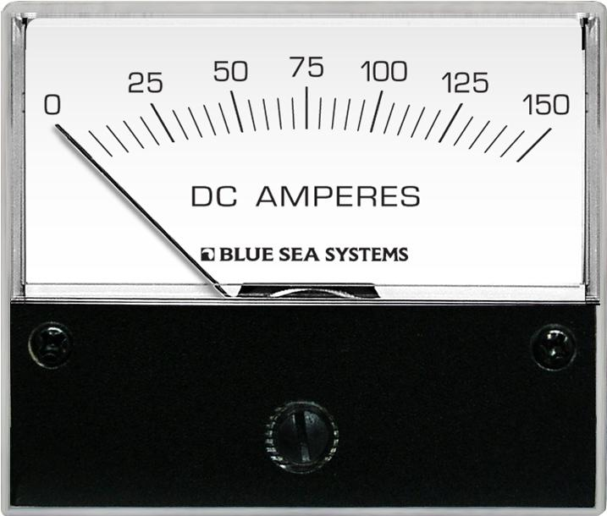

**DC MOTORS**

An electric motor is an electromechanical device that converts electrical energy to mechanical energy. The mechanical energy can be used to perform work such as rotating a pump impeller, fan, blower, driving a compressor, lifting materials etc. It is estimated that about 70% of the total electrical load is accounted by electrical motors only. Electric motors are the *work horse* of industry. The general working mechanism is the same for all DC motors (figure 8).

* An electric current in a magnetic field will experience a force.



* If the current carrying wire is bent into a loop, then the two sides of the loop, which are at right angle to the magnetic field, will experience forces in opposite directions. The pair of forces creates a turning torque to rotate the coil. Practical motors have several loops on an armature to provide a more uniform torque and the magnetic field is produced by electromagnet arrangement called the field coils.



The torque causes the coil to continually to rotate in one direction.

* The coil is mounted on a cylinder called the **rotor** or **armature**. In real motors, there are several coils and the armature is mounted onto an **axle** or **shaft**.
* As the motor spins the direction of the current must change each time the plane of the coil is perpendicular to the magnetic field to keep the coil rotating in the one direction. Otherwise, the direction of the torque would change each time the coil passes this point - carefully examine figure (4): when the coil turns through 180o  the forces on sides AB and CD reverse. This reversal of the current is achieved by using a **commutator** and **brushes**. The commutator is simply a pair of plates attached to the axle so they spin with the coil. These plates provide the two connections for the coil. The commutator and brushes work together to let current flow to into and out of the coil and to flip the direction of the current at just the right moment. The brushes are just two pieces of springy metal or carbon that make sliding contact with the contacts of the commutator.

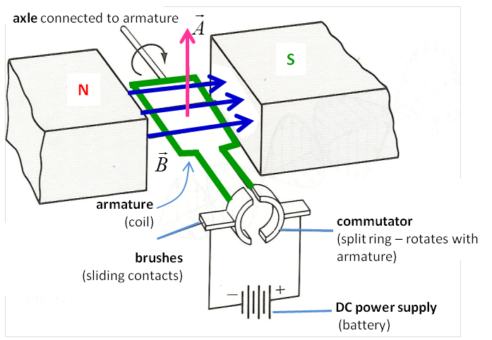

Fig. 8. Simple DC motor.

The main advantage of DC motors is speed control, which does not affect the quality of power supply. It can be controlled by adjusting the current through the armature – increasing the armature current will increase the rotational speed of the motor.

DC motors are available in a wide range of sizes, but their use is generally restricted to a few low speed, low-to-medium power applications like machine tools and rolling mills because of problems with the connections between the commutator and brushes. They are restricted for use only in clean, non-hazardous areas because of the risk of sparking at the brushes. DC motors are also expensive relative to AC motors.

|  |
| --- |
| **Predict Observe Explain**  Write and sketch **your predictions** for a single coil rotating in a magnetic field as shown in figure (8):   * How do the forces on the current element AB changes with rotational angle? * When does the current changes direction in the current element AB? * Sketch a graph of the current vs rotational angle for the current element AB. * Sketch a graph of the net torque on the current loop as a function of rotation angle.   **Observe** the animation of the armature turning in a magnetic field. Carefully note the changes in current, force and torque at different orientations of the coil. Use the right-hand palm rule to verify the directions of the forces shown in the animation.  **Explain** Compare your predictions with your observations, and explain any discrepancies. Write an explanation of how a DC motor works clearly stating the main principles and components.    [Image2](http://www.physics.usyd.edu.au/teach_res/hsp/u6/motor_1.htm) View the animation |

**BACK EMF IN MOTORS / LENZ’S LAW**

An electric motor operates by a current from some energy source (supply emf) passing through an external magnetic field. A current in a magnetic field experiences a force. The conductor carrying the current is wound into a coil (armature) so that it will experience a torque to cause the rotation.

However, by **Faraday’s law**, a coil rotating in the magnetic field produces a continually changing magnetic flux. Hence, an emf is induced in the rotating coil.

By **Lenz’s law** this emf must be in the opposite sensitive to the supply emf, otherwise the voltage would continually increase leading to an ever increasing current through the coil.

This induced emf is known as the **back emf**. It has opposite polarity to the supply emf (figure 9).

Consider an ideal motor with no friction or drag forces acting. The net voltage  across the coil of the motor is equal to the supply emf  minus the back emf 



If there is no load attached to the motor, the coil (armature) will spin faster and faster until the supply emf is equal to back emf. Then, the net voltage across the coil is zero, resulting in the coil current and hence torque acting on the coil to be both zero and so the coil will rotate at a constant angular speed.



When the load on the motor increases:

🡪 the armature spins more slowly

🡪 the rate of change of the magnetic flux deceases

🡪 induced emf decreases (back emf decreases)

🡪 coil voltage increases

🡪 coil current increases

If the load becomes too large causing the armature to rotate slowly or stop, then large currents through the coil will cause unwanted heating effects and damage the motor. When motors are turned on, there will be large coil currents unless there is some protection mechanism.



Fig. 9. Electric circuit for a DC motor

|  |
| --- |
| **Example**  The armature windings of a DC motor have a resistance of 5.0 Ω. The motor is connected to a 240 V power supply. When the motor reaches its full rotation speed the back emf is 188 V.  (a) When the motor is just starting, what the motor current? (b) What is the current when the motor is operating at its maximum rotation speed?  **Solution**  *R* = 5.0 Ω *ε* = 240 V *εback* = 188 V  Motor starting  *εback* = 0 V *I* = ? A *I* = *ε* / *R* = (240 / 5) A = 48 A  Motor max speed  *εback* = 188 V I = ? A  *I* = (*ε - εback*) / *R* = (240 - 188) / 5 A = 10 A  Faster the rotation speed the greater the induced back emf. Currents can be very high on starting. When a motor is jammed 🡪 rotation speed much reduced 🡪 reduced emf 🡪 increased current 🡪 motor heats up 🡪 motor maybe damaged. |



[VISUAL PHYSICS ONLINE](http://www.physics.usyd.edu.au/teach_res/hsp/sp/spHome.htm)

http://www.physics.usyd.edu.au/teach_res/hsp/sp/spHome.htm

If you have any feedback, comments, suggestions or corrections please email:

Ian Cooper School of Physics University of Sydney

ian.cooper@sydney.edu.au