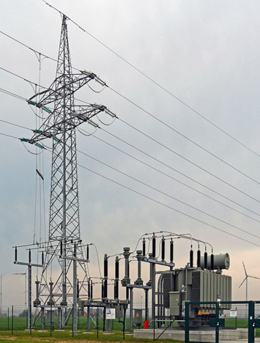

[**VISUAL PHYSICS ONLINE**](http://www.physics.usyd.edu.au/teach_res/hsp/sp/spHome.htm)

**MODULE 6**

**ELECTROMAGNETISM**

**TRANSFORMERS**

**ELECTRICTY DISTRIBUTION**

|  |
| --- |
| A **transformer** is a device for either increasing or decreasing an AC voltage.    **Ideal Transformer**  potential differences  conservation of energy  currents  **Step-up transformer** *NS* > *NP VS* > *VP IS* < *IP*  **Step-down transformer** *NS* < *NP VS* < *VP IS* > *IP*  **Non-ideal transformer**        The iron core of a transformer is **laminated** to reduce ohmic heating losses by reducing eddy currents    **Electrical energy distribution**  Electrical energy from power plants is distributed at very high potential differences to reduce ohmic heating losses in the transmission cables. |

**TRANSFORMERS**

A **transformer** is a device for either increasing or decreasing an AC voltage. Transformers are used everywhere. Our electrical supply from our power points is 240 Vrms, 50 Hz. Many electrical circuits in home devices operate at much lower voltages. So, transformers are used to produce smaller ac voltages.

A transformer is made of two coils called the **primary** and **secondary** (figure 1). They are usually wound onto a **soft iron core** (iron does not remain magnetised when current falls to zero). The iron core is laminated to reduce energy losses due to eddy currents. The changing magnetic flux produced by the ac current in the primary coil windings induces a changing magnetic flux at the secondary coil. This changing magnetic flux the induces an *emf* in the windings of the secondary coil.

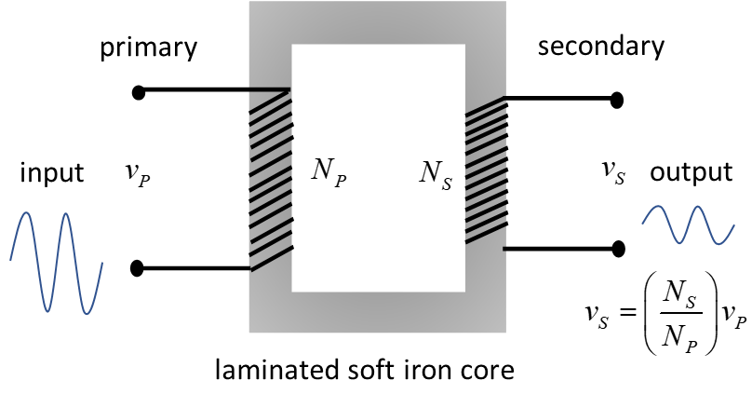

Fig. 1. A transformer.

Consider two solenoids placed near each other as shown in figure 2. One solenoid (primary) is connected to a battery via a switch that can be opened or closed. The other solenoid (secondary) is connected to a voltmeter. When the switch is open, the current in the primary coil is zero and the secondary voltmeter reads zero. When the switch has been closed for some time, the current in the primary coil is steady, and the secondary voltmeter reads zero. Only when the switched is open or closed do you get spikes in the secondary coil voltmeter. As the switch is either opened or closed, there is a sudden change in the primary current, that results in a changing magnetic field and a changing magnetic flux through the secondary coil. By Faraday’s Law, the changing magnetic flux induces an *emf* in the secondary coil.

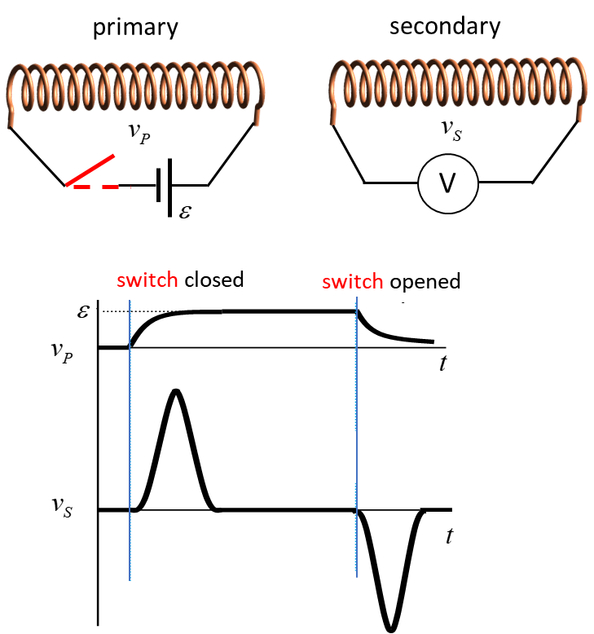

Fig. 2. Only a changing magnetic flux results in an induced *emf* in the secondary coil.

An example of a high voltage generated by an induced *emf* is when a 12 V DC voltage is switched on/off to a spark plug in a car. By switching on/off the 12 V DC voltage, voltage spikes ~ 25 kV are produced.

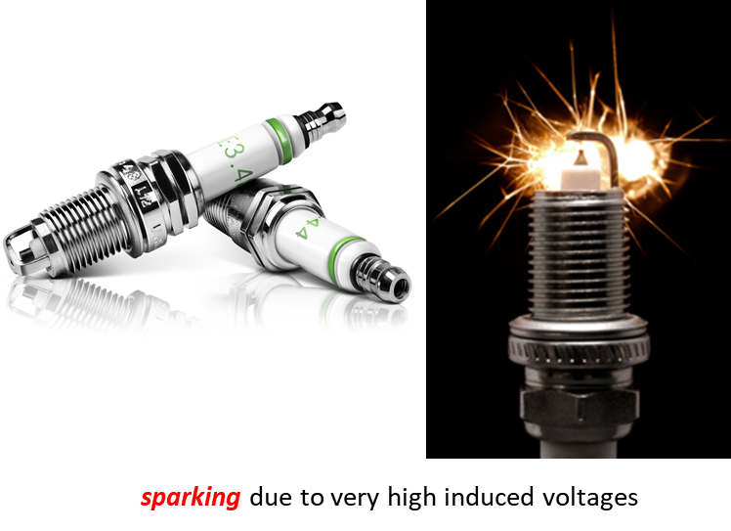

**Ideal Transformer equations**

The equations describing the connections between potential difference and currents in the primary coils and secondary coils of a transformer can be derived from the principle of conservation of energy (assume zero dissipative energy losses)

energy input = energy output

power input (primary) = power output (secondary)

**Faraday’s Law** – induced emf from a changing magnetic flux



Changing magnetic flux in primary = Changing magnetic flux in secondary



If there is 100% linkage of flux then



 potential differences

 conservation of energy

 currents



*V* represents in rms (**root mean square**) or **peak values** of the ac voltages. The rms value is defined as the square root of the mean value of the squared function. This is often used as the effective D.C. voltage (or current) of an a.c. voltage (or current). This value can then be used in the calculation of the average power of an AC waveform.

If less than 100% flux linkage, then



**Step-up transformer**: increase in secondary voltage (decrease in secondary current)

 

*NS* > *NP VS* > *VP  IS* < *IP*

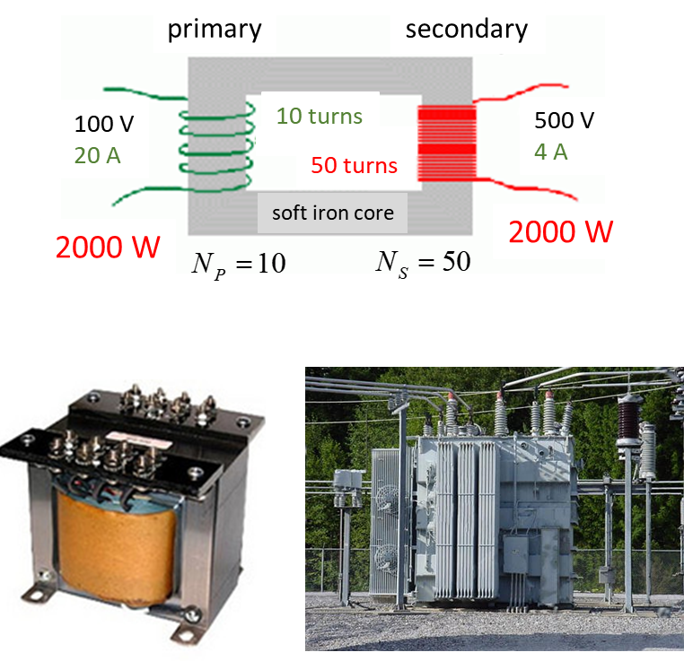

**Step-down transformer**: decrease in secondary voltage (increase in secondary current)

 

*NS* < *NP VS* < *VP IS* > *IP*

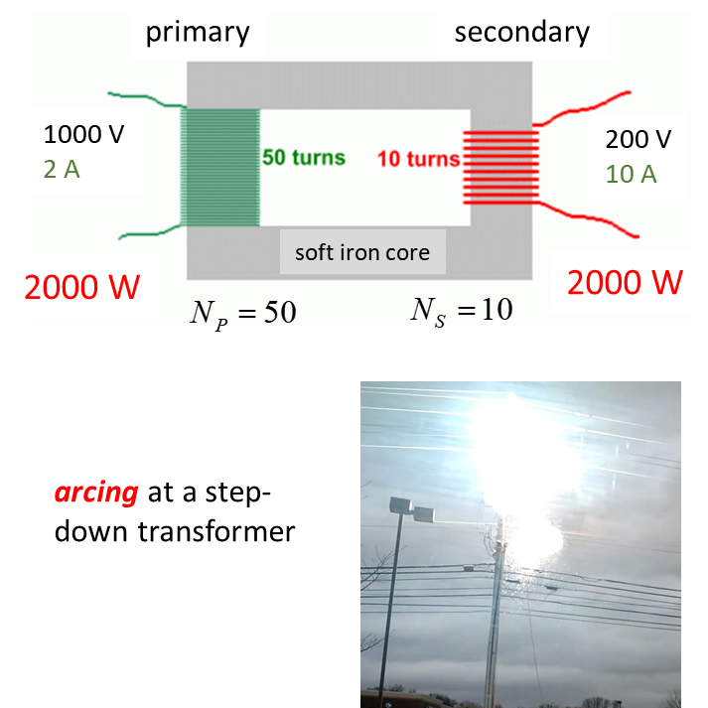

**Improving the design of transformers**

Real transformers are not ideal and the energy supplied to the primary coils is greater than the energy delivered by the secondary coils. There are ohmic heating losses in the windings of the transformers and in eddy currents that are induced in the iron core of the transformer. Also, the magnetic flux linkage between the primary coils and secondary coils is not perfect. So, the efficiency  of real transformers is less than 100%.

Non-ideal transformer







The ferromagnetic core used in transformers is laminated to reduce ohmic heating caused by induced eddy currents.



Fig. 3a. Laminations reduce the magnitude of eddy currents. This reduces the ohmic heating of the metal core.

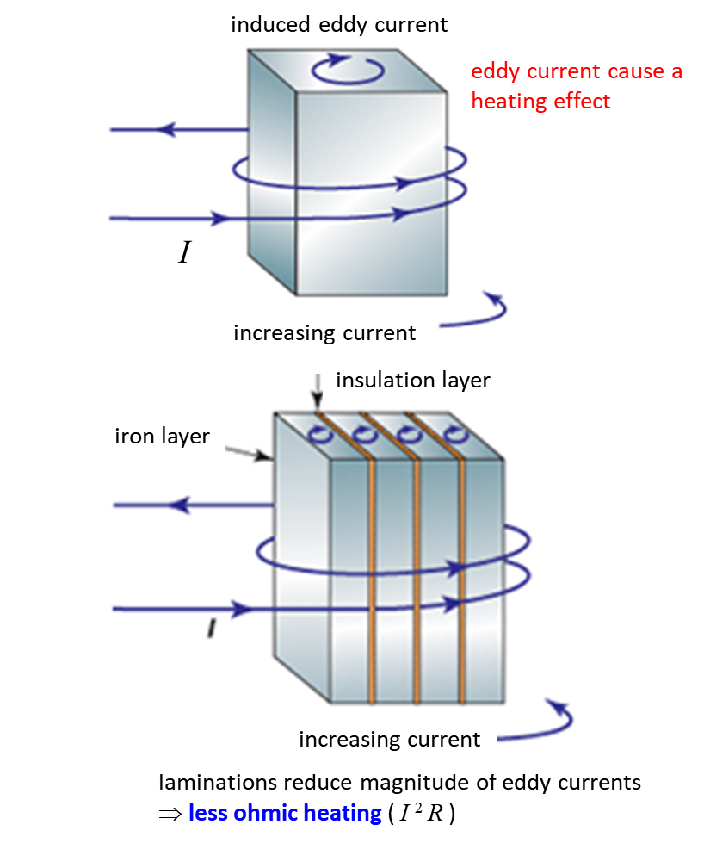

Fig. 3b. Laminations reduce the magnitude of eddy currents. This reduces the ohmic heating of the metal core.

|  |
| --- |
| **Example**  (a) A neon sign needs an operating voltage of 4800 V and is to be operated from a 240 V power point. How can this be achieved?  (b) The secondary coil of a step-down transformer consists of a larger diameter wire than the primary windings. Explain.  (c) Christmas lights contain a string of 20, 1.5 V lights in series with each other. The resistance of each globe is 3.0  Ω. They are connected to a 240 V power point using a transformer with 800 turns in the primary winding.  What is the power dissipated by the light globes?  What is the power need to be supplied by the transformer, if the coil is only 95% efficient?  How many turns does the secondary coil have in the transformer?  What is the current in the secondary coil to provide sufficient energy to light the globes?  What is the corresponding primary current?  **Solution**  **T**ransformer equations    (a)  Need a step-up transformer. The ratio of the turns of the primary to secondary windings is    (b)  In a step-down transform, the current in the secondary coils is greater than the current in the primary coils. So, to reduce ohmic heating loses  in the secondary windings a larger diameter could be used (the larger the diameter if a wire, then the smaller the resistance)  (c)  Number of lights in series *N* = 20  Single globe    All 20 light globes in series    Power  supplied by transformer  efficiency    Transformer    Currents |

**ELECTRICAL DISTRIBUTION**

**TRANSMISSION OF ELECTRICITY**

Power plants are located long distance from cities, so electrical energy must be transmitted over long distances. But, there is are always energy losses in the power lines due to ohmic heating . The energy loss can be minimized if power transmitted at high voltages.

In 2010 the total NSW electric energy production was about 100 000 GWh (gigawatt-hours). Much of this power was produced by seven coal-fired power stations. The largest of these is Bayswater with a capacity of 2640 MW from four 660 MW stream driven turbines. The Snowy Mountains hydroelectric scheme provides an additional capacity of 3740 MW. Several smaller hydro and gas turbine stations contribute a further 600 MW. These power stations are sited close to their source of energy - i.e. the coal fields or dams, because it is less costly (and more environmentally friendly) to transmit power than transport coal. Then the state power grid distributes the energy to the users. Very high voltage AC (alternating current) transmission lines are required to efficiently transmit large amounts of power over long distances.

AC voltages vary with time, so AC voltages are usually expressed in terms of the **rms** ("**root mean square**") value , which is the square root of the average of the square of the voltage.



where  is the rms value and  is the peak value (voltage amplitude).

In Australia, normal household voltage is 240 V rms at a frequency of 50 Hz. The actual voltage signal therefore varies as a sine wave between ±340 V, with a period of 20 ms. In the US and Canada power is supplied at 110 V rms and 60 Hz.

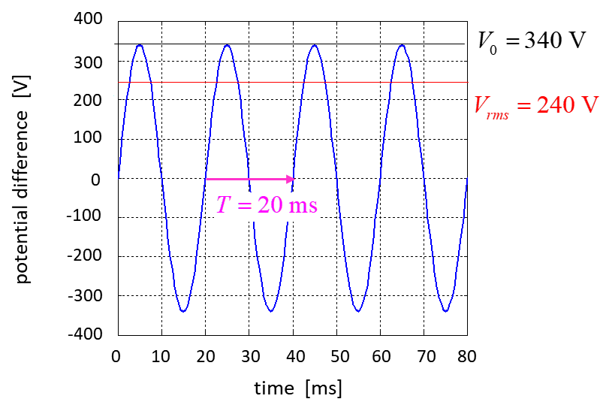

Fig.4. Australian domestic voltage supply is 240 Vrms, 50 Hz.

In NSW the power is produced at rms voltages between 17 and 23 kV at the power stations. It is transformed up to transmission line voltages which are typically 132 or 330 kV, with some others at 220 and 500 kV. Most of these transmission lines are aluminium conductors suspended overhead on steel lattice towers. The conductors are insulated from the towers by porcelain, glass or synthetic insulators. Transmission lines may also be laid underground, but at much higher cost than overhead lines.

However recent concerns with the possible effects of electromagnetic radiation from high voltage lines, plus the appearance of overhead lines, may make underground lines more attractive in the future, at least for short distances in urban areas.

Voltage levels must be reduced before the power can be used in the home or by industry. First, the power is delivered to substations where it is transformed to 66 or 132 kV to be sent, generally on wood or concrete poles, to zone substations where it transformed again to 11 or 22 kV.

From this point, it is transmitted to various substations and local transformers where it is stepped down to 240 V for general use. You can see the local transformers on poles in the street or in cubicles at ground level. At the local transformer, one lead, known as the **neutral** (N) is connected to the earth via a thick cable with one end buried in the ground. The other wire from the transformer, the active lead (A) is thus at an rms potential of 240 V relative to the ground, i.e. to our surroundings. The active and neutral conductors are connected to the A and N points of the user's outlet sockets. The user's earth (E) point is connected as directly as possible to the ground close to the house. Since the neutral wires in the power lines carry large currents and since they have finite resistance (ideally the resistance would be zero) they cannot be at the same potential at all places along the wire. The neutral is usually connected to the ground at several other points between the transformer and the houses to keep the neutral lead at a potential near earth potential (i.e. 0 V). This ensures that only the active lead is at a high potential which is less dangerous than having two high voltage wires.

The most common cause of electrocution is when a person contacts the active lead so that current flows to earth through the person. In such circumstances the current in the neutral lead will be less than the current in the active lead - a situation that is referred to as earth leakage.

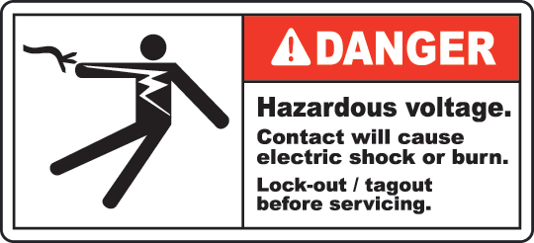

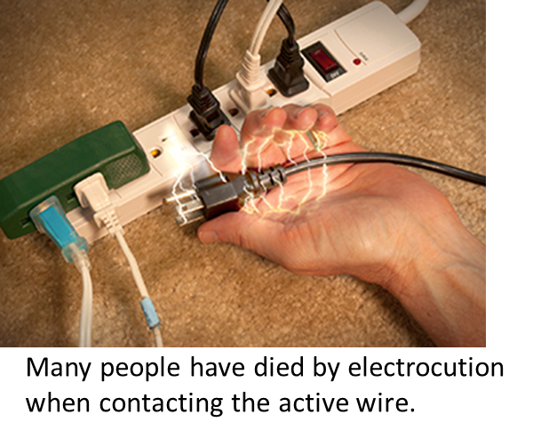

A device, called an **earth leakage circuit breaker**, detects this imbalance and immediately cuts of the electrical supply. The active and neutral leads are wound in opposite senses on a ring of ferromagnetic material (usually referred to as a core). The function of the ferromagnetic core is to guide the magnetic flux from each winding through the third winding. When the currents in the active and neutral leads are equal the fluxes due to each cancel and there is no net flux through the third winding. If however there is leakage to earth from the active lead the fluxes will not cancel and there will be a net flux through the third coil. As the flux will be alternating (at a frequency of 50 Hz) it will induce an emf in the third coil. With the aid of further electronics this signal can be used to trigger a circuit breaker that disconnects the mains supply. Other terms for earth leakage circuit breakers include core balance relays and earth leakage protectors. They can be installed as a single unit in the meter box of a domestic dwelling to provide protection for all power and light outlets. It is also possible to obtain portable units for use with individual appliances and power sockets that incorporate such devices. A typical power point unit will trip when an imbalance of greater than 10 mA is detected; in such circumstances the power cuts off within about 40 ms of the imbalance being detected.



Fig. 5. Transformers are used in the transmission of electrical energy from power plant to homes.

|  |
| --- |
| **Example**  A 330 kV transmission line is used to transmit electrical energy from a power station to a substation 50 km way. The resistance of the transmission line is 0.04 Ω.km-1. If the power transferred via the transmission lines was 5.28 MW, calculate the current in the lines and the power loss in the transmission.  Re-do the calculation for the transmission of the energy at only 240 V. Explain why it is necessary to use transformers to step up the voltages to very high values?  Solution  How to approach the problem (ISEE)  Type of problem: electric circuits  Knowledge:  Data:  = 330x103 V = 50 km  = 0.04 Ω.km-1  = (0.04)(50) Ω= 2.0 Ω = 5.28x106 W  =? A  = ?  = 240 V  Transmission at  = 330x103 V  The transmission line current is    The losses due to ohmic heating in the transmission lines    Transmission at  = 240 V  The transmission line current is    The losses due to ohmic heating in the transmission lines    This is an impossible answer, more energy lost than transmitted. This is why electrical energy is transmitted at very high voltages as it significantly reduced ohmic heating losses. The great advantage and main reason for use of ac over DC voltages is that they can be easily stepped up or stepped down using transformers making the transmission of energy much simpler. |

[VISUAL PHYSICS ONLINE](http://www.physics.usyd.edu.au/teach_res/hsp/sp/spHome.htm)

If you have any feedback, comments, suggestions or corrections please email Ian Cooper

ian.cooper@sydney.edu.au