[**VISUAL PHYSICS ONLINE**](http://www.physics.usyd.edu.au/teach_res/hsp/sp/spHome.htm)

**MODULE 7 NATURE OF LIGHT**

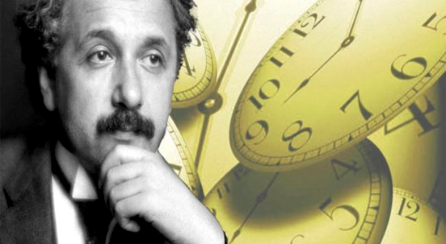

**LIGHT and SPECIAL RELATIVITY**

**FRAMES OF REFERENCE**

|  |
| --- |
| The location of an object and its velocity depends upon the **frame of reference of an observer**.  **Inertial frame of reference** has zero acceleration. Newton’s Law of Motion are valid.  **Non-inertial frame of reference** has a non-zero acceleration. Newton’s Laws of motion are not valid.  Different observer can have different views on the motion of an object: **space and time are relative concepts**, **not absolute ones**.  Postulate for the propagation of light through space - **ether model**. **Michelson-Morley experiment** attempted to measure the relative velocity of the Earth through the ether. **Null result**. Ether model had to be rejected.  **Maxwell** – electromagnetic radiation propagates at the speed of light independent of the frame of reference.  The ether model discarded.  **Einstein**: laws of physics are valid in inertial frames of reference; space and time are relative quantities; speed of light is a constant and does not depend upon the motion of the source or observer. |

**OVERVIEW OF SPECIAL RELATIVITY**

**Relativity is the study of the relative motions of objects**

Newton’s view of the Universe turns out to be wrong. From a Newtonian point of view time is an absolute quantity. A better model for the working of the Universe are Einstein’s theories of **Special Relativity** and **General Relativity**. **Space** and **time** are interconnected and different observes can get different measurements for time intervals and lengths.

Einstein’s Theories of Relativity are one of the greatest intellectual achievements of the 20th Century. **Special Relativity**, developed by Einstein in 1905, deals with systems that are moving at constant velocity (zero acceleration) with respect to each other. **General Relativity** proposed in 1916 deals with systems that are accelerating with respect to each other.

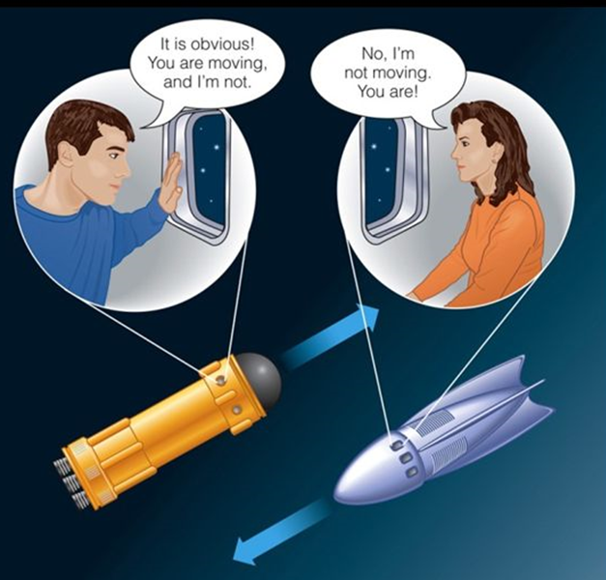

**What is the trajectory of a ball thrown into the air?** This is a simple question. But what is the answer?

Surprisingly, there is no unique answer to this question. The answer depends upon the person observing the motion of the ball. One observer claimed that the ball travelled in a straight-line path, up then down. Another observed claimed the ball travelled in a parabolic arc.

Who is correct? Both are correct descriptions.

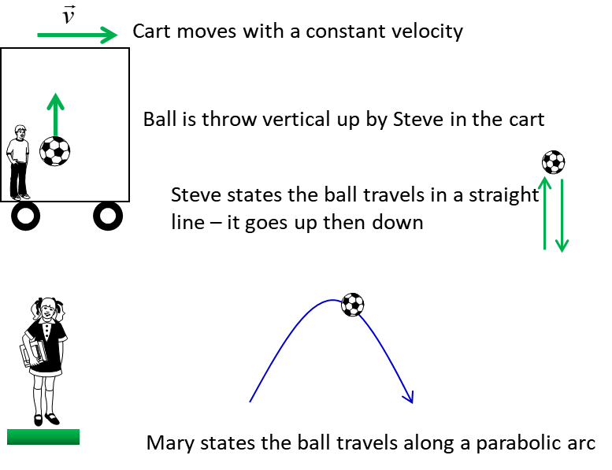

Is it day or night? – it depends on the location of the observer.

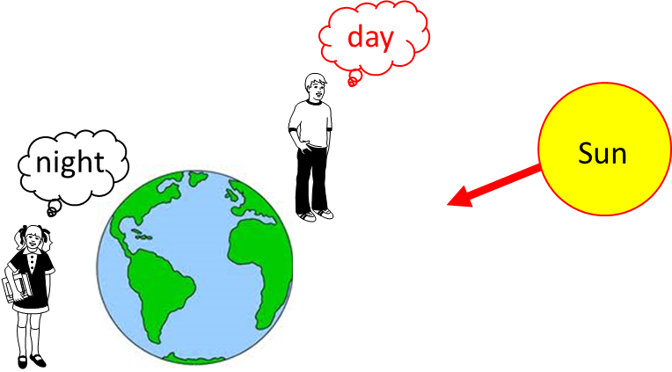

Is the pig on the right or left? – it depends upon the direction the observer is facing.



Which is bigger – the bear or mouse? – depends upon the viewing location

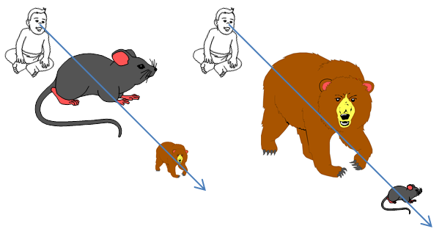

“up” or “down”?

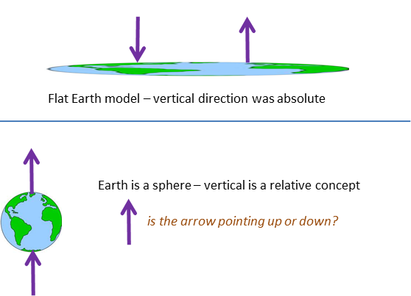

For us, it has not been easy to realise that the concept “up” and “down” are relative. We are inclined to use “common sense” and ascribe absolute sense to concepts.

**A description of motion depends upon the frame of reference of the observer.**

This is what Einstein’s Theory of Special Relativity is all about. Difference observes in different frames of reference can measure different values for length, time intervals and momentum.

In the Theory of Special Relative both space and time are relative concepts and this idea is in conflict with our notions of space and time based upon “common sense”.

But what is meant by time and space being relative? Consider observes A and B in two inertial frames of reference. They both make length and time interval measurements of the same event.

Observer A records the length as 623 m and the time interval as 156 s.

Observer B records the length as 321 m and the time interval as 556 s.

Who is correct?

Both can be correct because their measurements of the same event depend upon the relative velocity between the two inertial frames of reference. So, to start out study of Special Relativity we need to define clearly the frame of reference for an observer.

**Reference frames**

A coordinate system is necessary to describe the position and the velocity and apply Newton’s Laws of motion. So, the measurements of position, velocity and force depend upon the **frame of reference** of the observer.

If Newton’s Laws are valid in one frame of reference, then they are also valid in any reference frame moving at a uniform velocity relative to the first frame. This is known as **Newtonian principle of relativity** or **Galilean invariance**. Newton showed that it was not possible to perform any experiment to determine the absolute motion in space. Such reference frames are known as **inertial frames of reference**. A frame of reference which is accelerating and Newton’s Laws do not apply is known as a **non-inertial frame of reference**.

A truck travelling at a constant velocity can be regarded as an inertial frame of reference. In figure 1, these is no experiment that Mary or Steve perform inside their truck to determine their speed. A ball hanging from the ceiling falls vertical. Mary and Steve conclude that there is a zero net force acting on the ball. However, Eve is in an accelerating truck and therefore in a non-inertial frame of reference. Eve incorrectly concluded that there is a force acting on the ball to cause it to deviate from the horizontal. Such forces are known as fictitious forces. The ball no longer falls vertically because of the inertia of the ball (Newton’s 1st Law) and the greater the acceleration of the truck, the greater the deflection of the hanging ball.

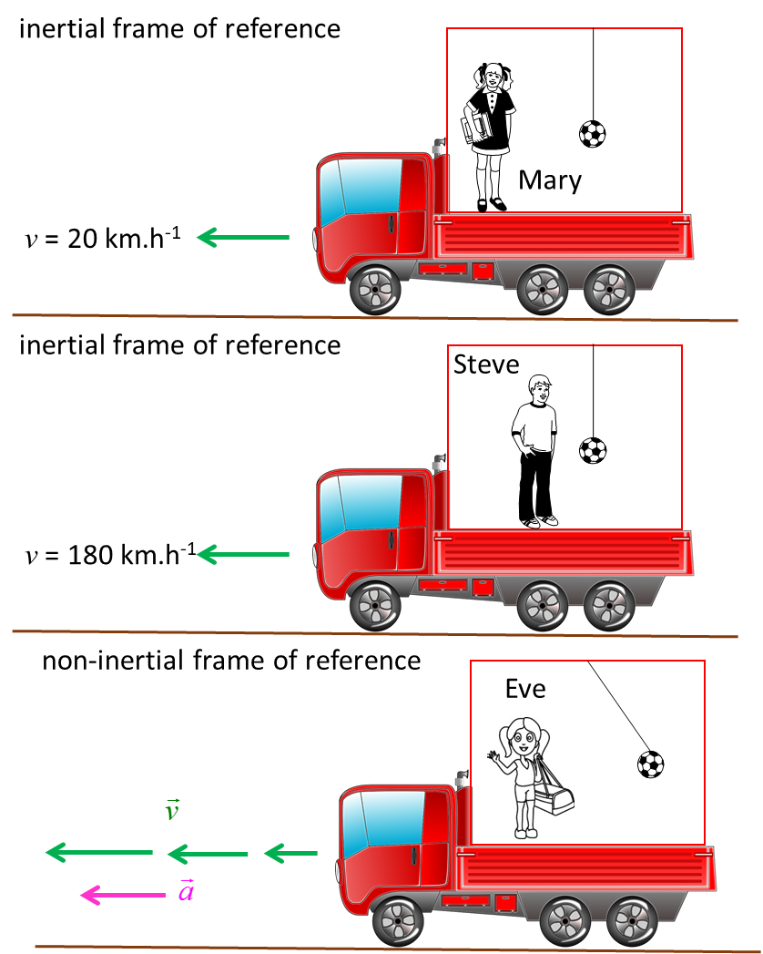

Fig. 1. Inertial and non-inertial frames of reference. Mary and Steve cannot perform an experiment to determine the absolute motion of the truck.

Ancient Greek philosopher **Aristotle** - it was obvious that objects would assume a preferred state of rest unless some external force propelled them - concepts of **absolute space** and **absolute time** – that is that both space and time exist in their own right, independently of each other and of other material things. So, it is possible to assign absolute values of position and time to events. Aristotle’s work was held in such high regard that it remained basically unchallenged until the end of the sixteenth century, when Galileo showed that it was incorrect.

**Galileo**

* Motion must be relative
* Motion involves displacements of objects relative to some reference system
* Principle of Galilean Relativity: the laws of mechanics are the same for a body at rest and a body moving at constant velocity.

**Isaac Newton**

* Laws of Motion and his Law of Universal Gravitation - only possible to determine the relative velocity of one reference frame with respect to another and not the absolute velocity of either frame
* No preferred or absolute reference frame exists. The Principle of Newtonian Relativity: the laws of mechanics must be the same in all inertial reference frames.

Due to Galileo and Newton, the concept of absolute space became redundant since there could be no absolute reference frame with respect to which mechanical measurements could be made. However, Galileo and Newton retained the concept of absolute time, or the ability to establish that two events that happened at different locations occurred at the same time - if an observer in one reference frame observed two events at different locations as occurring simultaneously, then all observers in all reference frames would agree that the events were simultaneous.

The Newtonian concept of the structure of space and time remained unchallenged until the development of the electromagnetic theory in the nineteenth century, principally by Michael Faraday and James Clerk Maxwell. Maxwell showed that electromagnetic waves in a vacuum ought to propagate at a speed of *c* = 3x108 m.s-1 (the speed of light). To 19th Century physicists this presented a problem. If EM waves were supposed to propagate at this fixed speed *c*, what was this speed measured relative to? How could you measure it relative to a vacuum? Newton had done away with the idea of an absolute reference frame. We now must do away with the concept of absolute time.

Note: An **event** is something that happens independently of the frame of reference, for example, a flash of lightning. An event can be characterized in a Cartesian reference frame by stating its (x, y, z and t) coordinates.

**ETHER MODEL FOR THE TRANSMISSION OF LIGHT**

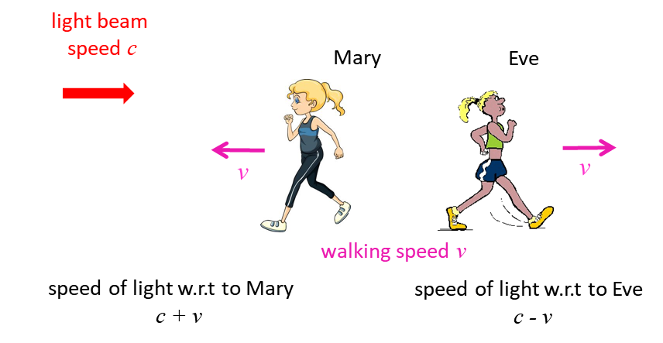

Fig. 1. Classical picture for the speed of light. The speed of light is relative to the motion of the observer, and so the speed of light is *c* + *v* or *c* - *v*. But this is not correct. The correct answer, is that the person will measure the speed of light to be the constant value ***c*** and it does not matter how fast or slower they are approaching or receding from the light beam or the speed of the light source.

It seemed inconceivable to 19th Century physicists that light and other electromagnetic waves, in contrast to all other kinds of waves, could propagate without a medium. It seemed to be a logical step to postulate such a medium, called the **ether** (or **aether**), even though it was necessary to assume unusual properties for it, such as zero density and perfect transparency, to account for its undetectability. This ether was assumed to fill all space and to be the medium with respect to which electromagnetic waves propagate with the speed *c*. It followed, using Newtonian relativity, that an observer moving through the ether with speed *v* would measure the speed of the light beam to be (*c* + *v*) if they were directly approaching the light source and (*c* - *v*) if moving away from the light source (figure 1).

***If the ether exists, an observer on Earth should be able to measure changes in the velocity of light due to the Earth’s motion through the ether***.

The **Michelson-Morley experiment** attempted to do just this.

When 19th Century physicists selected the ether as the medium for the propagation of electromagnetic waves they were merely borrowing and adapting an existing concept. The fact that certain physical events propagate themselves through space led to the hypothesis that space is not empty but is filled with an extremely fine substance, the ether, which is the carrier or medium of these phenomena. Indeed, the ether was proposed as the carrier of light in Rene Descartes’ Dioptrics, which in 1638 became the first published scientific work on optics. In this work, Descartes proposed that the ether was all-pervasive and made objects visible by transmitting a pressure from the object to the observer’s eye.

Robert Hooke in 1667 developed pressure wave theories that allowed for the propagation of light. In these theories, luminous objects set up vibrations that were transmitted through the ether like sound waves through air.

The Dutchman Christiaan Huygens published a full theory on the wave nature of light in 1690. According to Huygens, light was an irregular series of shock waves that proceeded with great speed through a continuous medium – the **luminiferous ether**. This ether consisted of minute elastic particles uniformly compressed together. The movement of light through the ether was not an actual transfer of these particles but rather a compression wave moving through the particles. It was thought that the ether particles were not packed in rows but were irregular in their orientation so that a disturbance at one particle would radiate out from it in all directions

In 1817 the French engineer Augustine Fresnel and the English scientist Thomas Young independently deduced that light was a transverse wave motion. This required a rethink of the nature of the ether, which until this time had been considered by most scientists to be a thin fluid of some kind. Transverse waves can only travel through solid media (or along the surface of fluids). Clearly, the ether had to be a solid. The solid also had to be very rigid to allow for the high velocity at which light travelled.

Clearly, this posed a problem, since such a solid would offer great resistance to the motion of the planets and yet no such resistance had been noted by astronomers. In 1845 George Stokes attempted to solve the dilemma by proposing that the ether acted like pitch or wax which is rigid for rapidly changing forces but is fluid under the action of forces applied over long periods of time. The forces that occur in light vibrations change extremely quickly (600×1012 times per second) compared with the relatively slow processes that occur in planetary motions. Thus, the ether may function for light as an elastic solid but give way completely to the motions of the planets.

In 1865 the great Scottish physicist James Clerk Maxwell published his theory of electromagnetism, which summarised the basic properties of electricity and magnetism in four equations. Maxwell also deduced that light waves are electromagnetic waves and that all electromagnetic waves travelled at 3×108 m.s-1 relative to the ether. The ether was now called the **electromagnetic ether** rather than the luminiferous ether and became a kind of absolute reference frame for electromagnetic phenomena.

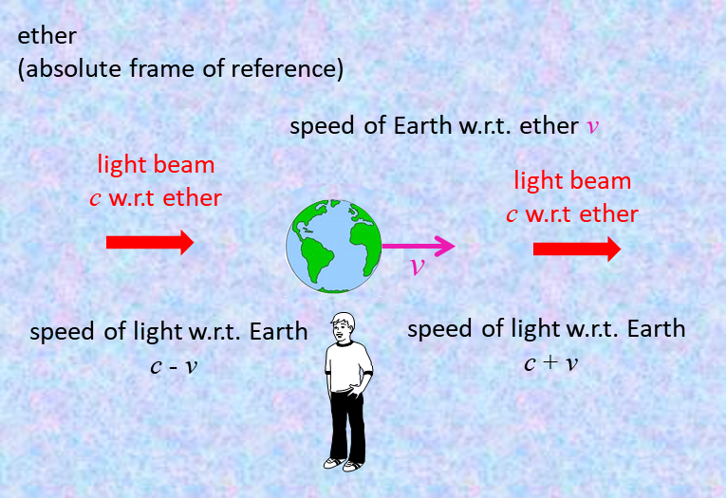

Fig. 2. Ether proposed as the medium for the propagation of electromagnetic waves. Classical concept: the speed of light depends on the relative motion of the Earth through the ether.

**ETHER – proposed medium for the propagation of electromagnetic waves**

|  |  |
| --- | --- |
| **Property of ether** | **Evidence** |
| Fills space, permeates all matter | light travels everywhere |
| Stationary | light travels in straight lines |
| Transparent | can’t see it |
| Extremely low density | can’t be detected |
| Great elasticity | medium must be elastic otherwise energy dissipated |

**MICHELSON – MORLEY EXPERIMENT**

In 1887, Albert Michelson & Edward Morley performed a very careful experiment to measure the motion of the Earth relative to the ether and thereby demonstrate that the ether existed. Their method involved using the phenomenon of the interference of light to detect small changes in the speed of light due to the Earth’s motion through the ether.

The apparatus was mounted on a solid stone block for stability and was floated in a bath of mercury so that it could be rotated smoothly about a central axis. The apparatus is assumed to be travelling through the ether with a uniform velocity *v* of about 30 km.s-1, equivalent to the Earth at rest with the ether streaming past it at a velocity –*v*.

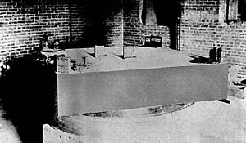

A beam of light from the source S is split into two beams by a half-silvered mirror K, half of the beam travels from K to M1 and is then reflected back to K - the other half reflected from K to M2 and then reflected from M2 back to K. At K part of the beam from M1 is reflected to the observer O and part of the beam from M2 is transmitted to O.

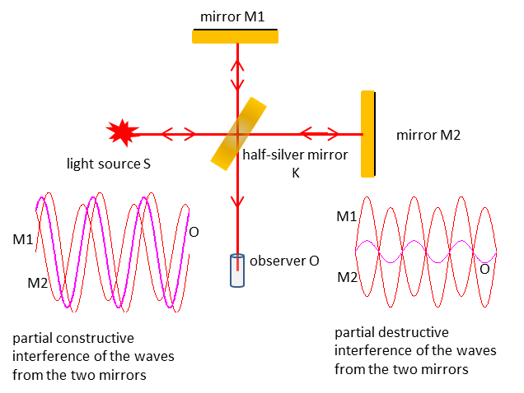

Fig. 3. **Michelson – Morley Interferometer**. The light from reflected by the two mirrors produces an interference pattern at the location of the observer.

Although the mirrors M1 and M2 are the same distance from K, it is virtually impossible to have the distances travelled by each beam exactly equal, since the wavelength of light is so small compared with the dimensions of the apparatus. Thus, the two beams would arrive at O slightly out of phase and would produce an interference pattern at O. There is a difference in the time taken by each beam to traverse the apparatus and arrive at O, since one beam travels across the ether stream direction while the other travels parallel and then anti-parallel to the ether stream direction.

This difference in time taken for each beam to arrive at O would also introduce a phase difference and would thus influence the interference pattern.

Now if the apparatus were to be rotated through 90o, the phase difference due to the path difference of each beam would not change. However, as the direction of the light beams varied with the direction of flow of the ether, their relative velocities would alter and thus the difference in time required for each beam to reach O would alter. This would result in a change in the interference pattern as the apparatus was rotated (changes in the patterns of bright and dark fringes).



Fig. 4. Interference patterns recorded at location O. The pattern on the right was expected where a fringe shift occurs but a null result was obtained as shown by the interference pattern on the left.

The Michelson-Morley apparatus was capable of detecting a phase change of as little as 1/100 of a fringe. The expected phase change was 4/10 of a fringe. However, no such change was observed - the result of the Michelson-Morley experiment was that no motion of the Earth relative to the ether was detected. Since the experiment failed in its objective, the result is called a null result.

The Michelson-Morley experiment is an excellent example of a critical experiment in science - the fact that no motion of the Earth relative to the ether was detected suggested quite strongly that the ether hypothesis was incorrect and that no ether (absolute) reference frame existed for electromagnetic phenomena – this opened the way for a whole new way of thinking that was to be proposed by Albert Einstein in his Theory of Special Relativity. The **null** result of the Michelson-Morley experiment was such a blow to the ether hypothesis and to theoretical physics in general that the experiment was repeated by many scientists for more than 50 years. **A null result has always been obtained**.

[VISUAL PHYSICS ONLINE](http://www.physics.usyd.edu.au/teach_res/hsp/sp/spHome.htm)

If you have any feedback, comments, suggestions or corrections please email:

Ian Cooper School of Physics University of Sydney

ian.cooper@sydney.edu.au