[**VISUAL PHYSICS ONLINE**](http://www.physics.usyd.edu.au/teach_res/hsp/sp/spHome.htm)

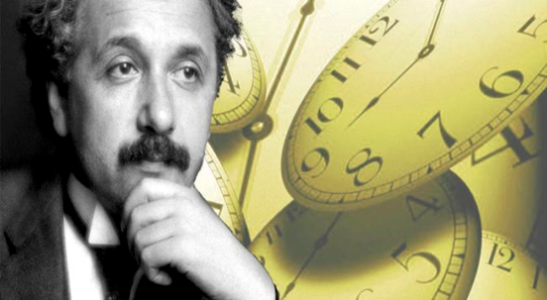

**LIGHT and SPECIAL RELATIVITY**

**EXPERIMENTAL VERIFICATION**

**TIME DILATION**

**HAFELE-KEATING ATOMIC CLOCK**

[Video: Hafele-Keating Experiment](https://www.youtube.com/watch?v=gdRmCqylsME)

An extremely accurate measurement of time can be made using a well-defined electronic transition in the 133Cs55 atom that has a frequency of 9 192 961 770 Hz.

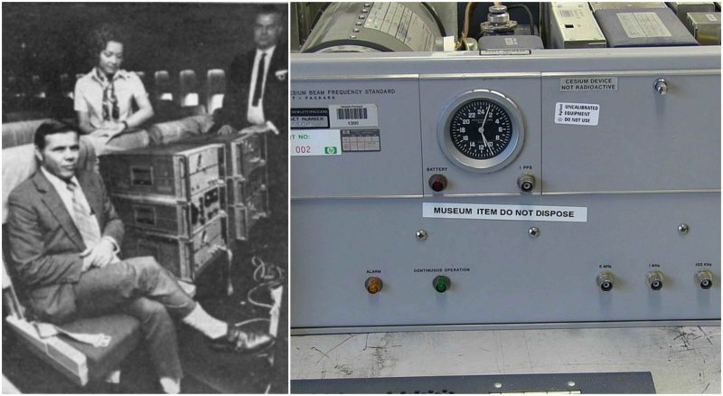

"During October, 1971, four cesium atomic beam clocks were flown on regularly scheduled commercial jet flights around the world twice, once eastward and once westward, to test Einstein's theory of relativity with macroscopic clocks. From the actual flight paths of each trip, the theory predicted that the flying clocks, compared with reference clocks at the U.S. Naval Observatory, should have lost 40 23 nanoseconds during the eastward trip and should have gained 275 nanoseconds during the westward trip ... relative to the atomic time scale of the U.S. Naval Observatory, the flying clocks lost 5910 nanoseconds during the eastward trip and gained 2737 nanosecond during the westward trip, where the errors are the corresponding standard deviations. These results provide an unambiguous empirical resolution of the famous clock "paradox" with macroscopic clocks."

J.C. Hafele and R. E. Keating, Science 177, 166 (1972)

In this experiment, both gravitational time dilation and kinematic time dilation are significant and are in fact of comparable magnitude. Their predicted and measured time dilation effects were as follows.

|  |  |  |
| --- | --- | --- |
|  | East – West  [ns] | West -East  [ns] |
| Gravitational | 144  14 | 179  18 |
| Kinematic | -184  18 | 96  10 |
| Net effect | -40  23 | 275  21 |
| Observed | -59  10 | 273  7 |

(1 ns = 1x10-9 s)

A negative time indicates that the time on the moving clock is less than the reference clock. The moving clocks lost time (ran slow) on the eastward trip but gained time (ran faster) during the westward trip. This occurs because of the rotation of the Earth, indicating that the flying clocks ticked faster or slower than the reference clocks on Earth. The special theory of relativity is verified with the experimental uncertainties.

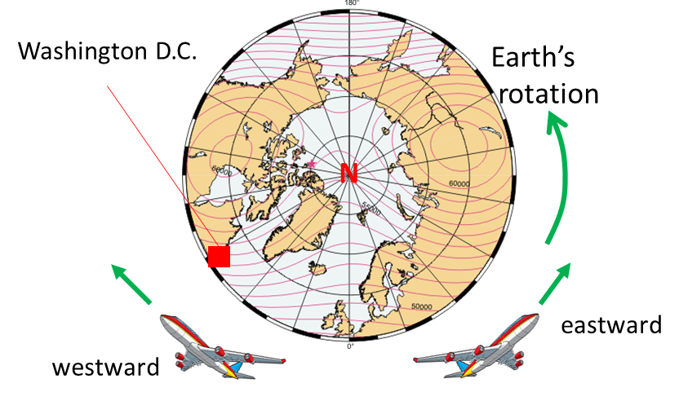

Fig. 2. Two planes take off from Washington D.C. where two atomic clocks are located at the U.S. Naval Observatory. One plane travels around the world in an easterly direction carrying an Cs atomic clock, while another Cs atomic clock is flown in a plane around the world in w westerly direction as the Earth rotates. At the end of the flights the clocks are compared. The results show that the effects of time dilation are correct.

|  |
| --- |
| **Exercise 1**  An aeroplane travels around the around the circumference of the Earth at 500 m.s-1. One clock remains on Earth and another clock is in the moving plane. Ignoring the effects of the Earth’s rotation and gravitational effects, estimate the time difference between the two clock for a round-the-world trip.  Radius of the Earth *RE* = 6371 km  **Solution**    Steve’s system  Time for plane travels around the world  circumference of Earth  speed of plane  flight time  Steve’s observes Mary’s moving clock: moving clock run slow according to the time dilation effect    The interval for the trip according to Mary’s clock is    Calculation of    Putting the numbers into a calculator gives  Since *v* is so small, you must use a power series expansion of the square root.    So, it is best to calculate the time difference  and not    At the end of the round-the-world trip, Mary’s clock would be 111 ns slower than Steve’s clock. Mary has aged move slowly than Steve by 111 ns. |

[VISUAL PHYSICS ONLINE](http://www.physics.usyd.edu.au/teach_res/hsp/sp/spHome.htm)

If you have any feedback, comments, suggestions or corrections please email:

Ian Cooper School of Physics University of Sydney

ian.cooper@sydney.edu.au