[**VISUAL PHYSICS ONLINE**](http://www.physics.usyd.edu.au/teach_res/hsp/sp/spHome.htm)

**DOPPLER EFFECT FOR LIGHT**

**DETECTING MOTION IN THE UNIVERSE**

**HUBBLE’S LAW**

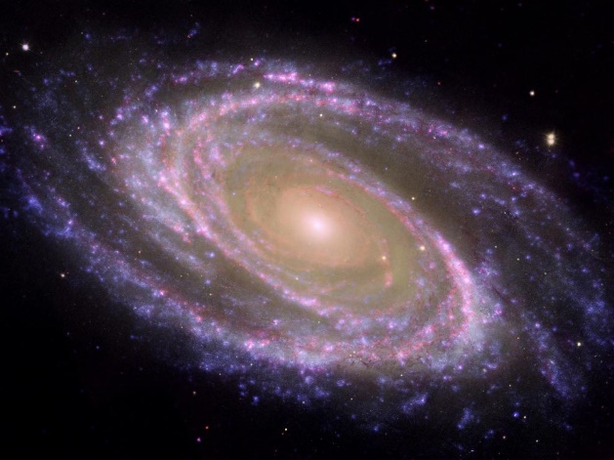

**Motion in the Universe**

Stars and interstellar gas are bound by gravity to form galaxies, and groups of galaxies can be bound by gravity in galaxy clusters. Except for stars in the Milky Way and the galaxies in the Local Group, almost all galaxies are moving away from us due to the expansion of the universe. This motion of stellar objects can be determined by looking at their spectrum. Because of the Doppler effect, objects moving towards us are blueshifted, and objects moving away are redshifted. The wavelength of redshifted light is longer, appearing redder than the source and the wavelength of blueshifted light is shorter, appearing bluer than the source light

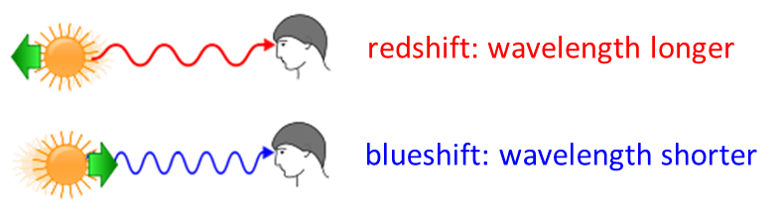

A redshifted absorption or emission line will appear more towards the red end of the spectrum than a stationary line. Conversely, a blueshifted absorption or emission line will appear more towards the blue end of the spectrum.

**Doppler Effect for Light**

We have studied the [Doppler Effect](http://www.physics.usyd.edu.au/teach_res/hsp/sp/mod31/doppler.pdf) for sound in Module 3.1. A change in frequency of the sound detected occurs when there is relative motion between the source and the observer. For sound, the speed of propagation for the wave is relative to the medium through which the sound is propagating. But for light, there is no medium. It is possible for the source of sound to travel fast than the speed of the sound wave. But, this is not possible for light. So, the Doppler Effect for sound is different to the Doppler effect for light. It can be shown that the equation describing the Doppler Effect for light because of the relativistic effect that the speed of light does not depend upon the relative motion of source or observer is

(1)  Relativistic Doppler Effect

where *v* is the magnitude of the relative velocity of source (s) and observer (o). The magnitude *v* is a positive number. If the source and receiver are approaching, then the frequency increases or if source and observer are receding from each other, then the frequency decreases . Whether the frequency is increased or decreased determines the sign + or – to be used in the numerator and denominator.

An atom absorbs and emits light of characteristic frequencies due to the quantized energy levels of the atom because the spacing of the energy levels is unique to the atom. Scientists have observed these characteristic frequencies in the light from stars and this makes it possible to identify atoms and molecules in distance stars and galaxies. It is mostly found that there is a shift in these frequencies.

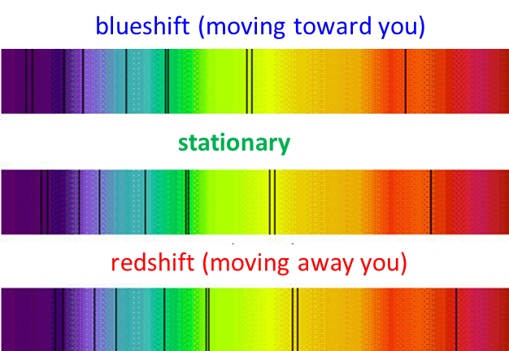

Fig. 1. Absorption lines in the visible spectrum showing the shift in frequency due to motion of the source. Molecules absorb energy at discrete frequencies which are unique to the atoms that constitute the molecules.

One reason for the shift in frequencies is the relativistic Doppler Effect and the shift in frequencies are used to estimate the speed of the emitting objects with respect to us. This is the source of the well-known redshifts in the light from stars caused by them moving away from us. The redshifts provide us with evidence of an expanding universe. The farther away the stars, the greater the redshift. This led to H. Shapley and E. Hubble to conclude the origin of the universe started with a **Big Bang**. The relativistic Doppler Effect is used to find the astronomic distances of objects such as quasars (objects that have enormous masses and emit incredibly amounts of radiation).

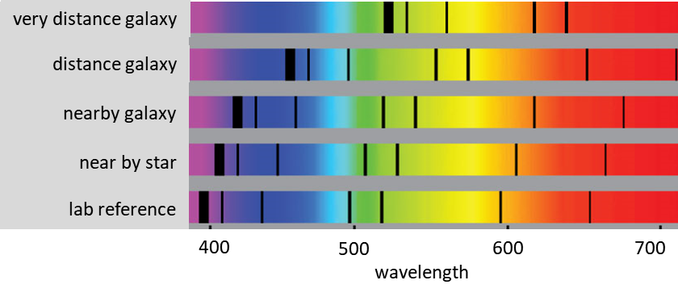

Fig. 2. The redshift of the light from distance astronomical objects. The redshift is used to estimate their distances from us.

Edwin Hubble would later use this information, as well as his own observations, to define **Hubble's law**: The further a galaxy is from the Earth, the faster it is moving away from us. Hubble's law can be generalised to



where *v* is the velocity,  is the Hubble Constant, and *d* is the distance from Earth.

Venus rotates in the opposite direction to the spin of the Earth. This was found by observing sunlight reflected from the surface of Venus – one side the light is redshift and on the other it is blueshifted. The same technique is used to study the rotation of stars.

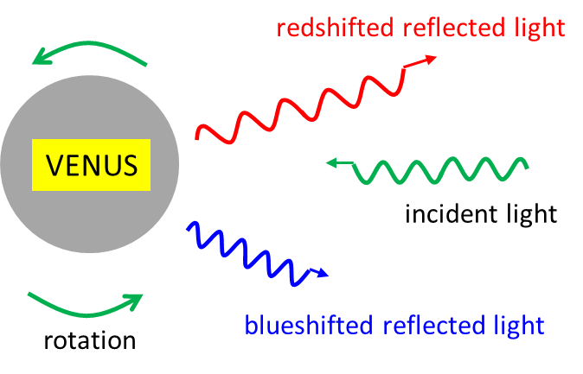

Fig. 3. The relativistic Doppler Effect is used to study the rotations of planets and stars.

[Australian Telescope National Facility](http://www.atnf.csiro.au/outreach/education/senior/astrophysics/spectra_info.html)

**Translational Motion**: If the spectral lines in a star's spectrum are uniformly redshifted this would indicate relative recessional motion between the observer and the star. The amount of redshift would depend on the recession velocity. A complicating factor is the fact that the motion may not be directly away from us. In this case the Doppler shift of lines would depend on the component of velocity away from us, that is the star's radial velocity. A star moving towards us would, of course, exhibit a blueshift in its spectral lines.

**Rotational Motion**: Even though we can still only resolve most stars as point sources they are in fact large, roughly spherical balls of hot gas and plasma. Stars rotate, that is they spin on their axis. The Sun's sidereal rotational period is about 26 days on the solar equator and possibly up to 36 days at the poles. The different rates are since it is not a solid sphere and the gas and plasma can rotate at different speeds. If we obtain a spectrum from a distant star that is rotating in the same plane as us, then the light gathered is a combination of light from across the disc of the star. As part of the star appears to rotate towards us its light will be blueshifted. The light from the part of the star rotating away from us will be redshifted. The section in the middle of the disc that is moving tangentially to us will not exhibit Doppler-shift.

**What effect will this have on the star's spectrum?**

The net effect is that the star's spectral lines will appear smeared out. This broadening of lines can be distinguished from the effects of pressure broadening due to stellar pressure. The beauty of rotational broadening is that it can be used to measure the rotation rate of stars. As with translational velocity the alignment of the plane of rotation of the star with Earth is a factor and must be calculated from the spectrum.

[VISUAL PHYSICS ONLINE](http://www.physics.usyd.edu.au/teach_res/hsp/sp/spHome.htm)

If you have any feedback, comments, suggestions, links or corrections please email:

Ian Cooper School of Physics University of Sydney

ian.cooper@sydney.edu.au