[**VISUAL PHYSICS ONLINE**](http://www.physics.usyd.edu.au/teach_res/hsp/sp/spHome.htm)

**MODULE 7 NATURE OF LIGHT**

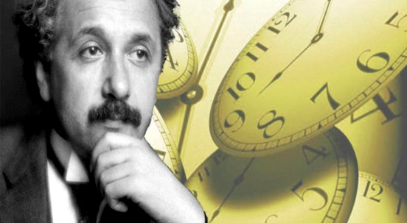

**LIGHT and SPECIAL RELATIVITY**

**EINSTEIN’S POSTULATES**

|  |
| --- |
| **Einstein’s Postulates for Special Relativity**  1. **The Principle of Relativity** – All the laws of physics are the same in all inertial reference frames – no preferred inertial frame exists.  2. **The Principle of the Constancy of the Speed of Light** – the speed of light in free space has the same value *c*, in all inertial frames, regardless of the velocity of the observer or the velocity of the source emitting the light.  **constant *c* ⇒ both space and time must be relative quantities**  **Einstein 🡪 Maxwell’s equations are correct 🡪 speed of light a fundamental constant – a law of nature**  The aether is not needed to explain light, and, in fact it does not exist.  **Simultaneity** is not an absolute concept, but depends on the reference frame of the observer. |

**POSTULATES OF SPECIAL RELATIVITY**

In the 19th Century it looked as if there was a preferred or absolute reference frame (the aether) as far as the laws of electromagnetism were concerned. However, in 1904 Henri Poincare proposed his Principle of Relativity: “The laws of physics are the same for a fixed observer as for an observer who has a uniform motion of translation relative to him”. Note that this principle applies to mechanics as well as electromagnetism. Although his principle acknowledged the futility in continued use of the aether as an absolute reference frame, Poincare did not fully grasp the implications. Poincare still accepted the Newtonian concept of absolute time. Einstein abandoned it.

In 1905, Albert Einstein (1879 – 1955) published his famous paper entitled: “*On the Electrodynamics of Moving Bodies*”, in which he proposed his two postulates of relativity and from these derived his Special Relativity Theory.

1. **The Principle of Relativity** – All the laws of physics are the same in all inertial reference frames – no preferred inertial frame exists.

2. **The Principle of the Constancy of the Speed of Light** – the speed of light in free space has the same value *c*, in all inertial frames, regardless of the velocity of the observer or the velocity of the source emitting the light.

The first postulate is significant because it extends Newtonian Relativity to all the laws of physics not just mechanics. All motion is relative and no absolute reference frame exists. In any problem, we can choose the frame of reference that makes the problem the simplest.

The second postulate is significant because it denies the existence of the aether, asserts that light moves at speed *c* relative to all inertial observers, predicts the null result of the Michelson-Morley experiment and forces us to rethink our understanding of space and time.

James Clerk Maxwell in 1864 developed a mathematical theory for the propagation of electromagnetic waves. A prediction from his theory was that light travels through a vacuum at the speed

*c* = 3x108 m.s-1. In his theory, nothing was said about a frame of reference in which the speed of light is to be measured or the motion of the source or the observer.

**Einstein 🡪 Maxwell’s equations are correct 🡪 speed of light a fundamental constant – a law of nature**

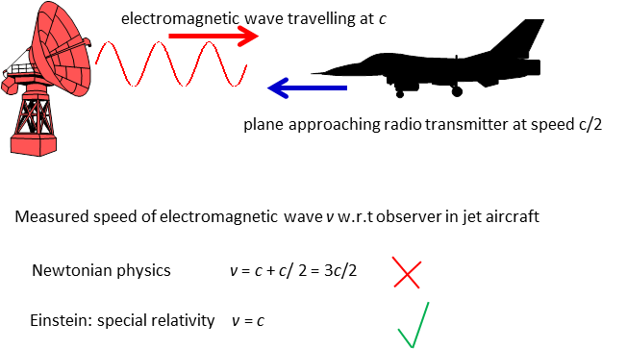

Fig. 1. The speed of light is constant no matter what are the speeds of the transmitter or receiver.

In Newtonian Relativity, if a pulse of light were sent from one place to another, different observers would agree on the time that the journey took (since time is absolute), but would not always agree on how far the light travelled (since space is not absolute). Since the speed of light is just the distance travelled divided by the time taken, different observers would measure different speeds for light. In Special Relativity, however, all observers must agree on how fast light travels. They still do not agree on the distance the light has travelled, so they must therefore now also disagree over the time it has taken. In other words, Special Relativity put an end to the idea of absolute time.

**constant *c* ⇒ both space and time must be relative quantities**

**RELATIVITY OF SIMULTANEITY**

Thought experiment (Gedanken) to illustrate that time is relative. Imagine two observers O1 and O2 standing at the midpoints of their respective trains (reference frames) F1 and F2. F1 is moving at a constant speed *v* with respect to F. Just at the instant when the two observers O1 and O2 are directly opposite each other, two lightning flashes (events) occur simultaneously in the F2 frame, as shown in figure (2). The question is: will these two events appear simultaneous in the F1 frame?

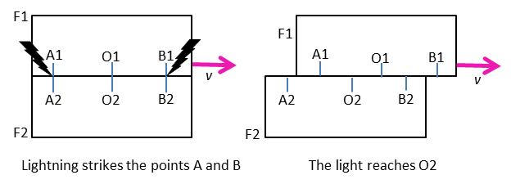

Fig. 2. Relativity of simultaneity

From our F2 reference frame, it is clear that observer O1 in the F1 frame moves to the right during the time the light is travelling to O1 from A1 and B1. At the instant that O2 receives the light from A2 and B2, the light from B1 has already passed O1, whereas the light from A1 has not yet reached O1. O1 will thus observe the light coming from B1 before receiving the light from A1. Since the speed of light along both paths O1 A1 and O1 B1 is *c* (according to the second postulate), O1 must conclude that the event at B1 occurred before the event at A1. The two events are not simultaneous for O1, even though they are for O2 – the two events that are simultaneous to one observer are not necessarily simultaneous to a second observer - there is no preferred reference frame, either description is equally valid - simultaneity is not an absolute concept, but depends on the reference frame of the observer.

**Einstein's First Thought Experiment**

Einstein wondered: "**Suppose I am sitting in a train travelling at the speed of light. If I hold a mirror in front of me, will I see my reflection?**"

There are two possibilities:

**NO**

If the train is travelling at the speed of light, light from his face would not reach the mirror in order to be reflected back. By not being able to see his reflection, he would know that the train was travelling at the speed of light without having to refer to an outside point. This violates the principle of relativity.

**YES**

This means that light would travel at its normal speed relative to the train. This does not violate the principle of relativity. However, it also means that, relative to a stationary observer outside the train, light would have to travel at twice its usual speed!

Eventually Einstein concluded - if we accept that the principle of relativity can never be violated, then

1. The aether model must be wrong.
2. He would see his reflection.
3. The speed of light is constant regardless of the motion of the observer.

In order to satisfy this third decision, he made a revolutionary statement: **it is not the speed of light that is changing, but time**.

In other words, the stationary observer and the moving observer perceive space and time differently. In classical physics space and time are constants and motion is defined by them. In Einstein's physics, it is the speed of light that is constant and space and time change to accommodate this. Using these ideas, Einstein put forward his Special Theory of Relativity

1. All motion is relative — the principle of relativity holds in all situations.
2. The speed of light is constant regardless of the observer's frame of reference.
3. The aether is not needed to explain light, and, in fact it does not exist.

[VISUAL PHYSICS ONLINE](http://www.physics.usyd.edu.au/teach_res/hsp/sp/spHome.htm)

If you have any feedback, comments, suggestions or corrections please email:

Ian Cooper School of Physics University of Sydney

ian.cooper@sydney.edu.au