[**VISUAL PHYSICS ONLINE**](http://www.physics.usyd.edu.au/teach_res/hsp/sp/spHome.htm)

**MODULE 7 NATURE OF LIGHT**



**LIGHT and SPECIAL RELATIVITY**

**EXPERIMENTAL VERIFICATION**

**Does Einstein's theory of special relativity accurately describe the motion of objects traveling close to the speed of light?**

The theory of Special Relativity has made many astonishing predictions. Einstein did not receive his Noble Prize for his Theory of Special Relativity but for a more minor contribution to our understanding science – the Photoelectric Effect. Scientist at the time, were uncertain of Einstein’s predictions – they were so inconceivable and so against long-held believes. For more than a century experiments have been carried out to test Einstein’s theories. So far, all experimental evidence has been confirmed the predictions of special relativity and general relativity.

**MUON DECAY**

**Experimental evidence for time dilation and length contraction**

**Muons** are unstable particles with a rest mass of 207 times that of an electron and a charge of ±1.6x10-19 C. Muons decay into electrons or positrons with an average lifetime of 2.2 μs as measured in their inertial frame of reference.

When high energy particles called **cosmic rays** (such as protons) enter the atmosphere from outer space, they interact with air molecules in the upper atmosphere creating a cosmic ray shower of particles including muons that reach the Earth’s surface. The muons created in these cosmic ray showers travel at 0.98*c* w.r.t to the Earth.

**Newtonian (classical) point of view**

Speed of muons

*v* = 0.98*c* = (0.98)(3.0x108) m.s-1 = 2.94x108 m.s-1

Average lifetime of muons (proper time)

*t*0 = 2.2 μs = 2.2x10-6 s

Average distance travelled by muon before decaying

*L*0 = *v t*0 = (2.94x108)(2.2x10-6) m = 650 m

Hence, from a Newtonian point of view, muons would not be able to reach the Earth’s surface from the upper atmosphere where they are produced.

However, experiments show that a large number of muons do reach the Earth’s surface in cosmic ray showers.

**Special relativity point of view**

Height above Earth’s surface muon produced

*L*0 = 100 km = 1.0x105 m (proper length)

From point of view of muons the distance to the Earth’s surface is contracted to a shorter length *L*



This contracted distance is much less and so many muons will be able to reach the Earth’s surface.

From an observer viewing the muon approaching, time intervals for moving “clock” will be dilated.

Average lifetime of muons (proper time)

*t*0 = 2.2 μs = 2.2x10-6 s

Dilated average lifetime w.r.t. Earth observer *t* = ? s



Average distance travelled by muons



Average distance is now short enough so that many muons will reach the Earth’s surface.

**Another look at muon decay**

The decay of muon can be accurately described by the radioactive decay law



where and  are the number of detected muons at times  and time *t* respectively. is the half-life (time for the number of muons detected to halve) and  is the decay constant. The measured half-life and decay constant for muons at rest in the laboratory are



An experiment was performed by placing a Geiger counter to detect muons on the top of a mountain 2000 m high. The muons are assumed to be moving at a speed equal to 0.98c. In a time interval *T* the Geiger counted 1000 muons. The Geiger counter was moved to the bottom of the mountain, 2000 m below the peak. In the same time interval T, the Geiger counter registered 540 muons. these are the muons that survived the trip without decaying.

Classically, we can calculate the number of muons surviving the trip.

distance travelled by muons 

speed of muons 

time interval for trip 

Number of surviving muons





So, only 45 muons should survive the trip. Something is wrong !!!

Our classical theory predicts 45 muons, but measurements record 540 muons. The problem must be approached using special relativity. The muons are moving at a speed of 0.98c w.r.t the Earth. so, we must take into account the time dilation effect.



The Earth based clock records a time interval of 6.80x10-6 s for the muon to travel from the top to the bottom of the mountain.



The Earth based observes see the muon’s “moving clock” record the proper time 



In the muon’s rest frame, the decay of the muon is given the radioactive decay law is





The number of muons surviving the trip is 538, which is in agreement with observations. An experiment like this was performed by B. Rossi and D. Hall in 1941 at Mount Washington, New Hampshire, U.S.A. Their results agreed with the predictions of special relativity and not the predictions of classical physics.

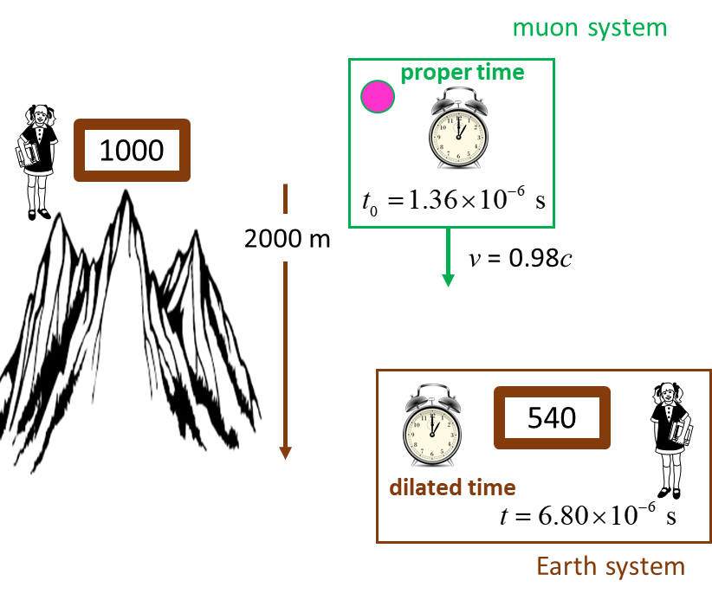

Fig. 1. The number of muons detected at the top of the mountain is 1000 whereas at the bottom of the mountain only 540 survived without decaying. The experimental result agrees with our time dilation equation.

**TIME DILATION**

**HAFELE-KEATING ATOMIC CLOCK**

[Video: Hafele-Keating Experiment](https://www.youtube.com/watch?v=gdRmCqylsME)

An extremely accurate measurement of time can be made using a well-defined electronic transition in the 133Cs55 atom that has a frequency of 9 192 961 770 Hz.

In October 1971, J. C. Hafele and R. E. Keating (American physicists) used four cesium beam atomic clocks to test the time dilation effect. They flew one clock in an easterly direction on a regularly scheduled commercial airline flights around the world and another clock in a westerly direction. The other two clocks stayed at fixed locations at the U.S. Naval Observatory in Washington D.C.

In this experiment, both gravitational time dilation and kinematic time dilation are significant, and are in fact of comparable magnitude. Their predicted and measured time dilation effects were as follows.

|  |  |  |
| --- | --- | --- |
|  | East – West  [ns] | West -East  [ns] |
| Gravitational | 144  14 | 179  18 |
| Kinematic | -184  18 | 96  10 |
| Net effect | -40  23 | 275  21 |
| Observed | -59  10 | 273  7 |

(1 ns = 1x10-9 s)

A negative time indicates that the time on the moving clock is less than the reference clock. The moving clocks lost time (ran slow) on the eastward trip but gained time (ran faster) during the westward trip. This occurs because of the rotation of the Earth, indicating that the flying clocks ticked faster or slower than the reference clocks on Earth. The special theory of relativity is verified with the experimental uncertainties.

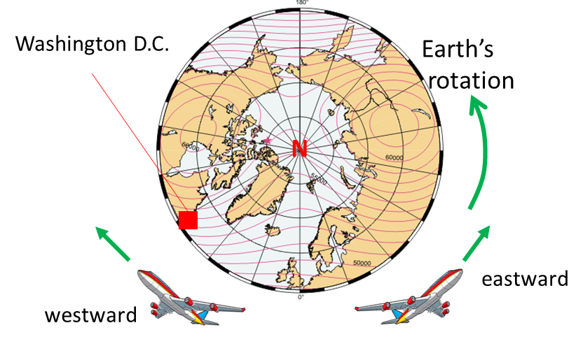

Fig. 2. Two planes take off from Washington D.C. where two atomic clocks are located at the U.S. Naval Observatory. One plane travels around the world in an easterly direction carrying an Cs atomic clock, while another Cs atomic clock is flown in a plane around the world in w westerly direction as the Earth rotates. At the end of the flights the clocks are compared. The results show that the effects of time dilation are correct.

|  |
| --- |
| **Exercise 1**  An aeroplane travels around the around the circumference of the Earth at 500 m.s-1. One clock remains on Earth and another clock is in the moving plane. Ignoring the effects of the Earth’s rotation and gravitational effects, estimate the time difference between the two clock for a round-the-world trip.  Radius of the Earth *RE* = 6371 km  **Solution**    Steve’s system  Time for plane travels around the world  circumference of Earth  speed of plane  flight time  Steve’s observes Mary’s moving clock: moving clock run slow according to the time dilation effect    The interval for the trip according to Mary’s clock is    Calculation of    Putting the numbers into a calculator gives  Since *v* is so small, you must use a power series expansion of the square root.    So, it is best to calculate the time difference  and not    At the end of the round-the-world trip, Mary’s clock would be 111 ns slower than Steve’s clock. Mary has aged move slowly than Steve by 111 ns. |

**PARTICLE ACCLERATORS**

**Special Relativity and particle accelerators**

Particle accelerators routinely create beams of particles traveling at nearly the speed of light. Without Einstein's theory of special relativity, they simply wouldn't work.



Einstein’s special relativity theory can be tested using the measurements gained from particle accelerator where very high velocities are commonplace.

The Tevatron accelerator, the LHC (Large Hadron Collider) and many other accelerators around the world provide excellent evidence that the counterintuitive ideas of Special Relativity are accurate.

|  |
| --- |
| **Exercise 2**  A pi meson (meson or pion) is an unstable particle formed in large numbers in nuclear reactions occurring in particle accelerators.  Image result for images pi meson decay  It has a mass of about 270 times larger than an electron’s mass and has the same charge as an electron. When many of these particles are observed at rest in the laboratory, it is found that they disintegrate to form other particles. After a time interval of 2x10-8 s, half the original number of pions have decayed (disintegrated). This time interval is called the **half-life**. When pions are used in particle accelerators, they can reach speeds of 0.98c. How long will it take according to laboratory clocks, for half these high-speed pions to decay?  **Solution**  Little is known about the process in which pions decay. However, the decay must be dependent upon the rate of decay. These processes act as a clock, and the “clock” moves with the pions. As seen from the laboratory frame (fixed frame), the pion clock will be running slow as described by the time dilation effect.  In the laboratory frame (fixed system), when the pions are rest, the proper time interval is *t*0= 2x10-8 s  The observer in the laboratory frame observing the decay process when the pions are moving will measure the dilated time interval *t* = ? s  Velocity of moving system (pion frame) *v* = 0.98 c  Time dilation effect      Since the pions decay because of their own internal processes, their “clock” must read 2x10-8 s when half have decayed. But, when moving, the time interval measured in the laboratory for half of the pions to decay is 5 times longer, 10x10-8 s.  Measurements such as those indicated in this example have been carried out at particle accelerators for decades, and the predictions of special relativity have always been confirmed by actual measurements. |

Prior to the shutdown of the Tevatron in 2011, the Fermilab accelerator complex consisted of five accelerators. Each accelerator added some energy to a proton until it reached the Tevatron's maximum energy of 1012 eV and at that energy, the proton travels with a velocity 0.9999995 *c* (a proton traveling at this speed could circle the Earth's equator almost eight times in a single second).

The maximum energies and corresponding observed velocities of the protons for the five accelerators are displayed in the table below. When protons leave the Booster, they are traveling at very nearly the speed of light. Yet when they were in the Tevatron, which provided 125 times more energy, their velocity was only a tiny bit faster. Even the LHC (Large Hadron Collider), with a maximum energy seven times higher than that of the Tevatron, only makes protons move an itty-bitty bit faster than the Tevatron.

|  |  |  |
| --- | --- | --- |
| Accelerator | Energy (eV) | v / c % |
| 1 Cockcroft-Walton | 7.50x105 | 4 |
| 2 Linac | 4.00x108 | 71 |
| 3 Booster | 8.0x109 | 99.4 |
| 4 Main Injector | 1.20x1011 | 99.997 |
| 5 Tevatron | 1.00x1012 | 99.99995 |
| LHC (Large Hadron Collider) | 7.00x1012 | 99.9999991 |

These measurements demonstrate that the velocities of particles with mass, do not exceed the speed of light, no matter how much energy we give them. This upholds the theory of special relativity, which says that nothing exceeds the speed of light.

Reference

<http://www.fnal.gov/pub/today/archive/archive_2014/today14-04-04_NutshellReadMore.html>

Special Relativity also says that energy and mass are essentially equivalent. The phenomenon of gaining higher velocities by adding energy to a particle is often explained as "mass increases as things go faster." I admit I have uttered those words myself, but the statement is actually wrong and so can be misleading.

For instance, some people hear the words "mass increases" and think that particles are getting heavier in the gravitational sense. In fact, it is more accurate to say that inertia increases as velocity increases. At low velocities, or nonrelativistic velocities, it is perfectly reasonable to equate inertia and mass. This is the reason even scientists sometimes say that mass changes with velocity. They use the phrase "relativistic mass" to label this fallacious idea of increasing mass.

In fact, there is only one mass, and that is what is often called "rest mass," which is the mass of an object when it is not moving. Even though the idea of relativistic mass is, strictly speaking, not correct, it is a valuable mental picture and helps us get used to the fact that objects cannot exceed the speed of light.

So, if you prefer to think about relativistic mass, go ahead and do so without feeling guilty. Just realize that if you push the idea too hard, it will lead you astray.

Some relativity sceptics are aware that laboratories such as Fermilab and CERN have demonstrated that the speed of light is a limitation in particle accelerators. They have an (incorrect) explanation, and it goes like this: Particle accelerators use electric fields to impart a force on (say) a proton. These electric fields, which accelerators use to propel the protons, are composed of photons, according to the theory of quantum electrodynamics. Thus, they reason, particle accelerators shoot photons at protons, and if a proton travelled faster than a photon, it would no longer feel the photon's force. They claim this is the reason that protons can travel no faster than light.

This reasoning does not explain how the tiny difference in the proton's speed between the Fermilab Booster and the Tevatron results in the beam's energy increasing by 125 times. So, the explanation is wrong, but it is a common one. Be aware of it.

**COSMOLOGICAL EVIDENCE**

[View Doppler Effect for Light](http://www.physics.usyd.edu.au/teach_res/hsp/sp/mod7/m7DopplerLight.pdf)

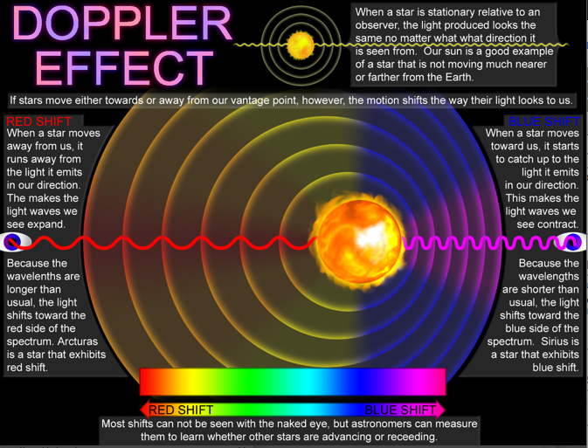

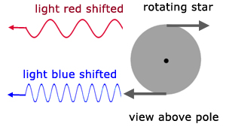

**NUCLEAR REACTIONS**

The energy released in nuclear reactions can be predicted form the theory of special relativity and the predictions agree

extremely well with measured values.

As an example, we will consider the emission of an alpha particle (helium nucleus) from a heavy nucleus of thorium where the parent nucleus is unstable and spontaneous explodes tearing the whole atom into two pieces.



The reaction is analogous to two blocks being held together by a spring and then released, resulting in the two blocks flying away from each other. In the nuclear reaction, the repulsive force is the electrostatic force of repulsion between the two positive offspring nuclei. The spring holding them together is the strong nuclear force which is not quite strong enough to hold the parent nucleus together permanently.

atomic mass unit amu 1 u = 1.66x10-27 kg

mass thorium nucleus 

mass helium nucleus 

mass radium nucleus 

mass (Ra + He) 

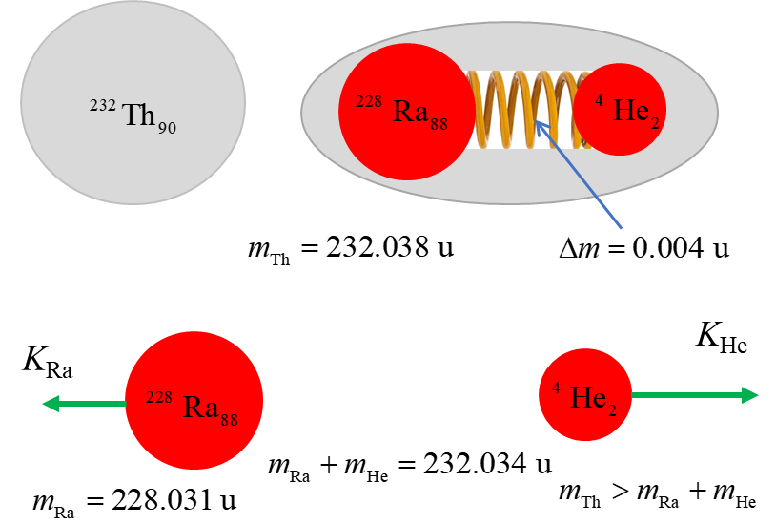



mass defect 

The mass of the thorium nucleus is greater than the constituent nuclei of radium and the alpha particle.

Where is the missing mass?

Mass and energy are equivalent and mass-energy must be conserved. The missing mass called the mass defect is the energy (mass) stored in potential energy bonding the nucleus of together.

When the decay occurs, the stored potential energy is converted into the kinetic energy of the daughter (offspring) nuclei.

mass defect 

binding energy 

kinetic energy of daughter nuclei



Putting in the numbers



In the decay the radium nucleus is much more massive than the helium nucleus, therefore, most of the kinetic energy will be possessed by the alpha particle. The measured value of the energy of the alpha particle from 232-thorium is about 4 MeV. This is another example, of the excellent agreement between the predictions of special relativity and laboratory measurements.

|  |
| --- |
| **Exercise 1**  Image that you are given the task of producing a 10 minute video clip for YouTube as an introductory lesson on special relativity. Make a list of the concepts that you would introduce. What images and animations would you include? [Watch Vdeo 1: Theory of relativity explained in 7 mins](Theory%20of%20relativity%20explained%20in%207%20mins) How does your production compare with the LondonCityGirl video?  The audio has a few errors in the physics. What were the errors?  The discussion on mass is incorrect. Why? How would you change the video to give a better model of mass, momentum and energy?  [Watch Video 2: Special Relativity: Crash Course Physics #42](https://www.youtube.com/watch?v=AInCqm5nCzw)  [Watch Video 3: Professor Dave Explains](https://www.youtube.com/watch?v=iIEeSiT3SI4)  Which video is best (1) or (2) or (3)?  Justify your answer. |

[VISUAL PHYSICS ONLINE](http://www.physics.usyd.edu.au/teach_res/hsp/sp/spHome.htm)

If you have any feedback, comments, suggestions or corrections please email:

Ian Cooper School of Physics University of Sydney

ian.cooper@sydney.edu.au