[**VISUAL PHYSICS ONLINE**](http://www.physics.usyd.edu.au/teach_res/hsp/sp/spHome.htm)

**MODULE 7 NATURE OF LIGHT**

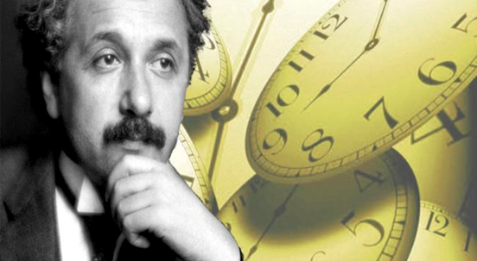

**LIGHT and SPECIAL RELATIVITY**

**LENGTH CONTRACTION**

**RELATIVISTIC ADDITION OF VELOCITIES**

|  |
| --- |
| **Time is a relative quantity**: different observers can measurement different time intervals between the occurrence of two events. This arises because the **speed of light is a constant and independent of the motion of the source of light or the motion of an observer**.  Image result for images time dilation effect  **Moving clocks run slow**  **Time Dilation Effect**  **Proper time *t*0** – the time interval between two events occurring at the same point in space w.r.t. a clock at rest w.r.t. that point.  **Dilated time interval *t*** time interval for event in moving frame as measured on clock by stationary observer.  *t* > *t*0 since  **Lorentz-Fitzgerald Contraction Equation of a moving object**    contracted length *L* and proper length *L*0  **Contraction takes place in the direction of motion only**    **Relativistic addition of velocities** |

**RELATIVE LENGTH: LENGTH CONTRACTION**

When measuring the length of an object it may be necessary to be able to determine the exact position of the ends of the object simultaneously.  However, observers in different reference frames may disagree on the simultaneity of two events. So, they may also disagree about the length of objects. In turns out, the length of a moving object appears to contract in the direction of motion relative to a “stationary” observer.

Equation (1) is known as the **Lorentz-Fitzgerald Contraction Equation** of a moving object

(1) 

* + - **Contracted length** of object  in direction of motion as measured by observer in stationary frame of reference.
    - Rest length or **proper length** of object  as measured by observer in the moving frame of reference. The proper length is measured in the frame in which the object is at rest.
* Velocity *v* (magnitude) of the object relative to the observer in the stationary frame of reference.

**Contraction takes place in the direction of motion only**

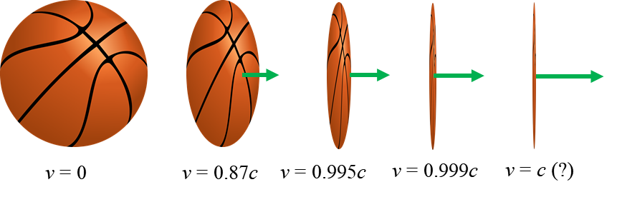

You are a stationary observer in an inertial frame of reference. A train was initially at rest in your frame of reference and you measure its length. However, when the train is in motion your measurement of its length is shorter. There is a contraction in its length. The train is shorter in the direction of motion, but just as high and wide as it was at rest as shown in figure 1.

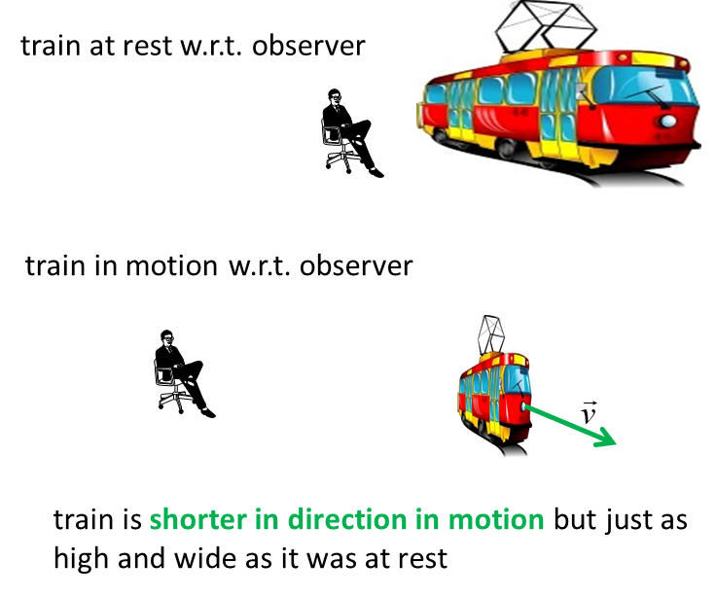

Fig. 1. How long is a train? It depends on the relative motion of the observer and the train.

This is a real difference in length of the object when it is motion relative to an observer. For a person in the train, there is no contraction in length (figure 2).

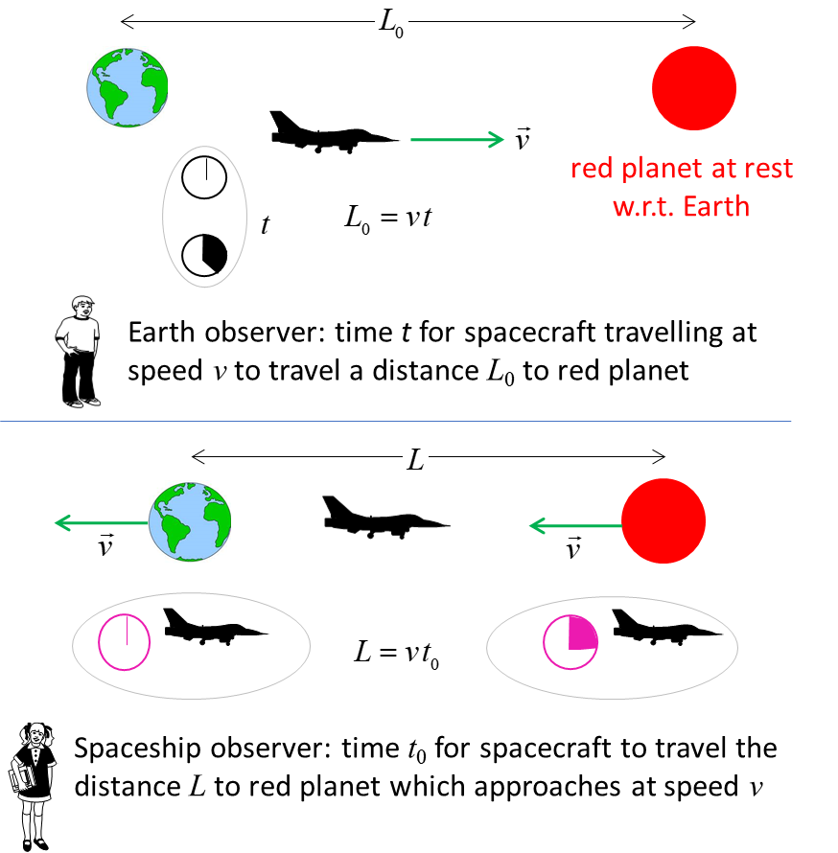

Fig. 2. A length is measured to be shorter when it is moving relative to the observer than when it is at rest.

Time dilation effect 

Length contraction 



We will now consider an alternative derivation for the contraction in lengths parallel to the relative motion through another thought experiment. We attach a laser to one end of a rod and a mirror at the other. The rod is at rest in Mary’s system, and the length of the rod is *L*M (proper length since it is at rest w.r.t observer Mary). Mary measures a time interval *t*0 for a pulse of light to make the round trip from laser to mirror and back. This is the proper time interval since the departure and return occur at the same location in Mary’s system.

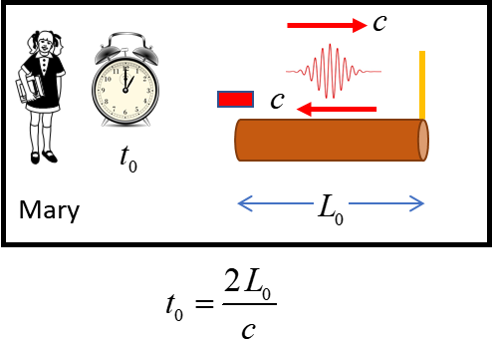

Fig. 3. The rod is stationary in Mary’s system. The light pulse travels a distance *L*0 from the light source to the mirror. The time for the round trip is *t*0.

In Steve’s system, the rod is moving to the right with constant speed *v.* Steve’s measures the length of the rod as *L* and the time for the light to travel from laser to mirror as *t*1*.* During this time interval *t*1, the rod with laser and mirror attached moves a distance to the right.

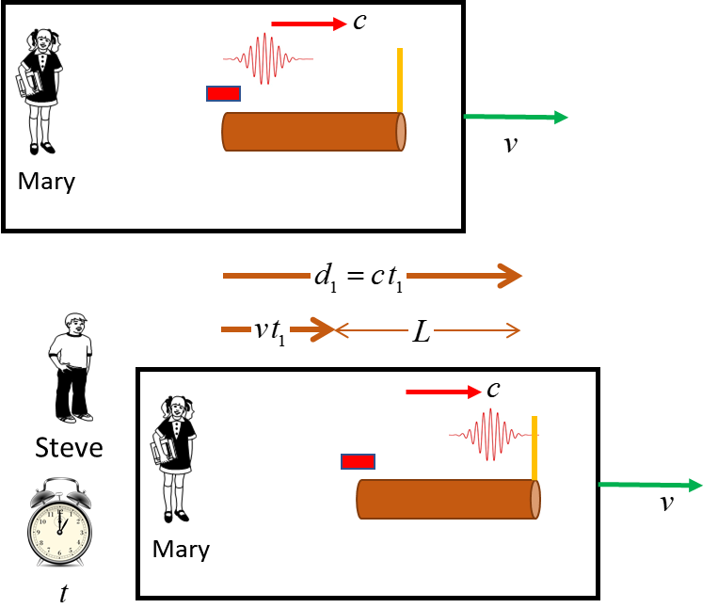

Fig. 4. The rod is moving to the right with constant speed *v* in Steve’s system. The light pulse travels a distance *d*1 from the laser to the mirror in time *t*1.

The total length of the path *d*1 from laser to mirror is therefore . But, the light pulse travels with speed *c,* so it is also true that . Eliminating *d,* we find



Note: the division of *L* by *c-u* does not mean that light travels with speed *c-u,* but rather the light pulse travels in Steve’s frame a distance greater than *L.*

Repeating a similar calculation, the time interval *t*2 from the return journey of the light pulse from the mirror to the laser is



The total time *t* for the for the round trip is



The proper time *t*0 and the dilated time *t* intervals are connected by

 but 

Hence, we can conclude

(1) 

**Another explanation**

There are two inertial frames of reference, Steve’s and Mary’s. From Steve’s point of view, Mary’s frame in moving with a constant velocity of magnitude *v.* They both make measurements of the length of a rod. The rod is stationary in Mary’s frame but moving with velocity *v* in Steve’s frame. They both measure the length of the rod by observing the time interval for a light pulse to travel from one end of the rod to the other. They observe know that the speed of light is the same w.r.t both frames of reference.

The distance measured by Mary is 

and the distance measured by Steve is 

So far everything is straight forward, but now here comes the “tricky part”. We must identify the proper and dilated time intervals and the proper length and the contracted length.

Steve’s clock is stationary w.r.t. his frame, therefore, his clock records the proper time and he view Mary’s clock which is the dilated time interval



Steve views the moving rod, so he measures the contracted length, while the rod is stationary in Mary’s frame, so it is the proper length



Length contraction is real. This is not an optical illusion, The rod is really shorter in Mary’s system than in Steve’s system.

|  |
| --- |
| **Example 1**  A spaceship flies past Earth at a speed of 0.990*c.* Mary on board the spaceship measures its length to be 400 m. What is Steve’s measurement for the length of the spaceship on Earth?  Steve and Eve on Earth are standing 60 m apart as they view the passing spaceship. How far apart are Steve and Eve from Mary’s point of view?  **Solution**  The problem relates to the length contraction of a moving rod. Mary in her system measures the proper length of the spaceship  Steve observes the spaceship moving at uniform velocity v and measures the length of the spaceship as L (contracted length)    Lorentz-Fitzgerald Contraction    The answer makes sense, the moving spaceship is observed to the shorter than in the frame stationary w.r.t. to the spaceship.  Steve and Eve are at rest in the frame of the Earth. Their separation distance of 60 m is the proper length. From Mary perspective, Steve and Eve are moving at a speed v. So, Mary will measure a contracted length *L* as the separation distance: |
| **Example 2**  The diameter of our galaxy is 6.0x1020 m.   1. If the speed of the spaceship was 0.99999*c*, how long would it take to cross the galaxy as measured from the frame of reference of the spaceship? 2. How much time would elapse on Earth for this journey across the galaxy?   **Solution**  (a)  A traveller in the spacecraft would be at rest in the spaceship and would see the galaxy approaching at speed *v* = 0.99999*c*. The traveller would see the galaxy contracted in the direction of motion. The contracted length *L* is  *L*0 = 6.0x1020 m  *v* = 0.99999*c*    If the time *t*0 is measured in the spacecraft, the time for the journey across the galaxy is  *t*0 = ? s = ? years  *L* = 2.7x1018 m  *L* = *v t*0    Even a spaceship travelling at speeds 0.99999*c* it still takes 300 years to cross the galaxy.  (b)  An Earth bound observer will view the moving clock on the spaceship and measure a dilated time interval  Spaceship time interval *t*0 = 300 years (proper time)  Dilated time interval for Earth observer *t* = ? years  *v* = 0.99999c      WOW!!! For the Earth observer, 64 000 years pass for the spaceship to cross the galaxy but on the spaceship only 300 years have passed.  Only, spaceships travelling at speeds extremely close to the speed of light can traverse the huge astronomical distances need for space travel in “reasonable” times. |

**THE RELATIVISTIC ADDITION OF VELOCITIES**

Suppose you were in a moving truck and fired a rocket. The truck was travelling at 100 km.h-1 and the rocket was launched with a muzzle speed at 200 km.h-1 (speed of rocket w.r.t truck) in the same direction that the truck was moving. Obviously the speed of the rocket is 300 km.h-1 w.r.t the ground (100 + 200 = 300).

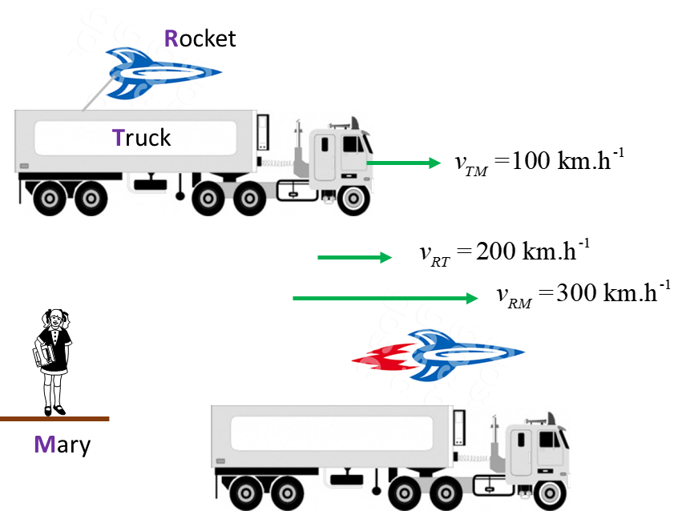

Fig. 5. Newtonian mechanics: adding velocities  .

Mary is in a spaceship travelling at 0.8*c* w.r.t. Steve . A rocket is launched from the spaceship by Mary at a speed of 0.7*c*  w.r.t. Mary . Hence, according to Newtonian mechanics, the speed of the rocket observed by Steve is 



But, our answer is wrong. We know that by Einstein’s postulate that the speed of an object must be less than the speed of light *c.* Einstein derived the correct formula for the addition of velocities. In our example, the velocity of the rocket w.r.t. to the ground is

(2)  relativistic addition of velocities

Applying the correction equation, the speed of the rocket w.r.t Steve is



Note: if the speed of light were infinite  , the denominator would be equal to 1, and we would recover the classical velocity addition equation. So, it is the finite speed of light that is responsible for relativistic effects.

**A New Standard of Length**

Length is one of the fundamental quantities in Physics because its definition does not depend on other physical quantities. The SI unit of length, the metre was originally defined as one ten-millionth of the distance from the equator to the geographic North Pole. The first truly international standard of length was a bar of platinum-iridium alloy called the standard metre and kept in Paris. The bar was supported mechanically in a prescribed way and kept in an airtight cabinet at 0 oC. The distance between two fine lines engraved on gold plugs near the ends of the bar was defined to be one metre. In 1961 an atomic standard of length was adopted by international agreement. The metre was defined to be 1 650 763.73 times the wavelength of the orange-red light from the isotope krypton-86. This standard had many advantages over the original – increased precision in length measurements, greater accessibility and greater invariability to list a few. In 1983 the metre was re-defined in terms of the speed of light in a vacuum. The metre is now defined as the distance light travels in a vacuum in 1/299792458 of a second as measured by a caesium clock. Since the speed of light is constant and we can measure time more accurately than length, this standard provides increased precision over previous standards. The reason for that particular fraction (1/299792458) is that the standard then corresponds to the historical definition of the metre – the length on the bar in Paris. So, our current standard of length is defined in terms of time in contrast to the original standard metre, which was defined directly in terms of length (distance).

[VISUAL PHYSICS ONLINE](http://www.physics.usyd.edu.au/teach_res/hsp/sp/spHome.htm)

If you have any feedback, comments, suggestions or corrections please email:

Ian Cooper School of Physics University of Sydney

ian.cooper@sydney.edu.au