[**VISUAL PHYSICS ONLINE**](http://www.physics.usyd.edu.au/teach_res/hsp/sp/spHome.htm)

**MODULE 7 NATURE OF LIGHT**

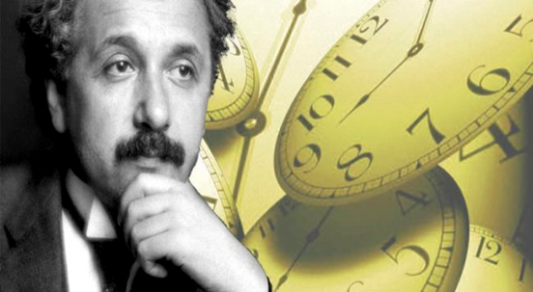

**LIGHT and SPECIAL RELATIVITY**

**MASS, MOMENTUM and ENERGY**

|  |
| --- |
| Einstein’s 1st postulate states that the laws of physics are the same for all observers in all inertial frames of reference. So, the laws of conservation of momentum and energy applied to isolated systems must be valid in all inertial frames of reference.  **Relativistic momentum**    The **mass** of an object is taken as an intrinsic property of the object and is now considered an **absolute quantity**.  **Einstein’s famous equation** should be written as  where m is a constant  **Rest energy**  **Total energy**      **Kinetic energy**    kinetic energy  **Photon**  total energy of a photon  linear momentum photon  **Law of conservation of mass-energy**  **Mass and energy are equivalent**  Matter and antimatter annihilation mass  energy  Pair production energy  mass  The stored potential energy (binding energy) holding atoms and nuclei together has a mass equivalent. This is the mass-energy source for chemical and nuclear reactions. |

**RELATIVISTIC MOMENTUM**

Einstein’s 1st postulate states that the laws of physics are the same for all observers in all inertial frames of reference. So, the laws of conservation of momentum and energy applied to isolated systems must be valid in all inertial frames of reference.

When you consider that the Newtonian method for the additions of velocities is incorrect, it will come as no surprise that the classical expression for momentum  is not valid at all speeds.

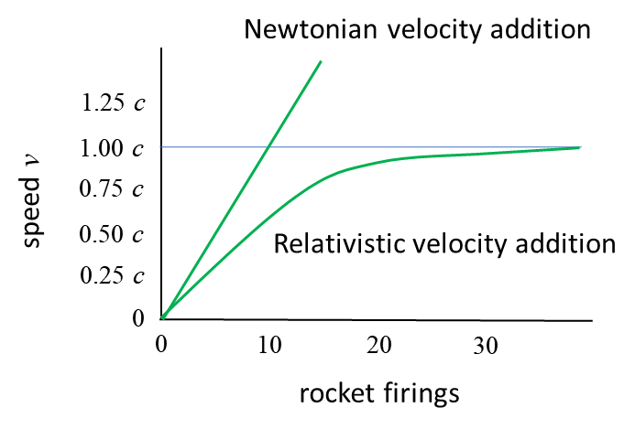

Fig. 1. Classically, a spaceship gets faster and faster as each time the rocket fires, momentum is added to the rocket. The correct, relativistic result is that the speed of the spaceship approaches the speed of light limit after an infinite number of rocket firings.

Consider the elastic [1D] collision of two objects. Using Newton mechanics principles of conservation of momentum and kinetic energy, the following equations can be derived.



Let 

then 

Exercise: check the numerical results.

Everything seems OK.

[Elastic Collisions](https://www.boundless.com/physics/textbooks/boundless-physics-textbook/linear-momentum-and-collisions-7/collisions-70/elastic-collisions-in-one-dimension-298-6220/)

But, what are the results if the speeds are much greater?

Let 

then 

Our numerical values are now incorrect, since the speed after the collision of object B is greater than the speed of light. We can’t abandon the principle of conservation of linear momentum. So, we need to change our definition of linear momentum. It can be shown that the correct relativistic definition for the momentum is

(1) 

As the speed *v* approaches the speed of light *c,* the relativistic momentum becomes significantly larger than the classical momentum, eventually diverging to infinity. For low speeds, the relativistic momentum and classical momentum agree.

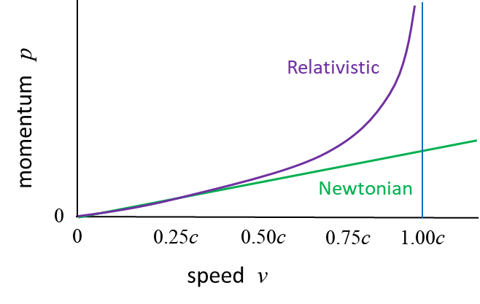

Fig. 2. Classically (Newtonian Mechanics) the momentum increases in proportion to the speed. The correct relativistic momentum increases to infinity as the speed approaches the speed of light.

Equation 1 is often thought of in terms of mass increase with speed. For example, assume that an object has a mass *m*0 (rest mass) when it is at rest. Then, the relativistic mass *m* of the object is



(2) 

The classical expression for momentum  can be used for all speeds if we simply interpret equation 2 as the mass of the object increasing with speed. The relativistic mass *m* approaches infinity as the velocity *v* approaches the speed of light *c.* Hence, a constant force acting on the object generates less and less acceleration , as the speed of light is approached. This is another example of seeing that the speed of light cannot be exceeded.

Today, most research physicists prefer to keep the mass *m* of an object as an invariant (constant) quantity. The **mass** of an object is taken as an intrinsic property of the object and is now considered an **absolute quantity**. In this model, with the mass as an invariant quantity, you do not need to refer to the terms rest mass and relativistic mass. So, it is better to use equation 1, the relativistic expression for momentum and not use equation 2, instead take *m* as a constant.

**RELATIVISTIC ENERGY**

**Einstein’s famous equation** is always written as



Using the model that mass is an absolute quantity, you need to be extra careful in giving the correct interpretation of Einstein’s famous equation .

Consider an object of mass *m* (*m* = constant) which is at rest in an inertial frame of reference. Then the object at rest possess energy by virtue of its mass. This energy called its **rest energy** *E*0*.*

(3)  rest energy

For an object of mass *m* in the inertial frame of reference, that has a speed *v,* then its **total energy** *E* is given by

(4) 

where *K* is the **kinetic energy** of the moving object in its inertial frame of reference. The total energy *E* in this context is simply the sum of the object’s kinetic energy *K* and its rest energy *E*0*.*

The kinetic energy K of the object can be expressed as

 kinetic energy

If , the it can be shown that the classical equation for the kinetic energy is valid

 kinetic energy 

Linear momentum is a more fundamental concept than kinetic energy. There is no conservation law of kinetic energy, whereas the law of conservation of linear momentum is inviolate as far as we know. A more important and fundamental equation for the total energy is

(5)  **total energy**

Certain particles are massless  such as the photon.

(6)  total energy of a photon

or, the linear momentum of a photon is

(7)  linear momentum photon

The energy of a photon is completely due to its motion, and not at all to its rest energy .

For a particle that has zero mass , then it must move at the speed of light *c.* Thus, photons propagate through space at the speed of light *c.*

|  |
| --- |
| **Exercise 1**  Show that a particle of zero mass propagates at the speed of light.  **Solution** |

**Equivalence of mass and energy**

The equation

(3)  rest energy

is one of the most famous equations in physics. Even when an object has zero velocity (zero kinetic energy), the object still has energy through its mass. Nuclear reactions are proof that mass and energy are equivalent.

In classical physics, we had the laws of conservation of mass and conservation of energy. We must modify these laws as mass and energy are connected. These two laws are combined into a single law, the **law of conservation of mass-energy**.

Even though we often say “energy is turned into mass” or “mass is converted to energy” or “mass and energy are interchangeable”, you must understand that what we mean is that **mass** and **energy** are actually **equivalen**t. Mass is simply another form of energy, and we can use the terms mass-energy and energy interchangeably.

|  |
| --- |
| **Exercise 2**  When you compress a spring between your fingers, does the mass of the spring (a) increase, (b) stay the same, or (c) decrease. Justify your answer.  **Solution**    When the spring is compressed by an amount *s,* the potential energy is increased by . Since the energy of the spring has increased, its mass must also increase by the amount . This increase in mass is too small to be measured. Check this statement by putting in some numbers.  **This is a very strange result**. The mass of the particles that constitute the spring (electrons, protons, neutrons) do not increase. The increase in mass of the spring is simply due to the increase in the energy due to the increase in energy associated with the interaction of the particles that make the spring. This reasoning is explained in the following example.  Consider two blocks, each of mass *m* (*m* is an invariant quantity) and kinetic energy *K* moving towards each other. A spring placed between them is compressed and locked into place after they collide. We can investigate the elastic collision by applying the law of conservation of mass-energy.    The energy before the collision is    The energy after the elastic collision    where *M* is the mass of the system of two block and spring joined together.  Applying the law of conservation of mass-energy    The new mass *M* is greater than the sum of the individual masses of the two blocks . The kinetic energy went into compressing the spring, so the potential energy increased.  So, kinetic energy has been converted into mass, the result being that the potential energy of the spring has caused the system to have more mass. The increase in mass is    The fractional increase in mass in this example is very small    If we take *m* = 0.1 kg and *v* = 10 m.s-1, and putting in the numbers  too small to measure  It is OK to use the classical equation for the kinetic energy since .  This example shows that the increase in mass for macroscopic systems is so small that the mass increase can be neglected. However, this is not true for nuclear systems. |

|  |
| --- |
| **Exercise 3 Combustion of petrol**  A car burns petrol to make a car move. In a journey a car used 100 L of petrol. What is the decrease in mass of the petrol consumed?  Every 1 kg of petrol used releases an energy of 43.6 kJ  Density of petrol is 750 kg.m-3  **Solution**  1st step is find the **mass** of petrol used:  1000 L = 1 m3 100 L = 0.1 m3  1 m3  750 kg 0.1 m3 = 75 kg  2nd step is find the **energy released**  1 kg  43.6x103 J 75 kg  3.27x106 J  3rd step is to find the **decrease in mass** of the petrol    You would need a good balance to measure the change in mass of the petrol resulting from the combustion of petrol with oxygen. So, it is not possible to measure any change in mass that occur in chemical reactions. However, this is not the case for nuclear reactions. |
| **Exercise 3 Production of energy by the Sun**  The rate at which energy reaches the Earth's surface from the Sun, is called the **Solar Constant**. It value is approximately equal to 1388 W.m-2. Use the values of the Solar Constant and the distance between the Earth and Sun to estimate the rate at which energy is emitted by the Sun and the corresponding decrease in the Sun’s mass.      **Image result for image Sun**  **Solution**  Assume that the Sun radiates uniformly in all direction. The energy emitted from the Sun passes through a spherical surface area *A* of radius  (the distance of the Earth from the Sun)    The rate *P* at which the energy passes this spherical surface is    Therefore, the rate at which energy is radiated from the Sun is    The corresponding rate of decrease in mass of the Sun is    The loss in mass of the Sun is equivalent to three times the mass of the Queen Mary every second.    The Sun loses a rather a large amount of energy each second. Since the mass of the Sun is 1.99x1030 kg, the loss in mass each year is small. Even after 1.5x109 years (1.5 billion years), radiating at its present rate, the Sun would lose a mere 0.01% of its mass. The Sun will not evaporate away in our lifetime. |

**Matter and Antimatter**

**Particle-Antiparticle interactions**

A particularly interesting feature of the equivalence of mass and energy is the existence of antimatter. For each charged particle that exists in nature, there is its corresponding antiparticle which has exactly the same mass but opposite charge. For example, the antiparticle for an electron (e-) is a positron (e+).

Antimatter is frequently created in particle accelerators, where particles collide at speeds approaching the speed of light.

When an electron (e-) and a positron (e+) meet, they annihilate converting their mass into energy in the form of gamma rays (γ)

**Electron – positron annihilation**

e- + e+ → γ + γ energy of gamma rays = 2*me**c*2 = 1.02 MeV

Both energy and charge are conserved in the reaction. In matter-antimatter annihilation, the particles vanish in a burst of radiation. A 1.02 MeV gamma ray can produce an electron/ positron pair in a process known as **pair production**.

γ → e- + e+

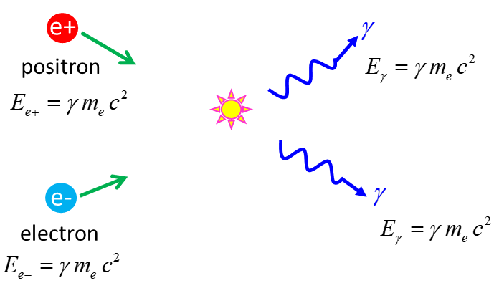

Fig. 3. The particle / antiparticle annihilate each other generating two high energy gamma ray photons. Both energy and mometum are conserved in the annihilation process. The kinetic energy and the rest energy of the electron and positron are converted into the energy of the zero mass photons.

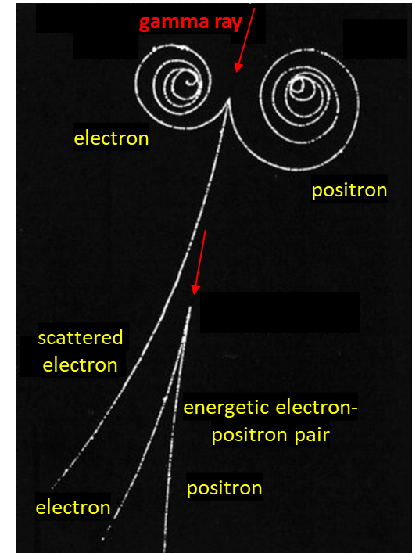

Fig. 4. Cloud chamber tracks: Pair production. From the charged particle tracks, what can you conclude about the magnetic field of the cloud chamber?

Electron-positron annihilation is the basis for the diagnostic technique called **positron-electron tomography** (**PET**). PET scanning is used to examine biological processes in the body. In a PET scan of the brain, a patient is injected with glucose that has been tagged with radioactive traces. These radioactive traces emit positrons in a nuclear reaction. These positrons collide with electrons in the brain and undergo annihilation. The two gamma rays emitted are detected by the instrumentation surrounding the patient. The recordings are analysed by a computer to produce coloured images showing the glucose metabolism levels within the brain.

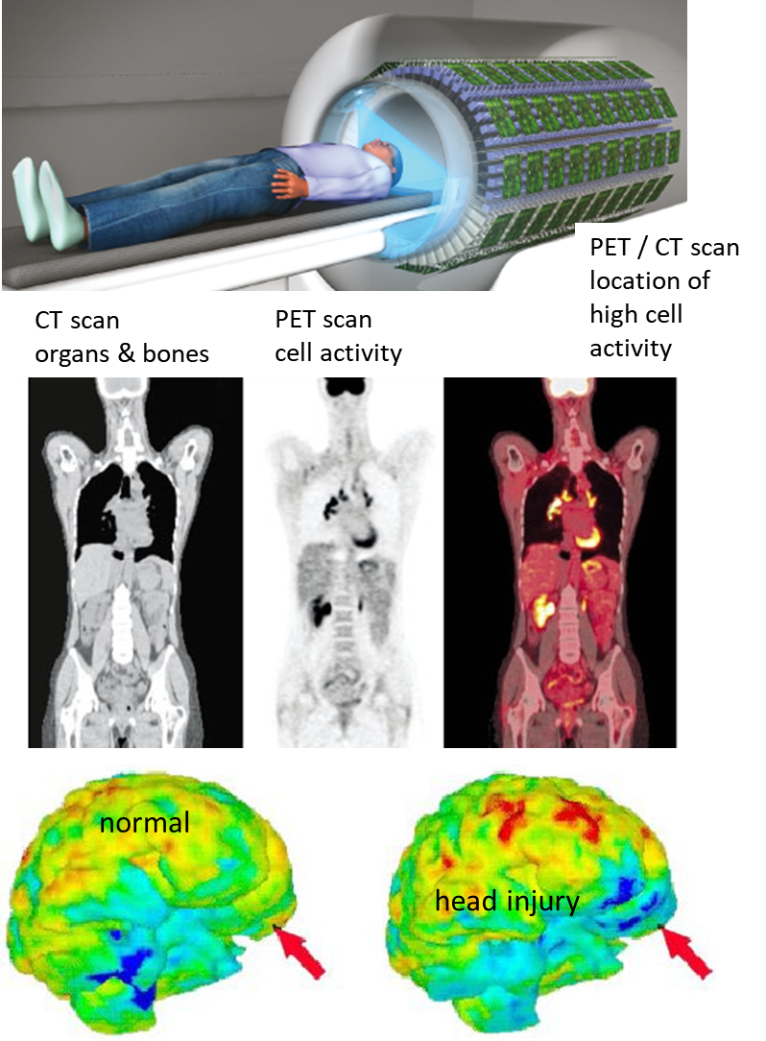

Fig. 5. PET scanning. The powerful diagnostic tools of PET scanning rely on the annihilation of matter and antimatter in a person’s brain.

**Nuclear Reactions**

In a nuclear **fusion** reaction, the light elements combine to produce heavy elements. The mass of the products is greater than the mass of the reactants. The mass difference Δ*m* is converted into kinetic energy of the products Δ*mc*2. This is the processes for creating the energy in the Sun and stars.

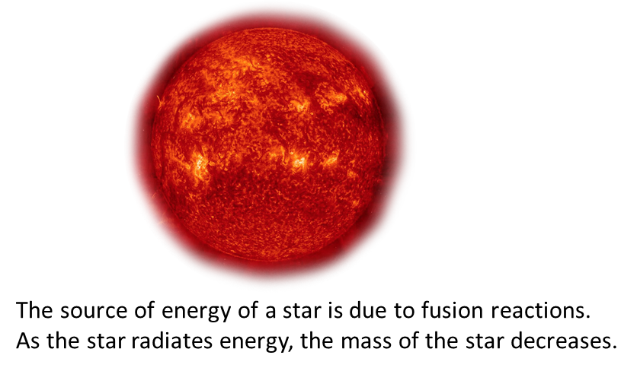

In nuclear reactions, heavy elements split into lighter ones in a process called **fission**. Again, there is a mass difference which appears as kinetic energy of the products. This is how energy is released in nuclear power reactors and in atomic bombs.

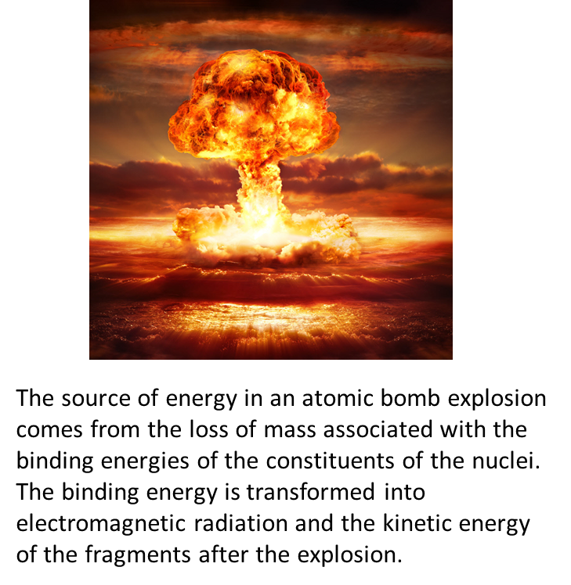

The equivalence of mass and energy is obvious when you study the binding energies of nuclei that are formed from individual particles. For example, a deuteron nucleus is a proton and a neutron bound together by the strong nuclear force. The potential energy associated with this force keeping the system together is called the **binding energy** *EB.* The binding energy is the work required to separate the particles in the bound system resulting in free particles at rest.

The mass of a proton plus the mass of a neutron is greater than the mass a deuteron.

Where is the missing mass?

We can model the binding force (strong nuclear force) between the proton and neutron in a deuteron nucleus as a compressed spring. The stored potential energy of the compressed spring accounts for the binding energy and the missing mass (mass defect).

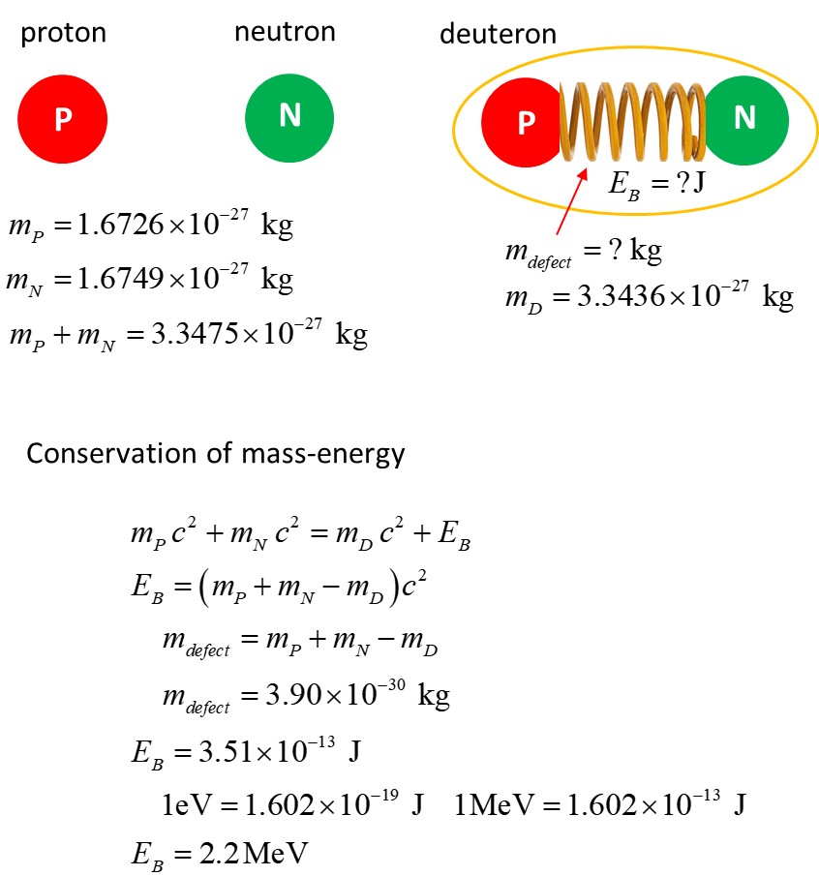

For the hydrogen atom, the binding energy of the proton and electron is 13.6 eV. So, binding energies associated with nuclear reactions are millions of times greater than the energies involved in chemical reactions. The binding energy of a deuteron represents a reasonable fraction of the rest energy and this fact is extremely important. The binding energies of heavy nuclei like uranium can be more than 1000 MeV, and even that much energy is not large enough to prevent uranium from slowly decaying to less massive nuclei. The coulomb repulsion between the many protons of the heavy nuclei is mainly responsible for the decay of the heavy elements.

[Watch video on Mass, Momentum and Energy](https://www.youtube.com/watch?v=Xo232kyTsO0)

[VISUAL PHYSICS ONLINE](http://www.physics.usyd.edu.au/teach_res/hsp/sp/spHome.htm)

If you have any feedback, comments, suggestions or corrections please email:

Ian Cooper School of Physics University of Sydney

ian.cooper@sydney.edu.au