[**VISUAL PHYSICS ONLINE**](http://www.physics.usyd.edu.au/teach_res/hsp/sp/spHome.htm)



**LIGHT and SPECIAL RELATIVITY**

**EXPERIMENTAL VERIFICATION**

**MUON DECAY**

**Experimental evidence for time dilation and length contraction**

**Does Einstein's theory of special relativity accurately describe the motion of objects traveling close to the speed of light?**

The theory of Special Relativity has made many astonishing predictions. Einstein did not receive his Noble Prize for his Theory of Special Relativity but for a more minor contribution to our understanding science – the Photoelectric Effect. Scientist at the time, were uncertain of Einstein’s predictions – they were so inconceivable and so against long-held believes. For more than a century, experiments have been carried out to test Einstein’s theories. So far, all experimental evidence has been confirmed the predictions of special relativity and general relativity.

**Muons** are unstable particles with a rest mass of 207 times that of an electron and a charge of ±1.6x10-19 C. Muons decay into electrons or positrons with an average lifetime of 2.2 μs as measured in their inertial frame of reference.

When high energy particles called **cosmic rays** (such as protons) enter the atmosphere from outer space, they interact with air molecules in the upper atmosphere creating a cosmic ray shower of particles including muons that reach the Earth’s surface. The muons created in these cosmic ray showers travel at 0.98*c* w.r.t to the Earth.

**Newtonian (classical) point of view**

Speed of muons

*v* = 0.98*c* = (0.98)(3.0x108) m.s-1 = 2.94x108 m.s-1

Average lifetime of muons (proper time)

*t*0 = 2.2 μs = 2.2x10-6 s

Average distance travelled by muon before decaying

*L*0 = *v t*0 = (2.94x108)(2.2x10-6) m = 650 m

Hence, from a Newtonian point of view, muons would not be able to reach the Earth’s surface from the upper atmosphere where they are produced.

However, experiments show that a large number of muons do reach the Earth’s surface in cosmic ray showers.

**Special relativity point of view**

Height above Earth’s surface muon produced

*L*0 = 100 km = 1.0x105 m (proper length)

From point of view of muons the distance to the Earth’s surface is contracted to a shorter length *L*



This contracted distance is much less and so many muons will be able to reach the Earth’s surface.

From an observer viewing the muon approaching, time intervals for moving “clock” will be dilated.

Average lifetime of muons (proper time)

*t*0 = 2.2 μs = 2.2x10-6 s

Dilated average lifetime w.r.t. Earth observer *t* = ? s



Average distance travelled by muons



Average distance is now short enough so that many muons will reach the Earth’s surface.

**Another look at muon decay**

The decay of muon can be accurately described by the radioactive decay law



where and  are the number of detected muons at times  and time *t* respectively. is the half-life (time for the number of muons detected to halve) and  is the decay constant. The measured half-life and decay constant for muons at rest in the laboratory are



An experiment was performed by placing a Geiger counter to detect muons on the top of a mountain 2000 m high. The muons are assumed to be moving at a speed equal to 0.98c. In a time interval *T* the Geiger counted 1000 muons. The Geiger counter was moved to the bottom of the mountain, 2000 m below the peak. In the same time interval T, the Geiger counter registered 540 muons. these are the muons that survived the trip without decaying.

Classically, we can calculate the number of muons surviving the trip.

distance travelled by muons 

speed of muons 

time interval for trip 

Number of surviving muons





So, only 45 muons should survive the trip. Something is wrong !!!

Our classical theory predicts 45 muons, but measurements record 540 muons. The problem must be approached using special relativity. The muons are moving at a speed of 0.98c w.r.t the Earth. so, we must take into account the time dilation effect.



The Earth based clock records a time interval of 6.80x10-6 s for the muon to travel from the top to the bottom of the mountain.



The Earth based observes see the muon’s “moving clock” record the proper time 



In the muon’s rest frame, the decay of the muon is given the radioactive decay law is





The number of muons surviving the trip is 538, which is in agreement with observations. An experiment like this was performed by B. Rossi and D. Hall in 1941 at Mount Washington, New Hampshire, U.S.A. Their results agreed with the predictions of special relativity and not the predictions of classical physics.

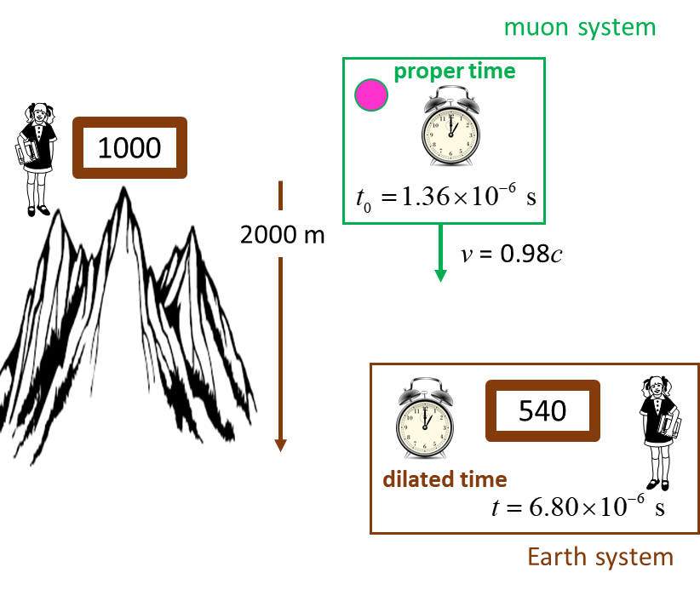

Fig. 1. The number of muons detected at the top of the mountain is 1000 whereas at the bottom of the mountain only 540 survived without decaying. The experimental result agrees with our time dilation equation.

[VISUAL PHYSICS ONLINE](http://www.physics.usyd.edu.au/teach_res/hsp/sp/spHome.htm)

If you have any feedback, comments, suggestions or corrections please email:

Ian Cooper School of Physics University of Sydney

ian.cooper@sydney.edu.au