[**VISUAL PHYSICS ONLINE**](http://www.physics.usyd.edu.au/teach_res/hsp/sp/spHome.htm)



**LIGHT and SPECIAL RELATIVITY**

**EXPERIMENTAL VERIFICATION**

**NUCLEAR REACTIONS**

The energy released in nuclear reactions can be predicted form the theory of special relativity and the predictions agree

extremely well with measured values.

As an example, we will consider the emission of an alpha particle (helium nucleus) from a heavy nucleus of thorium where the parent nucleus is unstable and spontaneous explodes tearing the whole atom into two pieces.



The reaction is analogous to two blocks being held together by a spring and then released, resulting in the two blocks flying away from each other.

In the nuclear reaction, the repulsive force is the electrostatic force of repulsion between the two positive offspring nuclei. The spring holding them together is the strong nuclear force which is not quite strong enough to hold the parent nucleus together permanently.

atomic mass unit amu 1 u = 1.66x10-27 kg

mass thorium nucleus 

mass helium nucleus 

mass radium nucleus 

mass (Ra + He) 

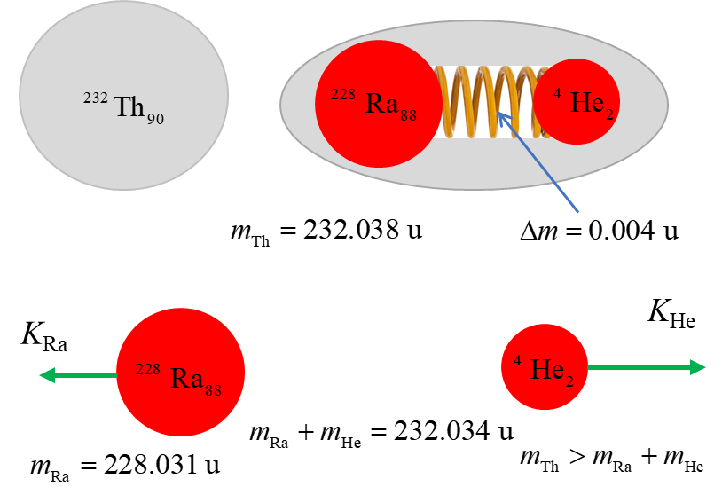



mass defect 

The mass of the thorium nucleus is greater than the constituent nuclei of radium and the alpha particle.

Where is the missing mass?

Mass and energy are equivalent and mass-energy must be conserved. The missing mass called the mass defect is the energy (mass) stored in potential energy bonding the nucleus of together.

When the decay occurs, the stored potential energy is converted into the kinetic energy of the daughter (offspring) nuclei.

mass defect 

binding energy 

kinetic energy of daughter nuclei



Putting in the numbers



In the decay the radium nucleus is much more massive than the helium nucleus, therefore, most of the kinetic energy will be possessed by the alpha particle. The measured value of the energy of the alpha particle from 232-thorium is about 4 MeV. This is another example, of the excellent agreement between the predictions of special relativity and laboratory measurements.

|  |
| --- |
| **Exercise 1**  Image that you are given the task of producing a 10 minute video clip for YouTube as an introductory lesson on special relativity. Make a list of the concepts that you would introduce. What images and animations would you include? Watch Vdeo 1: Theory of relativity explained in 7 mins How does your production compare with the LondonCityGirl video?  The audio has a few errors in the physics. What were the errors?  The discussion on mass is incorrect. Why? How would you change the video to give a better model of mass, momentum and energy?  [Watch Video 2: Special Relativity: Crash Course Physics #42](https://www.youtube.com/watch?v=AInCqm5nCzw)  [Watch Video 3: Professor Dave Explains](https://www.youtube.com/watch?v=iIEeSiT3SI4)  Which video is best (1) or (2) or (3)?  Justify your answer. |

[VISUAL PHYSICS ONLINE](http://www.physics.usyd.edu.au/teach_res/hsp/sp/spHome.htm)

If you have any feedback, comments, suggestions or corrections please email:

Ian Cooper School of Physics University of Sydney

ian.cooper@sydney.edu.au