[**VISUAL PHYSICS ONLINE**](http://www.physics.usyd.edu.au/teach_res/hsp/sp/spHome.htm)

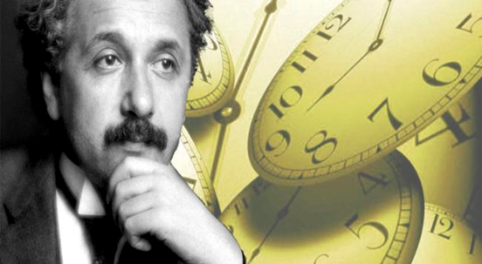

**LIGHT and SPECIAL RELATIVITY**

**EXPERIMENTAL VERIFICATION**

**PARTICLE ACCLERATORS**

Particle accelerators routinely create beams of particles traveling at nearly the speed of light. Without Einstein's theory of special relativity, they simply wouldn't work.

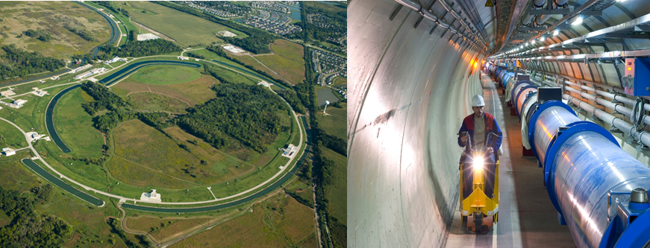

Einstein’s special relativity theory can be tested using the measurements gained from particle accelerator where very high velocities are commonplace.

The Tevatron accelerator, the LHC (Large Hadron Collider) and many other accelerators around the world provide excellent evidence that the counterintuitive ideas of Special Relativity are accurate.

|  |
| --- |
| **Exercise 1**  A pi meson (meson or pion) is an unstable particle formed in large numbers in nuclear reactions occurring in particle accelerators.  Image result for images pi meson decay  It has a mass of about 270 times larger than an electron’s mass and has the same charge as an electron. When many of these particles are observed at rest in the laboratory, it is found that they disintegrate to form other particles. After a time interval of 2x10-8 s, half the original number of pions have decayed (disintegrated). This time interval is called the **half-life**. When pions are used in particle accelerators, they can reach speeds of 0.98c. How long will it take according to laboratory clocks, for half these high-speed pions to decay?  **Solution**  Little is known about the process in which pions decay. However, the decay must be dependent upon the rate of decay. These processes act as a clock, and the “clock” moves with the pions. As seen from the laboratory frame (fixed frame), the pion clock will be running slow as described by the time dilation effect.  In the laboratory frame (fixed system), when the pions are rest, the proper time interval is *t*0= 2x10-8 s  The observer in the laboratory frame observing the decay process when the pions are moving will measure the dilated time interval *t* = ? s  Velocity of moving system (pion frame) *v* = 0.98 c  Time dilation effect      Since the pions decay because of their own internal processes, their “clock” must read 2x10-8 s when half have decayed. But, when moving, the time interval measured in the laboratory for half of the pions to decay is 5 times longer, 10x10-8 s.  Measurements such as those indicated in this example have been carried out at particle accelerators for decades, and the predictions of special relativity have always been confirmed by actual measurements. |

Prior to the shutdown of the Tevatron in 2011, the Fermilab accelerator complex consisted of five accelerators. Each accelerator added some energy to a proton until it reached the Tevatron's maximum energy of 1012 eV and at that energy, the proton travels with a velocity 0.9999995 *c* (a proton traveling at this speed could circle the Earth's equator almost eight times in a single second). The maximum energies and corresponding observed velocities of the protons for the five accelerators are displayed in the table below. When protons leave the Booster, they are traveling at very nearly the speed of light. Yet when they were in the Tevatron, which provided 125 times more energy, their velocity was only a tiny bit faster. Even the LHC (Large Hadron Collider), with a maximum energy seven times higher than that of the Tevatron, only makes protons move an itty-bitty bit faster than the Tevatron.

|  |  |  |
| --- | --- | --- |
| Accelerator | Energy (eV) | v / c % |
| 1 Cockcroft-Walton | 7.50x105 | 4 |
| 2 Linac | 4.00x108 | 71 |
| 3 Booster | 8.0x109 | 99.4 |
| 4 Main Injector | 1.20x1011 | 99.997 |
| 5 Tevatron | 1.00x1012 | 99.99995 |
| LHC (Large Hadron Collider) | 7.00x1012 | 99.9999991 |

These measurements demonstrate that the velocities of particles with mass, do not exceed the speed of light, no matter how much energy we give them. This upholds the theory of special relativity, which says that nothing exceeds the speed of light.

Reference

<http://www.fnal.gov/pub/today/archive/archive_2014/today14-04-04_NutshellReadMore.html>

Special Relativity also says that energy and mass are essentially equivalent. The phenomenon of gaining higher velocities by adding energy to a particle is often explained as "mass increases as things go faster." I admit I have uttered those words myself, but the statement is actually wrong and so can be misleading.

For instance, some people hear the words "mass increases" and think that particles are getting heavier in the gravitational sense. In fact, it is more accurate to say that inertia increases as velocity increases. At low velocities, or nonrelativistic velocities, it is perfectly reasonable to equate inertia and mass. This is the reason even scientists sometimes say that mass changes with velocity. They use the phrase "relativistic mass" to label this fallacious idea of increasing mass.

In fact, there is only one mass, and that is what is often called "rest mass," which is the mass of an object when it is not moving. Even though the idea of relativistic mass is, strictly speaking, not correct, it is a valuable mental picture and helps us get used to the fact that objects cannot exceed the speed of light.

So, if you prefer to think about relativistic mass, go ahead and do so without feeling guilty. Just realize that if you push the idea too hard, it will lead you astray.

Some relativity sceptics are aware that laboratories such as Fermilab and CERN have demonstrated that the speed of light is a limitation in particle accelerators. They have an (incorrect) explanation, and it goes like this: Particle accelerators use electric fields to impart a force on (say) a proton. These electric fields, which accelerators use to propel the protons, are composed of photons, according to the theory of quantum electrodynamics. Thus, they reason, particle accelerators shoot photons at protons, and if a proton travelled faster than a photon, it would no longer feel the photon's force. They claim this is the reason that protons can travel no faster than light.

This reasoning does not explain how the tiny difference in the proton's speed between the Fermilab Booster and the Tevatron results in the beam's energy increasing by 125 times. So, the explanation is wrong, but it is a common one. Be aware of it.

[VISUAL PHYSICS ONLINE](http://www.physics.usyd.edu.au/teach_res/hsp/sp/spHome.htm)

If you have any feedback, comments, suggestions or corrections please email:

Ian Cooper School of Physics University of Sydney

ian.cooper@sydney.edu.au