[**VISUAL PHYSICS ONLINE**](http://www.physics.usyd.edu.au/teach_res/hsp/sp/spHome.htm)

**MODULE 7 NATURE OF LIGHT**

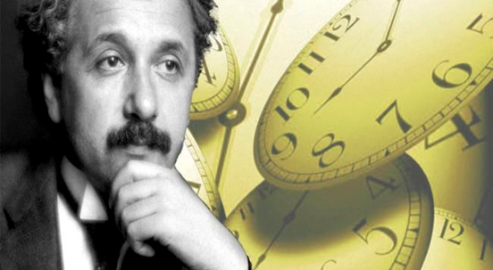

**LIGHT and SPECIAL RELATIVITY**

**TIME DILATION**

|  |
| --- |
| **Time is a relative quantity**: different observers can measurement different time intervals between the occurrence of two events. This arises because the **speed of light is a constant and independent of the motion of the source of light or the motion of an observer**.  Image result for images time dilation effect  **Moving clocks run slow**  **Time Dilation Effect**  The time interval of an event occurring at the same point in space w.r.t. an inertial reference frame as measured by a clock at rest in this reference frame is called the **proper time *t*0**.  **Dilated time interval *t*** – time interval of the event occurring in a moving inertia reference frame as measured by a stationary observer in their inertial reference frame.  since  **Twin paradox**: The twin who goes on a return space journey will return younger than the twin who stayed on Earth. |

**RELATIVE TIME: TIME DILATION**

In the Theory of Special Relativity, **time dilation** is the actual difference of elapsed time between two events as measured by observers in inertial frames of reference that are in relative motion. We assume that there are no gravitational effects because from the theory of General relativity, clocks run slow in stronger gravitational fields. This gravitational effect on time intervals must be taken into account for GPS satellite systems. Clocks on the ground run slower than clocks on board the GPS satellites.



<http://en.wikipedia.org/wiki/Time_dilation>

Concise Oxford Dictionary: dilate

make or become wider or larger; expand; widen; enlarge

The time interval for an event depends upon the relative motion between the location of the of the event and the location of an observer. Different observers may measure different time intervals. A time interval is a relative quantity and not an absolute quantity. This effect arises neither from technical aspects of the clocks nor from the fact that signals need time to propagate, but from the nature of **space - time** itself.

Consider two inertial frames of reference. Steve’s system is chosen as the fixed reference frame and Mary’s system as moving along the X axis with constant velocity *v* as shown in figure 1. In Mary’s system, a light globe is switch on and the light travels from the floor to the ceiling to activate and switch on a photodetector. The time interval of the event of the light travelling from the globe to the photodetector is measured by Mary’s clock (*t0*) in Mary’s system and by Steve’s clock (*t*) in Steve’s system. Mary records the **proper time interval** for the event since her clock and the event occur at a fixed position in her system.

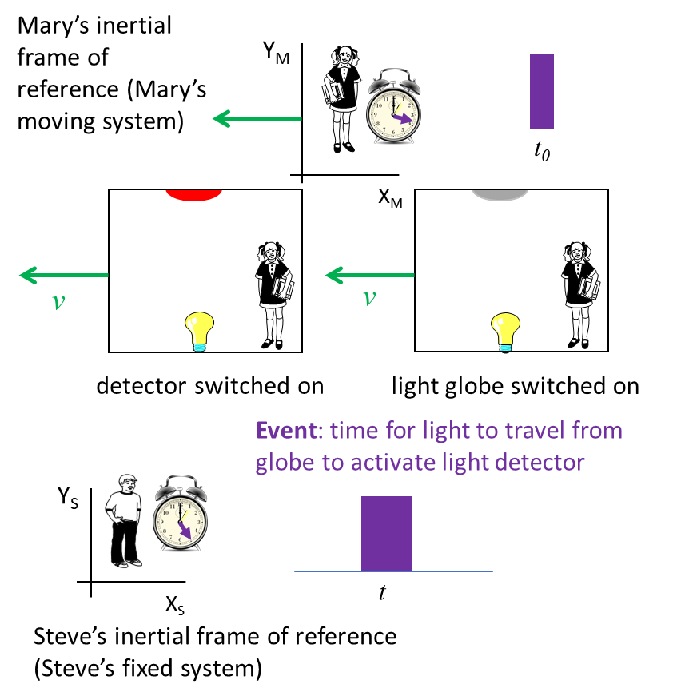

Fig. 1. Frames of reference.

We use Einstein’s postulate that the speed of light is constant for all observers. Using figure 2, we can calculate the time interval *t*0 for the event (light to travel from floor to ceiling, a vertical distance *y*) in Mary’s system and the time interval *t* in Steve’s system.

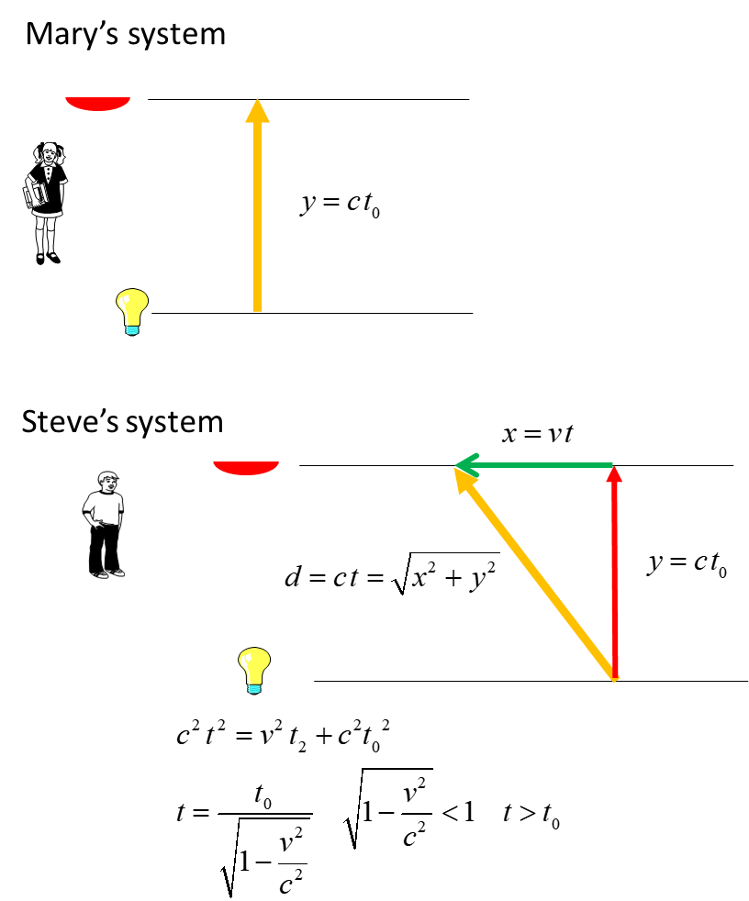

Fig.2. The time intervals for the event of the light travelling from the floor to the ceiling in Mary’s and Steve’s systems. The **orange arrows** show the path of the light in the two systems.

The **proper time** is always the smallest time interval. The proper time is always the time interval for an event that occurs at the **same location**. The time interval  measured in the fixed system is called the dilated time and the event is observed to occur at different locations.

This phenomenon is known as the **Time Dilation Effect** and is given by equation (1)

(1) 

**Time is a relative quantity**

* Different observers can measurement different time intervals for an event.
* This arises because the **speed of light is a constant and independent of the motion of the source of light or the motion of an observer**.

An observer watching a moving clock sees the passage of time on the moving clock to be slower than the passage of time on their own clock.

Time intervals are not absolute. This is a violation of a fundamental concepts in Newtonian physics (time is an absolute quantity).

**What does it mean that moving clocks run slow and *t* > *t*0?**

The moving clock is seen to “tick” more slowly than the identical clock at rest. The moving clock has a greater time interval between its ticks than the clock that is at rets, a moving clock runs slow. This is the **time dilation** effect.



Fig. 3. Time dilation term γ (gamma) varies with the ratio *v*/*c* where



The moving clock can be any kind of clock. It can be the time for sand to move through an hour glass, the time for a light to be switched on, the time between heartbeats or the time between ticks of a clock.

We could repeat the calculation can take Mary’s system as fixed Steve’s as the moving system and Mary would conclude that Steve’s clock is running slow. Because of the symmetry, each person can claim the clock in the other (moving) system is running slow

The time dilation effect must be taken into account in **GPS** since the communication satellites involved are moving with respect to each to other with relative speeds varying from 0 to 15.8km.s-1. These speeds are extremely small compared to the speed of light. However, for accurate position determinations, the small corrections due to the time dilation effect must be used.

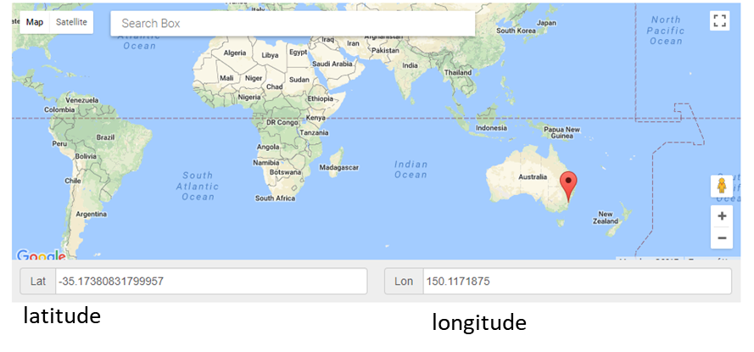

Using GPS to give the latitude and longitude of a location.

|  |
| --- |
| **Example 1**  Consider two trains with velocities *v*1 = 0.10*c* and *v*2 = 0.90*c* w.r.t. a stationary frame of reference. In the stationary frame of reference, the duration of an event was 1.00 s. What would be the duration of the event as measured by clocks on the trains?  **Solution**  How to approach the problem (ISEE)  Type of problem: special relativity / time dilation  Draw an annotated diagram – need to identify the systems and the frame system in which the proper time interval is measured. Note: it is not always easily to distinguish the system for the proper time or dilated time.  Knowledge: moving clocks run slow    Let the inertial reference frames be identify as Steve’s system, Mary’s system and Eve’s system. The event occurs in Steve’s system, so, the proper time interval is *t*0= 1.00 s. This event is observed by Mary and Eve in their systems. So, Mary and Eve become the fixed system and Steve’s system the moving system.    Proper time *t*0 = 1.00 s  Dilated time interval in Mary’s system is    Dilated time interval in Eve’s system is    The dilated time interval in Mary’s system (*t*1 = 1.005 s) is only slightly greater than the proper time (t0 = 1.00 s). However, the dilated time interval in Eve’s system (*t*2 = 2.29 s) is significantly larger than the proper time interval.  It is essential that you understand that this is not an illusion. It makes no sense to ask which of these times is the “real” time. Since no preferred reference frame exists all times are as real as each other. They are the real times seen for the event by the respective observers.  Time dilation tells us that a moving clock runs slower than a clock at rest by a factor of .  This result, however, can be generalised beyond clocks to include all physical, biological and chemical processes. The Theory of Special Relativity predicts that all such processes occurring in a moving frame will slow down relative to a stationary clock. |

|  |
| --- |
| **Example 2**  A day on Earth has 24.00 hours. How fast must a rocket travel so that the rocket’s clock measures a time interval of 23.00 hours?  **Solution**  How to approach the problem (ISEE)  Type of problem: special relativity / time dilation  Knowledge: moving clocks run slow    Data: proper time *t*0 = 23.00 h  Observing moving clock *t* = 24.00 h  Speed of moving clock *v* = ? *c*  Execute: (substitute numbers into formula for time dilation)    *v* = 0.29*c* |

**TWIN PARADOX**

The **Twin Paradox** is another example of a thought experiment in relativity. Consider two twins. Twin A takes a trip in a rocket ship at speed *v* relative to the Earth to a distant point in space and then returns, again at the speed *v*. Twin B remains on Earth the whole time. According to Twin B, the travelling twin will have aged less, since his clock would have been running slowly relative to Twin B’s clock and would therefore have recorded less time than Twin B’s clock. However, since no preferred reference frame exists, Twin A would say that it is he who is at rest and that the Earth twin travels away from him and then returns. Hence, Twin A will predict that time will pass more slowly on Earth, and hence the Earth twin will be the younger one when they are re-united. Since they both cannot be right, we have a paradox.

To resolve the paradox, we need to realise that it arises because we assume that the twins’ situations are symmetrical and interchangeable. On closer examination, we find that this assumption is not correct. The results of Special Relativity can only be applied by observers in inertial reference frames. Since the Earth is considered an inertial reference frame, the prediction of Twin B should be reliable. Twin A is only in an inertial frame whilst travelling at constant velocity *v*. During the intervals when the rocket ship accelerates, to speed up or slow down, the reference frame of Twin A is non-inertial. The predictions of the travelling twin based on Special Relativity during these acceleration periods will be incorrect. General Relativity can be used to treat the periods of accelerated motion. When this is done, it is found that the travelling twin is indeed the younger one. Note that the only way to tell whose clock has been running slowly is to bring both clocks back together, at rest on Earth. It is then found that it is the observer who goes on the round trip whose clock has slowed down relative to the clock of the observer who stayed at home. This has been confirmed by aircraft carrying clock’s around the Earth.



|  |
| --- |
| **Example 3**  Astronaut Mary travels from Earth to Vega (5th brightest star in the night sky), leaving her 30 year old twin brother Steve behind. Mary travels with a speed 0.990*c* and Vega is 25.3 light-years from Earth (1 light-year is the distance travelled by light in one year). At the end of the journey by Mary, what is the age of the twins?  During the journey through space, Mary’s pulse rate was monitored. Mary’s heart rate recorded on her monitor was 60 beats.min-1. What heart rate was recorded on Steve’s monitor?  **Solution**  Think How to approach the problem  Visualise the physical situation  Annotated diagram (known and unknown quantities, frames of reference  Type of problem special relativity time dilation  Knowledge    The event is the journey of Mary in the space ship from the Earth to Vega. In Steve’s fixed frame, the Earth and Vega are stationary and Mary travels the distance  between the Earth and Vega at a speed *v*. The distance  is known as the proper length. So, the time interval *t* for the journey by Steve’s clock is    Mary is in the moving frame and her clock records the **proper time interval**    Thus, when Mary reaches Vega, she is only 33.6 years old, but Steve who was left behind on Earth is 55.6 years old.  From the point of view of Mary, the journey took 3.61 y at a speed of 0.990c. Mary concludes that the distance  from the Earth to Vega is    *L* is known as the **contracted length**.  Note: Steve and Mary disagree on time interval and length measurements – time and distance are a relative concept.  Steve’s fixed system *t*  = 25.6 y *L*0 = 25.3 ly  Mary’s moving system *t*0 = 3.61 y *L*  = 3.57 ly  Mary’s system  Heart rate  Time interval between pulses (proper time) *t*0 = 1 / *fm* = 1 s  Steve’s system  Dilated time  Heart rate  In a one minute interval, Steve’s heart pulses 60 times. However, according to Steve, Mary’s heart only beats about 8 times in the one minute interval. So, Mary is aging less quickly than Steve.  You need to understand that time dilation effect does not just means slowing down of a clock, everything else show down. When the time is "stretched" your heartbeat, your metabolism, your respiration all things slows down. |

Time dilation slows everything down literally everything (apart from light). All cellular processes slow down, rate of hair growth slows down, cell degeneration slows down, cell regeneration slows down and as a consequence ageing slows down.

Time intervals aren't absolute. Different observers genuinely experience different intervals of time, and there is no privileged observer that can claim to have experienced the actual amount of time something took.

[VISUAL PHYSICS ONLINE](http://www.physics.usyd.edu.au/teach_res/hsp/sp/spHome.htm)

If you have any feedback, comments, suggestions or corrections please email:

Ian Cooper School of Physics University of Sydney

ian.cooper@sydney.edu.au