[**VISUAL PHYSICS ONLINE**](http://www.physics.usyd.edu.au/teach_res/hsp/sp/spHome.htm)

**MODULE 7 NATURE OF LIGHT**

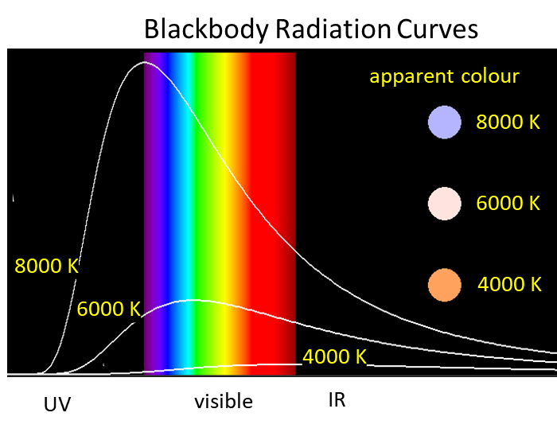

**Quantum Model**

**RADIATION FROM HOT BODIES**

[Review: Thermal Radiation](http://www.physics.usyd.edu.au/teach_res/hsp/sp/mod32/m32_radiation.pdf)

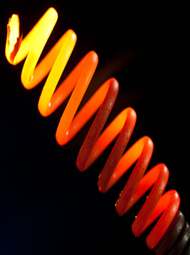For many centuries is had been known that when matter is heated it emits radiation. We feel the radiation emitted by a heating element as it warms up. When the heating element reaches about 500 oC its colour becomes dark red and changes to bright red around 700 oC. If the temperature was increased further, the colour would progressively change through orange, yellow, and finally white at a temperature close to 2500 oC.

A broad spectrum of wavelengths is emitted from an object when heated and this was of great interest to scientists of the 19th century. They measured the intensity of the radiation being emitted as a function of the material, temperature, and wavelength. They attempted to derive a mathematical model of the radiation emitted from hot objects. To do this, the starting point for physicists to develop a model is to consider the simplest or most idealized case of a problem for them to gain an insight that is needed before analysing more complex situations.

All objects simultaneously emit and absorb radiation. When an object’s temperature does not change with time, it is said to be in **thermal equilibrium** with its surroundings. Hence, the rate of emission must be equal to the rate of absorption of radiation so that its temperature remains constant. This implies that a good emitter of radiation must also be a good absorber of radiation. For thermal radiation, the simplest case to model is the radiation emitted and absorbed by a **blackbody**.

A **blackbody** has the ideal property that it absorbs all the radiation falling on it (zero reflection). The simplest way to construct a blackbody is to drill a small hole in the wall of a hollow container too create a cavity with a small opening to its surroundings. Any radiation entering the cavity through the small opening will be reflected around the cavity and then finally absorbed. If the blackbody is in thermal equilibrium, then it must also be an excellent emitter of radiation.

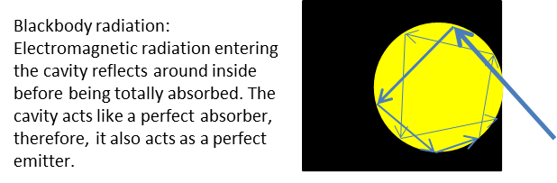

A blackbody is an object that completely absorbs all electromagnetic radiation falling on its surface at any temperature. It can be thought of as a perfect absorber and emitter of radiation. The radiation emitted from blackbodies was extensively investigated experimentally. These experimental results are best displayed in a graph called a **blackbody spectrum**.

The electromagnetic energy emitted from an object’s surface is called **thermal radiation** and is due to a decrease in the internal energy of the object. This radiation consists of a continuous spectrum of frequencies extending over a wide range. Objects at room temperature emit mainly infrared and it is not until the temperature reaches about 800 K and above that objects glows visibly.



Fig. 1. Spectral distribution of the radiation emitted from a blackbody for different temperatures [K].

Key features:

* There is a clear peak in the total power radiated per unit area per unit wavelength and the peak is located at smaller wavelengths for higher temperatures. This feature is summarized by the **Wien’s displacement law**



* The total power radiated increases with temperature, as described by the **Stefan-Boltzmann law**



Total power radiated from surface of object (thermal radiation) *Pradiated*  [watts W]

Stefan-Boltzmann constant *σ* = 5.6705x10-8 W.m-2.K4

Emissivity of the surface *ε* ≤ 1

Emissivity of a blackbody ε = 1 (perfect absorber and emitter)

Surface area of object *A*  [m2]

Surface temperature of object *T*

[measured in kelvin K: *T* K = 273.15 + *T* oC]

The Stefan-Boltzmann law equation can be applied to any material for which its emissivity is known. The emissivity of an idealized blackbody is *ε* = 1, otherwise 0 < *ε*  < 1.

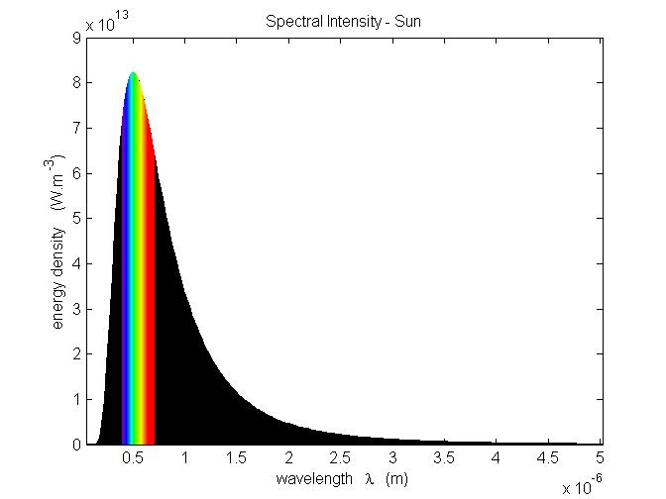

The **Sun** behaves as a blackbody with a surface temperature about 5800 K and peak wavelength of 500 nm [1nm = 10-9 m]. Only part of the radiation is in the visible portion of the electromagnetic spectrum.

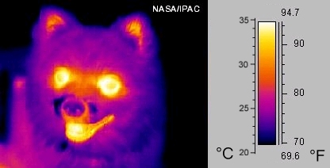

The hotter the surface, the shorter the wavelength and the greater the quantity of radiation emitted

There are thousands of practical uses of monitoring the radiation emitted from hot objects.



In the 1890’s, all attempts by the best scientists of the day failed to derive from basic principles, the shape of the spectral distribution for the radiation emitted from a blackbody. This was one of the most outstanding problems at the time and a real dilemma for physicists because it represented one of the few observations at the time that could not be explained in terms of classical physics. A prediction of a classical physics approach was that as the wavelength of the radiation became smaller and smaller, the amount of energy emitted became larger and larger leading to the conclusion:



Clearly something was wrong. This problem for small wavelengths became known as the ***ultraviolet catastrophe***.



In the late 1890s the German physicist, **Max Planck** (1858 – 1947) tried various functions of wavelength and temperature until he found a function that fitted the measurements of the spectral distribution for a blackbody at all wavelengths and temperatures. Planck assumed that radiation inside the cavity was emitted and absorbed by some type of oscillator contained in the cavity walls. He derived his Planck radiation law by making two important modifications to classical theory:



1. The oscillators for the absorption and emission of electromagnetic radiation can have only certain discrete energies determined by



Integer *n* = 1, 2, 3, …

Planck’s constant *h* = 6.6261x10‑34 J.s

Oscillation frequency *f*

1. The oscillators absorb or emit energy in discrete multiples of the fundamental quantum energy given by



Planck himself found the result that **energy was quantized** quite disturbing and spent several years trying to find a way to keep agreement with experiment while letting . Each attempt failed. Planck did not realize the significance of his findings. However, his contribution was an important step to the development of quantum physics, the theory that is now used to describe atoms, molecules and solids and has made possible the development of the computers and mobile phones we now use.

The wave nature of electromagnetic radiation is demonstrated by interference phenomena.



Interference from a double slit with blue light

From the contributions made by Planck and Einstein, to account for experimental findings, electromagnetic radiation must also have a **particle nature**. Hence, electromagnetic radiation can be modelled as a stream of particles called **photons**. The energy of a photon  is



[VISUAL PHYSICS ONLINE](http://www.physics.usyd.edu.au/teach_res/hsp/sp/spHome.htm)

If you have any feedback, comments, suggestions or corrections please email:

Ian Cooper School of Physics University of Sydney

ian.cooper@sydney.edu.au