[**VISUAL PHYSICS ONLINE**](http://www.physics.usyd.edu.au/teach_res/hsp/sp/spHome.htm)

**MODULE 7 NATURE OF LIGHT**

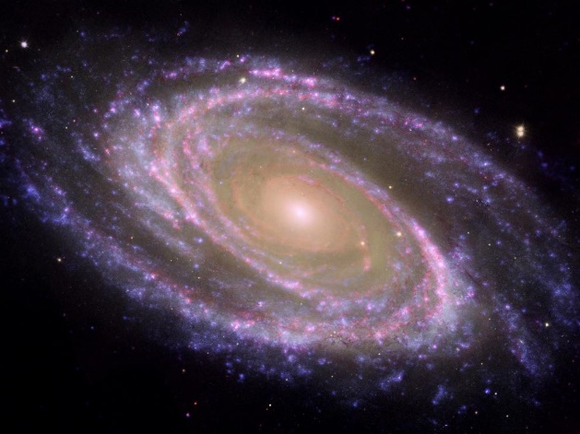

**ELECTROMAGNETIC WAVES**

**HERTZ’S EXPERIMENTS & OBSERVATIONS**

**PRODUCTION & RECEPTION OF RADIO WAVES**

Heinrich Rudolf Hertz (1857–1894) was a German physicist who first conclusively proved the existence of electromagnetic waves theorized by James Clerk Maxwell's electromagnetic theory of light. Hertz proved the theory by engineering instruments to transmit and receive radio pulses using experimental procedures that ruled out all other known wireless phenomena. The scientific unit of frequency – cycles per second – was named the "**hertz**" in his honour.

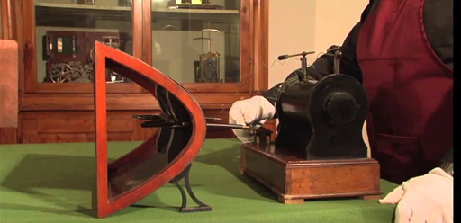

In 1856, James Clerk Maxwell showed theoretically that electromagnetic radiation which is propagated with the velocity of light ( *c* = 3x108 m.s-1), should be emitted from an oscillating electric circuit. Maxwell’s mathematical theory showed that a changing electric field gives rise to a changing magnetic field and a changing magnetic field to a changing electric field. This electromagnetic radiation, consisting of changing electric and magnetic fields at right angles to each other is propagated with the velocity of light *c* and should exhibit the wave-like characteristics of light propagation.

In 1887 Hertz designed a brilliant set of experiments to test Maxwell's hypothesis. He used an oscillator made of polished brass knobs, each connected to an induction coil and separated by a tiny gap over which sparks could leap.

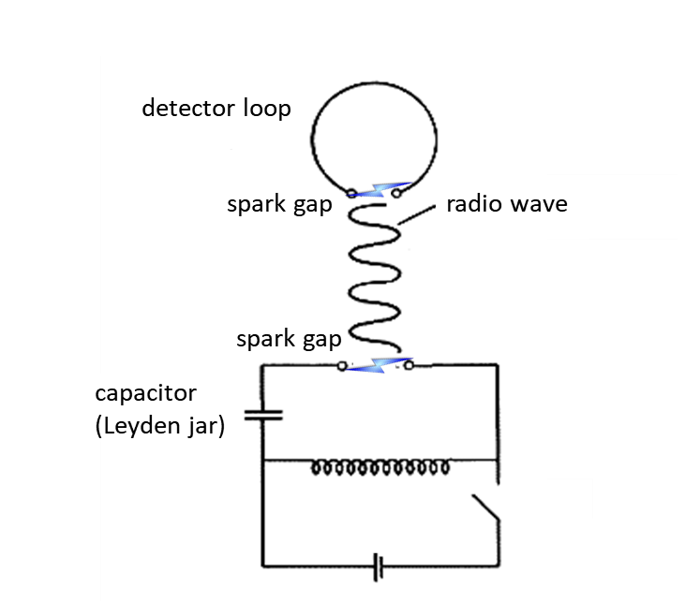

Fig. 1. Sketch of the apparatus used by Hertz for producing and detecting radio waves.

Hertz reasoned that, if Maxwell's predictions were correct, electromagnetic waves would be transmitted during each series of sparks. To confirm this, Hertz made a simple receiver of looped wire. At the ends of the loop were small knobs separated by a tiny gap. The receiver was placed several metres from the oscillator. According to theory, if electromagnetic waves were spreading from the oscillator sparks, they would induce a current in the loop that would send sparks across the gap in the loop. This did occur when Hertz turned on the oscillator, producing the first transmission and reception of electromagnetic waves (radio waves).

Hertz also noted that electrical conductors reflected the waves and they could be focused by concave reflectors. He found that non-conductors allow most of the waves to pass through.

In one of his experiments Hertz aimed the radiation at a wide metal sheet. The direct and reflected waves combined to form a standing wave. By moving the oscillator, Hertz found the positions of the nodes and antinodes of the standing wave. He measured the distance between the nodes and determined the wavelength *λ* of the electromagnetic wave and calculated the frequency of the oscillator *f*, Thus, he could determine the speed of the wave *v* = *fλ*. The value he obtained was the same as the speed of light *c*. This was the first experimental evidence in support of Maxwell’s mathematical theory of electromagnetic radiation.

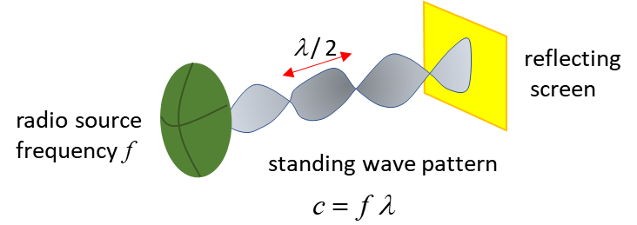

Fig. 2. Standing wave created between source and screen. From the measurements of *f* and *λ*, the speed of light *c* can be calculated from *c* = *f λ*.

In other experiments, he found that the small receiver spark was more vigorous if it was exposed to ultraviolet light from the transmitter spark. He first checked for some kind of electromagnetic effect, but found a sheet of glass effectively shielded the spark. He then found a slab of quartz did not shield the spark, whereupon he used a quartz prism to break up the light from the big spark into its component wavelengths and discovered that the wavelength which made the little spark more powerful was beyond the visible, in the ultraviolet (UV passes through quartz but not through glass). In 1887, Hertz concluded what must have been months of investigation

"… *I confine myself at present to communicating the results obtained, without attempting any theory respecting the manner in which the observed phenomena are brought about*."

Hertz had discovered the the **photoelectric effect**.

Fig. 3. The photoelectric Effect – when light above a critical frequency hits a metal surface, electrons are releases.

**The photoelectric effect was experimental evidence for the particle model of light.**

[VISUAL PHYSICS ONLINE](http://www.physics.usyd.edu.au/teach_res/hsp/sp/spHome.htm)

If you have any feedback, comments, suggestions, links or corrections please email:

Ian Cooper School of Physics University of Sydney

ian.cooper@sydney.edu.au