[**VISUAL PHYSICS ONLINE**](http://www.physics.usyd.edu.au/teach_res/hsp/sp/spHome.htm)

**MODULE 7 NATURE OF LIGHT**

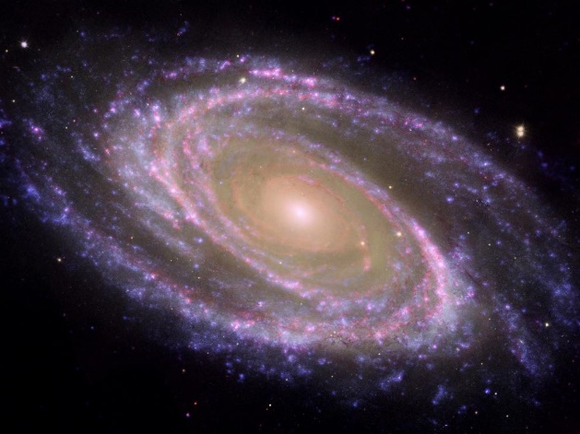

**ELECTROMAGNETIC WAVES**

**SPECTROSCOPY**

Electromagnetic waves are generated by accelerated charges. Also, electromagnetic waves are continually being emitting and absorbing by objects.

[Review: Methods of Heat Transfer- Radiation](http://www.physics.usyd.edu.au/teach_res/hsp/sp/mod32/m32_radiation.pdf)

**Blackbody Radiation**

Objects emit electromagnetic radiation from their surface due to the molecular motion of charges within the object. The molecules also absorb electromagnetic radiation that falls on the surface. The emission and absorption occurring at the surface is very temperature dependent. We can model this behaviour, by using the **Stefan-Boltzmann Law** equation

(1)  temperature in kelvin K

The power radiated (energy / time)  from the surface of an object depends upon the surface area *A* over which the radiation occurs, the nature of the surface described by the surface emissivity *e* and the temperature *T* [kelvin K] of the surface. The constant  is known as the Stefan-Boltzmann constant



Note that the power radiated is proportional to the fourth power of the temperature – a small change in temperature leads to a much larger change in the power radiated.

The nature of the surface described by the surface emissivity  is a dimensionless number between 0 and 1 and its value indicates how effective the surface is in radiating energy (or absorbing energy). A surface with  is a perfect radiator and the object radiating is called a **blackbody**. Generally, a dark coloured surface has an emissivity near 1, whereas a light-coloured surface has an emissivity must less than 1.

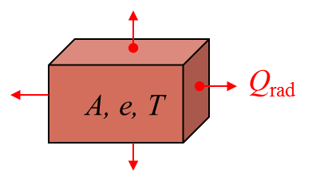

Radiation falling on a surface absorbs that radiation. Therefore, all surfaces are emitting radiation and absorbing it. Thus, if the temperature of a System is  and its surrounding temperature is  the net power  radiated by the object is

(2) 

If the surface temperature is greater than the surroundings , it radiates more energy that it absorbs, hence, .

If the surface temperature is less than the surroundings , it radiates less energy that it absorbs, hence, .

At equilibrium, where the surface and surroundings are at the same temperature, hence, .

A **blackbody**  is both a perfect radiator and absorber of electromagnetic radiation.

**Wien’s Displacement Law**

A useful law for understanding the radiation emitted from a hot object is **Wien's Displacement Law**. It states that peak wavelength  of the radiation emitted from a hot body is inversely proportional to the temperature .

(3)  Wien’s constant 

|  |
| --- |
| **Example 1**  Estimate the surface temperature of the Sun, given that the peak wavelength in the radiation emitted by the Sun is 0.5 μm. What band in the electromagnetic spectrum does the peak wavelength fall in?  The average surface temperature of the Earth is 16 oC. Estimate the peak wavelength of the radiation emitted from the surface of the Earth. What band in the electromagnetic spectrum does the peak wavelength fall in?  **Answers**  Sun  Earth  Note: you should remember these numbers |

**The solar Spectrum**

To a good approximation, the Sun radiates electromagnetic waves as a blackbody with a surface temperature of about 6000 K. The solar spectrum is displayed in figure 1.

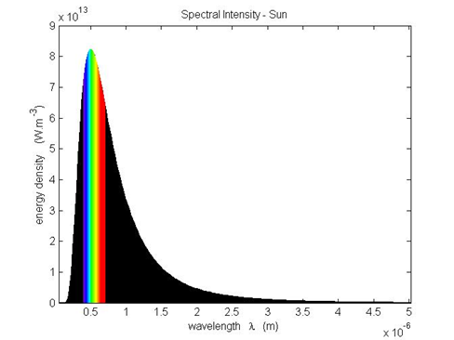

Fig. 1. The solar spectrum for the Sun modelled as a blackbody with a surface temperature of 6000 K. Most of the radiation is emitted in the IR band of the electromagnetic spectrum. Identify the spectral bands for UV, visible and IR in the figure.

**Spectra of reflected sunlight**

Sunlight is a portion of the electromagnetic radiation given off by the Sun, in particular, **infrared**, **visible**, and **ultraviolet** light. When the direct solar radiation is not blocked by clouds, we get sunshine which is a combination of bright light and radiant energy (thermal energy emitted from the surface of the earth). When it is blocked by clouds or reflects off other objects, we experienced diffused light. The ultraviolet radiation in sunlight has both positive and negative health effects, as it is both a principal source of vitamin D3 and a mutagen.

Sunlight is a key factor in photosynthesis, the process used by plants and other autotrophic organisms to convert light energy, normally from the Sun, into chemical energy that can be used to fuel the organisms' activities.

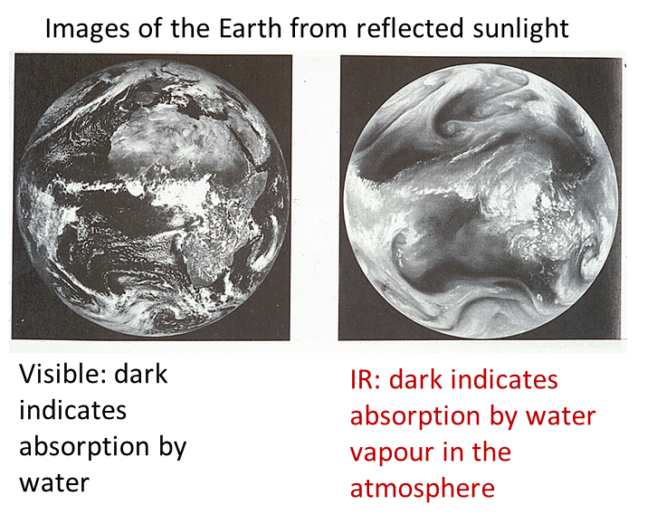

Fig. 2. Images of the Earth from outer space in the visible and IR bands.

The spectrum of all planetary objects (and humans, for that matter) has a double hump. One in the visible band due to reflected sunlight and another in the infrared due to thermal emission from the surface of the Earth (figure 3).

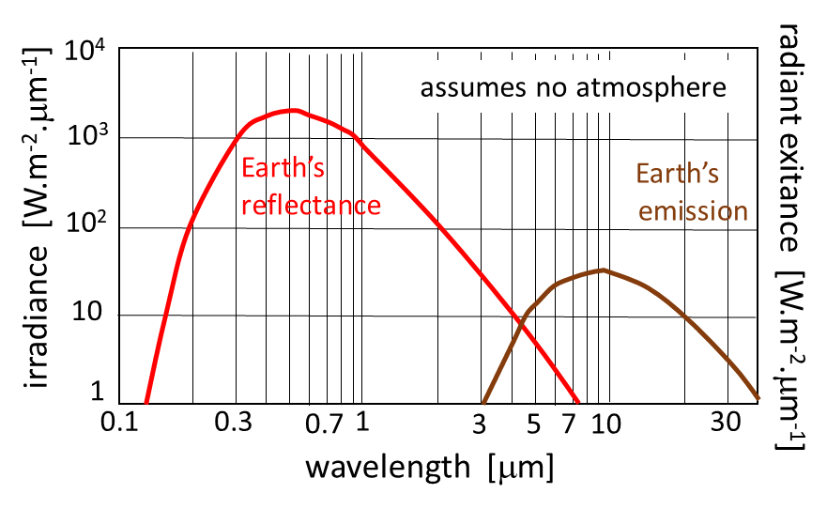

Fig. 3. The radiation emitted from the Earth’s surface is due to the reflection of the incident solar radiation, and the thermal energy radiated.

For reflection from the Earth’s surface, the spectral band ranges from ~0.1 μm to ~7 μm. The atmosphere is a good absorber for UV, so there is little reflection for wavelengths smaller than ~0.2 μm. The Earth's peak reflectance is centred near 0.5 μm (for the Sun's effective temperature of 5780 K). It is interesting to note that this wavelength of peak emission is optimal for the visual acuity of humans.

The wavelength range from ~3 μm to ~5 μm has a mixed contribution from both reflective and emissive radiation. The radiation emitted from the Earth’s surface is IR in the wavelength range ~3 μm to ~40 μm. The peak emission near 10 μm corresponding to a temperature of approximately 289 K (16 oC).

Each atom or molecules only emit or absorb electromagnetic radiation at a unique discrete set of wavelengths. Hence, it is possible to identify an atom or a molecule by the emission or absorption spectrum of the atom or molecule. The solar radiation reaching the Earth’s is reduced by the absorption of solar energy by molecules that constitute our atmosphere as shown in figure 4.

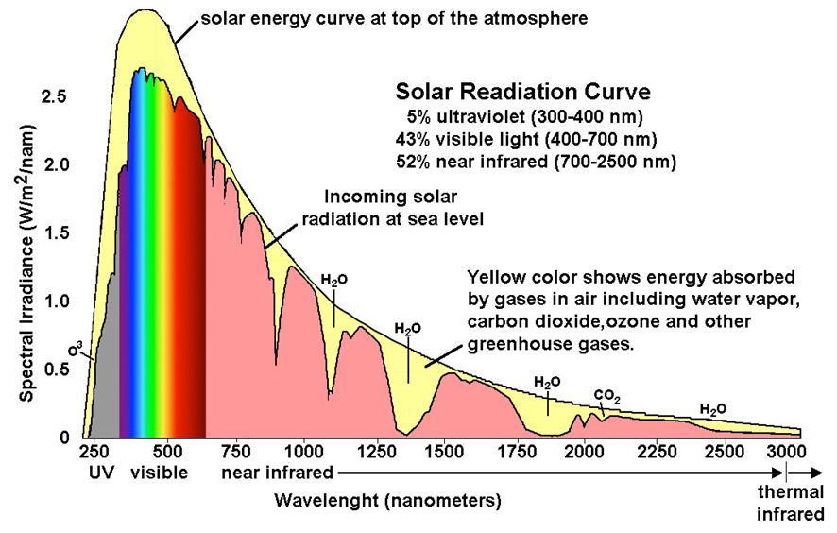

Fig. 4. Solar energy distribution at the top of the atmosphere and at the surface of the Earth.

[Website C02: What do you think of this article?](http://ice-age-ahead-iaa.ca/1/global_warming.html)

**Spectra of incandescent globes**

How efficient is an incandescent light globe in radiating visible light? Make a guess.

An incandescent light globe with a tungsten filament emits electromagnetic radiation like a blackbody with a surface temperature of about 2400 K as shown in figure 2.

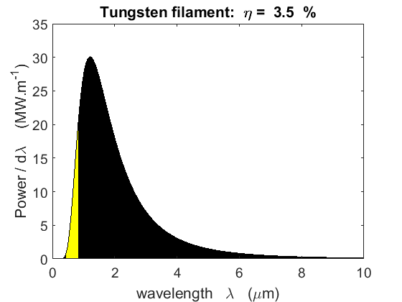

Fig. 5. Blackbody radiation curve for an incandescent light globe with a tungsten filament.

Identify the bands for UV, visible and IR.

For figure 5, the surface temperature of the tungsten filament is 2400 K and the light globe power dissipation is 55 W (power dissipated is equal to the area under the curve). The power emitted in the visible band is 1.9 W. Thus, the efficiency for the emission of visible light is only 3.5% (1.9/55). Most of the energy lost is in the infrared band which has a heating effect, not a lighting effect. The peak wavelength occurs in the infrared band and its value is 1.21 μm.

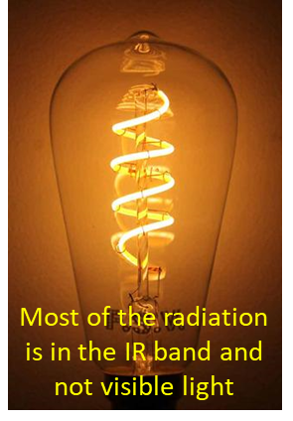

[VISUAL PHYSICS ONLINE](http://www.physics.usyd.edu.au/teach_res/hsp/sp/spHome.htm)

http://www.physics.usyd.edu.au/teach_res/hsp/sp/spHome.htm

If you have any feedback, comments, suggestions, links or corrections please email: ian.cooper@sydney.edu.au

Ian Cooper School of Physics University of Sydney