[**VISUAL PHYSICS ONLINE**](http://www.physics.usyd.edu.au/teach_res/hsp/sp/spHome.htm)

**ELECTROMAGNETIC WAVES**

**SPECTRA PRODUCED BY STARS**

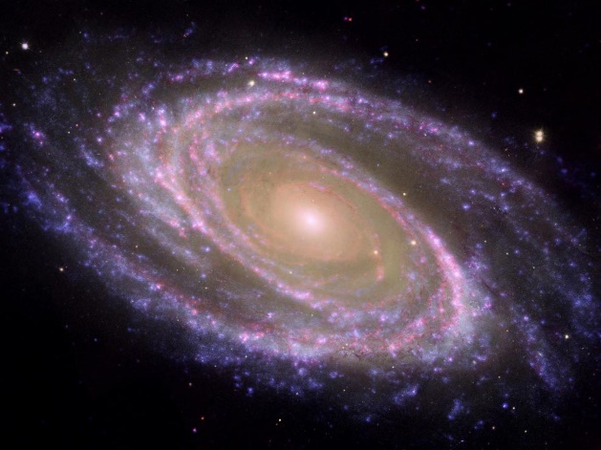

Astronomical spectroscopy is the study of astronomy using the techniques of **spectroscopy** to measure the spectrum of electromagnetic radiation, including visible light and radio, which radiates from stars and other hot celestial objects.

**Spectroscopy** can be used to derive many properties of distant stars and galaxies, such as their chemical composition, temperature, density, mass, distance, luminosity, and relative motion using Doppler shift measurements. A **spectrum** (the plural is **spectra**) is a graph of the amount of light something gives off (how bright the object is) at different wavelengths.

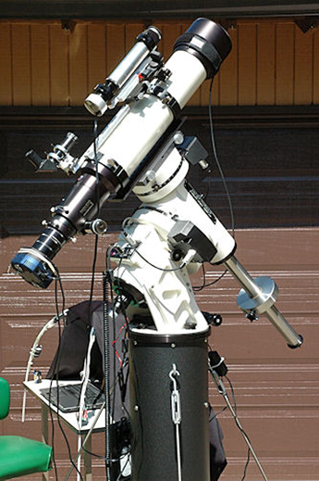

Fig. 1. Telescope do not just look at a star. Most of the time, a spectrometer is attached to the telescope. This telescope is fitted with a diffraction grating of 500 lines/mm which is used to disperse the star-light into a spectrum.

[Siding Spring Observatory](http://www.sidingspringobservatory.com.au/overview.html) on the edge of the Warrumbungle National Park near Coonabarabran, NSW, is Australia's premier optical and infrared astronomical observatory.

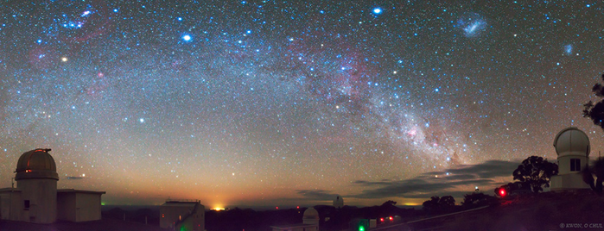

Fig. 2. The Milky Way above Siding Spring Observatory.

**Main features of a spectrum for a star**

A star emits light over the entire electromagnetic spectrum, from the gamma rays to radio waves.

**Continuum and its peak**: approximately a blackbody radiation curve with a wide “hill” peak.

**Absorption lines**: narrow "valleys" in the spectrum.

**Noise**: some small random fluctuation in the spectrum, noise is usually much smaller than the absorption lines.

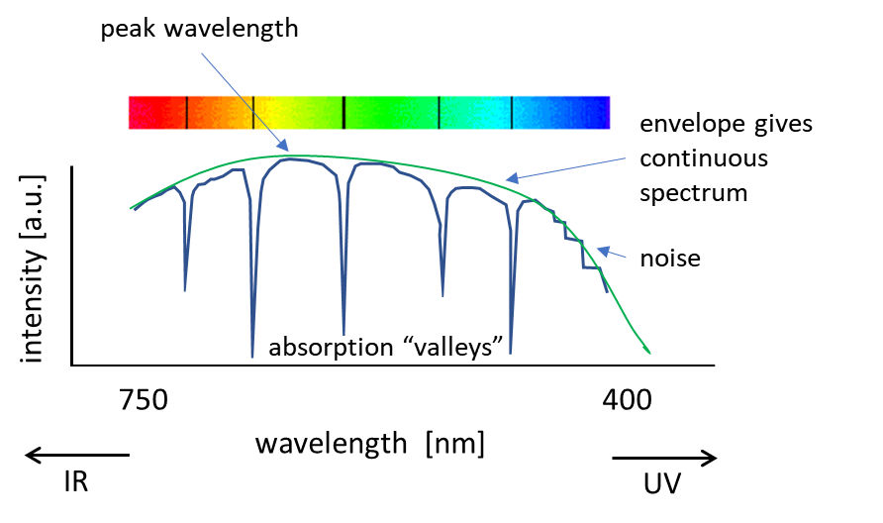

Fig. 3. Schematic diagram of the spectrum of a star.

* The spectrum of a star is composed mainly of **thermal radiation** that produces a **continuous spectrum** (blackbody radiation curve). The shape of the blackbody curve is determined by the temperature of the emitting surface.
* The **peak wavelength** in the continuum is determined by the star's surface temperature — the hotter the star, the **bluer** the continuum peak and the cooler the star then **redder**. The continuum peak wavelength is symbolized by *λpeak*. The continuum peak wavelength of light emitted by an object is inversely proportional to its temperature as described by the **Wien Displacement Law**.

 Wien’s constant 

Note: an inverse relationship, the longer the peak wavelength, the lower the temperature.

* **Absorption lines** are produced by atoms whose electrons absorb light at a specific wavelength, causing the electrons to move from a lower energy level to a higher one. This process removes some of the continuum being produced by the star and results in dark features in the spectrum.

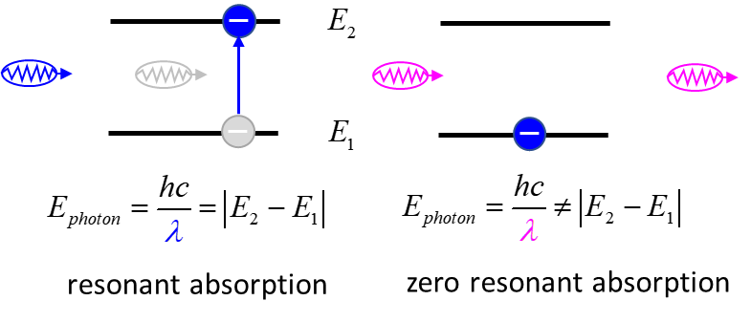

**Spectrum of a real star**

The star Vega spectral type is A0V and its luminosity class is a V.

Vega's spectrum is dominated by the hydrogen Balmer series Hα (3  2), Hβ (4  2), Hγ (5  2), Hδ (6  2), Hε (7  2), and Hζ (8  2) absorption lines.

O2 and H2O absorption lines are observed.

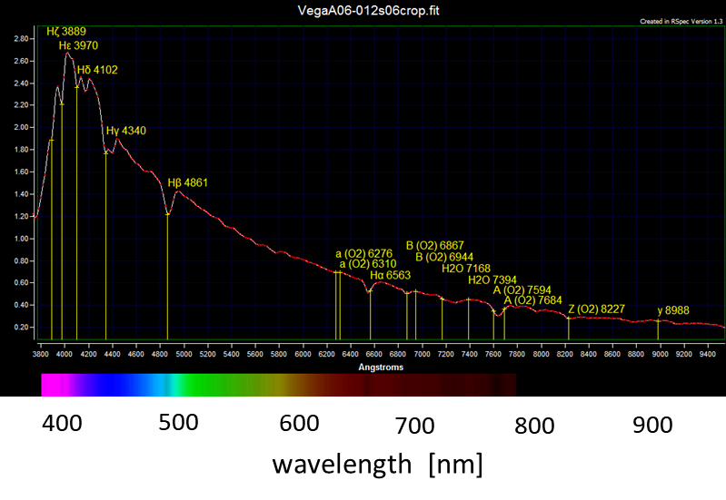

[Fig.4.](http://www.stargazing.net/david/NSI2011/VegaA06-012s06_20110802_1104.html) The spectrum of the star Vega. Absorption lines (wavelengths in nm):

**Hydrogen**: Hα (656.3), Hβ (486.1), Hγ (430.4), Hδ (410.2), Hε (397.0), and Hζ (388.9) absorption lines.

**Oxygen** O2: 822.7, 768.4, 759.4, 694.4, 686.7, 631.0, 627.6

**Water** H2O: 739.4, 716.8

|  |
| --- |
| **Exercise**  Calculate the surface temperature of the Star Vega.  Use the [Rydberg Equation](http://www.physics.usyd.edu.au/teach_res/hsp/sp/mod7/m7emrEAS.pdf) to check the absorption line wavelength for the Balmer series absorption lines.    **Solution**    Vega would appear as a violet-blue coloured star.      Similar calculation for the other hydrogen lines. |

|  |
| --- |
| **Exercise**    Estimate the surface temperatures of a red and blue stars.  **Solution**  We can use the Wien Displacement Law to estimate the temperature of a star      **RED STAR**  **BLUE STAR** |

**Chemical composition of stars**

Determining the chemical composition of a star from its spectrum turns out to be quite a tricky business. The starting point is of the process is comparing the absorption lines of a star with emission spectra of known gases. It took the astronomical community about three decades to figure it out.

Very dense, hot material in the inner regions of a star produces a bright continuum spectrum with light of all wavelengths. As the photons fly outwards into space, some are absorbed by atoms in the cooler outer layers of the stellar atmosphere, called the **photosphere**.

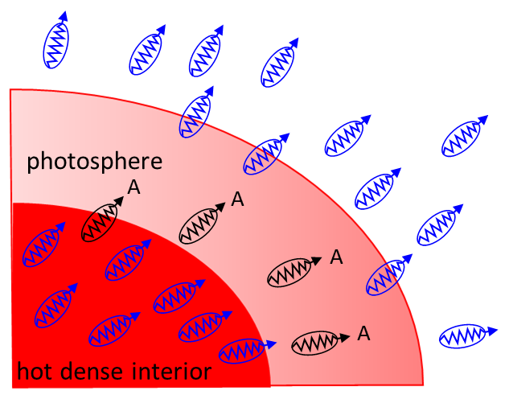

Fig. 5. Absorption (A) of photons occurs in the photosphere.

If we see an absorption line due to some element, we can be sure that there are some atoms of that element in the photosphere. But is the converse not necessarily true.

To date more than 20 000 absorption lines have been listed for the Sun between 293.5 and 877.0 nm, yet only approximately 75% of these lines have been linked to elemental absorption. By analysing the width of each spectral line in an emission spectrum, both the elements present in a star and their relative abundances and density can be determined.

Some of the elements and absorption lines for the spectrum of the Sun (wavelength in nm)

O2 898.765 822.696 759.370 686.719 627.661

Hα 656.281 Hβ 486.134 Hγ 434.047 Hδ 410.175

Na 589.592 588.995

He 587.5618

Hg 546.073

Fe 527.039 516.891 495.761 466.814 438.355 430.790

382.044 358.121 302.108

Mg 518.362 517.270 516.733

Ca 430.774

Ca+ 396.847 393.368

Ti+ 336.112

Ni 299.444

|  |
| --- |
| **Exercise**  For each wavelength, state whether it is in the IR, visible or UV band. |

Each absorption line indicates an ion of a certain chemical element, with the **line strength** indicating the **abundance** of that ion. The relative abundance of the different ions varies with the temperature of the photosphere. The **width** of certain absorption lines in the star's spectrum, varies with the **density** of the atmosphere.

We now know that stars are mostly made up of hydrogen and helium, with small amounts of some other elements. This is only known due to spectroscopy. Helium was first discovered in the Sun before it was isolated on Earth.

**Stellar Density and Pressure Broadening**

In attempting to classify stars using their spectral characteristics astronomers faced a problem with some stars. Two stars may appear to have the same lines but one of them shows broader lines than the other in a photographic spectrum. Are they then the same spectral class? This question was resolved when the spectral data was combined with the information about the luminosity some stars that had been obtained separately. A photographic example for A3-class stars is shown below.

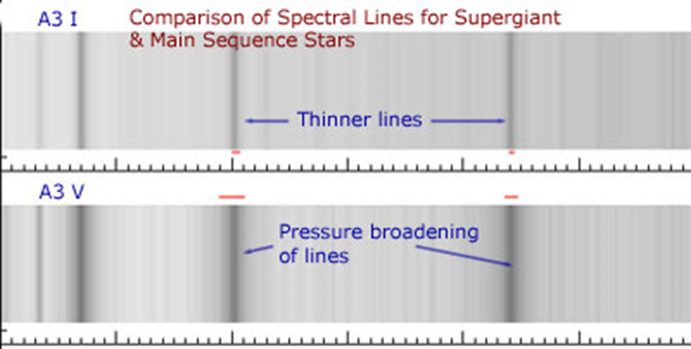

[Fig. 6.](http://www.atnf.csiro.au/outreach/education/senior/astrophysics/spectra_info.html) Comparison of spectral line widths for A3 I and A3 V class stars.

The **broader lines** for the V luminosity class star arises due to the **denser outer layers in the atmosphere** of a main sequence star.

The width of the line (and the depth for an intensity plot) provides information about the outer layers of the star, the region in which the absorption of photons from the core occurs. Large stars have a very low relative density in their outer layers as the volume occupied by a given mass of gas is much greater.

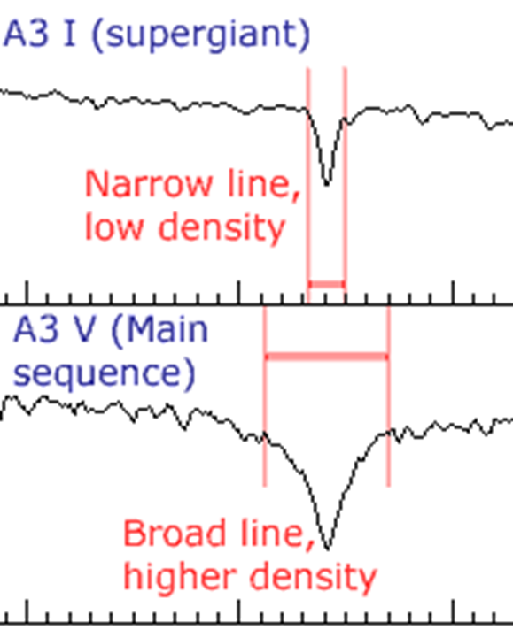

[Fig. 7.](http://www.atnf.csiro.au/outreach/education/senior/astrophysics/spectra_info.html) Comparison of spectral line widths for A3 and A3 V class stars. The broader lines for the V luminosity class star arises due to the denser outer layers in the atmosphere of the main sequence star.

[Stellar classification](https://en.wikipedia.org/wiki/Stellar_classification)

[VISUAL PHYSICS ONLINE](http://www.physics.usyd.edu.au/teach_res/hsp/sp/spHome.htm)

If you have any feedback, comments, suggestions, links or corrections please email:

Ian Cooper School of Physics University of Sydney

ian.cooper@sydney.edu.au