[**VISUAL PHYSICS ONLINE**](http://www.physics.usyd.edu.au/teach_res/hsp/sp/spHome.htm)

**MODULE 7 NATURE OF LIGHT**

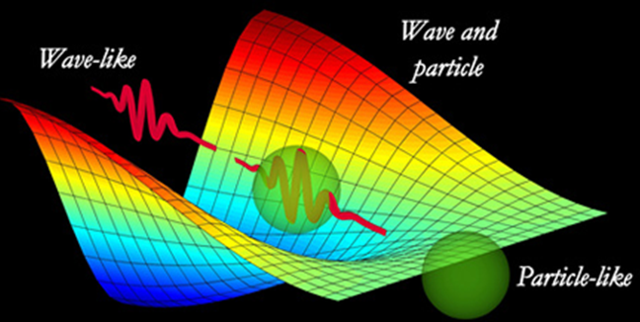

**WAVE or PARTICLE ???**

Light was recognised as a wave phenomenon well before its electromagnetic character became known.

The problem of the nature of light is an old one. In the late 1600s, important questions were raised, asking if light is made up of particles, or is it waves?

Sir Isaac Newton (1643-1727) felt that light consisted of a stream of very small particles, whereas his contemporary, Christian Huygens (Dutch physicist 1629-1695), though it was a succession of waves. Neither person offered any hypothesis as to what kind of wave or particle was involved.

In 1678, Huygens, believed that light was made up of waves vibrating up and down perpendicular to the direction of the light travels, and therefore formulated a way of visualising wave propagation. This became known as **Huygens' Principle**. Huygens suggested that light wave peaks form surfaces like the layers of an onion. In a vacuum, or other uniform mediums, the light waves are spherical, and these wave surfaces advance or spread out as they travel at the speed of light. This theory explains why light shining through a pin hole or slit will spread out rather than going in a straight line (diffraction). Newton's theory came first, but the theory of Huygens, better described early experiments. Huygens' principle lets you predict where a given wavefront will be in the future, if you have the knowledge of where the given wavefront is in the present.

There are several ways resolve the issue. The first convincing diffraction experiment with light waves was performed in 1801 by Thomas Young (English scientist 1773-1829).

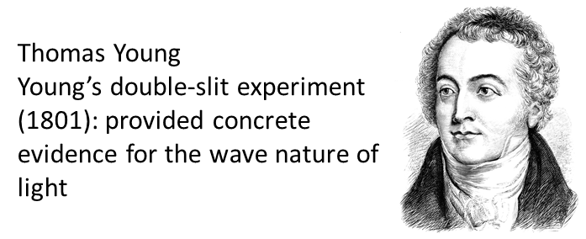

**Young** performed a **double-slit experiment**. The light source was monochromatic (light of a single wavelength). The light source was placed behind a narrow-slit S in an opaque screen, and another screen having two narrow slits A and B close together on the other side. Light from S passes through both slits A and B, then to a viewing screen (figure 1). If light were not a wave phenomenon, we would expect to find the viewing screen completely dark, since no light ray can reach it from the source along any straight-line path. However, an interference pattern is observed on the viewing screen consisting a series of bright and dark fringes which provides even stronger evidence for the wave nature of light. The origin of the bright and dark striations is the principle of superposition, one of the fundamental laws governing wave behaviour.

**Superposition principal**: When two or more waves of the same nature travel past a given point at the same time, the amplitude of the wave at that point is the sum of the instantaneous amplitudes of the individual waves.

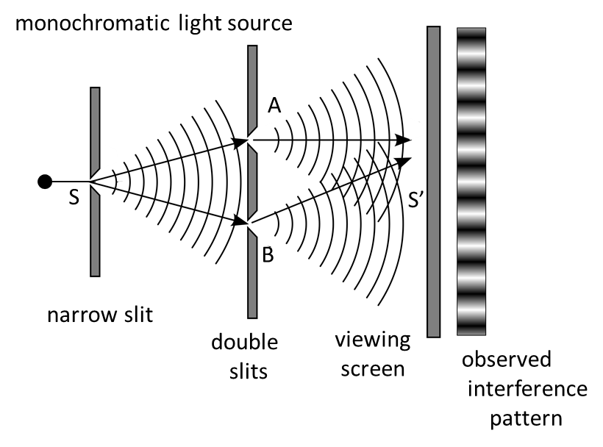

Fig. 1. Young’s double-slit experiment. In the absence of diffraction-interference, the viewing screen would be completely dark, since no light ray can reach it from the source along a straight-line path. However, a definite interference pattern of bright and dark bands is observed on the viewing screen.

Later in 1815, Augustin Fresnel supported Young's experiments with mathematical calculations.

So, it become accepted that the light was a wave phenomenon, and Newton’s model was rejected.

In 1900, Max Planck proposed the existence of a light quantum, a finite packet of energy which depends on the frequency and velocity of the radiation from his mathematical analysis of the light emitted from hot objects.

In 1905, Albert Einstein from work of Plank on emission of light from hot bodies, Einstein suggested that light is composed of tiny particles called **photons**, and each photon has energy . Using his particle model, he was able to give a correct explanation of the **photoelectric effect** (emission of electrons from a metal surface when light is shined onto to it).

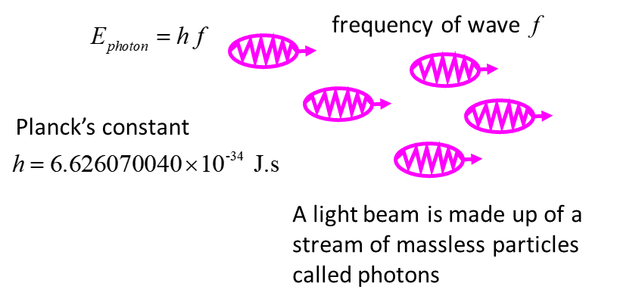

Fig. 2. Einstein postulated that light had a particle nature. The particles were called photons and the energy a photon is .

Newton was not entirely wrong. Today, we must accept the notion that light behaves as a wave in its propagation, but the interaction of light with matter is best explained using a particle model for light.

It was later shown that matter (particles) have a wave nature. So, the world we live in is not so simple.

Through the work of Max Planck, Einstein, Louis de Broglie, Arthur Compton, Niels Bohr and many others, current scientific theory holds that all particles also have a wave nature (and vice versa) This phenomenon has been verified not only for elementary particles, but also for compound particles like atoms and even molecules. For macroscopic particles, because of their extremely short wavelengths, wave properties usually cannot be detected.

**Wave–particle duality** is the concept in quantum mechanics that every particle or entity may be partly described in terms not only of particles, but also of waves. It expresses the inability of the classical concepts "particle" or "wave" to fully describe the behaviour objects.

“It seems as though we must use sometimes the one theory and sometimes the other, while at times we may use either. We are faced with a new kind of difficulty. We have two contradictory pictures of reality; separately neither of them fully explains the phenomena of light, but together they do”.

Albert Einstein

Louis de Broglie suggested that for all material particles as well as to photons, the momentum *p* of the particle is related to its matter wave wavelength

 de Broglie: Matter waves

[VISUAL PHYSICS ONLINE](http://www.physics.usyd.edu.au/teach_res/hsp/sp/spHome.htm)

If you have any feedback, comments, suggestions or corrections please email:

Ian Cooper School of Physics University of Sydney

ian.cooper@sydney.edu.au