[**VISUAL PHYSICS ONLINE**](http://www.physics.usyd.edu.au/teach_res/hsp/sp/spHome.htm)

**MODULE 7 NATURE OF LIGHT**

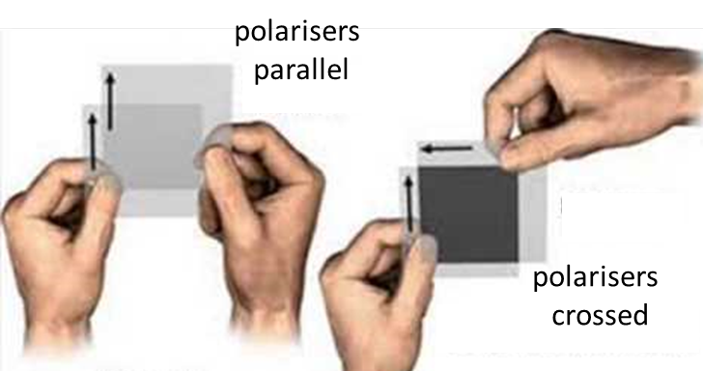

**POLARISATION**

[View video on polarisation of light](http://www.cyberphysics.co.uk/topics/light/polarisation.htm)

Is light a longitudinal or transverse wave?

**Longitudinal waves** are characterised by motion of the particles of the medium parallel to the direction in which the waves travel, e.g. sound waves in air.

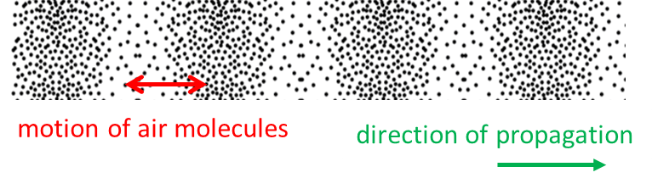

Fig. 1. Longitudinal sound wave in air.

**Transverse waves** are characterised by the motion of the particles of the medium perpendicular to the direction in which the waves are propagating, e.g. vibrations of a guitar string.

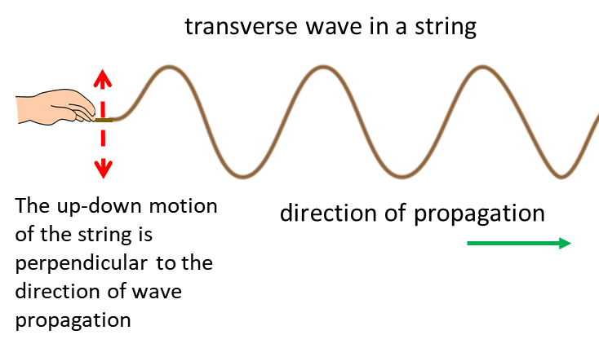

Fig. 2. Transverse wave along a string.

Reflection, refraction, diffraction, interference occur in the propagation of both transverse and longitudinal waves.

A definitive distinction between longitudinal and transverse waves may be made based upon the capacity to be polarised. A **linearly (plane) polarised** beam of transverse waves is one whose vibrations occur in only a single direction perpendicular to the direction of propagation of the wave, so that the entire motion in which the beam travels is confined to a plane called the **plane of polarisation**.

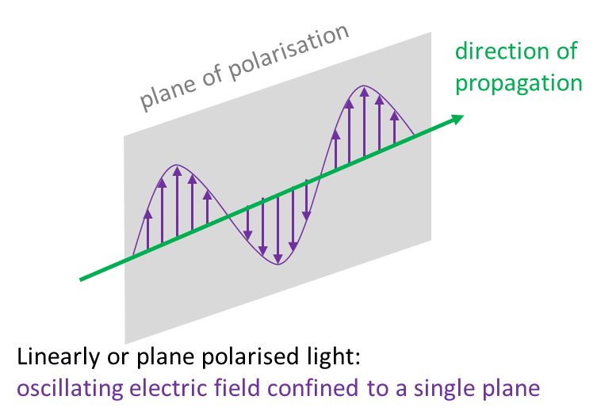

Fig. 3. Linearly or plane polarized light.

When many different directions of polarisation are present in a beam of transverse waves, often with vibrations occurring equally in all directions perpendicular to the direction of propagation, the beam is said to be **unpolarised**.

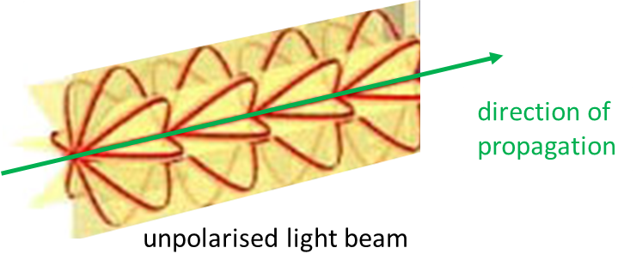

Fig. 4. Unpolarized light beam consists of vibrations in many planes perpendicular to the direction of propagation.

Since the vibrations constituting a longitudinal wave can only take place in one direction – in the direction of propagation, longitudinal waves cannot be polarised. By establishing whether light can be polarised or not, then, we have a means for determining the type of wave - longitudinal or transverse.

We can show experimentally that light is a transverse wave by using a microwave beam incident upon a metal grid as shown in figure 5. A typical wavelength of a microwave beam is about 3 mm. Provided the vertical metal grid spacing is smaller than the wavelength, when the grid intercepts the microwaves only the microwaves that are perpendicular to the vertical metal grid are transmitted.

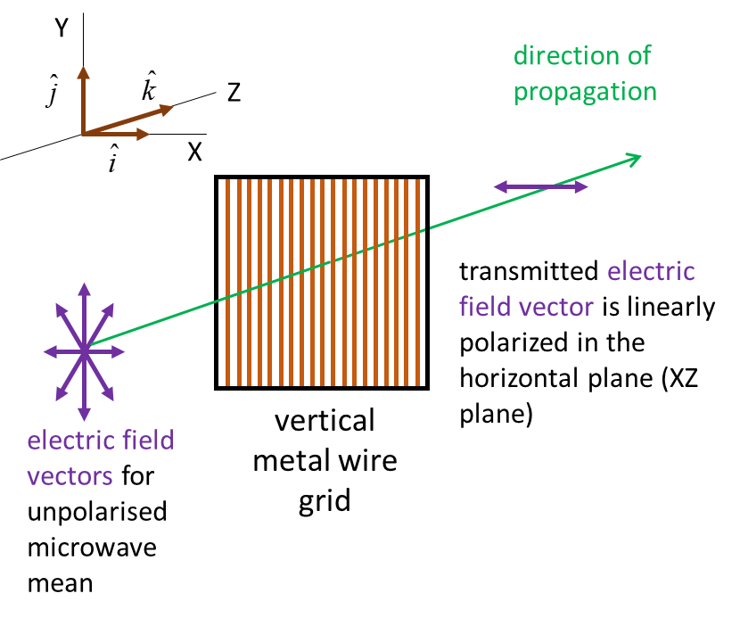

Fig. 5. Action of vertical metal grid wire grid on an unpolarised microwave beam. Effective absorption of all vertical components of the radiation occurs when .

The oscillation of the electric field for the microwave beam can induce electric currents in the metal grid when the grid and electric field are parallel to each other, and the energy will be absorbed from the beam. That is, the free electrons in the metal are set into oscillatory motion and these currents dissipate energy as thermal energy.

Also, these oscillating electrons radiate electromagnetic energy in all directions, except in the direction of the oscillation and in the forward direction there is a cancellation of the incident and radiated waves. The main reason for the disappearance of the transmitted wave is the destructive interference between the incident and generated wave.

When the plane of oscillation of the electric field is perpendicular to the metal grid, minimum absorptions occurs and the beam will pass through the grid with zero or little attenuation provided  as shown in figure 6. When the grid and electric field are oriented perpendicular to each other, appreciable oscillations of the free electrons cannot occur and so there is little cancellation between the incident and generated wave.

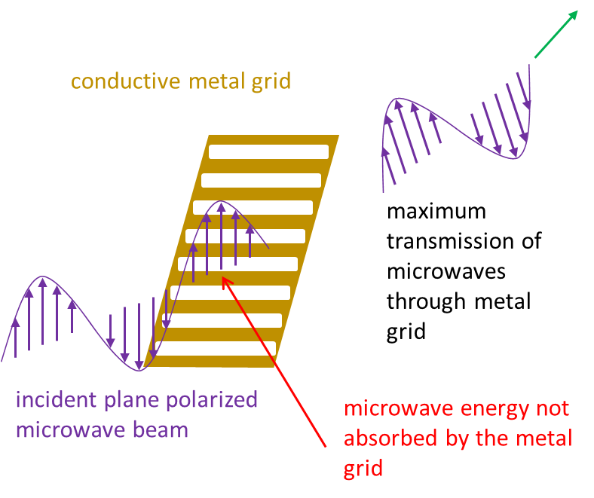

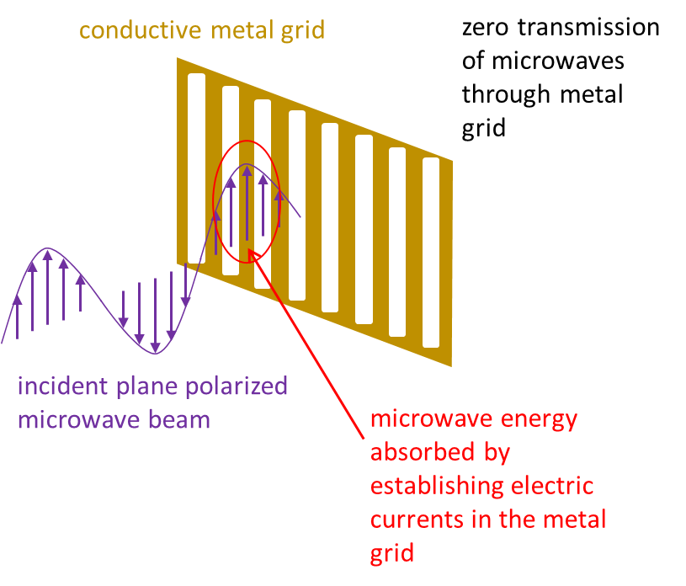

Fig. 6. Experiments with microwaves and a metal grid provides conclusive evidence that microwaves are transverse waves because they exhibit polarisation behaviour.

The orientation of any linearly (plane) polarised beam can be expressed in terms of its X, Y and Z components. Figure 7 shows an incident microwave beam with electric field . When the grid is oriented in the Y direction, the vertical component is absorbed and only the horizontal component  is transmitted.

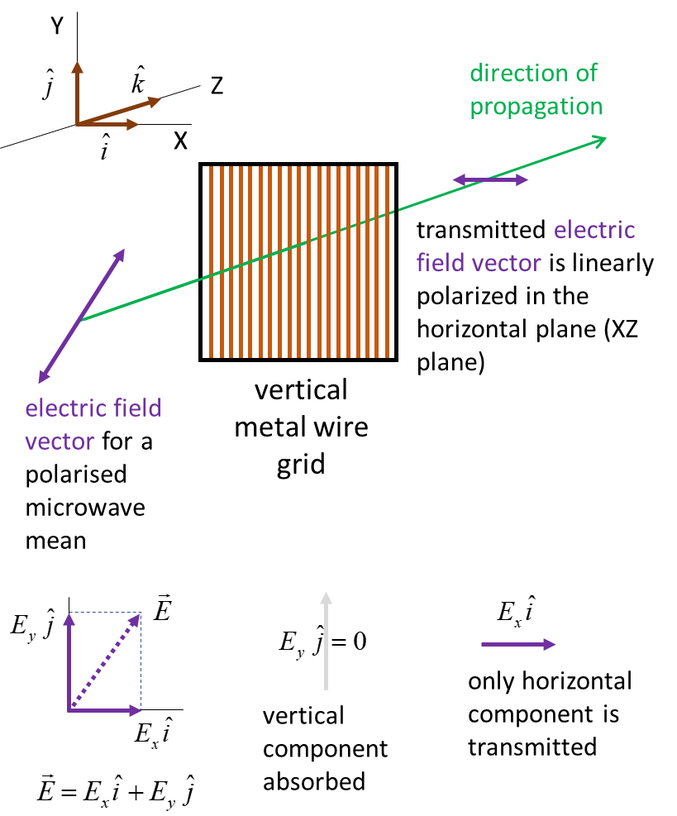

Fig. 7. Only components of the electric field that are perpendicular to the grid are transmitted.

The door of a microwave oven has a metal mesh embedded in it. So, zero microwave radiation can pass through the door, because all components of the electric field will be absorbed by the metal grid.

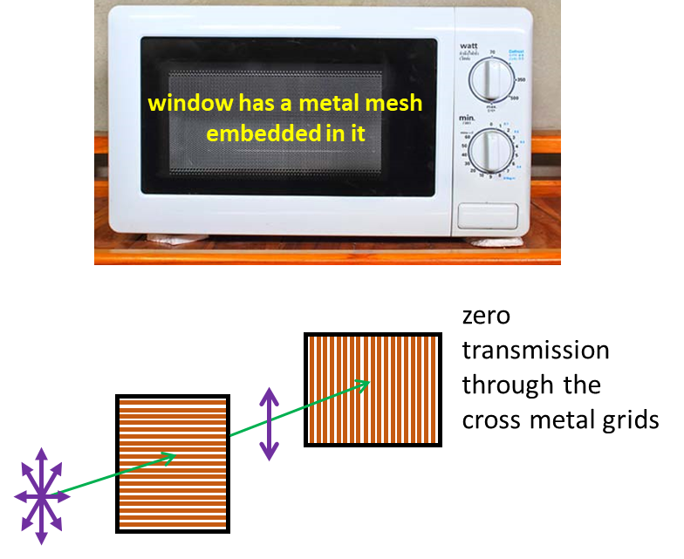

Fig. 8. For safety reasons, a microwave oven has a metal mesh embedded into its door so that there is zero transmission of the microwave radiation through it.

A good example of the use of polarisers are the polaroid lens in sunglasses. **Polaroid** is an artificially made polarising material. It consists of two plastic sheets with a thin layer of needle-like quinine iodosulfate crystals between them. The crystals are aligned using a very strong electric field and the resulting clear material transmits only light in a single plane of polarisation. In sunglasses, the crystals are aligned horizontally so that they strongly absorb the components of the light in the horizontal direction compared to the vertical direction (figure 9).

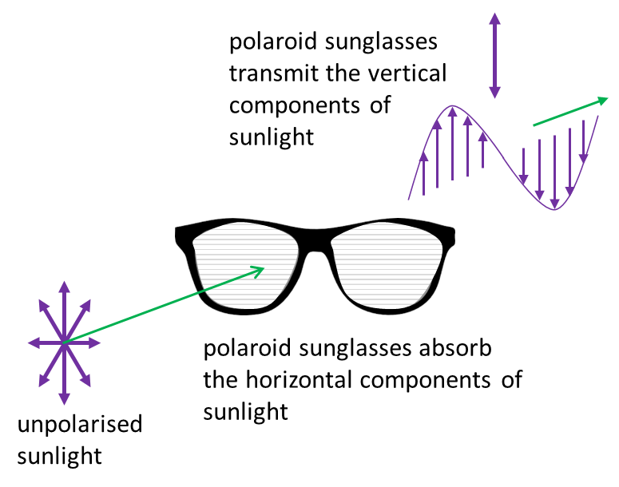

Fig. 9. Polaroid sunglasses have polaroid lens that are strong absorbers of the component of the electric field orientated in the horizontal plane.

When light strikes a non-metallic surface at any angle other than the perpendicular, the reflected beam is polarised preferentially in the plane parallel to the surface (figure 10).

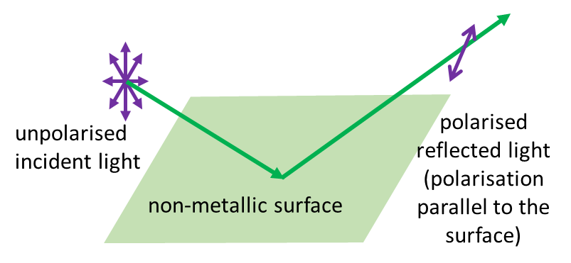

Fig. 10. Light reflected from a non-metallic surface is polarised with its plane of polarisation parallel to the surface.

Polaroid sunglasses are made so that the vertical component of the electric field is preferentially transmitted to eliminate the more strongly reflected horizontal component. So, wearing polaroid sunglasses will reduce the glare (figure 11). Fishermen were Polaroids to reduce reflected glare from the surface of water and thus see beneath the water more clearly.

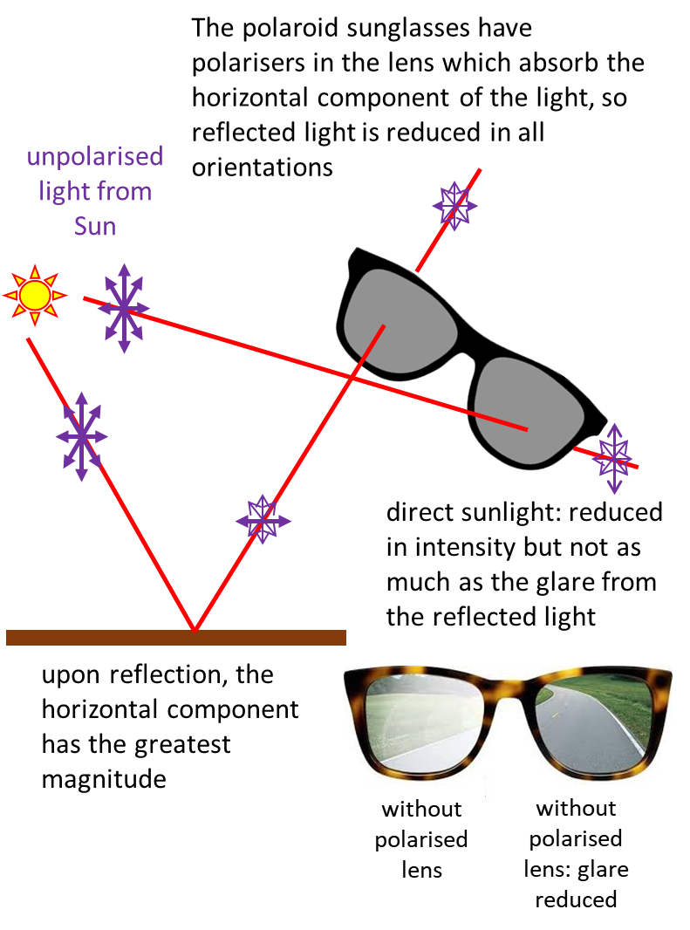

Fig. 11. Light reflected from a non-metallic surface is partially polarised parallel to the surface. Polaroid sunglasses preferentially absorb the horizontal component of sunlight, thus reducing the glare.

**Photoelasticity**

When transparent materials are placed between two polarises, colourful stress patterns are observed (figure 12). Very complicated stress distributions can be analysed by these optical methods.

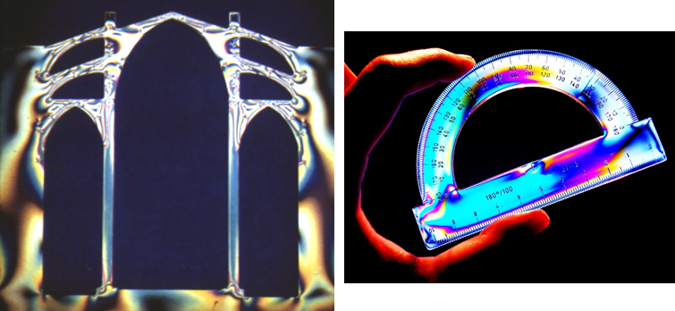

Fig. 12. Stress patterns in transparent materials are revealed by because light is a transverse wave and can be polarised.

**Malus’s Law for polarised light**

We will consider the experimental arrangement of shining **unpolarised light** through a pair of Polaroid sheets which are labelled the **Polariser** and **Analyser**. The transmitted light is detected by a **Photocell** as shown in figure 13. The Photocell measures the intensity of the light transmitted to it. The intensity of the light is proportional to the square of the electric field of the light

(1) 

The Polariser is adjusted so the light passing from the Polariser to the Analyser is linearly polarized with a vertical plane of polarisation. So, the Polariser has its **polarising axis** (transmission axis) in the vertical direction. For an ideal polarising filter, the transmitted intensity is half the incident intensity (50% of the radiation absorbed because only one component of the electric field is transmitted through the filter).

The Analyser can be rotated about the axis of the optical system and the angle  of its polarising axis is measured w.r.t. the vertical. The Analyser is rotated and set to the position to give a maximum intensity  as measured by the Photocell detector. This position will have the polarising axis of the Analyser in the vertical direction and the angle between the Analyser’s polarising axis and the vertical is . The angle of the Analyser is then set to  as shown in figure 13. The incident electric field for the Analyser is . The component of the electric field transmitted from the Analyser to the Photocell is . Thus, using equation 1, the light intensity transmitted through the Analyser gives

Malus’s Law for polarised light passing through an Analyser

(2) 

Equation 2 was discovered experimentally by E.L. Malus in 1809. Malus’s Law applies only if the incident light passing through the Analyser is already linearly polarised.

|  |
| --- |
| **Exercise 1**  Draw two graphs to test Malus’s Law for the Analyser angle   when the light incident upon the Analyser is linearly polarized.  At what angle is the intensity a maximum? At what angles is there extinction of the light through the filter? At what angle is the Analyser set to reduce the intensity to 50% of its maximum value?  **Solution**    You cannot make definite mathematical conclusions about curved lines. If possible, you need to plot the data to get a straight line. In this case we can do this by plotting the graph  of .    The maximum intensity is 10 a.u. and this occurs at the angle .  Zero light passes through the ideal filter at the angles .  The intensity drops to 50% of its maximum values at the angle |

[View video on Malus’s Law](https://www.youtube.com/watch?v=ILCvDQdiaKs&t=109s)

[View an interesting video: Polarized Light Explained + Experiments](https://www.youtube.com/watch?v=PJHCADY-Bio)

|  |
| --- |
| **Exercise 2**  Four polarisers are placed on an optical bench between an unpolarised light source and a photocell. The polarising axes of the polarises w.r.t. the vertical are 30o, 60o, 45o and -30o. If the incident intensity on the first polariser is 100 a.u., what is the intensity recorded by the photocell?  What angle must the last polariser by set at so that the intensity recorded by the photocell is (i) a minimum and (ii) a maximum?  **Solution**  You need to draw a careful annotated diagram of the situation  and then apply Malus’s Law to each polariser.      The unpolarised light in passing through polariser P1 is reduced in intensity by 50%.    For the linear polarised light passing through P2, the angle between the polarising axes of P2 and P1 is 30o    For the linear polarised light passing through P3, the angle between the polarising axes of P3 and P2 is 15o    For the linear polarised light passing through P4, the angle between the polarising axes of P4 and P3 is 75o    Hence, the intensity recorded by the photocell is 2.3 a.u.  The polariser P3 is set at an angle of 45o. If zero intensity is to be recorded by the photocell, the angle between the polarising axes (transmission axes) must be 90o. Therefore, polariser P4 can be set to the angle -45o since cos(90o) = 0.    For a maximum (*I* = 2.3 a.u.), the polarisation axes of P3 and P4 must be parallel. Therefore, P4 should be set to 45o to give a maximum since cos(0) = 1. |

|  |
| --- |
| **Exercise 3: Computer Simulation Experiment**  You can do an online version of Malus’s experiment at  <http://tutor-homework.com/Physics_Help/polarized_light.html>  Record values of the angle and intensity to draw the graphs shown in the solution to Exercise 1. Why is the experimental results too good? |

[VISUAL PHYSICS ONLINE](http://www.physics.usyd.edu.au/teach_res/hsp/sp/spHome.htm)

If you have any feedback, comments, suggestions or corrections please email:

Ian Cooper School of Physics University of Sydney

ian.cooper@sydney.edu.au