[**VISUAL PHYSICS ONLINE**](http://www.physics.usyd.edu.au/teach_res/hsp/sp/spHome.htm)

**PARTICLE ACCELERATORS**

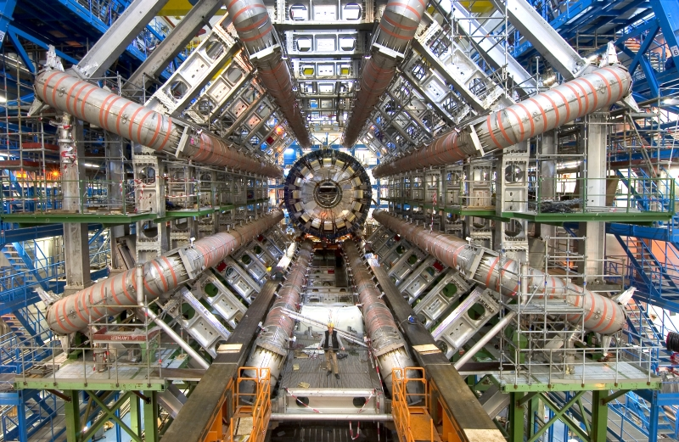

Particle accelerators are used to accelerate elementary particles to very high energies for:

* Production of radioisotopes
* Probing the structure of matter

There are many different types of particle accelerator including the **Van de Graaff accelerator**; **cyclotron**; **synchro-cyclotron; synchrotron** and **linear accelerator**.

**Production of radioisotopes**

Most of the radioisotopes found in nature have relatively long half-lives and belong to elements which are not suitable to be injected into our bodies. Hence, most radioisotopes that are to be injected into a patient must be produced artificially in a nuclear reactor or particle accelerator. Particle accelerators are used to bombard target nuclei with beams of charged nuclei to produce a wide range of isotopes, including many proton-rich nuclei that are not produced in nuclear reactors, for example, 18F9 and 11C6. The incident particles have a range of energy from ~ 10 MeV to ~ 100 MeV.

Beams of protons, deuterons and alpha particles are mainly used. An example of this method is the production of 22Na11 where a target of 24Mg12 is bombarded with deuterons

24Mg12 + 2H1 → 22Na11 + 4He2

The sodium is separated from the magnesium by chemical means.

**Probing the structure of matter**

Beams of very high energy particles are useful probes to investigate the structure of matter.

* The higher the energy (higher velocity and momentum) of a particle, the smaller the de Broglie wavelength λ = *h*/*p*. The smaller the de Broglie wavelength, the smaller the detail that can be investigated (the better the resolving power of a beam of such particles).
* The higher the energy of an incident particle colliding with a target particle, the more massive are the possible product particles, since, some of the energy of the incident particle will be converted into mass according to *E* = *mc*2. Therefore, conditions that may have existed in the early stages of the creation of the universe maybe studied in a laboratory.

## Cyclotron

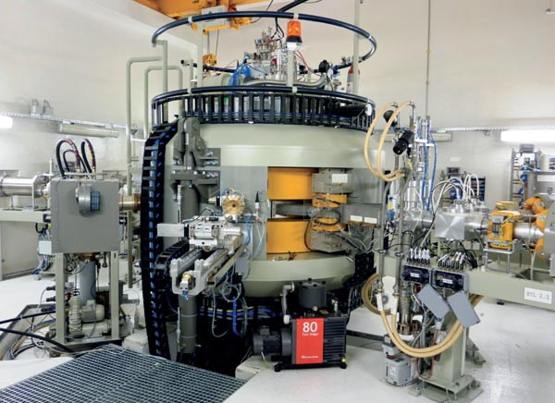

In a cyclotron, a magnetic field is used to deflect charged particles into a circular path and an electric field is used to accelerate the charged particles between a pair of electrodes. In an evacuated chamber, the charged particles with charge *q* and mass *m* move in a circular trajectory of radius *R* because they travel perpendicularly to a uniform magnetic field *B*.

Magnetic force = Centripetal force

direction of force given by right hand palm rule

  ⇒

Radius of circular path  

Angular speed (angular velocity)  period 

 

All the charges rotate around the cyclotron with the same period *T*. An alternating potential difference with period *T*/2 is applied between two hollow electrodes called **dees**, creating a periodic electric field (polarity of electric field reverses) in the gap between the two dees. In each half cycle the charged particles are accelerated by the electric field as they cross the gap between the dees, thus, increasing their speed and kinetic energy. As the speed of the charged particles increase, so does their radii.

The charge particles enter the cyclotron near its centre and as they are accelerated they move in semicircles of increasing radius, and finally exit the cyclotron with maximum speed (energy) as the maximum radius.



Fig. 1. Schematic diagram of a cyclotron. Use the right-hand palm rule to check the direction of the force acting on the positive charges.

There are serious problems with a cyclotron in giving very high energy to the charged particles. They require very large diameter electromagnets and as charged particles get faster and faster, relativistic effects cause the period of motion of the charge particles to increase and the motion of the charges becomes out of step with the alternating electric field.

## The Synchrotron

A more practical way in which to attain higher energies is to use a **synchrotron**. This consists of a single, circular, evacuated tube. High energy particles from another accelerator are injected into the synchrotron which consists of a vacuum chamber in the form of a thin doughnut called the accelerating ring. The charged particles travel around the accelerating ring in a circular path due to their deflection by a series of magnets placed around the ring. As the charged particle speed up, the magnetic fields are increased so that the charges retrace the same trajectory over and over.

 

The charged particles are accelerated by high frequency electric fields applied across gaps in metallic cavities inside the synchrotron ring. The frequency is synchronised with the constant angular frequency ω of the charges in the accelerator ring.

The Tevatron at the Fermilab in Illinois, U.S.A. accelerates protons up to energies as high as 1000 GeV (1TeV = 1012 eV). The accelerator ring is 2 km in diameter and ~ 1013 protons are accelerated for a few seconds before exiting the synchrotron.



Fig. 2. Schematic diagram of a synchrotron.

Accelerated charges emit electromagnetic radiation, for example, the microwave radiation from mobile phone towers. In a synchrotron, the charged particles are moving in a circular path, hence they are accelerating and the charges emit **synchrotron radiation**. High energy accelerators are often constructed underground to provide protection from this radiation. To reduce the energy loss of the particles, the synchrotrons typically have large radii so that the acceleration of the charges are reduced (*a*C = *v*2/*R* *R* ↑ ⇒ *a*C ↓)

**The Linear Accelerator (Linac)**

In a linear accelerator, the charged particles are accelerated along a straight evacuated chamber by electric fields of constant radio frequency produced by sets of electrodes. The charged particles are repelled from one set of electrodes and attracted to another set of electrodes as they travel through the particle accelerator. Thus the charged particles are given a velocity boost and since the voltage boost is on for a fixed period of time, the distance between the electric field free regions becomes increasing larger.



Fig. 3. Schematic diagram of a linear accelerator.

Linacs are sometimes used as the pre-acceleration device for large circular particle accelerators.

The longest linear accelerator is the 3 km long, Stanford Linear Acceleration (U.S.A.), it can accelerate electrons up to 50 GeV (50x109 eV), that is, up to 99.99% of the speed of light.

In accelerating electrons and positrons, the linac has a crucial advantage over circular machines, because of the small mass of electrons and positrons, if they moved in a circular path they would emit very large quantities of electromagnetic radiation and lose so much energy that high kinetic energies could not be achieved.

**Detection of particles**

The passage of charged particles in matter is observed by the ionisation they produce. This ionisation can be collected at electrodes or observed by the ensuing light pulse materials called scintillators. The energy of the particle is measured if it deposits all its energy in the detector. Its momentum is measured from its trajectory in a magnetic field. The energy can be derived from this if the identity of the particle is

known (or assumed).

On the other hand, neutral particles do not leave a track; we observe them only if they interact with something and produce a charged particle in the process, whose track we can then follow. The energy and momentum of the neutral particle is determined by making assumptions about the nature of the interaction and then applying conservation laws for energy and momentum. Often a number of particles are produced in the interaction and then the total energy and momentum of all particles must be measured in order to estimate the energy and momentum of the incident neutral particle.

The **Wilson Cloud Chamber** is a particle detector used for detecting ionizing radiation.

In its most basic form, a cloud chamber is a sealed environment containing a supersaturated vapour of water or alcohol. When a charged particle (e.g., an alpha or beta particle) interacts with the mixture, it ionizes it. The resulting ions act as condensation nuclei, around which a mist will form because the mixture is on the point of condensation. The high energies the incident particles mean that a trail is left, due to many ions being produced along the path of the charged particle. These tracks have distinctive shapes, for example, an alpha particle's track is broad and shows more evidence of deflection by collisions while an electron's is thinner and straighter.

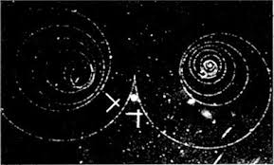When a uniform magnetic field is applied across the cloud chamber, positively and negatively charged particles will curve in opposite directions, according to the Lorentz force law with two particles of opposite charge (right hand palm rule).

<http://en.wikipedia.org/wiki/Cloud_chamber>

**Web Search:** Wilson Cloud Chamber animations

[VISUAL PHYSICS ONLINE](http://www.physics.usyd.edu.au/teach_res/hsp/sp/spHome.htm)

If you have any feedback, comments, suggestions or corrections please email:

Ian Cooper School of Physics University of Sydney

ian.cooper@sydney.edu.au