[**VISUAL PHYSICS ONLINE**](http://www.physics.usyd.edu.au/teach_res/hsp/sp/spHome.htm)

**GAMMA DECAY**

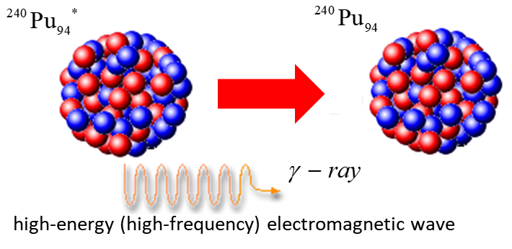

**Gamma rays** (γ rays) are **photons** having very high energy that were emitted from excited nuclei, much like emission of photons by excited atoms. Like an atom, a nucleus itself can be in an excited state. When it jumps down to a lower energy state it emits a photon called a γ ray. The energy level separations in a nucleus (~ MeV) are much greater than the energy level differences in an atom (~ eV). For a given decay, the γ ray always has the same energy and since the photon is electrically neutral, there is no change in the element as a result of the decay.

Gamma rays are extremely high frequency (short wavelength) electromagnetic waves where the photons are emitted from excited nuclei.

* N, Z and A do not change



A nucleus can be in an excited state after it suffers a violent collision with another particle, or more commonly the daughter nucleus remaining after an α decay or β decay is left in an excited state.

226Ra88 → 222Rn86**\*** + 4He2

energy of α particle 4.685 MeV

222Rn86**\*** → 222Rn86 + γ

energy of γ ray 0.186 MeV

What is the difference between a γ ray and an X ray?

Fundamentally there is no difference. They are both just high energy electromagnetic radiations, although γ rays usually have higher energies. We distinguish between the two on how they are created:

The source of γ rays is the nucleus.

The source of X rays electronic transition in an atom.

Gamma rays have very great penetrating power. They move at the speed of light and have a very short wavelength or high frequency. The energy of the photon of a gamma ray is



Typical values (check the calculations with your calculator):

λ ~ 3x10-12 m *f* = *c* / λ ~ 1020 Hz

*Ephoton* ~ 7x10-14 J ~ 0.4 MeV

[VISUAL PHYSICS ONLINE](http://www.physics.usyd.edu.au/teach_res/hsp/sp/spHome.htm)

If you have any feedback, comments, suggestions or corrections please email:

Ian Cooper School of Physics University of Sydney

ian.cooper@sydney.edu.au