[**VISUAL PHYSICS ONLINE**](http://www.physics.usyd.edu.au/teach_res/hsp/sp/spHome.htm)

**THE BIG BANG THEORY**

**Age of the Universe**

Hubble's Law tells us that the universe is expanding. So, in the past the universe was much smaller than it is today. If we assume that the expansion rate (how fast the galaxies appear to be moving apart) has been constant over the history of the universe, we can estimate how long ago the galaxies began their separation, hence, we can estimate the age of the universe.

We know how fast the universe is expanding, because we know the value of Hubble's constant *H.*

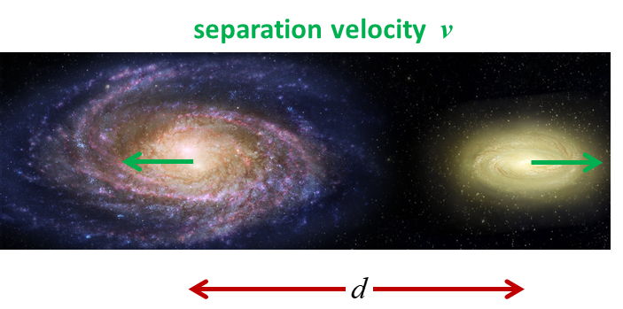

Fig. 1. The Universe is expanding.

 Hubble’s Law

where *d* is the distance between two astronomical galaxies and *v* is their apparent speed of separation.

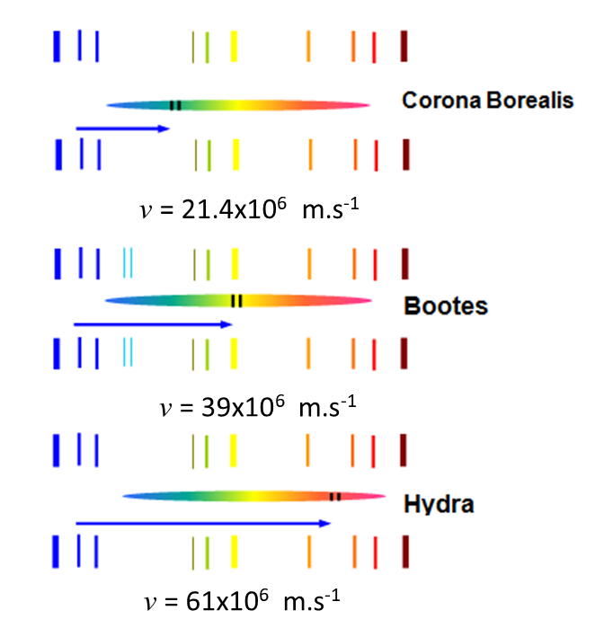

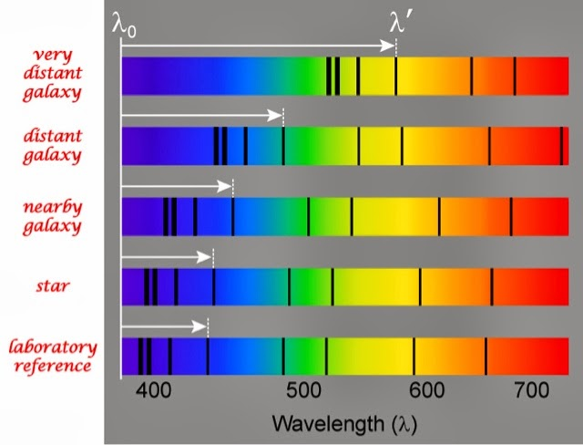

Fig.2. Galaxies are receding from each other. The recession velocity is measured from the absorption lines in the spectra of a galaxy.

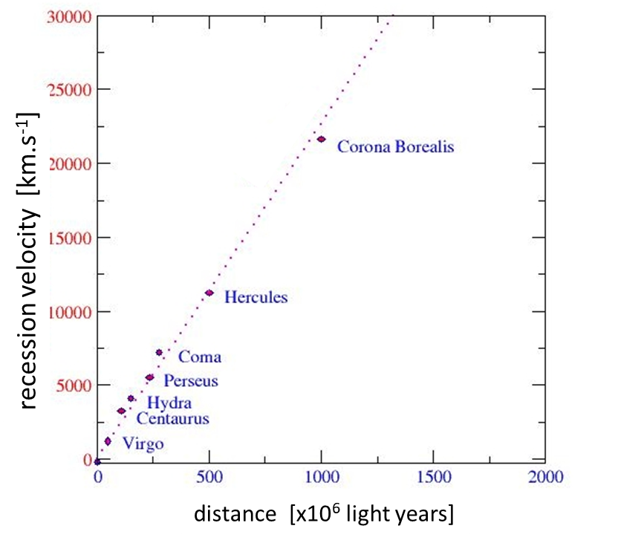

Fig. 3. Hubble’s Law for clusters of galaxies. 

(parsec 1 p = 3.0857x1016 m)

At some point, the galaxies were touching, and we can consider that time the moment of the Big Bang. If you take the separation *d* between the two galaxies and divide that by the apparent velocity *v,* that will leave you with how long it took for the galaxies to reach their current separation.

For example, consider that you are now 100 km miles from home. You drove 50 km.h-1 entire time. So, how long did it take you to get here?



So, the time *t* it has taken for the galaxies to reach their current separations is



So, an estimate for the age of the Universe is

 age of Universe

The best estimate for the Hubble constant is



Astronomical distances are often measured in mega-parsecs





So, the age of the Universe is



The age of the Universe is in the order of 13 billion years.

From stellar evolution, we have estimated the ages of the oldest globular clusters to be approximately 12-13 billion years old. These are the oldest objects we have identified, and it is a nice check on our estimates for the age of the Universe that they are consistent.

**Big Bang Theory**

Given the following information (Evidence for the Big Bang):

* Hubble's Law implies the Universe is expanding.
* We observe the galaxies in the Universe to lie in a filament / void structure, but overall to be distributed on the largest scales in a homogeneous and isotropic way.
* General Relativity describes the behaviour of space-time in the Universe.
* The observation in 1964 by A. Penzias and R. Wilson, two Bell Laboratory scientists, that a cosmic microwave background radiation permeates the Universe. This background radiation is attributed to the Big Bang.

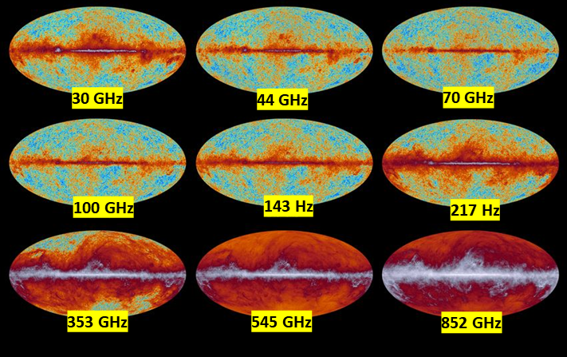

Fig. 4. Cosmic Microwave Background Radiation (CMBR) at 9 microwave frequencies.

This CMBR is the remnant radiation from the Big Bang due to the cooling of the Universe and the Doppler-shift in frequencies to give today a peak wavelength of 3x1011 Hz (300 GHz) and this corresponds to a blackbody temperature of 3 K.

* There is good agreement between the predictions of the primordial nucleosynthesis of the elements and the known abundance of the elements in the Universe. This applies to the light elements that were produced in the very early stages of the big Bang.

Astronomers have adopted a model known as the **Big Bang model** to describe the Universe that incorporates the information above.

**Big Bang model**: the entire visible Universe and all its contents was contained in a tiny region that was originally the size of a pinpoint. At one instant in time, that very hot, very dense point began expanding, and it is now much larger and much cooler than it was at the beginning.

**The First Few Minutes**

The beginning of the Big Bang is sometimes referred to as the **primeval fireball**. Cosmologists and particle physicists can predict quite accurately what physical processes occur onwards from about 10-3 seconds after the start of the Big Bang.

The beginning of the Universe was driven by cosmological inflation where the Universe expanded by a factor

1 000 000 000 000 000 000 000 000 000 000

in

0.000 000 000 000 000 000 000 000 000 000 000 010 seconds

It was as if a coin 10 mm in diameter suddenly blew up to 10 million times the width of the Milky Way galaxy. This expansion is faster than the speed of light, but that speed limit does not apply to the expansion of space. This expansion was not entirely uniform and these irregularities produces the observed minuscule variations in the temperature of the cosmic microwave background radiation in different directions.

The temperature of the fireball drives the resulting mix of particles and radiation, and we can divide the Universe evolution into five stages; heavy particle era; light particle era; a radiation era and the present-day era of matter. As the Universe expands its temperature and density decline.

**1. The unknown era**: 0 < Time < 10-43 s (Planck Time)

??? No theories, so we call it, The theory of Everything.

**2. Heavy particle era**: temperature > 1012 K Time < 10-6 s

Expansion of the Universe, temperature drops from ~1030 to ~ 1028 K

Gravity forces established.

Strong force established. The fundamental particles, quarks and leptons formed and their antiparticles. The Universe can be described as a hot, quark-electron soup.

Universe continues to cool.

Quarks (up and down) bind together to form protons and neutrons. There are more protons than neutrons because they are slightly less massive.

Temperature drops ~1012 K. By the end of this era, the Universe consists of photons, electrons, neutrons, protons and their antiparticles. The four fundamental forces of nature: gravity, strong nuclear force, electromagnetic force and the weak force are now distinct. Protons, neutrons, electrons and their antiparticles are created by highly energetic photons through the process of pair production. Particle and antiparticle annihilations occur to create photons.

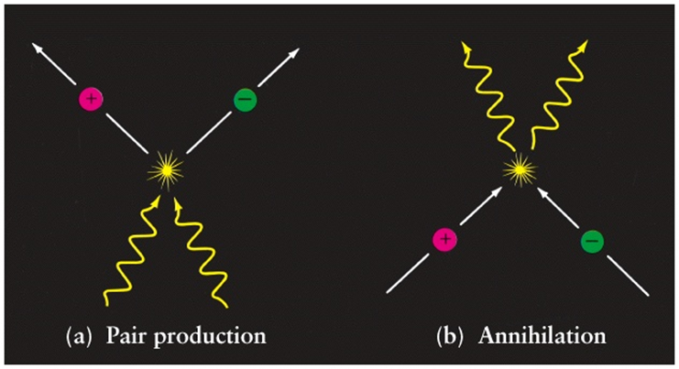

Fig. 5. Creation and destruction of particles. In the interactions both energy and momentum must be conserved.

**3. Light particle era**: 1012 K > Temperature > 6 x 109 K

10-6 s < Time < 6 s

As the temperature declines, not enough energy exists to create many massive particles, so light particles (electrons) are preferentially formed. Protons and electrons interact to form neutrons. As the temperature falls to 6x109 K photons do not have enough energy to form proton-electron pairs, and the radiation era begins. Many neutrons decay into protons and electrons, but a reservoir of neutrons is left to play an important part in the radiation era.

**4. Radiation era**: 109 K < Temperature < 104 K

6 s < Time < 500 000 years

Key nuclear reactions occur in this era. This is the beginning of nucleosynthesis (formation of nuclei). The nuclei of simple elements are made from the remaining neutrons and protons. Deuterium (2H1) is made by combining a neutron and proton. Further reactions create 4He2 (normal helium) at about 25% of the total mass (with the remaining ~75% being hydrogen). Nucleosynthesis stops at the production of 4He2 because at this stage (unstable) nuclei with atomic masses of 5 or 8 can only be bypassed by stellar nucleosynthesis, and stars have not yet formed! The Universe consists primarily of photons, protons, helium nuclei and electrons. Atoms are not able to be formed because of the intense electromagnetic radiation ionises them as soon as they are formed. Photons interact freely with charged particles through the interaction and are absorbed, emitted and scattered by particles.

**5. Matter era**: Temperature < 3000 K Time > 500 000 years

At about 1 million years the temperature has dropped to about 3000 K, which allows nuclei to capture electrons and form neutral atoms (this process is called recombination).

Radiation and matter decouple, such that matter becomes transparent to radiation. That is, the Universe has cooled enough that electromagnetic radiation (photons) has decoupled from matter. Until about 700 000 years, the Universe was radiation dominated, meaning that most of the energy was in the form of photons, which were continually being absorbed and emitted by ions. At about 3000 K, the temperature is low enough that protons can combine with electrons to form hydrogen atoms. From this time on, the Universe is matter dominated with more energy being in the form of matter than radiation. Because photons are now free to pass through the Universe, the blackbody radiation temperature at this stage was about 3000 K. In our expanding Universe, this radiation is redshifted with respect to us and we observe the background radiation temperature of 3 K. This is the cosmic microwave background radiation. that was detected by Penzias and Wilson and COBE (The Cosmic Background Explorer was a satellite dedicated to cosmology, which operated from 1989 to 1993. Its goals were to investigate the cosmic microwave background radiation of the Universe and provide measurements that would help shape our understanding of the cosmos).

Atoms are now able to form, and matter begins to clump togther to form molecules, gas clouds, stars and eventually galaxies. The rest is history.

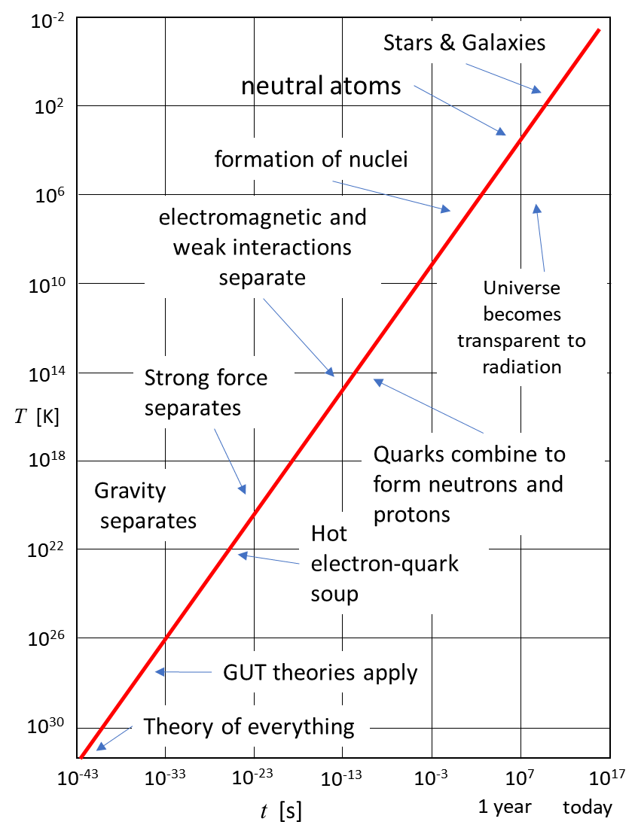

Fig. 5. The temperature of the Universe is displayed as a function of time since the Big Bang.

[View: Planets, Stars, Galaxies, and the Universe](https://www.e-education.psu.edu/astro801/)

[VISUAL PHYSICS ONLINE](http://www.physics.usyd.edu.au/teach_res/hsp/sp/spHome.htm)

If you have any feedback, comments, suggestions or corrections please email:

Ian Cooper School of Physics University of Sydney

ian.cooper@sydney.edu.au