[**VISUAL PHYSICS ONLINE**](http://www.physics.usyd.edu.au/teach_res/hsp/sp/spHome.htm)

**DECAY SERIES**

**RATE OF DECAY / HALF-LIFE**

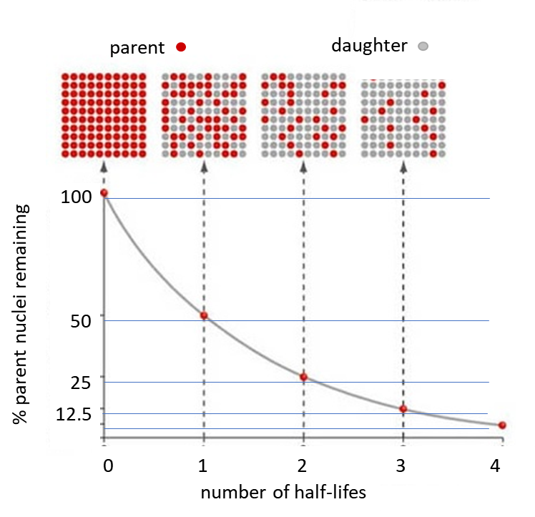

**DECAY SERIES**

Often when one radioactive isotope decays into another, the daughter is also unstable and further decays occur until a stable nucleus is created. Such successive decays are said to form a **decay series**. Because of such decay series, certain radioactive elements are found in nature that otherwise would not exist.

The isotope of uranium-238 undergoes a succession of decays until the stable isotope of lead-206 is created.



**RATE OF DECAY and HALF-LIFE**

A macroscopic quantity of any radioactive isotope consists of an enormous number of unstable nuclei. The decay of an individual nucleus is a **random event** and can’t be predicted. However, in a given period of time, we can predict how many nuclei will decay, by assuming that each nucleus has the same probability of decaying in each second that it exists. The number of decays Δ*N* that occur in a very short period of time Δ*t* is proportional to the total number of radioactive nuclei present at that instant of time



The negative sign indicates the number of radioactive nuclei is decreasing and the constant of proportionality *λ* is called the decay constant. Each different isotope has its own unique decay constant. The greater the value of the decay constant, the more decays that occur in a given time interval.

If at a time *t* = 0, there are *N*0 radioactive nuclei, then at some later time *t* the number of remaining radioactive nuclei *N*, is given by the **radioactive decay law**



So, the number of radioactive nuclei decreases exponentially with time. The rate of decay is given often specified by its **half-life *T*1/2** and the value of the decay constant λ. The half-life is defined to be the time interval it takes for half the number of the nuclei to decrease by the factor 2.

*t* = *T1*/2 *N* = *N0* / 2 ⇒ (1/2) = *e*-λ t

⇒ *T1*/2 = ln(2) / λ = 0.693 / λ

natural logarithm ln( ) ≡ loge( )

⇒ λ = ln(2) / *T1*/2 = 0.693 / *T1*/2

The longer the half-life of an isotope, the smaller the decay constant, and the more slowly does it decay.

The **mean life** **τ** (average lifetime – on average how long nuclei survive before they decay) of an isotope is given by



The rate of decay *A* or the number of decays per second is

 hence 



The activity *A* also decreases exponentially with time.

The half-lives of radioactive isotopes vary from as short as 10-22 s to about 1021  yr (~ 1028 s).

The isotope of gas radon 222Rn86 decays into the isotope of polonium 218Po84 via alpha decay. The energy of the emitted helium nucleus is 5.59 MeV and its half-life is 3.8235 days. Figure (3) shows the exponential decay of radon starting with a sample of 100 g of the gas. The mass of radon gases halves in each successive half-life time interval.



Fig. 3. The exponential decay of radon.

[VISUAL PHYSICS ONLINE](http://www.physics.usyd.edu.au/teach_res/hsp/sp/spHome.htm)

If you have any feedback, comments, suggestions or corrections please email:

Ian Cooper School of Physics University of Sydney

ian.cooper@sydney.edu.au