[**VISUAL PHYSICS ONLINE**](http://www.physics.usyd.edu.au/teach_res/hsp/sp/spHome.htm)

**ORIGIN OF THE ELEMENETS**

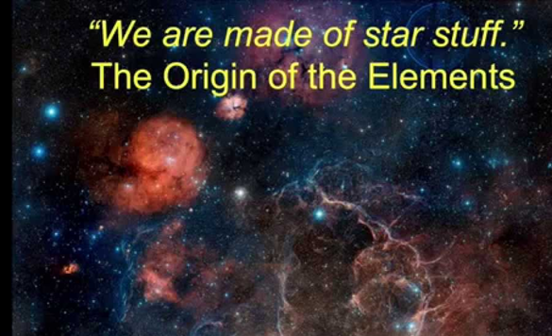

[Watch Video: The Origin of the Elements](https://www.pbslearningmedia.org/asset/phy03_vid_origin/)

The ordinary matter in our universe (known as baryonic matter) is made up of 94 naturally occurring elements. It is one of the stunning achievements of twentieth century science that the question of where these elements came from has now been answered.

The story of the origin of the elements is intimately intertwined with the evolution of our Universe. It is also a central part of the evolution of life on Earth. The elements that make up our bodies reflect the cosmic abundance of the elements, and their presents on the Earth is, itself, part of the evolutionary history of stars.

“We are not simply in the universe; we are born from it.”

(Tyson 1998).

"Historians of science a hundred years hence will remember twentieth-century astronomy for two main accomplishments:

* The development of a cosmology of the early Universe, from creation through consequent expansion.
* The understanding of stellar evolution - stars change as they age and that these changes in turn alter their local environment and the chemical makeup of their parent galaxy.

Because all elements heavier than helium have been nucleosynthesized by stars, all the heavier chemical elements that are the raw materials of life were one time part of a stellar life cycle. We are the product of the stars. This is one of the most profound insights to have arisen out of twentieth-century astronomy. Life is clearly a property of the evolving universe made possible by stellar evolution.

A few minutes after the Big Bang, neutrons and protons are formed when the temperature had dropped enough to make the existence of free quarks impossible. On further cooling, neutrons and protons could undergo thermonuclear fusion and form light elements. The light element formed just after the Big Bang include: hydrogen 1H1, its isotope deuterium 2H1, helium 3He2 4He2 and the isotope of lithium 7Li3. It is easier to understand that the most abundant atoms in our universe should be the ones that formed first from subatomic particles. The formation of these light nuclei is called **primordial nucleosynthesis**.

For a while the number of protons and neutrons was almost the same, until the temperature dropped enough to make the slight mass difference favour the protons (neutron is slightly more massive than the proton). Isolated neutrons are not stable, so the ones that survived are the ones that could bond with protons to form deuterium, helium, and lithium.

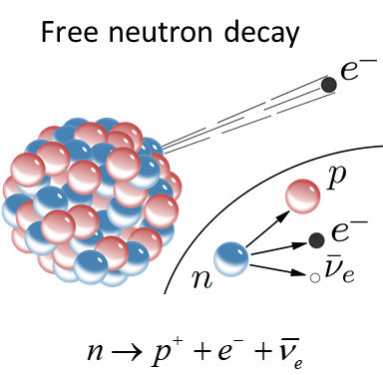

So, the light elements formed in the first few minutes after the Big Bang. But, it was millions of years later before the heavier elements were formed in stars via nuclear fusion processes.

Nucleosynthesis of elements can be used as a test of the Big Bang model. By measuring the present relative abundances of the elements, physicists can work backwards and test the conditions of the early Universe when neutrons and protons fused to form the first elements.

Two of the main processes for producing energy in stars and creation of elements are called the **proton-proton chain** and the **carbon** or **CNO cycle**.

**Proton - Proton Chain**

The proton-proton chain is a series of reactions that eventually converts four protons into two alpha particles. As stars from due to gravitational attraction of interstellar matter, the thermal energy produced by the attraction is enough to cause protons to overcome their Coulomb repulsion and fuse.

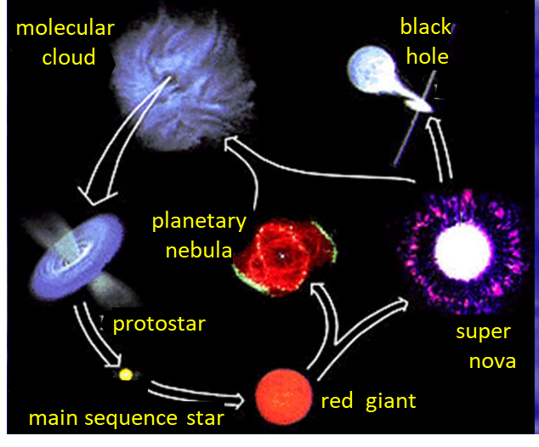

Fig. 1. The evolution of stars.

Deuterium is produced in a weak interaction beta decay process



This process is extremely slow, only 1 collision in about 1026 produces a reaction. This is good, otherwise the Sun would *explode*.

The deuterons are then able to combine with a proton to form helium



The helium-3 are then able to form helium-4



In this set of reactions, a total of six protons  are required to produce one  and two . The process consumes four protons (). The total *Q* (kinetic energy created) for the six protons to produce one  nucleus is 24.7 MeV. An additional 2 MeV is derived from the annihilation of two positrons  for a total of 26.7 MeV.

The proton-proton chain is extremely slow because of the initial fusing of two protons. As these chain reactions proceed, the star’s temperature increases, and eventually  nuclei are formed by a process that converts three  into .

**CNO or Carbon Cycle**

Another, cycle to produce  and  is called the **carbon** or **CNO cycle**.



Four  and one  nuclei are required to produce  and . The  only acts as a catalyst in the set of reactions.

The proton-proton chain is probably responsible for most of the Sun’s energy. The CNO cycle requires temperatures greater 20x106 K because of the higher Coulomb repulsion between  and  and this is higher than temperatures in our Sun. So, it is unlikely that the CNO cycle is activated in the Sun.

A hydrostatic equilibrium exists in stars between the gas pressure acting to produce an expansion and the gravitational attraction tending to contract the star. As the lighter elements are consumed in fusion reactions to produce heavier nuclei, the gravitational attraction is greater than the gas pressure and the star contracts in size resulting in an increase in temperature of the star’s interior. The higher temperature permits higher Z (atomic number) nuclei to fuse. This process continues in a star until a large part of the star’s mass is converted to iron. The star then collapses under its own gravity become depending on its mass, a white dwarf, neutron star, or a black hole or it may undergo a supernova explosion.

The vast majority of the known mass of the Universe is composed of hydrogen and helium. Approximately 25% of the known mass being nuclei and the remaining 75% being all most free protons . The other elements exist in only minute quantities.

The elements heavier than iron (Z = 28) are produced during a supernova event. A **supernova** is an astronomical event that occurs during the last stellar evolutionary stages of a massive star's life, whose dramatic and catastrophic destruction is marked by one final titanic explosion. This causes the sudden appearance of a "new" bright star, before slowly fading from sight over several weeks or months.

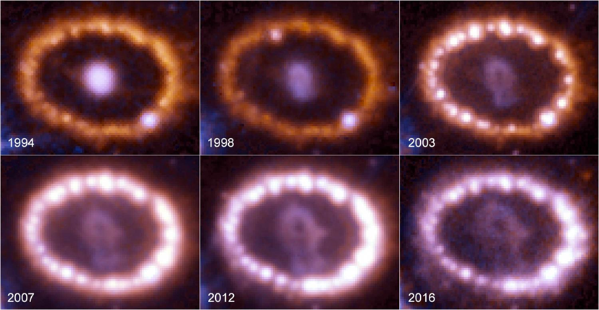

Fig. 2. The evolution of the supernova 1987A.

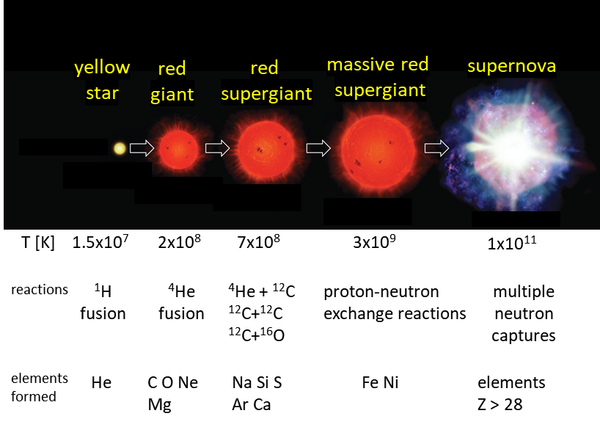

Fig.3. Stages in the life cycle a massive star, showing the temperatures at which the primary nuclear reactions occur and the elements mainly produced.

The calculations of the abundance of the elements from Big Bang model and in excellent agree with the observed abundances of the elements.

The latest view:

[Physics Today Jan 2018 Formation of the heaviest elements](http://physicstoday.scitation.org/doi/10.1063/PT.3.3815?utm_source=Physics%20Today&utm_medium=email&utm_campaign=9059989_Q%20-%20TWIP%208%E2%80%9312%20January&dm_i=1Y69,5E6QD,E1N0MB,KV8JP,1)

[VISUAL PHYSICS ONLINE](http://www.physics.usyd.edu.au/teach_res/hsp/sp/spHome.htm)

If you have any feedback, comments, suggestions or corrections please email:

Ian Cooper School of Physics University of Sydney

ian.cooper@sydney.edu.au