[**VISUAL PHYSICS ONLINE**](http://www.physics.usyd.edu.au/teach_res/hsp/sp/spHome.htm)

**NUCLEAR FISSION**

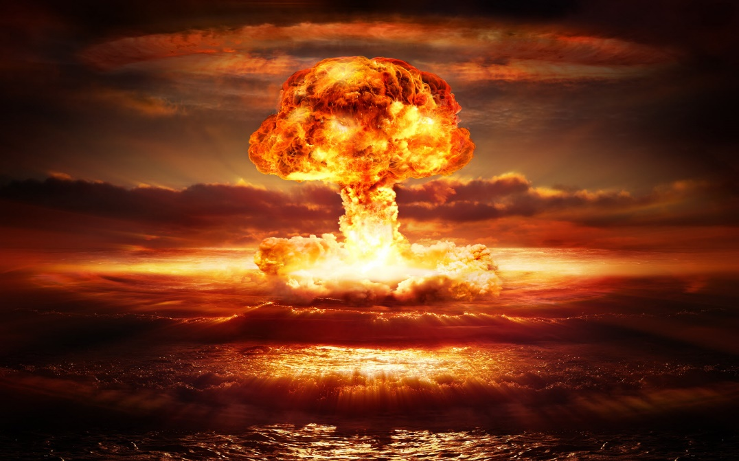

A very significant nuclear transmutation which is initiated by a neutron is called **nuclear fission**. In this transmutation, which can take place when only certain heavy nuclei such as 235U92 absorb an incoming neutron. The heavy nucleus then splits into two lighter nuclei (fission fragments) with two or more other neutrons being released. The mass of products is less than original mass of the nucleus that split. The energy liberated is mainly the kinetic energy of the products.

Usually the fragments are unstable and a series of radioactive decays occur until stable nuclei are formed. This is why the **fallout** from a nuclear reactor accident or an atomic bomb blasts are highly radioactive and potentially fatal to many life forms.

Typical fission reactions are:

235U92 + 1n0 🡪 236U92* 🡪 144Ba56 + 89Kr36 + 31n0

235U92 + 1n0 🡪 236U92* 🡪 140Xe54 + 89Sr38 + 21n0

The contributions to the energy released in a typical fission of a heavy nucleus are:

* ~ 84% appears as kinetic energy of the fission fragments.
* ~ 3% appears as kinetic energy of the released neutrons.
* ~ 3% emission of gamma rays.
* ~ 10% given off in the radioactive decay of the fission fragments.

The first artificially induced nuclear fission reaction was achieved by Enrico Fermi in 1934, although at the time he did not realise that fission had occurred. Fermi bombarded uranium with neutrons and produced radioactive products that emitted β particles. Fermi assumed that he had produced a new isotope of uranium, 239U92, and that this had undergone beta decay to form an isotope of the first transuranic element, atomic number 93, known today as 239Np93 (neptunium). Further transuranic elements could then be formed by further beta decays.

Two German chemists, Otto Hahn and Fritz Strassman, repeated Fermi’s experiments in 1938 and used careful isotopic half-life analysis to identify the products of the reaction. To their surprise they found that not only was 239U92 produced but also many lighter elements, such as (141Ba56, 92Kr36), (144Ba56, 89Kr36), (149La57, 85Br35), (143Xe54, 90Sr38). Hahn and Strassman though that these lighter elements were the products of the splitting of a uranium nucleus. This was confirmed in 1939 by two Austrian physicists, Lise Meitner and Otto Frisch, who showed that when a 235U92 nucleus absorbs a neutron, the nucleus splits into two smaller nuclei and emits one, two or three neutrons in the process. Meitner & Frisch called the process **nuclear fission**.

We can visualize the fission process by viewing the nuclear as a drop of liquid. Then the absorption of a neutron by a nuclear causes the nucleus (the liquid drop) to vibrate. When the nucleus vibrates like a liquid drop the spherical shape is distorted and becomes more pear-shaped. The strong nuclear force is only short ranged and acts only between adjacent nuclei. When the distortion occurs, the attractive force holding the bulk of the nucleus together is weakened and this may lead to the nucleus splitting into two lighter nuclei. This explanation of fission is referred to as the **liquid drop model**.



Fig. 1. Fission according to the liquid drop model.

Because each fission event releases two or more neutrons, while only one neutron is required to initiate the fission process, an avalanche of fissions can occur in a sample of fissionable material. When uncontrolled, an **uncontrolled chain reaction** can occur where an immense amount of energy is liberated in a very short period of time. If we assume that two neutrons emitted in each fission and that 10-8 s elapses between the emission and absorption, a chain reaction starting with a single fission will release 2x1013 J of energy is less than 10-6 s.

**An uncontrolled chain reaction can cause an explosion of exceptional magnitude**.



Fig. 2. Chain reaction.

When properly controlled, so that one neutron per fission causes another fission reaction, a **controlled chain reaction occurs** in which the energy output per second is constant. This occurs in a **nuclear reactor**. This type of reaction is very efficient. For example, in one day to give an energy output of 24 000 kWh requires 1 g of a suitable radioactive isotope compared with 3 tons of coal.

**NUCLEAR FISSION REACTOR**

The enormous about of energy given out in a nuclear fission reaction makes it a suitable process for the generation of electricity in a **fission reactor**. The energy release from uranium is ~ 1014 J.kg-1 whereas for coal it is ~ 107 J .kg-1.

**Main fission reactor components**

* Source of **fissionable material** (**fuel rods**)
* A **moderator** to slow down neutrons to increase the probability of absorption by a nucleus to split into the two fission fragments and release other neutrons.
* Movable **control rods** absorb neutrons to maintain the reactor at a critical level to maintain a self-sustaining chain reaction and in the event of an accident can be dropped to be into reactor vessel to shut-down the fission process.
* A **reflector** surrounding the fuel rods and moderator to prevent the loss of neutrons thereby improving the efficiency of the reactor.
* A **radiation shield** surrounding the reactor vessel.
* **Heat exchanger** for the transfer of the energy released by the fission reactions to produce steam.
* The steam from the heat exchanger turns a **turbine** so that electricity is produced in an **electric generator**.

The main components of a **pressurized water reactor** are shown in figure 3.



Fig. 3. Pressurized water reactor.

In a uranium fission reactor, the fuel is the isotope **235U92** and not the main isotope 238U92 found in natural uranium ore (99% 238U92). A 235U92 nucleus can absorb a slow moving neutron to give a 236U92 nucleus which then undergoes fission, but this does not happen with a 238U92 nucleus. So the natural uranium ore must be enriched to ~ 1% 235U92 to give a **critical mass** of fuel.

If the amount of uranium exceeds the critical mass a sustained nuclear reaction is possible as few neutrons are lost and there are sufficient neutrons available to initiate further fission reactions. If the mass of fuel is less than the critical mass, most neutrons escape before additional fissions occur and the chain reaction is not sustained.



Fig. 4. The minimum mass of uranium required for a sufficiently large self-sustaining chain reaction is called the critical mass.

The uranium can’t be enriched using chemical methods. The uranium must be enriched by physical means using gaseous diffusion of UF6 in giant processing plants. The molecules of 235U diffuse slightly more easily than 238U molecules (due to mass differences). After about 1500 stages of diffusion a greater percentage of 235U can be obtained. Also, giant gas centrifuges can be used to process the natural uranium ore.

The probability that a 235U92 nucleus will absorb a neutron is increased if they are moving slowly. But, the neutrons emitted during fission are moving very fast. To slow down the neutrons a **moderator** is used. The moderator is used to elastically scatter the high-energy neutrons and thus reduce their energy. The best moderators are those which the mass of its atoms are similar to the mass of a neutron (a billiard ball can come to rest by striking another billiard ball but will bounce of a much more massive ball with little change in speed). Some material commonly used include deuterium 2H1 (heavy water), carbon (graphite), boron and beryllium.

To have a self-sustaining chain reaction, then, at least one neutron produced must cause another fission to occur. It most important to control the number of neutrons. If the less than one neutron is available for other fissions, then the reactor is **subcritical**. If the number of neutrons available for other fissions is more than one, then the reactor would become **supercritical** which would be extremely dangerous. The number of neutrons is controlled by **movable control rods** and a **reflector**. The control rods are usually made from cadmium because cadmium atoms can easily absorb neutrons thus reducing the number of neutrons that would otherwise cause more fissions. The position of the control rods is continually adjusted so the reactor is just in a **critical** condition.

In an emergency, the control rods can be dropped into the reactor vessel to shut down the fission process. The reflector is often just water, from which neutrons are back scattered into the fuel area.

The reactor must be contained within a secure vessel with adequate radiation shielding to project people working in the reactor.

The purpose of the reactor is to generate electricity. In a pressurized water reactor, the moderating water is under high pressure and circulates from the reactor to an external heat exchanger where it produces steam which drives a turbine to operate the electric generator.

**Reactor problems**

Serious accidents can occur in generating electricity from nuclear fission reactors.

* Radioactive elements can be released into the atmosphere and ground water.
* The safe disposal of the radioactive wastes produced in the fission process.
* Some of the waste products have half-lives of thousands of years.
* The products can be used to make nuclear weapons.

In 1979 an accident occurs at the Three Mile Island Plant in Pennsylvania, U.S.A.

In 1986 a major nuclear accident occurred at Chernobyl in the Ukraine.

Following a major earthquake, a 15 m tsunami disabled the power supply and cooling of three Fukushima Daiichi reactors, causing a nuclear accident on 11 March 2011.

**Web search**: Find out more about these three incidents.

**NUCLEAR FISSION CALCULATIONS**

Calculate the energy released in the fusion reaction

235U92 + 1n0 🡪 236U92* 🡪 136Xe56 + 88Sr36 + 121n0

Conservation of energy – assume initial and final kinetic energies neutrons are negligible

Energy of products = Energy of reactants

[*M*(Xe) + *M*(Sr) + 12*M*(n)] *c*2 + *K*products = [*M*(U) + *M*(n)] *c*2

M(Xe) = 135.907220 u M(Sr) = 87.905614 u

M(n) = 1.008665 u

M(U) = 235.043923 u 1u = 931.5 MeV

*K*products = [*M*(U) - *M*(Xe) - *M*(Sr) - 11*M*(n)]*c*2

= [235.043923 – 135.907220 – 87.905614 –

(11)(1.008665)](931.5) MeV

*K*products = 126.5 MeV

|  |
| --- |
| **Example**  What initial mass of 235U92 is required to operate a 500 MW reactor for 1 year? Assume 40% efficiency and the energy released in the fission of one uranium atom is on average 200 MeV.  Find the energy consumed in MeV by the power station in one year at 40% efficiency  *P* = Δ*E* / Δ*t* 1 eV = 1.6×10-19 J 1 MeV = 1.6×10-13 J  Energy required in one year  *E* = *P* Δ*t*  = (1/0.40)(500×106)(1)(365)(24)(60)(60) / (1.6×10-13) MeV  Δ*E* = 2.45×1029 MeV  Find the number *N* of uranium atoms that undergo fission  *N* = 2.45×1029 / 200 = 1.22×1027 atoms of uranium  Find the total mass *mtot* of uranium  molar mass of 235U *M* = 235×10-3 kg  mass of 235 atom *m*  Avogadro’s number *NA* = 6.02×1023  *M* = *NA m* *Mtot* = *Nm* *m* = *M* / *NA*  *Mtot* = (*N* / *NA*) *M* = (1.22×1027 / 6.02×1023) (235×10-3) kg  ***Mtot* = 480 kg** |

**MANHATTAN PROJECT**

In January 1939, a Physics Conference took place in Washington (U.S.A.) about the possibility of producing an atomic bomb. Some scientists argued that the technical problems involved in producing such a bomb were too difficult to overcome, but the one thing they were agreed upon was that if such a weapon was developed, it would give the country that possessed it the power to blackmail the rest of the world. Several scientists at the conference took the view that it was vitally important that all information on atomic power should be readily available to all nations to stop this happening.

On 2nd August, 1939, three Jewish scientists who had fled to the U.S.A. from Europe, Albert Einstein, Leo Szilard and Eugene Wigner, wrote a joint letter to President Franklin D. Roosevelt, about the developments that had been taking place in nuclear physics. They warned Roosevelt that scientists in Germany were working on the possibility of using uranium to produce nuclear weapons. Roosevelt responded by setting up a scientific advisory committee to investigate the matter.

In May, 1940, Germany invaded Denmark, the home of Niels Bohr, the world's leading expert on atomic research. It was feared that he would be forced to work for Nazi Germany. With the help of the British Secret Service he escaped to Sweden before being moving to the United States.

In 1940, a project was started in the U.S.A. to develop atomic bombs for use in the war against Germany and Japan. This was going to be the very first use of fission. President Roosevelt after being approached by leading scientists including Einstein authorised a program known as the **Manhattan Project** to see if an atomic bomb could be built. The project was headed by the scientist J. Oppenheimer and the administrative head General Leslie Groves. The Manhattan Project was conducted at the secret location of Los Alamos in the New Mexico desert where the first atomic bomb was exploded. Scientists recruited to produce an atom bomb included Robert Oppenheimer (USA), David Bohm (USA), Leo Szilard (Hungary), Eugene Wigner (Hungary), Rudolf Peierls (Germany), Otto Frisch (Germany), Felix Bloch (Switzerland), Niels Bohr (Denmark), James Franck (Germany), James Chadwick (Britain), Emilio Segre (Italy), Enrico Fermi (Italy), Klaus Fuchs (Germany) and Edward Teller (Hungary).

Winston Churchill and Franklin D. Roosevelt were deeply concerned about the possibility that Germany would produce the atom bomb before the allies. At a conference held in Quebec in August, 1943, it was decided to try and disrupt the German nuclear programme. In February 1943, saboteurs successfully planted a bomb in the Rjukan nitrates factory in Norway. As soon as it was rebuilt it was destroyed by 150 U.S.A. bombers in November, 1943. Two months later the Norwegian resistance managed to sink a German boat carrying vital supplies for its nuclear programme.

Enrico Fermi was in charge of the development of the first nuclear reactor (nuclear pile). Fermi had determined theoretically that a fission chain reaction should be achieved using naturally occurring uranium when one reaction would lead to another and so on, producing the required self-sustaining chain reaction. The uranium fuel was spread evenly throughout a pile of very high purity carbon blocks. The carbon blocks were designed to reduce the speed of neutrons ejected from uranium nuclei, so that they could then produce another fission reaction. Cadmium rods were also inserted throughout the pile to capture neutrons and thereby control the reaction. Fermi’s reactor was built on the squash courts under the football stadium at the University of Chicago.

On December 2nd 1942, the cadmium control rods were slowly, partially withdrawn from the pile. The amount of radiation produced and the rate and magnitude of temperature increase were in agreement with Fermi’s predictions. The reactor ran at a steady rate, indicating that the control rods were absorbing sufficient neutrons to maintain a self-sustaining chain reaction. After the Fermi’s successful demonstration of achieving a self-sustaining chain reaction, work on the Manhattan Project after began in earnest.

To build an atomic bomb it was necessary that the fission material used was subcritical during transportation but supercritical to produce the uncontrolled nuclear explosion at the right moment. The mass had to be less than the critical mass but when the bomb was to be detonation these masses were imploded by a conventional explosive charge so that criticality is attained suddenly

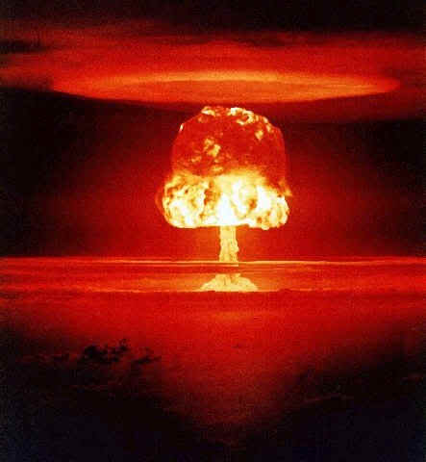Trinity was the code name of the first bomb successfully tested at Alamogordo, New Mexico on 16th July, 1945. By the time the atom bomb was ready to be used Germany had surrendered. Leo Szilard and James Franck circulated a petition among the scientists opposing the use of the bomb on moral ground s. However, the advice was ignored by Harry S. Truman, the U.S.A.'s new president, and he decided to use the bomb on Japan.

The first use of fission was to produce atomic bombs.



Fig. 5. In fission, a heavy nucleus such as uranium splits into two intermediate sized nuclei after being struck by a neutron.

Two types of bombs were developed in the Manhattan Project

**235U92 bomb – gun barrel assembly method**

The two subcritical masses 235U92 were held well apart at opposite ends of a barrel (tube). On detonation, these two pieces of uranium were compressed together so that criticality is attained suddenly. In this way the chain reaction spreads throughout the combined fission material. The result is an uncontrollable fission reaction.

The two subcritical masses of 235U92 in the form of hemispheres each had a hollow cut into their centres which were filled with Be which is a good source of neutrons. When the two hemispheres came together, the hollows close around a ball of polonium, a good source of α particles. The α particles hit the Be and produce a huge flux of neutrons, which then cause the supercritical fission reaction that leads to the explosion of the device (figures 2 and 3).



Fig. 6. A schematic diagram of the gun method to detonate a 235U92 bomb.



Fig. 7. The uranium bomb code named “little boy” that was dropped on Hiroshima on August 6, 1945.

The atomic bomb consisting of only a few kilograms of 235U92 dropped on the Japanese city of Hiroshima on August 6, 1945 had an explosive force of 20 000 tons of TNT.

**239Pu94 bomb – implosion assembly method**

A more sophisticated fission bomb consists of a just subcritical mass of 239Pu94. This subcritical mass is imploded by a preliminary chemical high-explosive. This causes a sudden compression which rapidly results in an increase in the density of the plutonium and the fission material becomes supercritical. The explosive is carefully layered in several segments surrounding a sphere of 239Pu92. The explosion crushes the sphere so that the plutonium becomes supercritical and the uncontrolled chain reaction is triggered (figure 4). The plutonium bomb was dropped on Nagasaki on August 9, 1945.



Fig. 8. Schematic diagram of the implosive method used in a 239Pu94 bomb and a picture of “fat boy”, the plutonium bomb dropped on Nagasaki, August 9, 1945.

Together, these relatively small devices killed well in excess of 100 000 people and caused massive devastation to both cities and it has been estimated that over the years around 200 000 people have died as a result of the bombs being dropped.

Japan did not surrender immediately after the first bomb on Hiroshima and a second bomb was dropped on Nagasaki three days later. On August 10, 1945 the Japanese surrendered. The Second World War was over.



Fig. 9. The mushroom cloud over Hiroshima after the dropping of the uranium atomic bomb (Little Boy) and the destructive aftermath of the bomb.

[VISUAL PHYSICS ONLINE](http://www.physics.usyd.edu.au/teach_res/hsp/sp/spHome.htm)

If you have any feedback, comments, suggestions or corrections please email:

Ian Cooper School of Physics University of Sydney

ian.cooper@sydney.edu.au