[**VISUAL PHYSICS ONLINE**](http://www.physics.usyd.edu.au/teach_res/hsp/sp/spHome.htm)

**TRANSMUTATION OF THE ELEMENTS**

**NUCLEAR FUSION**

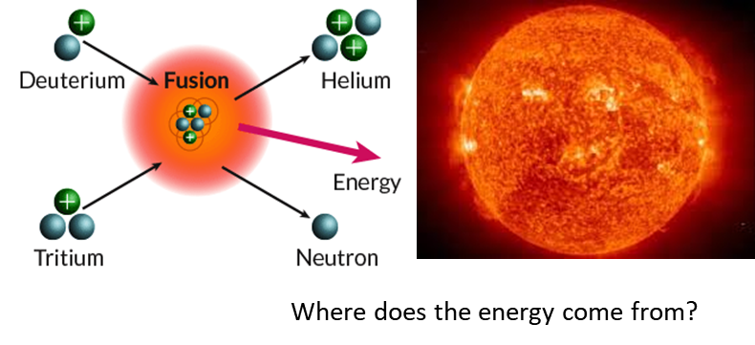

It is possible to change the structure of nuclei by bombarding them with energetic particles. Collisions which change the identities of the target nuclei are called nuclear reactions. The first nuclear reaction was performed by Rutherford in 1919 in which a nitrogen target was irradiated with α-particles from a natural radioactive source.

 nuclear transmutation

The process of building up nuclei by bring together individual protons and neutrons or building large nuclei by combining small nuclei is called **nuclear fusion**.

The mass of every stable nucleus is less than the sum of the masses of its constituent protons and neutrons.

The mass of the helium isotope 4He2 is less than the combined mass of its two protons and two neutrons. Thus, if two protons and two neutrons were to come together to form a helium nucleus there would be a loss of mass. This loss in mass is responsible for the release of an enormous amount of energy in this fusion process.

Virtually all the energy of the universe originates in the fusion of hydrogen nuclei into helium nuclei in the interior of stars.

To view the proton-proton cycle which is one of the main fusion processes for producing energy by our Sun, go to

<http://burro.astr.cwru.edu/Academics/Astr221/StarPhys/ppchain.html>

An interesting web site to visit is:

<http://education.jlab.org/index.html>

[VISUAL PHYSICS ONLINE](http://www.physics.usyd.edu.au/teach_res/hsp/sp/spHome.htm)

If you have any feedback, comments, suggestions or corrections please email:

Ian Cooper School of Physics University of Sydney

ian.cooper@sydney.edu.au