[**VISUAL PHYSICS ONLINE**](http://www.physics.usyd.edu.au/teach_res/hsp/sp/spHome.htm)

**THE STANDARD MODEL OF MATTER**

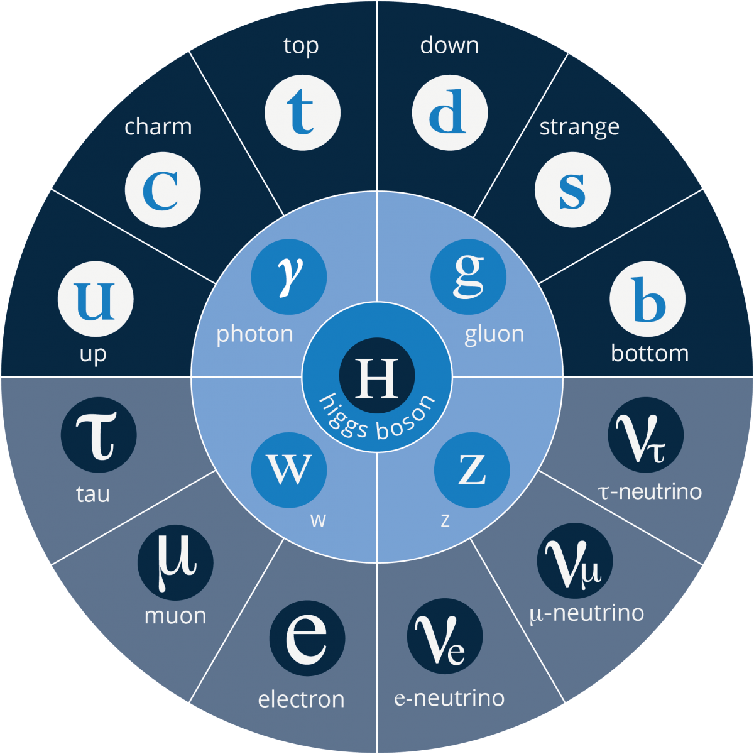

The "Standard Model" of subatomic and sub nuclear physics is an intricate, complex and often subtle thing and a complete study of it is beyond the scope of high school study and indeed beyond undergraduate university study. However, it is important and

is capable of explaining nearly all aspects of physics at its most fundamental level.

Putting things into perspective

|  |  |  |
| --- | --- | --- |
| **Object** | **Size** | **Break up energy** |
| Sand grain | 1 mm |  |
| Virus | 100 nm (10-7 m) | 1 meV |
| Atom | 100 pm (10-11 m) | 10 eV |
| Nucleus | 10 fm (10-14 m) | 8 MeV |
| Nucleon | 1 fm (10-15 m) |  |
| Quark | < 1 am (10-18 m) |  |

The nature of the atom was established in 1911 by Rutherford’s experiments on the scattering alpha particles off thin gold films. There were more large angle scattering than expected from the gold atoms in which the positive and negative charges were assumed to be spread out over the whole atom. The implication of the scattering experiments was that an atom had a small positive nucleus so that its strong electric field of the nucleus could deflect the alpha particles. Thus, an atom consists of a small heavy central positive nucleus surrounded by electrons with most the atom being simply empty space.

**Exercise**

Calculate how energetic must an alpha particle be in order to reach the surface of a gold nucleus in a head on collision. (*R*nucleus = I.23 A1/3 fm *A*gold = 200 ans: *E*alpha ~ 31 MeV)

To investigate the structure of matter, high energy projectiles from an accelerator are smashed into a target. High energies are required for two reasons.

1. The projectiles must have very short deBroglie wavelengths as the wavelength of the matter wave needs to about the same order of magnitude of the dimensions to be investigated in the target.
2. The incident particles must have enough energy to produce **new** particles in the collision of the constituents of the target.

From experiments using accelerators many **elementary particles** other than the electron, proton and neutron have been discovered.

The most widely accepted theory of elementary particles at present is the **Standard Model**.

All matter consists of:

* **Fermions** which exert attractive or repulsive forces on each other.
* **Gauge bosons** which are force-mediating particles exchanged between fermions.

There are two varieties of **fermions** both of which are divided into **three** generations:

* **Leptons** are essentially point-like fundamental particles.
* **Quarks** maybe also point-like (< 10-18 m) and are always found confined together and never as isolated particles in a free state. Quarks make up particles called **hadrons**.

Everything from galaxies to mountains to molecules is made from fermions (quarks and leptons). But that is not the whole story. Quarks behave differently to leptons.

**ANTI-MATTER**

For every type of matter particle, there also exists a corresponding **anti-matter** particle, or antiparticle. Anti-particles look and behave just like their corresponding matter particles, except they have opposite charges. For instance, a proton is electrically positive whereas an anti-proton is electrically negative. The **positron** is the anti-particle of the electron.

Gravity affects matter and anti-matter the same way because gravity only depends upon the masses of particles and not their charges. The usual symbol for an anti-particle is a bar over the corresponding particle symbol, e.g., the neutrino  and the anti-neutrino . When a matter particle and anti-matter particle meet, they annihilate into pure energy with the emission of two photons. The idea of anti-matter is strange, made all the stranger because the universe appears to be composed entirely of matter, and nobody knows why! Anti-matter seems to go against everything you know about the universe.

**Creation**

Particle / anti-particle pairs can be created from energy, e.g., a photon if its energy is greater than the total mass-energy of the pair of particles created. For example, an electron / positron pair can be created near the nucleus which absorbs some momentum so that momentum can be conserved



**Annihilation**

When a particle and its anti-particle meet, they annihilate and produce energy, e.g.,



Need to have at least two photons produced to conserve energy and momentum



**Fermions and bosons**

The terms fermions and bosons describe the statistics of particles, i.e., how particles behave in a quantum system, for example, electrons in a crystal or an atom; quarks in a hadron; and nucleons in a nucleus.

Fermions are particles that obey the Pauli Exclusion Principle

Two particles in a quantum system can’t occupy the same quantum state

Fermions have a property called **spin** and the **orientation of the spin** together determines their behaviour in quantum systems, for example, in an external magnetic field. The spin for fermions always have a half integer value of 1/2 or 3/2 or 5/2, … . Two particles with the same magnitude of spin but different spin orientations have different quantum properties, so for example, two otherwise identical quarks can coexist in the same nucleon with their spins pointing in opposite directions and two electrons can exist together in a 1s subshell.

Bosons are particles that do **not** obey the Pauli Exclusion Principle and have zero or integer spins (0, 1, 2, … ). An unlimited number of bosons can co-exist simultaneously in the same quantum state.

The Standard Model is a good theory. Experiments have verified its predictions to incredible precision, and all the particles predicted by this theory have been found. But it does not explain everything:

* Gravity is not included in the Standard Model.
* The Standard Model in itself does not predict particles masses. It is believed that the **Higgs boson** may be the key to understanding the mystery of particle masses.
* Why are there only three generations or families of fundamental particles?
* Do quarks and leptons actually consist of more fundamental particles?

The everyday world of atoms and molecules are made up of only the first generation quarks and leptons, the first generation antiparticles and higher generations only make fleeting appearances with a couple of exceptions e.g., the positron and the electron antineutrino. Positrons are produced quite frequently in beta decays and neutrino interactions are so rare that once created in say beta decay they continue roaming the universe for a long time.

**BOSONS – force carrier particles**

The Standard Model asserts that the forces governing the interaction of quarks and leptons can be understood by using the quantum mechanics of fields. Quantum field theory suggests that forces between particles are due to the **exchange of special force-carrying particles** called **gauge bosons**. Bosons are particles which do not obey the Pauli Exclusion Principle, all the bosons in a quantum system can occupy the same quantum state.

**Force carrier particles – gauge bosons**

(graviton, photon, gluon, W+  W-  Z0)

In the Standard Model of Matter there are **four** fundamental forces.

* **Gravitational force**: a long-range force acting on all masses in the universe. It is the weakest of all the forces. It is believed to be carried by the **graviton**, which has not yet been observed experimentally.
* **Electromagnetic force**: a long-range force that acts on all charges in the universe. It holds atoms and molecules together. It is carried by the **photon**.
* **Strong nuclear force**: holds protons and neutrons together in the nucleus. It is a short-range force operating at nuclear distances (~ 10-15 m). In the Standard Model, it also binds quarks together and is carried by the **gluon**.
* **Weak nuclear force**: interaction between particles such as electrons to change them into other forms. It is short-ranged (~ 10-17 m). It is responsible for beta decay. In the Standard Model, it also transforms one quark type into another and is carried by the W+, W- and Z0 bosons.

**The interactions**

|  |  |  |  |  |  |  |
| --- | --- | --- | --- | --- | --- | --- |
| **Force** | **Exchange boson** | **“*charge*”** | **Range** | **Mass**  ***m* / *m*p** | **Relative Strenght** | **No. of types** |
| Gravitation | graviton | Mass | infinite | 0 | 10-39 | 1 |
| Weak nuclear | W+ W- Z0 | Weak | ~10-18 m | ~ 90 | 10-9 | 3 |
| Electromagnetic | photon | Electric | infinite | 0 | 10-2 | 1 |
| Strong nuclear | gluon | Colour | ~ 10-15 m | 0 | 1 | 8 |

**Which particles “feel” forces**

|  |  |  |  |  |
| --- | --- | --- | --- | --- |
| **Particle** | **Gravity** | **Weak** | **Electro-magnetic** | **Strong** |
| Charged leptons | y | y | y | n |
| Neutral leptons | y | y | n | n |
| Quarks | y | y | y | y |
| photons | y | n | y | n |
| Z0 | y | y | n | n |
| W+ W- | y | y | y | n |
| gluons | y | n | n | y |

Interactions are mediated by exchange bosons, meaning that particles interact and exert forces on one another by exchanging a particle. Each force has a different kind of particle. This model arises from the electric force, where a charge (on a particle)

produces a surrounding field and another charge (on a particle) feels a force. When the electromagnetic radiation was found to consist of photons the idea of interaction by particle exchange was born.

**Fermions: LEPTONS**

There are **six** leptons pairs (particle / antiparticle), three pairs of which have an electrical charge and three pairs of which do not. They appear to be point-like particles without internal structure. The best known lepton is the **electron** **e**. The other two charged leptons are the **muon μ** and the **tau τ**, which are charged like electrons but are much more massive. The other leptons are the three pairs of **neutrinos ν**. Neutrinos have zero electrical charge, very little mass, and they are very hard to find. Note that the antielectron has a special name, the **positron**. Leptons do not experience the strong force and interact through the weak nuclear force and the electromagnetic force if they are charged.

|  |  |  |  |  |
| --- | --- | --- | --- | --- |
| **LEPTON FLAVOUR** | **PARTICLE**  **(charge)** | **ANTIPARTICLE**  **(charge)** | **MASS**  **(MeV/c2)** | **Lifetime**  **(s)** |
| **Electron** | e- (+e) | positron e+ (+e) | 0.511 | stable |
| Electron-neutrino | (0) | (0) | < 3x110-6 | stable |
| **Muon** | (-e) | (+e) | 105.7 | 2.2x10-6 |
| Muon-neutrino | (0) | (0) | < 0.19 | stable |
| **Tau** | (-e) | (+e) | 1777 | 2.9x10-13 |
| Tau-neutrino | (0) | (0) | < 18.2 | stable |

* mass of proton 938.3 MeV/c2

mass of neutron 939.6 MeV/c2

The mass of the neutrinos are uncertain and maybe zero, however evidence gathered over recent years of neutrino oscillations (neutrinos in flight changing generations or flavours) requires that in at least one of the generation neutrinos must have mass. Nevertheless it is still very small.

There are **three** generations of leptons:

|  |  |  |
| --- | --- | --- |
| 1st | 2nd | 3rd |
| e |  |  |
|  |  |  |

The second and third generations charged leptons (muons and taus) are unstable and decay to lower generations. The electron hasn't anywhere to decay to. The heavier leptons, the muon  and the tau , are not found in ordinary matter at all. This is because when they are produced they quickly decay or transform into lighter leptons. Sometimes the tau lepton will decay into a quark – antiquark pair and a tau neutrino. For example, the muon decays into an electron and two neutrinos



Electrons and the three kinds of neutrino pairs are stable and the types we commonly see around us.

**In all interactions the number of each type of lepton is conserved**.

[VISUAL PHYSICS ONLINE](http://www.physics.usyd.edu.au/teach_res/hsp/sp/spHome.htm)

If you have any feedback, comments, suggestions or corrections please email:

Ian Cooper School of Physics University of Sydney

ian.cooper@sydney.edu.au