[**VISUAL PHYSICS ONLINE**](http://www.physics.usyd.edu.au/teach_res/hsp/sp/spHome.htm)

**Millikan’s Oil-Drop Experiment**

Robert Andrews Millikan (1868 –1953) was an American experimental physicist honoured with the Nobel Prize for Physics in 1923 for the measurement of the elementary electronic charge and for his work on the photoelectric effect. His work in measuring the charge on an electron is one of the most famous of all physics experiments.

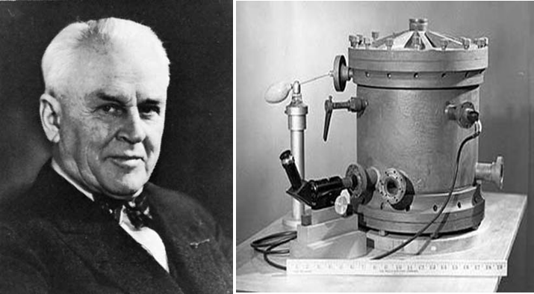

The interpretation of the measurement of the *e/me* ratio depends on the assumption that the charge on the electron is the same as the charge on any singly ionised atom. Many attempts had been made to measure the charge on an electron, but all results were very inaccurate. However, Millikan in 1909 overcome many of the experimental difficulties faced by other experimentalists in his liquid-oil-drop experiment. His method was based on using oil drops with only small numbers of electrons to give the charge.

[View video: Bozeman Science Elementary charge](https://www.youtube.com/watch?v=Fz-QPXwhQTI)

A version of Millikan’s apparatus is shown in figure 1. Small droplets of a suitable oil are released from an atomiser into a hole in the upper plate of a parallel plate capacitor. The oil drops become charged by picking up stray electrons or using X-rays or alpha particles to produce further ionisations and hence extra electrons. The motion of single oil drops which are illuminated by a bright light source are observed through a microscope.

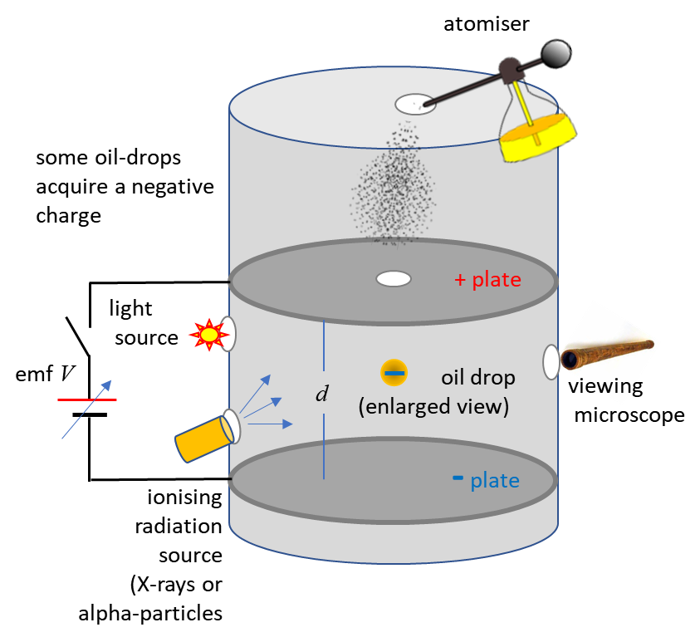

Fig. 1. A schematic diagram of Millikan’s apparatus for measuring the electronic charge *e.*

The motion of a **single oil drop** was observed through the microscope as the drop was falling with zero electric field. When the electric field was switched on, the motion of the oil drop rising was observed. Repeated time interval measurements were made on a single oil drop as in moved up and down through a fixed distance as the electric field was switched on-off-on … .

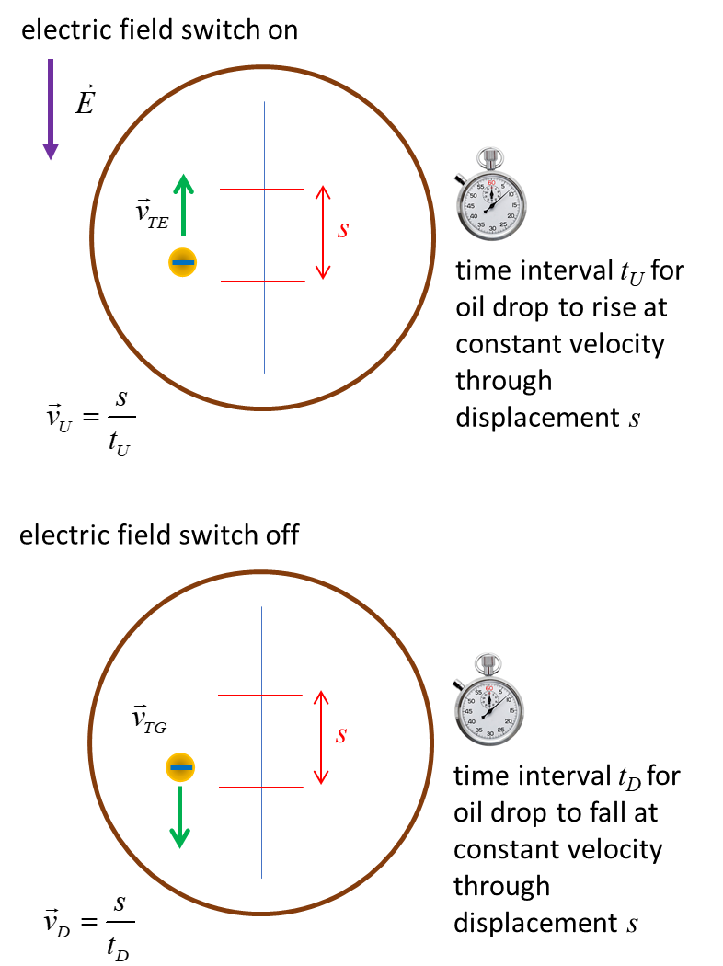

Fig .2. View through the microscope. When the oil drop was moving at a constant velocity, the time interval *t* for the oil drop to move through a displacement *s* could be measured using the graticule markings on the microscope. The terminal velocity is given by .

When the net force acting on an oil drop is zero, the acceleration is also zero and the oil drop moves at a constant velocity equal to its [terminal velocity](http://www.physics.usyd.edu.au/teach_res/hsp/sp/mod2/m2_FM.pdf) as shown in figure 2.

When the oil drop is falling due to the gravitational force, the terminal velocity is



When the oil drop is rising due to the electric force, the terminal velocity is



The distance between the parallel plates is *d* and the potential difference is *V.* So, the magnitude of the uniform electric field between the plates is



The forces acting on an oil drop are shown in figure 3.

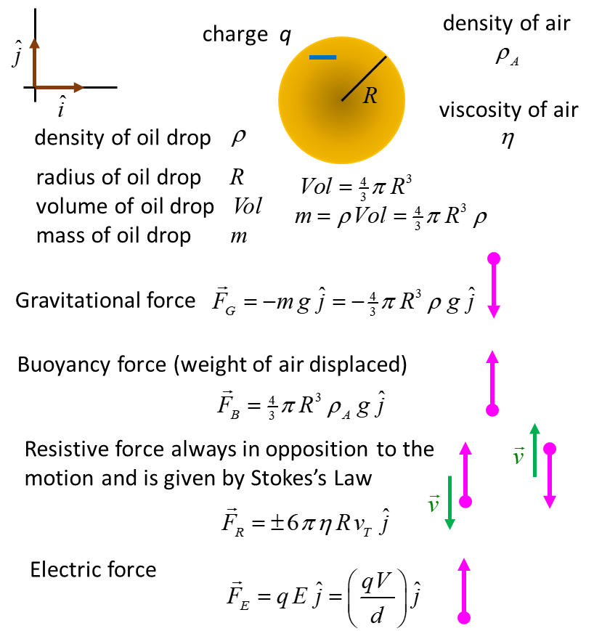

Fig. 3. The forces acting on the oil drop.

When zero voltage is applied across the plates of the capacitor, the oil drop falls under the influence of the gravitational force. As the speed of the oil drop increases, the resistive force acting on the oil drop also increases until the terminal velocity of the oil drop is reached. The net force acting on the oil drop is then zero.



By measuring the time interval  for the oil drop to fall the distance *d,* it is then possible to calculate the radius *R* of the oil drop



The voltage *V* applied to capacitor is such that the oil drop can be forced to rise at a constant velocity  when the net force on the oil drop is zero.



The final equation for *q* looks quite intimidating. But for small falling oil drops Stokes’s Law is not a good approximation and Millikan included a correction factor into the equation for *q.*

The values for the acceleration due to gravity, the density and viscosity of air are well known. The measurements for the distance between the capacitor plates, the voltage between the plates and the graticule spacing of the microscope easy to make. So, Millikan only had to measure the transit time intervals  and  to estimate the charge on a single oil drop.



But these time intervals are not so easy to make. This is a very difficult and tedious experiment to perform because of the challenge in timing a single oil drop as the voltage to the capacitor is switched on and off and the charge on the oil drop sometimes changes. Yet, Millikan was able to measure *q* for many thousand oil droplets.

So, in his experiments, a single oil drop is timed over measured distances, rising and falling as long as possible, and these measurements repeated for other oil drops. He concluded from his experimental data, that the charge on an oil drop is always an integral multiple of a certain basic unit.



where *N* is an integer, and the charge on an oil drop always changes by a discrete amount which again is an integral multiple of the basic unit *e.*

Thus, this experiment gives direct proof that electric charge always occurs in discrete amounts which are integral multiples of the **elementary** (**electronic**) **charge** *e* and so establishes the discreteness or atomicity of charge. It also establishes the electron as the fundamental unit of charge.

The above mathematical analysis looks very complicated, but, we can redo the mathematics in small steps to make the calculation of the charge on an air drop a simple task.

We start with known values for the density and viscosity of air

density of air 

viscosity of air at 15 oC 

However, Stokes’s law overestimates the resistive force acting on an oil drop. So, it is better to use a corrected value for the viscosity



We will use values from an actual experiment conducted with a teaching laboratory version of Millikan’s oil drop apparatus.

Acceleration due to gravity 

Density of oil 

Separation of capacitor plates 

Distance for time intervals measurements



The voltage between the capacitor was 

The time intervals for the falling and rising for a single oil drop are shown in Table 1. As the drop moves up and down, the charge on the drop changes due to the ionising radiation.

Table 1. Measurements for the time intervals in seconds for a single drop to travel down and up through the fixed distance *s.*

|  |  |  |  |  |  |  |  |  |  |  |
| --- | --- | --- | --- | --- | --- | --- | --- | --- | --- | --- |
| *tD* | 15.2 | 15.0 | 15.1 | 15.0 | 14.9 | 15.1 | 15.1 | 15.0 | 15.2 | 15.2 |
| *tU* | 6.4 | 6.3 | 6.1 | 24.4 | 24.2 | 3.7 | 3.6 | 1.8 | 2.0 | 1.9 |

We now have all the required values to start the calculation to find the charges *q* on the oil drop.

Electric field between plates of capacitor



From Table 1 we can find the average value for the interval time *tD* of the falling drop



Terminal velocity of falling oil drop



Radius of oil drop



Volume of oil drop



Mass of oil drop



Gravitation force acting on oil drop



Buoyancy force acting on oil drop (weight of air displacement by oil drop)



The buoyancy force is insignificant in its effect upon the motion of the oil drop since .

Terminal velocities for the oil drop when rising due to effect of the electric field. Calculate the terminal velocity for each value of *tU* in Table 1.



|  |  |  |
| --- | --- | --- |
| *vU*  x10-5 m.s-1 | | |
| 12.970 | 13.175 | 13.607 |
| 3.402 | 3.430 |  |
| 22.432 | 23.056 |  |
| 46.111 | 41.500 | 43.684 |

Note: The values for the terminal velocities can be arranged into four groups. The greater the terminal velocity, the larger the charge on the oil drop.

Calculate the resistive force  acting on the oil drop



|  |  |  |
| --- | --- | --- |
| *FR*  x10-15 N | | |
| 27.160 | 27.591 | 28.500 |
| 7.124 | 7.183 |  |
| 46.979 | 48.284 |  |
| 96.568 | 86.911 | 91.485 |

Finally, using the values for the resistive force in Table 1, we can calculate the charge on the oil drop



|  |  |  |
| --- | --- | --- |
| *q*  x10-19 C | | |
| 3.197 | 3.233 | 3.3008 |
| 1.541 | 1.546 |  |
| 4.835 | 4.943 |  |
| 8.933 | 8.135 | 8.513 |

A convenient way to graph the results, is to plot the charges *q* on a number line:

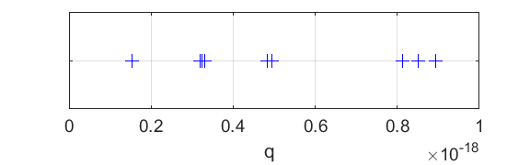

Fig. 4. The charges on the oil drop can be placed into four groups.

From the Table for the charges and figure 4, we can conclude that the charge on the oil drop is **quantised**. There are four different charges on the oil drop. We can now test the hypothesis that the charge *q* is an integral number of elementary charges *e*



|  |  |  |  |  |  |
| --- | --- | --- | --- | --- | --- |
| *q*  x10-19 C | | | *qavg*  x10-19 C | *N* | *qavg*  / N  x10-19 C |
| 3.197 | 3.233 | 3.3008 | 3.246 | 2 | 1.623 |
| 1.541 | 1.546 |  | 1.544 | 1 | 1.544 |
| 4.835 | 4.943 |  | 4.889 | 3 | 1.630 |
| 8.933 | 8.135 | 8.513 | 8.527 | 5 | 1.705 |
| average elementary charge *eavg* | | | | | 1.6255 |

So, the results of analysing the experiment data, give an estimate for the elementary charge of



which agrees quite well with the accepted value for the elementary charge



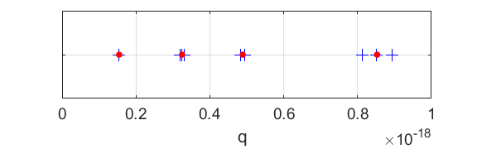

Fig. 5. Plot of the charges on the oil drop and the average charge for each of the four groups.

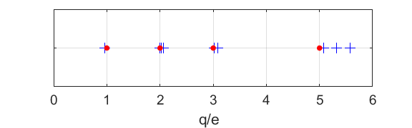

Fig. 6. Plot of the *q* / *e* for the charges on the oil drop which provides strong evidence for the quantisation of charge .

**A simple model for the estimation of the elementary charge**

Another method to estimate the elementary charge is to keep the oil drop suspended by the action of the electric field. When the oil drop is suspended the strengths of the electric force and gravitational force are equal in magnitude.

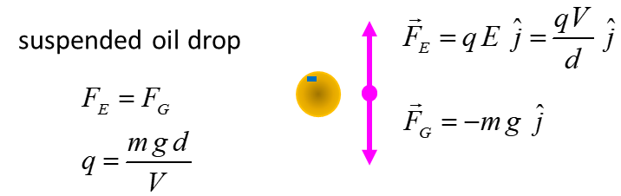

Fig. 4. Forces acting on a suspended oil drop.

So, to estimate *q* we need to be able to measure the mass *m* of the oil drop. The mass *m* is found by measuring the terminal velocity  of a falling oil drop. If we ignore the buoyancy force, then the gravitational force must be equal to the resistive force.

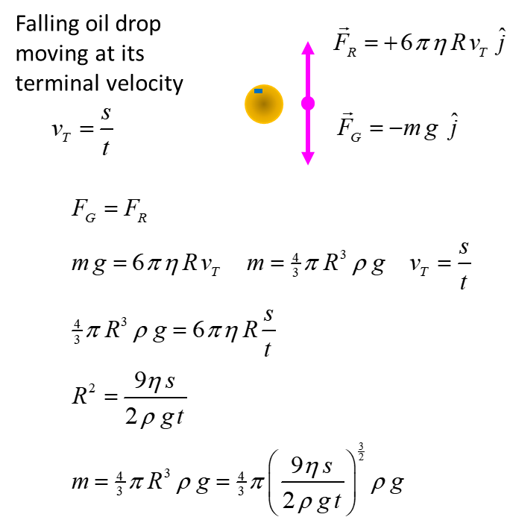

Fig. 5. The mass of an oil drop can be estimated by measuring the time interval *t* for the oil drop to fall the distance *s* when it is falling at its terminal velocity .

So, the charge *q* is



where



|  |
| --- |
| **Exercise**  Again, watch the video  [View video: Bozeman Science Elementary charge](https://www.youtube.com/watch?v=Fz-QPXwhQTI)  The video is good but there are a few shortcomings. What are they? Justify your answer.  What was the most beneficial aspects of the video for you?  [Another video](http://www.kentchemistry.com/links/AtomicStructure/Millikan.htm) |

|  |
| --- |
| **Exercise**  Try the simple computer simulation on the Millikan Oil Drop Experiment  [Simulation](http://www.thephysicsaviary.com/Physics/Programs/Labs/MillikanOilDropLab/index.html) |

|  |
| --- |
| **Exercise**  Do the workshops / experiments  [Millikan’s Oil Drop Experiment #1](http://www.physics.usyd.edu.au/teach_res/hsp/sp/mod8/wks8Millikan1.pdf)    [Millikan’s Oil Drop Experiment #2](http://www.physics.usyd.edu.au/teach_res/hsp/sp/mod8/wks8Millikan2.pdf) |

It is worth emphasizing the double importance of Millikan’s beautiful experiment. First, he had measured the charge of an electron *e.* Combined with measurements of made by Thomson and others, he could calculate the mass of the electron . Second, and possibly even more important, he had established that all charges, positive and negative, come in multiples of the elementary charge *e.*

**MATLAB**

Every physics teacher and student should be using Matlab.

The analysis of the oil drop experiment and plots were done using a Matlab mscript. The mscript **spMillikan.m** can be downloaded from the directory

<http://www.physics.usyd.edu.au/teach_res/mp/mscripts/>

Also download the mscripts **spMillikan1.m spMillikan2.m**

Below is a copy of the mscript. Even if you don’t use Matlab or know the language, you should work through each line of code. You can often learn more by coding than doing traditional physics problems, or by doing computer simulations and even reading the notes on the Millikan experiment.

% spMillikan1.m

% 171003

% Ian Cooper School of Phyiscs University of Sydney

% http://www.physics.usyd.edu.au/teach_res/mp/mscripts/

% Calculations for Millikan's Oil Drop Experiment

% from experimental data

% S.I. units used for all physical quantities

clear all

close all

clc

% KNOWN PARAMETERS =============================================

% separation distance between capacitor plates [m]

d = 8.00e-3;

% acceleration due to gravity [m/s^2]

g = 9.81;

% oil drop displacement for terminal velocity [m]

s = 8.30e-4;

% density of air [kg.m^3]

rho_A = 1.225;

% corrected viscoisty of air [N.s/m]

eta = 1.60e-5;

% density of oil [kg.m^3]

rho = 839;

% elementary charge [C]

e = 1.602e-19;

% MEASUREMENTS ===================================================

% voltage between plates of capacitro [V]

V = 968;

% time intervals for falling oil drop: E = 0 [s]

tD = [15.2 15.0 15.1 15.0 14.9 15.1 15.1 15.0 15.2 15.2];

% time intervals for rising oil drop: E <> 0 [s]

tU = [6.4 6.3 6.1 24.4 24.2 3.7 3.6 1.8 2.0 1.9];

% CALCULATIONS ===================================================

% uniform electric field between plates of capacitor [V/m]

E = V / d;

% mean time interval for falling oil drop [s]

tD_avg = mean(tD);

% terminal velocity of falling oil drop [m/s]

vD = s / tD_avg;

% radius and volume of oil drop [m] [m^3]

R = sqrt(9*eta*vD / (2*g*(rho - rho_A)));

Vol = (4/3)*pi*R^3;

% mass of oil drop [kg]

m = Vol * rho;

% terminal velocity rising oil drops [m/s]

vU = s ./ tU;

% gravitational force [N]

FG = m*g;

% bouyancy force

FB = -Vol*rho_A*g;

% resisitive force

FR = (6*pi*eta*R).*vU;

% charge [C]

q = (FG + FB + FR) ./ E;

% Average charge per group

q_avg(1) = mean(q(4:5));

q_avg(2) = mean(q(1:3));

q_avg(3) = mean(q(6:7));

q_avg(4) = mean(q(8:10));

% Averages for elementary charge for each group

eN(1) = q_avg(1)/1;

eN(2) = q_avg(2)/2;

eN(3) = q_avg(3)/3;

eN(4) = q_avg(4)/5;

% Estimate for eleementary charge

e_avg = mean(eN);

% GRAPHICS ========================================================

figure(1)

set(gcf,'units','normalized','position',[0.01 0.5 0.3 0.15]);

fs = 14;

xP = q;

yP = zeros(1,length(xP));

hPlot = plot(xP,yP,'+b');

set(hPlot,'MarkerSize',10);

grid on

set(gca,'YTickLabel',[]);

xlabel('q ','fontsize',fs);

set(gca,'fontsize',fs);

figure(2)

set(gcf,'units','normalized','position',[0.32 0.5 0.3 0.15]);

fs = 14;

xP = q;

yP = zeros(1,length(xP));

hPlot = plot(xP,yP,'+b');

set(hPlot,'MarkerSize',10);

hold on

xP = q_avg;

yP = zeros(1,length(xP));

hPlot = plot(xP,yP,'or');

set(hPlot,'MarkerSize',5);

set(hPlot,'MarkerFaceColor','r');

grid on

set(gca,'YTickLabel',[]);

xlabel('q ','fontsize',fs);

set(gca,'fontsize',fs);

figure(3)

set(gcf,'units','normalized','position',[0.65 0.5 0.3 0.15]);

fs = 14;

xP = q./e;

yP = zeros(1,length(xP));

hPlot = plot(xP,yP,'+b');

set(hPlot,'MarkerSize',10);

hold on

xP = [1 2 3 5];

yP = zeros(1,length(xP));

hPlot = plot(xP,yP,'or');

set(hPlot,'MarkerSize',5);

set(hPlot,'MarkerFaceColor','r');

grid on

set(gca,'YTickLabel',[]);

xlabel('q/e ','fontsize',fs);

set(gca,'fontsize',fs);

[VISUAL PHYSICS ONLINE](http://www.physics.usyd.edu.au/teach_res/hsp/sp/spHome.htm)

If you have any feedback, comments, suggestions or corrections please email:

Ian Cooper School of Physics University of Sydney

ian.cooper@sydney.edu.au