[**VISUAL PHYSICS ONLINE**](http://www.physics.usyd.edu.au/teach_res/hsp/sp/spHome.htm)

**THE STANDARD MODEL OF MATTER**

**QUARKS**

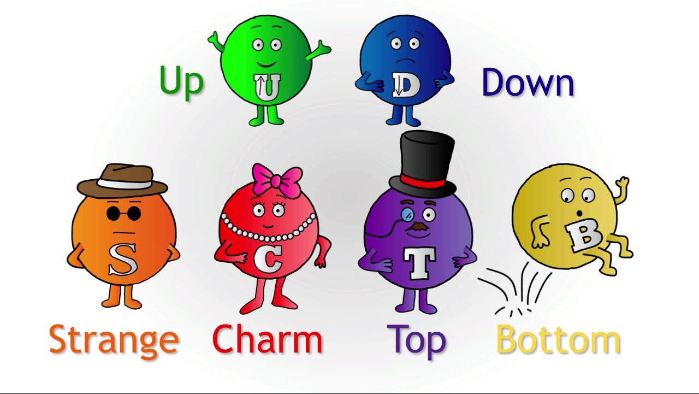

Quarks are one type of matter particle. Most of the matter we see around us is made from protons and neutrons, which are composed of quarks. There are six quarks / antiquark pairs, but physicists usually talk about them in terms of pairs: up/down, charm/strange, and top/bottom. Also, for each of these quarks, there is a corresponding antiquark.

The quarks combine to form particles called **hadrons** (particles which can feel the strong force).

There are two distinct types of hadrons:

* **Baryons** - three quarks or three anti-quarks
* **Mesons** - a quark/anti-quark pair

|  |  |  |  |  |
| --- | --- | --- | --- | --- |
| **QUARK FLAVOUR** | **SYMBOL** | **CHARGE** | **MASS**  **(MeV/c2)** | ***m*quark / *m*proton** |
| **Up** | **u** | **(+2/3) e** | **6** |  |
| **Down** | **d** | **(-1/3) e** | **3** |  |
| **Strange** | **s** | **(-1/3) e** | **100** | **0.1** |
| **Charm** | **c** | **(+2/3) e** | **1250** | **1.3** |
| **Bottom** | **b** | **(-1/3) e** | **4500** | **4.8** |
| **Top** | **t** | **(+2/3) e** | **175000** | **187** |
| **Up** |  | **(-2/3) e** | **6** |  |
| **Down** |  | **(+1/3) e** | **3** |  |
| Strange |  | (+1/3) e | 100 | 0.1 |
| Charm |  | (-2/3) e | 1250 | 1.3 |
| **Bottom** |  | **(+1/3) e** | **4500** | **4.8** |
| **Top** |  | **(-2/3) e** | **175000** | **187** |

The light quark masses are not well defined. They are strongly bound to each other and a single quark can never be experimentally isolated for a measurement.

Quarks have the unusual characteristic of having a **fractional electric charge**, unlike the proton and electron, which have integer charges of +1 and -1 respectively. Quarks also carry another type of charge called **colour charge**. Quarks only exist in groups with other quarks and are never found alone. Composite particles made of quarks are called **hadrons**. Although individual quarks have fractional electrical charges, they combine such that hadrons have a net integer electric charge. Another property of hadrons is that they have **zero colour charge** even though the quarks themselves carry colour charge.

The name quark and the idea that protons, neutrons and other particles were composed of quarks was made by the American physicist, Murray Gell-Mann and he won the 1969 physics Noble Prize.

The properties of the interaction between quarks are described by a theory called quantum chromodynamics. The equivalent of electric charge for electrical forces is called **colour charge** for the strong nuclear force. Whereas in electrodynamics there are two charges, + and -, there are three colour charges; red (**R**), green (**G**) and blue (B). The idea of colour charge is needed in order to explain why baryons can contain three otherwise identical quarks. For a hadron, the three colour charges when added together must produce white as hadrons have to be colourless.

**Antiquarks possess anticolour:**

antired () = white - red = cyan

antigreen () = white – green = magenta

antiblue () = white – blue = yellow

**Baryons** contain three quarks, each quark a different colour, hence:

R + G + B gives W (white), i.e., zero colour charge.

**Antibaryons**, containing three antiquarks are also colourless.

cyan + magenta + yellow

= white – red + white – green + white – yellow

= white (colourless)

**Mesons**, containing a quark/antiquark pair, must also be colourless and so the pair

must possess opposite colours; eg a cyan antiquark() together with a red quark

cyan + red

= white – red + red

= white ⇒ colourless (zero colour).

**Gluons**, the messenger bosons for the strong force, carry a colour and an anticolour and so can change the colour of quarks within a hadron, which must however remain colourless.

Quarks and gluons are colour-charged particles. Just as electrically-charged particles interact by exchanging photons in electromagnetic interactions, colour-charged particles exchange gluons in strong interactions. When two quarks are close to one another, they exchange gluons and create a very strong colour force field that binds the quarks together. The force field gets stronger as the quarks get further apart. Quarks constantly change their colour charges as they exchange gluons with other quarks.

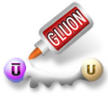

Like colours repel and unlike colours attract, however because the quarks inside a hadron can change colours the situation is more complex and the colour states are not pure colours but are mixes of the three colours.

[Visit: The Particle Adventure](http://www.particleadventure.org/index.html)

The six different varieties of quarks are often called the **quark flavours**. The flavour names arose historically. The first quark model (1964) needed only three quarks: up, down and strange. The up and down were introduced since only two kinds of quark

were needed to explain ordinary matter and, like proton and neutron, the two were considered to, somehow, be two different states of the same thing. The name strange was introduced since the addition of the strange quark was needed to explain the observed behaviour of some particles produced in collision of high energy cosmic ray particles with matter. The particles were produced quickly and in pairs (in the strong nuclear reaction, but decayed slowly (i.e. travelled farther) and decayed separately. The quark model explanation was that one of the pair of particles contained a strange quark and the other an anti-strange quark and that the decays involved the flavour changing weak interaction, a much slower process.

**Baryons**

3 quark combinations (qqq). All baryons interact through the strong force. The lightest and most stable baryons are the proton (uud) and neutron (udd).



The existence of quarks has been well established by experimentation. When high energy electron beams are used to probe the proton or neutron for instance, three distinct scattering centres are found inside each particle. For example, in the 1960's experiments like the Rutherford scattering of alpha particles from gold atoms were performed but this time with high energy electrons were scattered off protons. The results also produced larger deflections then was expected for the case where the proton's charge was distributed over the volume of the proton. The results were consistent with the charge being concentrated in small spaces (such as point like quarks).

**In all interactions, the total baryon number is conserved**

There are many different hadrons that have been created when sub-atomic particles with high energies are smashed into each other. Some examples are (mass of particle in MeV/c2 is shown in brackets):

Proton p (938.3), neutron n (939.6), Λ0 (1116), Σ+ (1189), Σ0 (1193), Σ‑ (1197)

**Greek Alphabet**

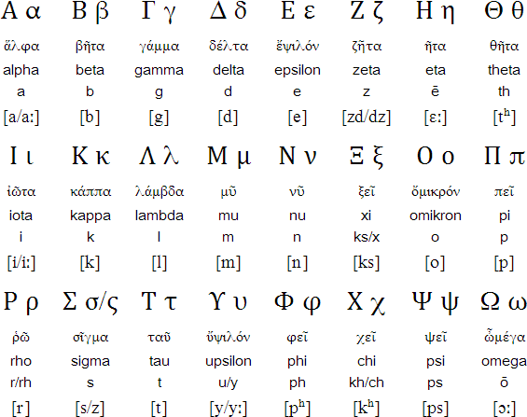

**Mesons** 2 quark combinations ().

Mesons consist of a quark and an anti-quark pair and interact through the strong nuclear force. One example of a meson is a pion π+ () which is made of an up quark and a down anitiquark. The antiparticle of a meson just has its quark and antiquark switched, so an antipion π- is made of a down quark and an up antiquark ().



Mesons are unstable because they consist of a particle and an antiparticle and often decay in millionths of a second to produce other particles such as photons, electrons and neutrinos.

There are many different mesons that have been created when sub-atomic particles with high energies are smashed into each other. Some examples are (mass if particle in MeV/c2 is shown in brackets):

π0 (135.0), π+ (139.6), π- (139.6), K+ (493.7), K- (493.7), η0 (547.3)

**All mesons are bosons**

**Beta decay**

Beta decay, is a quark flavour change phenomenon.

At the nuclear level, we write it as

Beta plus decay 

AXZ → AYZ-1 + 01 +  element X → element Y

Beta minus decay 

AXZ → AVZ+1 + 0-1 +  element X → element V

At the nucleon level, the decay involves one nucleon, the other nucleons in the nucleus are spectators

Beta plus decay  p+ → n +  + 

Beta minus decay  n → p+ +  + 

The first of these decays can only occur within a nucleus, the second is also the fate of a free neutron, it decays with a half-life of 615 s.

At the quark level, one of the quarks changes flavour, the other quarks in the nucleon don’t change.

Beta plus decay 

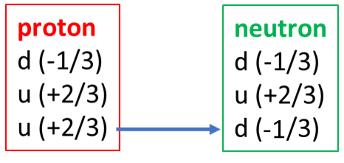

We can describe this in terms of exchange bosons. The u changes to a d with the emission of a W+, which decays into e+ and . The interaction takes such a short time and in such a small space that the uncertainty principle allows short term local variations in energy and momentum of the particles to cover energy and momentum conservation during the interaction, but, the total final energy and momentum of the particles must be the same as the initial energy and momentum. After the decays, the daughter nuclei may be in another unstable state and another

decay will take place.

Beta minus decay 

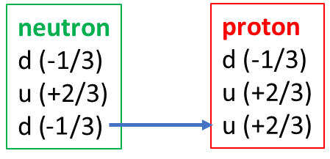

**Web-sites**

European Laboratory Geneva Switzerland

<http://particleadventure.org/particleadventure/>

<http://cem.ch>

Fermi National Accelerator Laboratory USA

<http://www.foal.gov/>

Stanford Linear Accelerator Laboratory USA

<http://www2.slac.stanford.edu/wc/>

**NUCLEAR and PARTICLE PHYSICS: A SHORT HISTORY**

1895 X rays discovered by Roentgen

1896 Henri Becquerel discovered radioactivity ( beta from 234Th *E*β = 0.26 and 0.19 MeV. The parent 238U alpha decay *E*α = 4.I9 Mev)

1896 Lorentz interprets Zeeman splitting as the motion of charged particles in atoms

1897 Electron is discovered. The value of *e*/*m* of cathode rays measured by J.J. Thomson

1899 J.J. Thomson also measures *e*-, establishing small value of *me*. Ernest Rutherford publishes study showing that "Becquerel rays" have at least two components which he calls a (absorbed) and b (penetrating)

1900 Paul Villard discovers γ rays as very penetrating radiation from "radium", evidence grows that radiation is similar to X-rays but not confirmed until 1914 when Rutherford reflects them from crystals

1902 Rutherford and Soddy explain radioactivity as transmutation of the elements

1905 Einstein paper "On the Electrodynamics of Moving Bodies" Special Relativity

1909 α particle identified as Helium nucleus

1911 Rutherford realises that reflection of a particle from gold foil means that the positive charge in an atom is concentrated in a very small region (*r* < 10-13 m)

1920 Proton identified; named by Rutherford

1923-30 Development of Quantum Mechanics

1923 Louis deBroglie introduces wave-particle duality

1924 Bose-Einstein statistics

1925 Wolfgang Pauli proposes Exclusion Principle

Werner Heisenberg Wave Mechanics

Intrinsic spin proposed Samuel Goudsmit and George Uhlenbeck

1926 Erwin Schroedinger wave equations

Fermi-Dirac statistics

1928 Dirac equation

α decay as tunnelling phenomenon proposed (Gamow, Gumey, Condon)

1929-32 Ernst Lawrence builds cyclotron

1930 Pauli proposes neutrino hypothesis

1931 Paul Dirac proposes positron

Robert Van de Graaff generates 1.5 MV

1932 Carl Anderson discovers positron

James Chadwick discovers neutron

Proton-neutron nucleus proposed by Heisenberg

John Cockroft and Ernest Walton produce first nuclear reaction using accelerator

1934 Discovery of radiation induced radioactivity (Irene Curie and Jean Joliot).

Theory of β decay Enrico Fermi

1935 Hideki Yukawa proposes meson hypothesis and the concept of exchange of particles mediating force. (Meson - name given to particles with mass between *me* and *mp*. Now use this name for particular kind of strongly interacting bosons)

1936 Meson detected (later tums out to be muon - a lepton – heavy electron)

Bohr proposed that a compound nucleus in formed in nuclear reactions

1938 Nuclear fission discovered by Otto Hahn and Fritz Strassman

1939 Liquid drop model of nuclear fission, Bohr and Wheeler

1940 First transuranium produced (McMillan and Seaborg).

Pauli proposes connection between spin and statistics.

l941 First betatron, magnetic induction electron accelerator.

1942 Experiments on controlled fission by Enrico Fermi leading to development of fission bomb (1945) and power generation (1950's)

1946 Berkeley synchrotron operational (deuterons)

Nuclear magnetic resonance (F. Bloch and E. Purcell)

Development of radiocarbon dating (W. Libby)

1947 Cecil Powell identifies pion (meson) and muon (lepton) in emulsion as a decay: parent called π meson and daughter called μ meson

1947-50 V-particles observed in cosmic ray data later renamed as K-mesons and 'hyperons' (particles with mass > *m*neutron )

1949 Shell model of nucleus proposed by Mayer, Jensen, Hexel Suess

1952 First thermonuclear (fusion) bomb

1953 "Strangeness" hypothesis (Murray Gell-Mann, Kazuhiko Nishijima) and strange particles produced.

1955 Antiproton discovered (O. Chamberlain, E. Segre, C. Wiegand, T. Ypsilantis)

1956 Neutrino detected from beta decay in reactors (Frederick Reines and Clyde Cowan)

1956 Parity violation observed in 60Co decay (Tsung Dao Lee, Chen Ning Yang, Chien-Shiung Wu et al)

1964 CP violation in K0 decay (James Cronin and Val Fitch)

Quark model of hadrons proposed by Gell-Mann and independently by George Zweig

W- minus observed

1965 Introduction of "colour" quantum number, but all observed particles are colourless (Han and Nambu)

1967 Steven Weinberg and Abdus Salam achieve unification of electromagnetic and weak forces into an single "electroweak" theory

1970 Sheldon Glashow adds a fourth quark (the charmed quark) to the quark model to explain why certain reactions are not seen!

1971 Proton-proton collider at CERN

1975 Martin Perl discovers the τ particle (tau) - third generation of leptons

1977 Leon Lederman discovers the upsilon particle (meson U-particle b ) - third generation of quarks inferred (b, t)

1983 Carlo Rubbia discovers the exchange particles for the weak force: the W+ & W- (80 GeV/c2) and, Z0 (91 GeV/c2)

1991 Upper limit on generations seems to be limited to 3: from decay rates of Z0

1995 Top quark found at (179 ± 12 Ge/c2) at Fermilab Tevatron accelerator

2000+ Heaviest elements (Z = 118 A = 293 N = 176 - but only for a moment ...

Antihydrogen atoms produced at CERN: Antiproton with positron

Construction is underway of large hadron collider at CERN. The two oppositely directed hadron beams will cross at four places. At two of these large detectors are being built; ATLAS at one and CMS at the other. Australia is a part of the ATLAS collaboration.

An extensive array of cosmic ray detectors, called the Auger project, is starting operation in Argentina. This is also an international collaboration and Australia is a part of it. Eventually another array will be built in the northern hemisphere.

There are strong indications of the existence of neutron and possibly quark stars and work is under way on modelling these.

CP violation observed in B-zero mesons (b and d quark combinations)

Relativistic Heavy Ion Collider has started operation at Brookhaven with four detectors.

Neutrino oscillation experiments have reported results indicating that not all neutrinos in the three generations can be massless.

A number of new neutrino telescopes have been built and have reported results: (1) IceCube which is a telescope, using one cubic kilometre of ice below the surface of the South Pole as part of the detector designed to make images of the universe using neutrinos. (2) AMANDA (Antarctic Muon and Neutrino Detector Array) another experiment in the Antarctic ice to look for energetic neutrinos from astronomic point sources.

2012 Possible evidence for the Higgs particle

*Adapted from Dr Juris Ulrichs notes on Quanta to Quarks, Science Teachers Workshop, School of Physics, University of Sydney, 2006*

[VISUAL PHYSICS ONLINE](http://www.physics.usyd.edu.au/teach_res/hsp/sp/spHome.htm)

<http://www.physics.usyd.edu.au/teach_res/hsp/sp/spHome.htm>

If you have any feedback, comments, suggestions or corrections please email: ian.cooper@sydney.edu.au

Ian Cooper School of Physics University of Sydney