[**VISUAL PHYSICS ONLINE**](http://www.physics.usyd.edu.au/teach_res/hsp/sp/spHome.htm)

**RADIOACTIVITY AND THE TRANSMUTATION OF THE ELEMENTS**

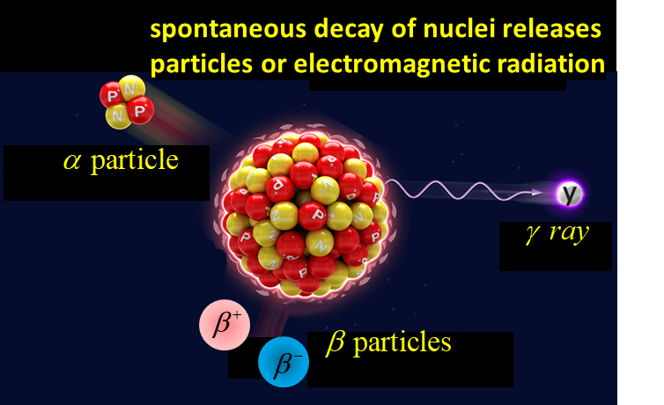

Experimental work around the turn of the 20th Century by Henri Becquerel (1852 - 1908), Ernest Rutherford (1871 - 1937), Marie Curie (1867 – 1934) and Pierre Curie (1859 – 1906) and others indicated that three kinds of natural radiations: **alpha particles α**, **beta particles β** and **gamma rays γ** were emitted from a nucleus of an unstable atom.

These radiations were emitted naturally from certain elements such as uranium, polonium, radium, and actinium. Further, it was found that the emission of natural radiations by one element usually led to the production of a different element. For instance, radium was produced as a result of the radioactive decay of uranium. This change of a parent nucleus into a different daughter nucleus is called a **nuclear transmutation**. One element effectively changes into another element.

When transmutation occurs, the sum of the atomic numbers on the left-hand side of the nuclear equation equals the sum of the atomic numbers on the right-hand side. Likewise, the sum of the mass numbers on the left-hand side of the nuclear equation equals the sum of the mass numbers on the right-hand side.

Alpha decay 

Beta decay 

Gamma decay

[VISUAL PHYSICS ONLINE](http://www.physics.usyd.edu.au/teach_res/hsp/sp/spHome.htm)

If you have any feedback, comments, suggestions or corrections please email:

Ian Cooper School of Physics University of Sydney

ian.cooper@sydney.edu.au