[**VISUAL PHYSICS ONLINE**](http://www.physics.usyd.edu.au/teach_res/hsp/sp/spHome.htm)

**STELLAR EVOLUTION**

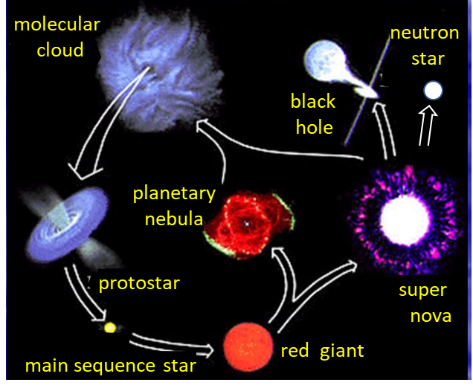

Stars are born when mainly hydrogen gaseous clouds contract due to the attractive pull of the gravitational force. A huge gas cloud will evolve into numerous smaller contracting gaseous centres called **protostars**. As the contraction continues, hydrogen nuclei accelerate. When pairs of hydrogen nuclei gain sufficient kinetic energy to overcome the Coulomb repulsion between them, fusion can take place (“hydrogen burning”), for example, as in the **proton-proton chain** reaction.

**Proton-Proton chain**









The energy output of the Sun is mainly due to the proton-proton sequence of fusion reactions.

In more massive stars, the **carbon cycle** (**CNO**) produces the same net effect.



Four  and one  nuclei are required to produce  and . The  only acts as a catalyst in the set of reactions.

|  |
| --- |
| **Example 1**  Show that the fusion of four protons in the proton-proton chain releases an energy of approximately 25 MeV.  **Solution**  The net result of the nuclear fusion reactions in the proton-proton cycle is    Mass proton *mp* = 1.007276 u  Mass beta particle (positron) *me* = 5.485799x10-4 u  Mass of helium nucleus *m*He4 = 4.001506 u  atomic mass unit 1 u = 1.660539040x10-27 kg  Energy/mass is conserved in the fusion reaction  *Mbefore = Mafter + dM*  Mass defect *dM* = *Mbefore - Mafter*  *Mbefore* = 4 *mp*  *Mafter* = *M*He4 + 2 *me*  *dM* = (4)( 1.007276 ) - 4.001506 – (2)( 5.485799x10-4 ) u  *dM* = 0.026503 u = 4.400849x10-29 kg  The energy released in the fusion reaction is  *Q = dm c*2 *=* (4.400849x10-29 ) (3x108)2 = 3.955285x10-12 J  *Q* = 24.7 MeV 1 MeV = 1.6x10-13 J |

The fusion reactions take place primarily in the core of a star, where the core temperature is very high (Sun’s core temperature ~ 15x106 K, whereas its surface temperature is ~ 6000 K).

The tremendous release of energy in these fusion reactions produces an outward pressure sufficient to halt the inward gravitational contraction. The protostar becomes a young main sequence star. The location of the star on the HR diagram is determined by the mass of the star. The more massive the star, the farther up and to the left it is located on the HR diagram.

The Sun required ~30 million years to reach the main sequence, and is expected to remain there about 10 billion years. More massive stars than the Sun have shorter lives, because they are hotter and the Coulomb repulsion is more easily overcome, so they use up their fuel faster.

As hydrogen fuses to form helium, the helium that is formed is denser and tends to accumulate in the central core where it was formed. As the core of helium grows, hydrogen continues to fuse in a shell around it. When most of the hydrogen in the core has been used, the rate of energy generated by fusion decreases and the outward acting gas pressure also decreases as a result. So, the gravitational forces cause the star to contract and heat up again.

The hydrogen in the shell around the core then fuses even more fiercely because of this rise in temperature, allowing the outer envelope of the star to expand and to cool. The star will now have a reddish appearance because of the lower surface temperature, it will have grown in size and be more luminous. This process marks a new step in the evolution of a star as it is no longer a main sequence star but a **red giant** and on the HR diagram the star will be located higher and to the right. Our Sun has been a main sequence star for about 4.5x109 years and will remain as a main sequence star for another 5x109 years before cooling and expanding out to about the orbit of the Earth (Figure 1). (Governments do not need to take action about the evolution of our star for many years).

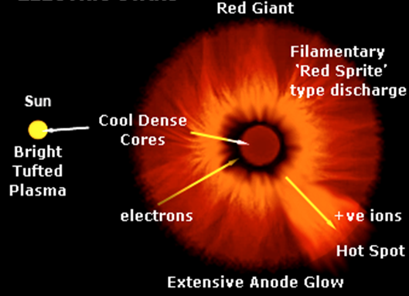

Fig. 1. A red giant star.

As the star’s outer envelope expands, its core continues to contract and temperature increases. When the core temperature reaches about ~108 K, helium nuclei can undergo fusion, despite their greater charge and hence greater electrical repulsion.

Typical fusion reactions include



The first reaction is slightly endothermic (energy input needed for the reaction to proceed). The second reaction must occur very rapidly since  decays very rapidly back into two alpha particles. The net effect of the two fusion reactions is the production of carbon from helium



The star becomes more luminous and moves into the horizontal branch on the HR diagram (figure 2). Further fusion reactions are possible, resulting in heavier nuclei up to about Z = 12. For example, an alpha particle can fuse with a carbon nucleus to form an oxygen nucleus



and elements such as neon and magnesium  can also be formed.

When no further fusion energy can be obtained because of the large Coulomb repulsion between nuclei. The core again contracts under gravity. The outer envelope expands again and the star becomes an even brighter and larger red giant. Eventually the outer layers escape into space, and the newly revealed surface is hotter than before. So, the star moves to the left in the HR diagram (figure 2).

Stars must evolve since:

* The energy supply (its fuel) of an active star must eventually be depleted.
* A star bereft of energy sources cannot support itself against gravitational collapse.
* A complicated mixture of nuclei of heavier than hydrogen and helium is built up during a star’s lifetime (Zmax ~ 26, iron).
* Stars with different initial masses come to end their active life as red giant stars which have different structures and compositions. Finally, we end up with different types of dead stars, such as, white dwarfs, neutron stars or even a black hole.

Active fusion reactions in the first stages in the life stars kept them luminous because of their hot cores. Such stars are made predominately of plasma particles (electrons and ions) that behave as an ideal gas. The kinetic pressure exerted by this plasma supports the star again collapse due to the gravitational force. However, as a star’s energy source becomes exhausted, gravity makes it collapse until it is supported by some pressure other than that due to the kinetic pressure of an ideal gas.

**Dead Stars: White dwarfs**

* A star born with a mass less than 8 solar masses

(solar mass = mass of our Sun)

* Final mass of stars, less than 1.4 solar masses

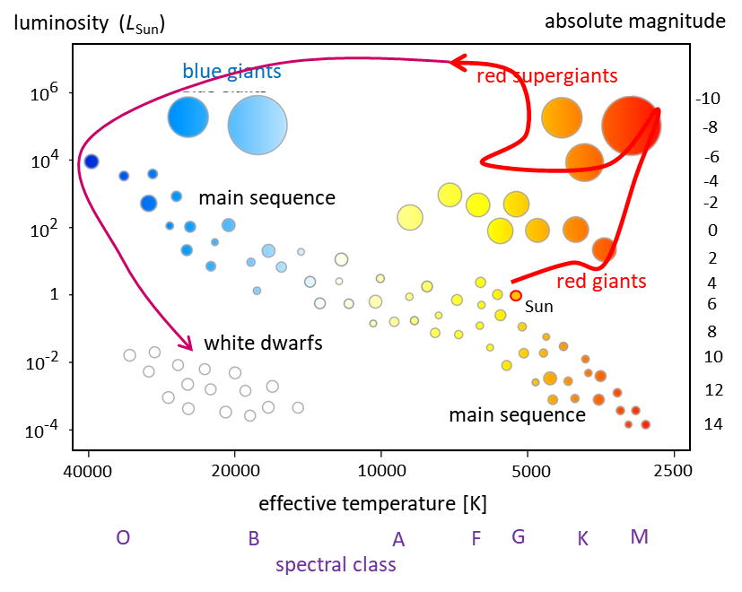

Fig. 2. Evolution of our Sun plotted on a HR diagram. For stars born with a mass less than 8 solar masses follow a similar evolutionary trajectory.

Following the red giant stage, stars like the Sun follow the trajectory on the HR diagram as shown in figure 2 to become a **white dwarf** star. A white dwarf with a residual mass equal to that of the Sun would be about the size of the Earth.

A white dwarf contracts to the point at which the electrons start to overlap, but no further because, by the **Pauli Exclusion Principle**, no two electrons can be in the same quantum state.

At this point the star is supported against further collapse by this electron degeneracy pressure. A white dwarf continues to lose internal energy by radiation, decreasing in temperature and becoming dimmer until it glows no more. It has then become a cold dark chunk of extremely dense material (~ 108 kg.m-3). The “lights go out” and the star becomes a dark cold chunk of ash called a **black dwarf**.

**Neutron Stars**

* A star born with a mass greater than 8 solar masses

(solar mass = mass of our Sun)

* Final mass of stars in the range 1.4 to 2.5 solar masses

For more massive stars, as they collapse, the electron Pauli pressure is not sufficient to prevent further collapse. Such massive stars become neutron stars or even black holes.

The more massive main sequence stars have hotter cores, partly for the simple reason that they have a thicker layer of insulation around the core. At higher temperatures, the nuclei have greater kinetic energies. This means that larger nuclei with greater charge can overcome the greater repulsive coulomb force between themselves and undergo fusion reactions. Therefore, a broader range of fusion reactions is possible in these more massive stars. In a long sequence of reactions, larger and larger nuclei are gradually built up until Z = 28. Iron (Z = 26) and Nickel (Z = 28). No nuclei are created with Z > 28, since no fusion energy can be liberated in further fusion reaction creating nuclei with Z > 28. The reason for this is that the nucleons for iron and nickel are more strongly bound than any other nucleus (figure 3). To form nuclei with greater mass, in which nucleons are less tightly bound, would require the absorption of energy. So, at this stage a star has runout of fuel, fusion can no longer supply energy.

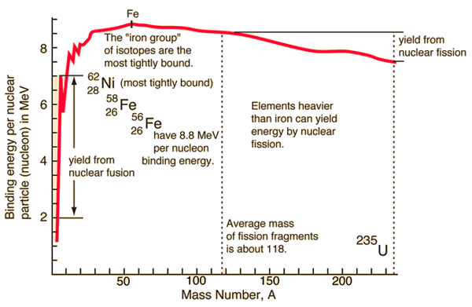

Fig. 3. Binding energy per nuclear of the elements.

Reactions take place now that absorb energy and this causes a rapidly reduction in the star’s core temperature. This results in a sudden decrease in the kinetic gas pressure, so the core starts to collapse under gravity. The gravitational potential energy released as the core collapses again raises the temperature and new fusion reactions are initiated which is then followed by an explosion of the star. During the explosion, the brightness of the star increases by many orders of magnitude. They are so bright they can be seen in galaxies other than the Milky Way. Dramatic events like this are called **supernovae** and have been observed on Earth a few times in recorded history.

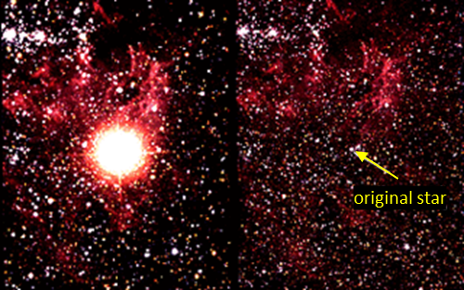

Fig. 4. A supernova is a large explosion that takes place at the end of a star's life cycle. On the left is Supernova 1987A after the star has exploded. On the right is the star before it exploded.

Each supernova has a short life, typically flaring up in a few days, and fading away steadily, with its light output decreasing by a factor of two every few months. However, the remnants of the explosion can still be detected. During the explosion, the kinetic energy acquired by nuclei allows them to fuse to produce nuclei with atom numbers up to 94 (plutonium). The evolution of a supernova is shown in figure 5.

During the explosion, electrons each relativistic speeds, and as the collapse of the core continues, enormous density are reached (1013 kg.m-3). Electrons acquire sufficient energy to combine with protons to from neutrons.

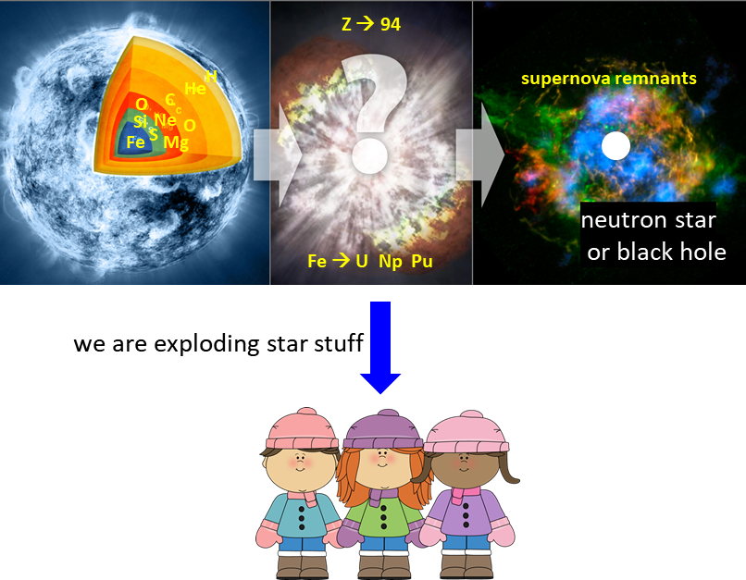

Fig .4. Evolution of a supernova. The end result will be a neutron star or if the star was extremely massive, a black hole is left. Only during the supernova do nuclei have sufficient kinetic energy to fuse together to produce nuclei up to atomic number Z = 94. It is true, we are made from stuff formed in stars and supernova explosions. After the explosion, we are left with a remnant supernova which is a ring of gas and dust. At the centre of a neutron star or black hole is left.

The presence of heavy elements on Earth and in our solar system suggests that our solar system formed from the debris of a supernova explosion.

**Neutron production**



So, the neutron-producing reactions only occur when the electrons have relativistic speeds. This means that neutron cannot be produced in white dwarfs. However, when the electrons have relativistic speeds, the Pauli Exclusion pressure is inadequate to prevent further collapse. Neutron also obey the Pauli Exclusion Principle and a slow moving and so, we are left with a star simply composed of neutrons at enormous densities equal to the density of a nucleus (~1018 kg.m-3 centre of neutron star).

**Black Holes**

There is a limit to the maximum mass of a neutron star. If the mass of the neutron star is too great, further collapse is possible, gravity keeps pulling everything together. The continuing collapse will take them well beyond nuclear densities. The strange body that is now formed is called a black hole.

Features of a black hole

* All matter is trapped within the black hole
* Light is trapped by a black hole. No radiation can escape, such a body is truly black.
* Any object or electromagnetic radiation passing near a black hole will be deflected by the gravitational field of the black hole. If the body or radiation comes too close, then it will be swallowed up, never to escape.
* The black hole is composed of super-dense matter ?

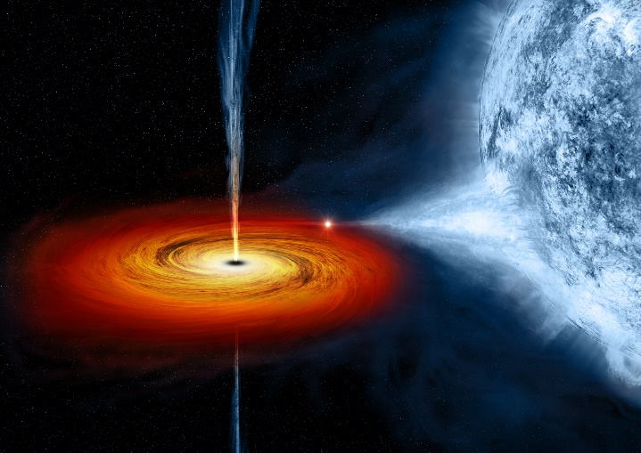

Fig. 5. An artist's drawing a black hole named Cygnus X-1. It formed when a large star caved in. This black hole pulls matter from blue star beside it.

|  |  |  |  |
| --- | --- | --- | --- |
| **Typical values** | **White dwarf** | **Neutron Star** | **Sun** |
| Mean density [kg.m-3] | 108 | 1014 to 1018 | 1400 |
| Mass [*MSun*] | < 1.4 | > 1.4 | 1 |
| Radius [km] | 6000 | 10 | 6.96x105 |
| Rotation periods | 0.02 to 100 days | 0.1 s | 25 days |
| B-field [T] | < 103 | 105 | 10-4 |
| Surface Temperature [K] | < 50 000 | ~106 | 5800 |



[VISUAL PHYSICS ONLINE](http://www.physics.usyd.edu.au/teach_res/hsp/sp/spHome.htm)

If you have any feedback, comments, suggestions or corrections please email:

Ian Cooper School of Physics University of Sydney

ian.cooper@sydney.edu.au