[**VISUAL PHYSICS ONLINE**](http://www.physics.usyd.edu.au/teach_res/hsp/sp/spHome.htm)

**J. J. Thomson: *e*/*me* Experiment**

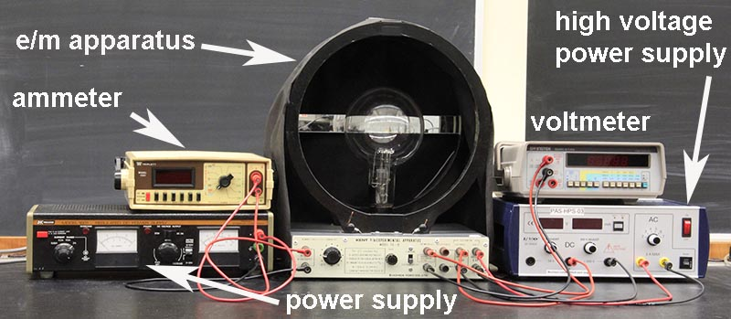

Sir Joseph John Thomson (1856-1940) performed a wide range of experiments which were crucial to our understanding of the electron and the electrical nature of matter.

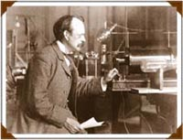

In 1897, he measured the charge to mass ratio of the cathode ray particles. The value he obtained corresponded to the charge / mass ratio for an electron. Thus, there was conclusive evidence that cathode rays were a stream of **electrons**.



He first accelerated electrons that were emitted from a hot cathode in an electric field *EA* produced by an accelerating voltage *VA* to increase their kinetic energy. The speed of an electron in passing the anode is



where *e* is the charge of the electron and *m­e* is the mass of the electron.

The electrons then passed into a region of crossed electric and magnetic fields. A voltage *V* was placed across a pair of parallel plates with a separation distance *d*. This produced a uniform electric field *E* = *V*/*d* which gives an upward deflection of the electron beam (along path X). The electric force *FE* on an electron is



A pair of Helmholtz coil carrying a current *I* produced a uniform magnetic field to deflect the electron beam downward (path Y – right hand palm rule). The magnetic force *FB* to deflect an electron is



Thomson them adjusted the strengths of the electric and magnetic fields so that the electric force and the magnetic force had equal magnitudes so that the electrons travelled straight thought the tube without any deflection (path Z). Hence, from measurements of *V*A, *V*, *B* and *d*, the *e*/*me* ratio can be estimated:







Thomson’s first measurement for *e*/*me* was 0.77×1011 C.kg-1. Even though Thomson’s result was different from the now accepted value of 1.759×1011 C.kg-1, his measurement was a tremendous achievement. Thomson can be considered the “discoverer” of the electron, although many people contributed to the investigation into the nature of matter. Thomson believed that an electron was not an atom, but a part of an atom.

Another method by Thomson used only a magnetic field to deflect the electron beam. In the absence of the deflecting electric field, the cathode ray beam is bent into a circular path of radius *R* due to the magnetic force *FB* on the electrons. The magnetic force produces the centripetal force *FC ,* hence

magnetic force = centripetal force





Alternatively, once the radius of curvature *R* has been measured, the electric field *E* is adjusted so that the beam has zero deflection and this occurs when



Measurements of *VA*, *R* and *B* or *V*, *d*, *R* and *B* can then be used to measure the *e*/*me* ratio.

Even though Thomson used several different gases in his tube and different metals for his electrodes, he found a consistent value for the *e*/*me* ratio. From this observation, he argued that there was only one type of electron which must be contained in all atoms.

The basic research into electrical discharges in evacuated tubes led to the invention of the television. The heart of a television set is a large cathode ray tube. Electrons are emitted from a hot cathode and the path of the electron beam can be controlled by varying the applied electric and/or magnetic fields. When the electrons hit the end of the tube a fluorescent phenomenon occurs where the kinetic energy of the electron is transferred into a flash of light producing the television picture. Motorola produced the world’s first cathode ray television in 1947.

This is only one of the many examples were investigations into the fundamental nature of nature has led to significant changes in technology and society. Without governments investing $$$ into basic research, technological and social benefits will be drastically reduced in future.



[Review: motion of charged particles in electric fields](http://www.physics.usyd.edu.au/teach_res/hsp/sp/mod6/m6Electric.pdf)

[Review: Motion of charged particles in magnetic fields](http://www.physics.usyd.edu.au/teach_res/hsp/sp/mod6/m6Magnetic.pdf)

[View video: Thomson’s e/m experiment](https://www.youtube.com/watch?v=dkGTFhmC18g)

[Simulation: Thomson’s e/m experiment](http://www.thephysicsaviary.com/Physics/Programs/Labs/ThompsonetomLab/index.html)

[**VISUAL PHYSICS ONLINE**](http://www.physics.usyd.edu.au/teach_res/hsp/sp/spHome.htm)

If you have any feedback, comments, suggestions or corrections please email:

Ian Cooper School of Physics University of Sydney

ian.cooper@sydney.edu.au