[**VISUAL PHYSICS ONLINE**](http://www.physics.usyd.edu.au/teach_res/hsp/sp/spHome.htm)

**ALPHA DECAY**

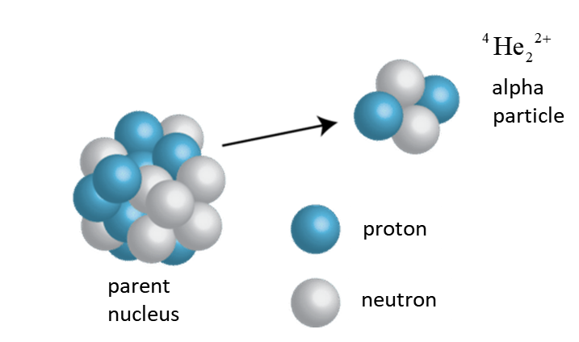

An alpha particle (α particle) is a helium nucleus 4He2 that is naturally emitted from an unstable nucleus producing a nucleus of a new element.

Emission of a 4He2 nucleus:

N → (N – 2) Z → (Z – 2) A → (A – 4)

Transmutation of a **parent** P into its **daughter** D:

APZ → A-4DZ-2 + 4He2

**Example**



radium → random + α

226Ra88 → 222Rn86 + 4He2

Alpha decay occurs because the strong nuclear force is unable to hold large nuclei together (Z > 82). The attractive strong nuclear force only acts between neighbouring nucleons since it is short ranged.

However, the repulsive electrostatic force is long ranged and acts all the way across a nucleus and dominates the strong nuclear force. An α particle is very a very tightly bound unit and this is why a helium nucleus is emitted rather than some other combination of protons and neutrons.

A gamma ray is emitted when a parent nucleus decays by emitting an alpha particle and the daughter nucleus is left in an excited state (*). The excited daughter nucleus than emits a gamma ray. So, in an α source, γ rays are often emitted as well as the α particles.

226Ra88 → 222Rn86 + 4He2

energy of α particle 4.871 MeV

226Ra88 → 222Rn86**\*** + 4He2

energy of α particle 4.685 MeV

222Rn86**\*** → 222Rn86 + γ

energy of γ ray 0.186 MeV

The excited nucleus can also be represented by the superscript **\***, e.g., 222Rn86*

One widespread application of nuclear physics is present in nearly every home in the form of an ordinary smoke detector.

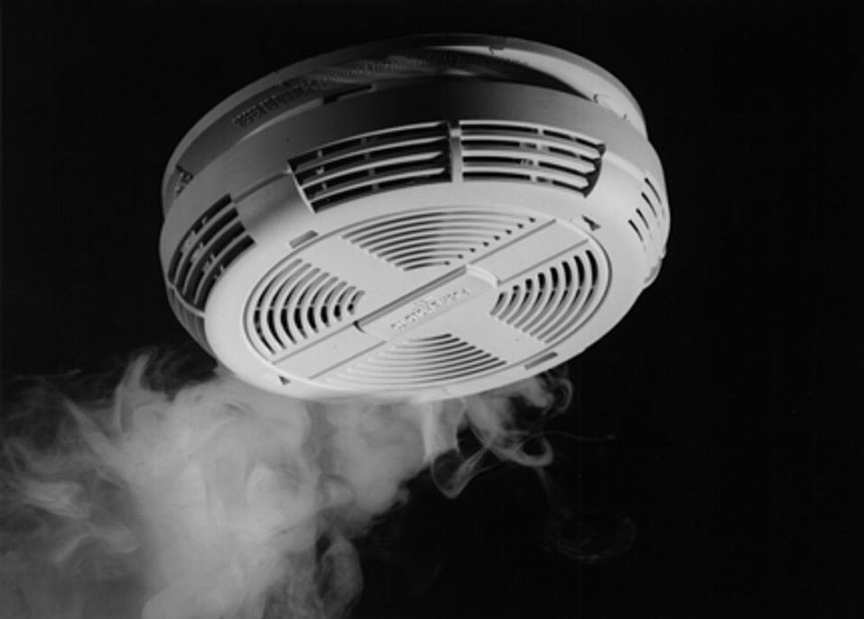

**Web search**: How does a smoke detector work?

Alpha particles have the least penetrating power compared to beta particles and gamma rays as they move with a smaller velocity. Alpha particles very easily ionize the atoms in there vicinity and hence loss energy very rapidly and therefore do not travel very far into a material. In air, alpha particles only travel about 100 mm.

Alpha particles are not particularly dangerous to a person with external exposure. However, if ingested, they can cause serve damage to cells and organs because of the high ionizing power.

[VISUAL PHYSICS ONLINE](http://www.physics.usyd.edu.au/teach_res/hsp/sp/spHome.htm)

If you have any feedback, comments, suggestions or corrections please email:

Ian Cooper School of Physics University of Sydney

ian.cooper@sydney.edu.au