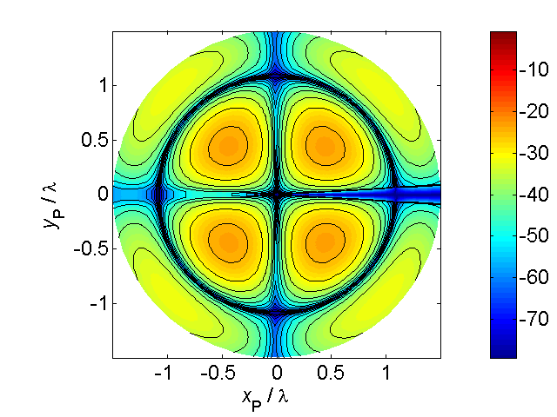[**VISUAL PHYSICS ONLINE**](http://www.physics.usyd.edu.au/teach_res/hsp/sp/spHome.htm)

**EARLY MODELS OF THE ATOM**

The atom was believed to be smallest building block of matter and an indivisible unit, until the late 19th century. There was no direct evidence that atoms could be subdivided at this time. However, observations made on the behaviour of gases inside discharge tubes indicated that atoms could be subdivided into electrically charged fragments.

[Review: discharge tubes](http://www.physics.usyd.edu.au/teach_res/hsp/sp/mod7/m7emrDT.pdf)

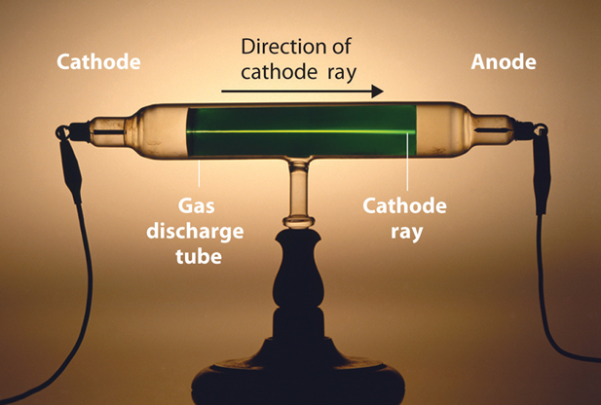A typical discharge tube consists of a glass tube with two electrodes sealed at either end.

Fig.1. Discharge tube showing path of cathode rays (electrons).

The electrodes are connected to a high voltage source. The negative terminal is known as the cathode and the positive terminal the anode. When a discharge tube is filled with air at atmospheric pressure and a voltage in excess of 10 kV is applied to the terminals, nothing is observed. However, as the air inside the tube is evacuated and the air pressure reduces, a current starts to flow and the tube glows. When a screen is placed inside the tube and coated with a substance such as zinc sulphide, flashes of light are observed being emitted from the screen. The flashes of light hints that the individual particles must be striking the screen and these particles travel from the cathode (-) to the anode (+). These beams were first called **cathode rays** and were thought to be negatively charged particles. Also, the cathode rays were deflected by a magnetic field in the same direction as a beam of negatively charged particles would be deflected. The beams could also be deflected by an external electric field again indicating the negative nature of the particles.

J.J Thomson in 1897 used a special discharge tube to measure the charge to mass ratio for the cathode rays. His results showed that these particles are all identical, no matter what material is used for the cathode or what gas was sealed inside the tube.

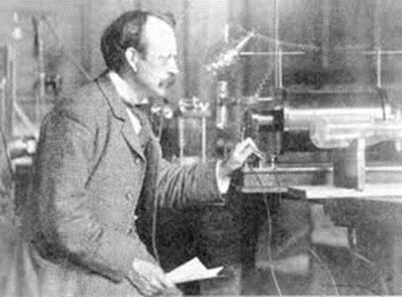

Fig. 2. J. J. Thomson (1897): Cathode ray tube experiments discovers the electron.

* Electron discovered by J.J. Thomson in 1897 when he was studying the properties of cathode rays.
* Thomson measured the charge-to-mass ratio (*e/m*) of cathode ray particles using the deflection of the charged particles in both electric and magnetic fields.
* Thomson determined the (*e/m*) for the electron, but was not able to determine the mass of the electron.

From such observations on using discharge tubes, the conclusions were that the cathode rays are a beam of electrons and these electrons are a constituent of all matter.

1909 R.A. Millikan determined the charge of an electron and shows that this was the smallest possible charge that could be detected. His experiments were known as Millikan’s oil drop experiments.

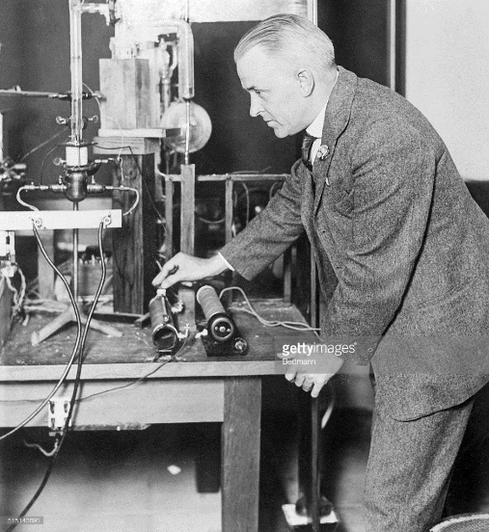

Fig. 3. Robert Millikan and his oil drop experiment (GettyIames).

Experiments by Goldstein in 1896 suggested that positively charged particles also exist within discharge tubes. If electrons have sufficient energy they can ionise neutral atoms producing positive ions which are accelerated towards the cathode. Most of the ions will pick up electrons and be neutralised leaving only a few positive particles reaching the cathode. In a special tube with a hole in the cathode, a beam of positive particles can pass through the cathode. It was found that these positive particles were much more massive than electrons, with the mass determined by the type of gas inside the discharge tube.

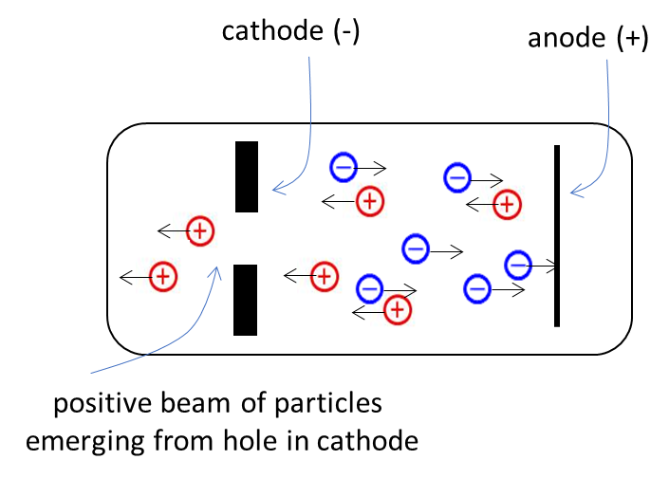

Fig. 4. Discharge tube used for investigating positive particles.

On the basis his experiments, J. J. Thomson argued that electrons must be contained inside atoms and hence the atom is in fact divisible. At this time, the structure of the atom was unknown. Thomson proposed in 1898 that the atom can be considered a sphere of positive electricity in which negative electrons are embedded. This is often referred to as a **plum pudding model** (or fruit cake studded with nuts). Most of the mass of the atom would have to be associated with the positive electricity. But, this plausible model raises many unanswered questions and the predictions using this model did not agree with result of experiments.

A method of finding out what it is like inside a fruit cake is to simply plunge your finger inside it. This is essentially what **Geiger** and **Marsden** did in 1911 at the suggestion of Earnest **Rutherford**. They fired highly energetic alpha particles from the radioactive element polonium. Rutherford wanted to perform an experiment to test Thomson’s plum pudding model. According to the Thomson’s model, the energetic alpha particles would pass straight through thin metals since the positive charge and mass of the metal are uniformly distributed and so the alpha particle has little reason to swerve off its original path.

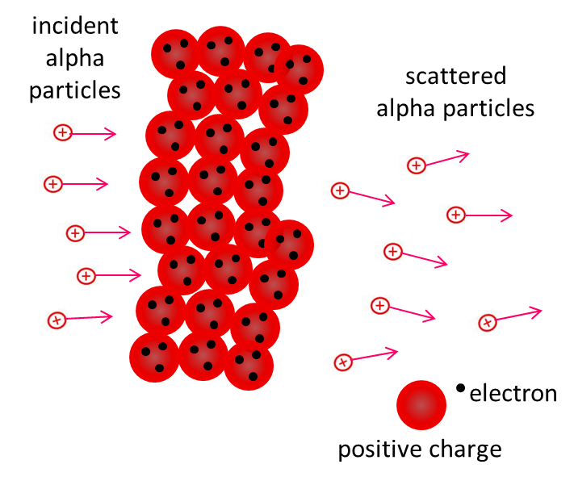

Fig. 5. Penetration of a metal foil by alpha particles as predicted by Thomson’s model. In the metal, positive charge spread uniformly and electrons embedded here and there to give weak electric fields. Therefore, very little deflection of alpha particles is expected. However, this prediction did not agree with experimental results.

In the **Rutherford experiment**, an alpha source was placed in front of a lead sheet with a hole in it to give a narrow beam. On the other side of the thin metal foil was a movable zinc sulfide screen which gave off a flash of light when struck by an alpha particle so that the trajectories of the alpha particle could be determined.

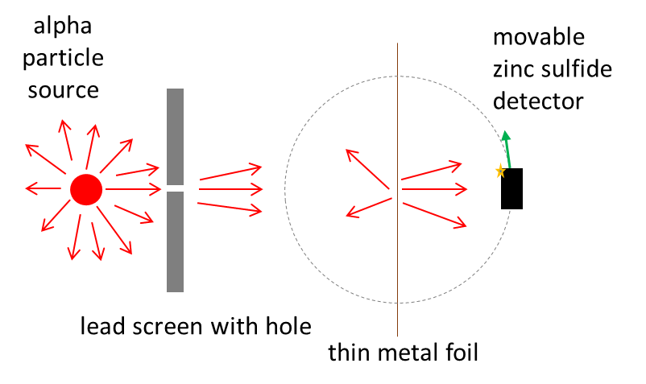

Fig. 6. Rutherford’s scattering experiment.

The finding of Geiger and Marsden was that, while most of the alpha particles emerged with little deflection in passing through the foil, a few particles where scattered through very large angles. Some particles were actually reflected back along their path.

To Rutherford this was absolutely unbelievable:

“it was as incredible as if you fired a 15 inch shell at a piece of tissue paper and it came back and hit you”.

The Thomson model could not account for such large deflections. If the charge and mass were uniformly spread throughout the metal, a positively charged alpha particle would not encounter a large repulsive or major obstacle anywhere in its path. To explain the results of the scattering experiment, Rutherford proposed a model in which the positive charge and mass in the foil are concentrated in very small regions – the atom has a very small **nucleus**, with the electrons some distance away. With the atom being largely empty space, it is easy to see why most alpha particles pass right through the thin foil. For those alpha particles coming near a nucleus, the alpha particles would experience a strong repulsive force from the positive concentration of charge of the massive and immovable nucleus.

The atom has a diameter in the order of 10-10 m whereas the diameter of the nucleus is in the order of 10-15 m and the ratio of the volume of the nucleus to that of the atom is a staggering 1:1015 – the atom is truly composed mostly of empty space.

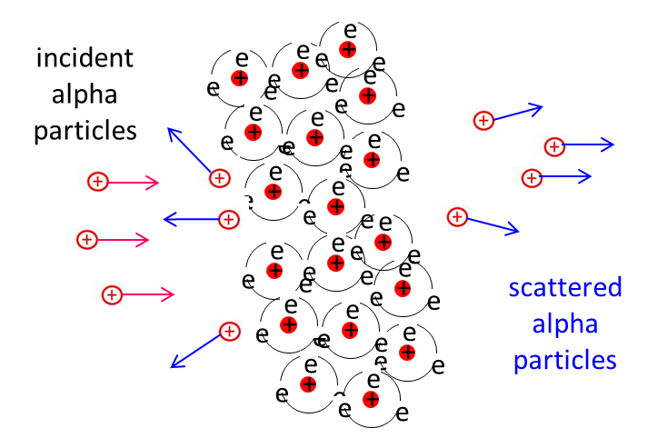

Fig. 7. Rutherford model of the atom, concentrated tiny positive nucleus with electrons some distance away.

Rutherford was able to obtain a mathematical formula to describe the scattering of alpha particles by thin films and the predictions from this formula agreed with the experimental results. **Rutherford is credited as the discoverer of the nucleus**.



Fig. 8. The trajectories of alpha particles being scattered from a positive nucleus based upon Rutherford scattering formula. Alpha particles approaching close to the nucleus are scattered through large angles while the others pass through with little deflection.

The model of the atom that emerges from Rutherford’s work is a tiny, massive nucleus with a positive charge surrounded at some distance way by light electrons, with the negative charge of the electrons balancing the positive charge of the nucleus. These electrons must be in motion, otherwise the electrostatic force between them would pull the electrons into the nucleus. So, the electrons would cycle around the nucleus like the planets around the Sun in dynamically stable orbits. Therefore, the electrons must be accelerating so that they do not collapse into the nucleus.

But, a well-known principle of classical physics is that, an accelerating charge must loss energy by the emission of electromagnetic radiation. Consequently, the electrons would spiral down into the nucleus as they loss energy and the atom should collapse (figure 9).

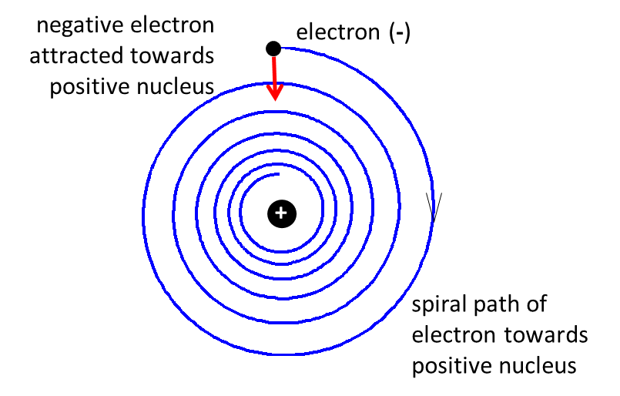

Fig. 9. According to electromagnetic theory, an accelerating charge losses energy by emitting radiation, hence, electrons in atoms should spiral towards the nucleus. The Rutherford model can’t overcome this problem.

Classical physics is thus completely unable to account for the fact that atoms exist at all.

[VISUAL PHYSICS ONLINE](http://www.physics.usyd.edu.au/teach_res/hsp/sp/spHome.htm)

If you have any feedback, comments, suggestions or corrections please email:

Ian Cooper School of Physics University of Sydney

ian.cooper@sydney.edu.au