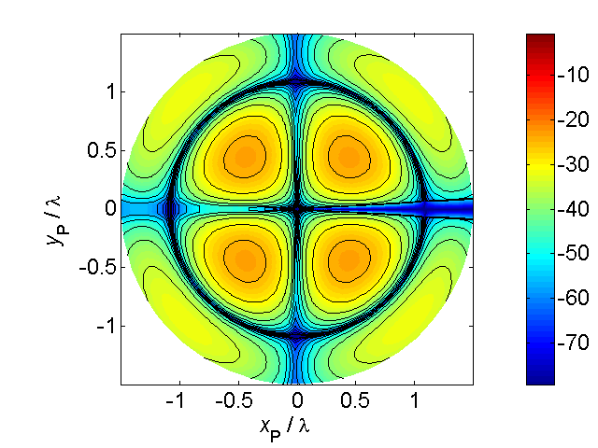[**VISUAL PHYSICS ONLINE**](http://www.physics.usyd.edu.au/teach_res/hsp/sp/spHome.htm)

**BOHR MODEL OF THE ATOM**

Bohr type models of the atom give a totally incorrect picture of the atom and are of historical significance only.

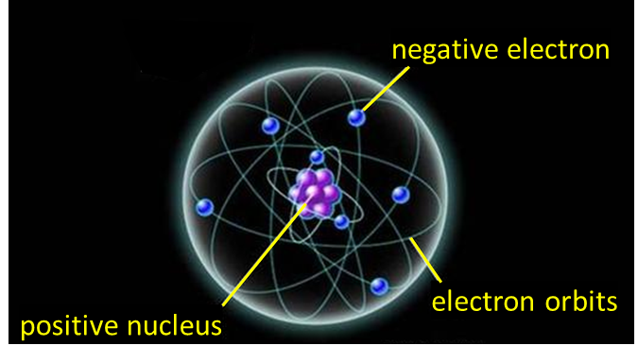

Fig. 1. Bohr’s planetary model of the atom.

However, the Bohr models were an important step in the development of quantum mechanics. Quantum mechanics is a mathematical theory to account for the atomic related behaviour of our physical world. In quantum mechanics, the electrons bound to an atom are described in terms of waves. No longer can one talk about the path of an electron moving around the nucleus, but only about the probability of finding an electron at a certain location.

Niels Bohr proposed the Bohr Model of the Atom in 1913. Because the Bohr model is a modification of the earlier Rutherford Model, some people call Bohr's Model the Rutherford-Bohr Model. Unlike earlier models, the Bohr model explains the Rydberg formula for the spectral emission lines of atomic hydrogen.

[Review: atomic spectra](http://www.physics.usyd.edu.au/teach_res/hsp/sp/mod7/m7emrEAS.pdf)

The Bohr model is a planetary model in which the negatively-charged electrons orbit a small, positively-charged nucleus because of the Coulomb force between the positively-charged nucleus and the negatively-charged electrons.

He developed his theory based upon assumptions that would lead to an explanation of the line spectra emitted from atoms and to a derivation of the Rydberg equation for hydrogen-like atoms. Bohr used the ideas of Planck and Einstein that radiation is emitted and absorbed in discrete amounts and these ideas lead to the concept of the photon.

**Main Points of the Bohr Model**

Bohr used the Rutherford model of the atom as his starting point. His modifications involved two postulates that were simply acknowledgements of experimental facts related to the spectral emissions. These postulates were at odds with the ideas of classical physics. The Bohr picture of the atom was of a central positive nucleus with an electron in “**allowed**” circular stable orbit such that the electron’s angular momentum was quantised. The electron in a stable orbit did not lose energy by the emission of electromagnetic radiation. Bohr assumed that classical electromagnetic theory was not completely valid for atomic systems.

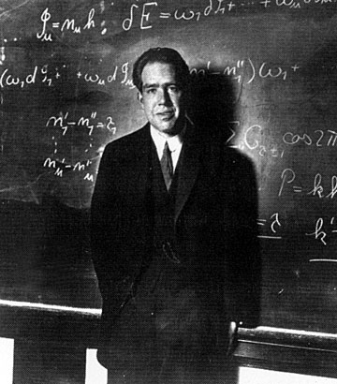

**Postulate 1**

An atom can exist in certain allowed or stationary states, with each state having a definite value for its total energy. When the atom is in one of these states it is stable and does not radiate energy. The total energy of an orbiting electron is quantised such that the electron’s angular momentum *L* has a set of discrete values given by equation (1)

(1)  *n* = 1, 2, 3, …

*m*  mass of electron

*v*  orbital velocity of electron

*r*  orbital radius

*h*  Planck’s constant *h* = 6.63x10-34 J.s

*L*  angular momentum

**Postulate 2**

An atom emits or absorbs energy only when an electron moves from one stable state to another. In a transition from its initial state to its final state, a photon is either emitted or absorbed and the energy of the photon is equal to the difference in the energy of the two states (equation 2)

(2) 

 energy lost or gained by atom

 energy of emitted or absorbed photon

*h*  Planck’s constant *h* = 6.63x10-34 J.s

*f* frequency of electromagnetic radiation (photon)

*Ei* total energy of electron in initial state *ni*

*Ef*  total energy of electron in final state *nf*

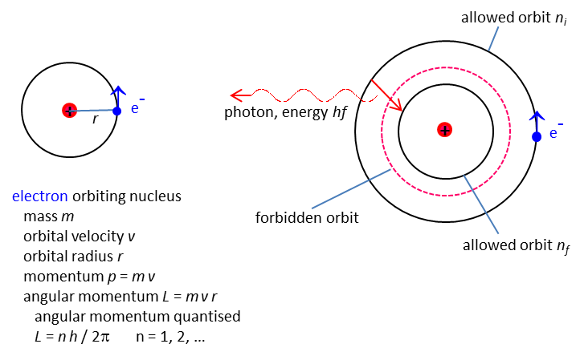

Fig. 2. Bohr’s model of the atom.

We can derive an equation for the radii of the stable circular obits (equation 3) and the total energies of the allowed states (equation 4) using the ideas of classical electromagnetic theory and Bohr’s quantisation of angular momentum postulate.

The allowed radii *rn* of the stable states are

(3) 

The total energies of the electron *En* (*E = EK + EP)* are

(4) 

*ε*0 permittivity of free space *ε*0 = 8.85x10-12 C2.N-1.m-2

*h*  Planck’s constant *h* = 6.63x10-34 J.s

*qe*  electron charge *e* = 1.602x10-19 C

*me*  electron mass *m* = 9.11x10-31 kg

*n*  principle quantum number *n* = 1, 2, 3, …

**Derivation of Bohr’s equations for the hydrogen atom**

* Stationary orbit 🡪 total energy is constant *E* = *EK* + *EP*
* attractive force between p+ and e- 🡪 circular orbit 🡪

 Coulomb force = centripetal force

* Potential energy of e- 🡪 
* Kinetic energy of e- 🡪 
* Total energy of e- 🡪 
* angular momentum e- quantized 🡪 
* Radius of stationary state, principle quantum number *n* 🡪



Bohr radius, *n* = 1



* Total energy of e- 🡪 





Negative sign 🡪 electron bound to nucleus

Ionization energy 🡪 13. 6 eV 1 eV = 1.602×10-19 J

*E*1 = -13.6 eV

*E*2 = - 3.4 eV

*E*3 = -1.51 eV

*E*4 = -0.85 eV

*E*5 = - 0.54 eV

Hydrogen spectral lines

 🡪 

**agreement with Rydberg equation**

**Problems with the Bohr Model**

A fatal shortcoming for any theory is that it should not agree with experimental results. The discrepancies between predicted and measured wavelengths for line spectra other than hydrogen were enough to indicate that modifications would have to be made to Bohr’s theory of the atom. Another difficulty lay in the nature of the postulates. The quantisation rule for angular momentum was completely arbitrary and there was a conceptual difficulty with how the electromagnetic waves emitted by an atom were produced and what was the oscillation that determined the frequency of the emitted radiation.

* It violates the Heisenberg Uncertainty Principle because it considers electrons to have both a known radius and orbit.
* The Bohr Model provides an incorrect value for the ground state orbital angular momentum.
* It makes poor predictions regarding the spectra of larger atoms.
* It does not predict the relative intensities of spectral lines.
* The Bohr Model does not explain fine structure and hyperfine structure in spectral lines.
* It does not explain the Zeeman Effect.

[VISUAL PHYSICS ONLINE](http://www.physics.usyd.edu.au/teach_res/hsp/sp/spHome.htm)

If you have any feedback, comments, suggestions or corrections please email:

Ian Cooper School of Physics University of Sydney

ian.cooper@sydney.edu.au