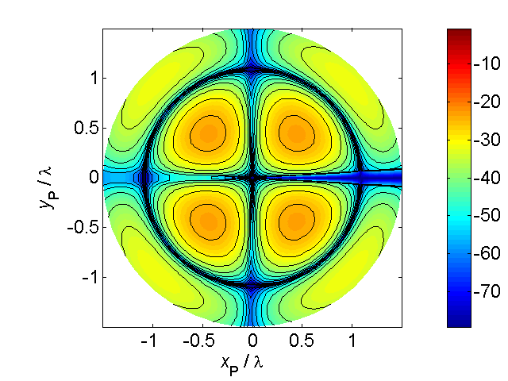[**VISUAL PHYSICS ONLINE**](http://www.physics.usyd.edu.au/teach_res/hsp/sp/spHome.htm)

**de BROGLIE’S MATTER WAVES**

In 1905, Einstein had shown that the photoelectric effect can be accounted for if the incident electromagnetic radiation is assumed to have particle like properties. That is, under certain circumstances electromagnetic waves have properties which are indistinguishable from those of particles. At the same time, phenomena such as interference and diffraction are best treated by describing electromagnetic radiation in terms of a wave motion. Therefore, we must accept the idea of this the dual picture of electromagnetic radiation (light).

In 1923, de Broglie postulated that the same idea might be attributed to electrons, protons, atoms and molecules, which we refer to as the particles of modern physics. That is, particles may have a dual nature just as light.

**Light – photons**

Electromagnetic radiation travels at the speed of light *c*, and for monochromatic radiation it is characterised by its frequency *f* or its wavelength  where

(1) 

The electromagnetic radiation can be considered as a beam of particles called **photons**. The energy *E* of each photon and its momentum *p* are given by

(2)  photon

(3)  photon

where *h* is Planck’s constant

**Particles – matter waves**

de Broglie hypothesis was that if the particle nature of light is represented by its momentum *p* and its wave nature by its wavelength , then the momentum of a particle *p* should be related to its wavelength . This gives the famous deBroglie relationship

(4)  particle

The wave associated with a particle is called a **matter wave** and  is called the **de Broglie wavelength**.

**DAVISSON AND GERMER EXPERIMENT**

In 1927, Davisson and Germer confirmed de Broglie's momentum-wavelength

postulate by observing that electrons exhibited diffraction effects when

reflected from single nickel crystals. This was the first experimental confirmation of the wave nature of electrons.

Davisson and Germer investigated the scattering of electrons from a nickel crystal surface in a vacuum. Electrons were accelerated through a high electric potential *V* before being incident upon a nickel crystal. A schematic diagram of the experimental setup is shown in figure (1).

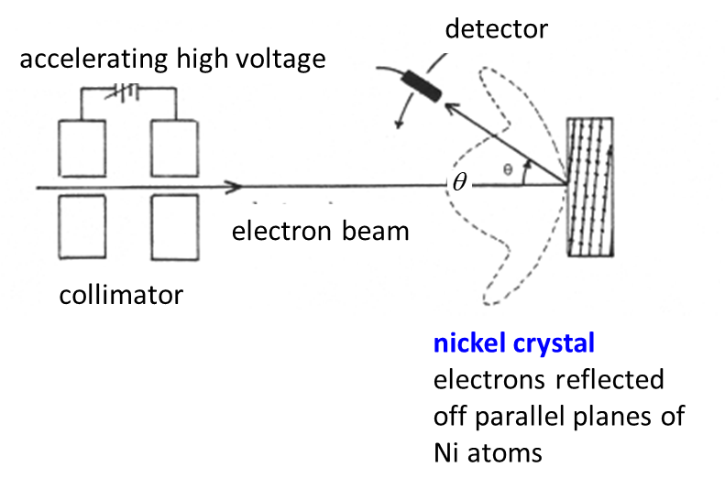

Fig.1. Diagram of the Davisson and Germer experiment.

The unexpected result was that the electrons were very strongly reflected at certain angles and not others. The behaviour of electrons was the same as that observed for the scattering of X-rays from a metal surface. The electrons were observed to undergo diffraction. The only conclusion to be made to explain the observations was that the **electrons** must behave as a **wave** and hence a wavelength  can be associated with the electron motion.

The scattering of the electrons could be described by the Bragg equation which was used to model the scattering of X-rays from crystal (equation 5).

(5) 

where *d* is the spacing between crystal planes,  the angle at which strong reflections occur, and  is the wavelength associated with the electron beam.

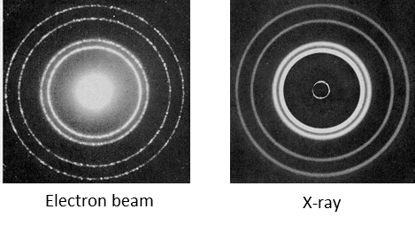Since this experiment performed in 1927, diffraction experiments with other particles, such as neutrons, protons, atoms, and molecules also show diffraction effects.

The result of this experiment and other experiments indicated that there **no** clear distinction between **particles** and **waves**. Experiments with electromagnetic radiation normally regarded as a wave show a particle nature in experiments such as the photoelectric effect. This leads to the concept of **wave-particle duality**. However, in no single experiment does a photon or an electron simultaneously show both particle and wave properties.

The kinetic energy *EK* of an electron after being accelerated by the high potential *V* is



and its momentum is



and the electron’s wavelength from the de Broglie relationship is



Davisson and Germer found that their results were quite consistent with this value for the wavelength of the electrons as compared with the wavelength predicted by using the Bragg equation.

Many other experiments have been carried out to show the existence of matter waves with a wavelength λ associated with a beam of particles.

|  |
| --- |
| **Exercise 1**  Describe the diffraction pattern one would obtain by shooting gunshot (mass *m* = 0.1 g and velocity *v* = 200 m.s-1) through a slit which is 2.00 mm wide.  **Solution**  *m* = 0.1 g = 10-4 kg *v* = 200 m.s-1 *d* = 2.00 mm = 2.00x10-3 m *h* = 6.63x10-34 J.s  momentum of gunshot *p* = *mv* = 2x102 kg.m.s-1  wavelength of gunshot λ = *h* / *p* = 3.3x10-32 m  This wavelength is so so small one can never observe any wave like behaviour of the gunshot. The gunshot would pass through the slit in straight lines, there would be no observable wave effects. |

|  |
| --- |
| **Exercise 2**  Electrons were scattering off a nickel crystal with the distance between parallel planes of atoms being 0.1075 nm and the diffraction peak was at the angle 50o for the case when *n* = 1. (a) What was the wavelength of an electron?  The electrons were accelerated from rest by a voltage of 54 V before being scattering from the surface of the nickel crystal. (b) What was the wavelength of an electron?  **Solution**  *n* = 1 *d* = 0.1075 nm = 0.1075x10-9 m *θ* = 50o *V* = 54 V  *e* = 1.602x10-19 C *h* = 6.63x10-34 J.s *me* = *m* = 9.11x10-31 kg  (a)  Bragg equation    (b)  Kinetic energy of electron *EK* = *eV* = (1.602x10-19)(54) J = 8.65x10-18 J  de Broglie equation    There is excellent agreement between the two values of the electron wavelength and provides convincing evidence of the wave nature of electrons as well as the de Broglie relationship. |

Thus, we have this **dual** picture of nature – **particle / wave**.

However, in no single experiment does a photon show both wave and particle properties nor does a particle simultaneously show both particle and wave properties.

**The de Broglie Model**

Louis de Broglie’s contribution to the description of the atom was inspired by the controversy that was raging in 1922 over the dual nature of light. Various experiments in physical optics shored that light was a wave. Experiments like the photoelectric effect showed that light behaved like corpuscles.

The two sides of this argument are represented in figure 2, Viewed as a wave, light has a wavelength and frequency. It is composed of alternating electric and magnetic fields. As the light advances, it follows a ray path presented by the wavy line (electric field variation) directed along the x-axis. In a sense, we do not have a precise location of the light. We know what it is, but not where it is. Viewed as a corpuscle, the light has an energy and an associated mass. It is precisely located at a position along the x-axis at one instant of time. We speak of it as a corpuscle of energy, but the precise description of the inside of the corpuscle is unknown. As a corpuscle, we know where it is, but not what it is. Nevertheless, it is the same light.

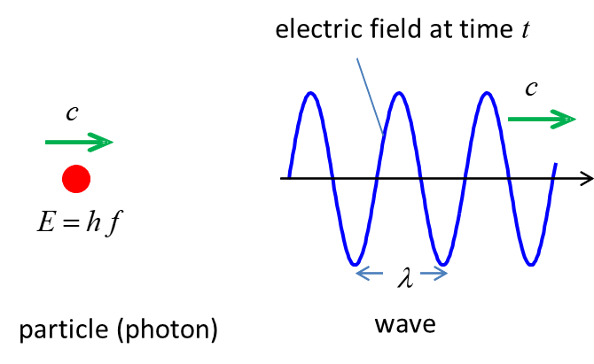

Fig. 2. Wave and particle of light.

de Broglie noted that the corpuscular properties were more obvious for very energetic light – light of a shorter wavelength. He suggested a composite picture of a **wave train** (**wave packet**) to represent this dual nature (figure 3).

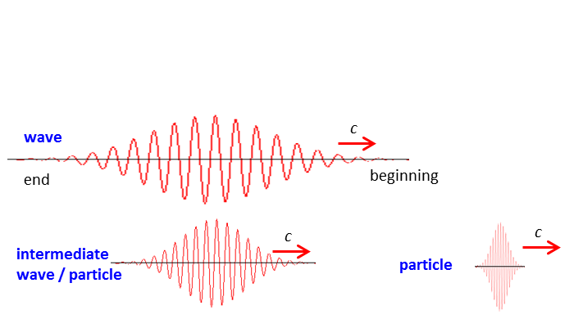

Fig. 3. Wave packet or wave train.

These are like waves, except they have a beginning and an end. Light has a beginning (when we turn on the light) and an end (when we shut it off) and so the light occupies a limited part of space. If the wavelength is large and the beginning and end of the wave train are far apart, the wave train resembles a wave. If the frequency is very high and the space occupied very small, the wave train looks like a particle.

Combining the particle and wave pictures we can get a mathematical relationship between the wave property – wavelength *λ* and particle property – momentum *p* = *mv*

Wave picture 

Particle picture (Einstein’s special theory of relativity)



Planck’s hypothesis 

Light (electromagnetic radiation) 

Hence, de Broglie reasoned that a similar relationship should exist for particles

(4)  **de Broglie relationship**

Consider a speeding bullet *m* = 0.1 kg and *v* = 1000 m.s-1. Its wavelength is



The wavelength is so so so so small that it always looks like a bullet and not a wave.

Consider an electron *m* = 9.11x10-31 and *v* = 1000 m.s-1. Its wavelength is



The wavelength of the electron is small and its wave nature would be observable in diffraction experiments.

**de Broglie’s matter waves & Bohr’s quantization of stationary states**

In the Bohr model of the atom, an electron can occupy only certain allowed orbits or stationary states for which the orbital angular momentum *L* of the electron is quantized

 *n* = 1, 2, 3, …

There was no justification to the postulate except that the Rydberg equation could be derived from the Bohr model.

In the de Broglie model of the atom, the Bohr’s allowed orbits corresponded to radii where electrons formed **standing waves** around the nucleus, that is, a whole number *n* of de Broglie wavelengths must fit around the circumference of an orbit of radius r.



de Broglie was then able to explain the stability of electron orbits in the Bohr atom. When an electron is in one of the allowed orbits or stationary states, it behaves as if it is a standing wave, not a charged particle experiencing centripetal acceleration. Thus, the electron does not emit EM radiation when it is in a stationary state within the atom.



Fig. 4. de Broglie model of the hydrogen atom: Bohr orbits and de Broglie’s standing waves.

Diffraction patterns are most intense when the size of the aperture or obstacle is comparable to the size of the wavelength of the wave. The electrons in the Davisson & Germer experiment were scattered in specific directions, which could only be explained by treating the electrons as waves with a wavelength related to their momentum by the de Broglie relation. Particles would have bounced off the nickel in all directions randomly. The de Broglie proposal on a wave like character for matter had little direct effect until the discovery of the wave like character of electrons. Until then, it was seen as a theoretical model of matter that was acceptable enough on mathematical grounds. Only after the approval by Einstein was de Broglie awarded his PhD based upon his hypothesis.

[VISUAL PHYSICS ONLINE](http://www.physics.usyd.edu.au/teach_res/hsp/sp/spHome.htm)

If you have any feedback, comments, suggestions or corrections please email:

Ian Cooper School of Physics University of Sydney

ian.cooper@sydney.edu.au