[VISUAL PHYSICS ONLINE](http://www.physics.usyd.edu.au/teach_res/hsp/sp/spHome.htm)

**WORKSHOP**

**MILLIKAN’S OIL DROP EXPERIMENT #2**

**Modern version of Millikan oil drop experiment**

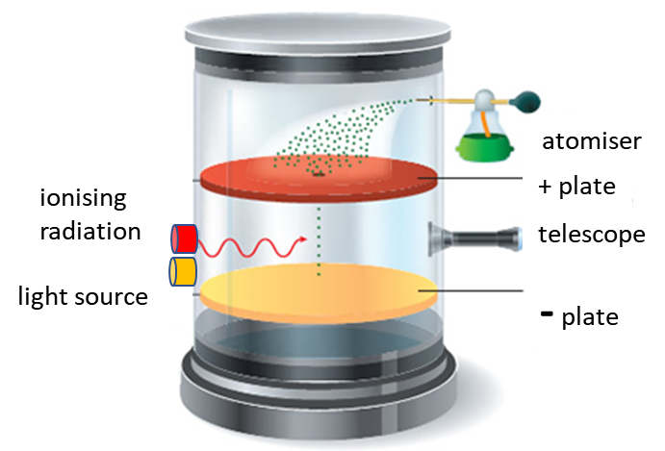

Before you start this Workshop / Experiment you should review the notes on Millikan’s Oil Drop Experiment

[Millikan’s Oil Drop Experiment](http://www.physics.usyd.edu.au/teach_res/hsp/sp/mod8/m8Millikan.pdf)

**Part 1.**

In a more modern version of Millikan’s oil drop experiment, small plastic spheres are used instead of oil drops. Their diameter is about 1  (1x10-6 m) and their mass can be accurately measured. This avoids the measurement of the oil drop’s terminal velocity and the dependence on Stokes’s law. The mass of the oil drop was the most inaccurate of the measurements made by Millikan.

The plastic spheres sprayed in a liquid solution from an atomiser and are easily viewed through the microscope. The plastic spheres are bombarded by alpha-particles from a radioactive source so that they can acquire a charge more effectively.

When a plastic sphere is held stationary between the plates of the capacitor, the magnitude of the charge can be expressed as

(1) 

By making many measurements we can determine whether the charges determined from equation 1 are multiples of some basic charge unit.

In an actual experiment, the mass of spheres was



and the spacing between the capacitor plates was

 a

The voltage *V* between the plates was adjusted and measured to keep a plastic sphere stationary in the field of view of the microscope. Table 1 shows 30 values that were recorded for *V* to keep the plastic spheres stationary.

Table 1: Measurements of voltage between capacitor plates to keep a sphere stationary.

|  |  |  |  |  |  |
| --- | --- | --- | --- | --- | --- |
| Sphere | *V* [V] | Sphere | *V* [V] | Sphere | *V* [V] |
| 1 | -30.0 | 11 | -126.3 | 21 | -31.5 |
| 2 | +28.8 | 12 | -83.9 | 22 | -66.8 |
| 3 | -28.4 | 13 | -44.6 | 23 | 41.5 |
| 4 | +30.6 | 14 | -65.5 | 24 | -34.8 |
| 5 | -136.2 | 15 | -139.1 | 25 | -44.3 |
| 6 | -134.3 | 16 | -64.5 | 26 | -143.6 |
| 7 | 82.2 | 17 | -28.7 | 27 | +77.2 |
| 8 | 28.7 | 18 | -30.7 | 28 | -39.9 |
| 9 | -39.9 | 19 | 32.8 | 29 | -57.9 |
| 10 | 54.3 | 20 | -140.8 | 30 | +42.3 |

For each sphere calculate its charge *q*.

It is best to do the calculations and graphs in a spreadsheet.

Why are some voltage negative while others are positive?

Think of several ways to graph the results to find the elementary charge and test the hypothesis that charge is quantized.

Perform the web based simulation and obtain another 30 sets of data and repeat your analysis.

[Simulation](http://www.thephysicsaviary.com/Physics/Programs/Labs/MillikanOilDropLab/index.html)

Compare your findings to the data given in table 1 and the data your obtained from the simulation.

**PART 2. MILLIKAN’S OIL DROP EXPERIMENT**

In order to find the electron’s charge *e* Millikan needed to know the mass *m* of his oil drops, and this was actually the source of his greatest uncertainty in determining *e.* His value was about 0.5% low as a result. However, to show that all charges are multiples of some basic unit, it was not necessary to know *m.*

Ignoring the buoyancy force, the forces on the oil drop when it is moving with a constant velocity equal to its terminal velocity are:

Gravitational force 

Electric force 

Falling oil drop

Resistive force 



Rising oil drop

Resistive force 



Hence, we can conclude



where *K* is a constant as long as Millikan watched a single drop and did not vary *E.*

We see that *q* is proportional to the quantity .

Thus, if it is true that *q* is always an integer multiple of *e,* it must also be true that  is always an integer multiple of some fixed quantity.

Table 2 shows a series of timings for a single droplet made with a commercial laboratory version of Millikan’s experiment. the parameters for the experiment are:

Distance travelled by drop *s* = 8.30x10-4 m

Density of oil  = 839 kg.m-3

Acceleration due to gravity *g* = 9.81 m.s-2

Viscosity of air (corrected for applying Stokes’s law)

 = 1.60x10-5 N.s.m-2

Electric field *E* = 1.21x105 N.C-1

Table 2. Measurements for the time intervals in seconds for a single drop to travel up (*tE)* and down (*tG)* a fixed distance *s.*

|  |  |  |  |  |  |  |  |  |  |  |
| --- | --- | --- | --- | --- | --- | --- | --- | --- | --- | --- |
| *tG* | 15.2 | 15.0 | 15.1 | 15.0 | 14.9 | 15.1 | 15.1 | 15.0 | 15.2 | 15.2 |
| *tE* | 6.4 | 6.3 | 6.1 | 24.4 | 24.2 | 3.7 | 3.6 | 1.8 | 2.0 | 1.9 |

Calculate  and show that within the uncertainties this quantity is always an integer multiple of one fixed number, and hence charge is always a multiple of one fixed charge.

Estimate the radius *R* of the drop and its mass *m.*

Estimate the four different charges *q* on the drop.

Estimate the elementary charge *e.*

**SAMPLE RESULTS**

**PART 1**

The values for the charge *q* on the spheres can be plotted along a number line. The blue dots are the actual measurements for *q.* The red dots are the integer multiples values of the elementary charge *e*

*e =*1.602x10-19 C

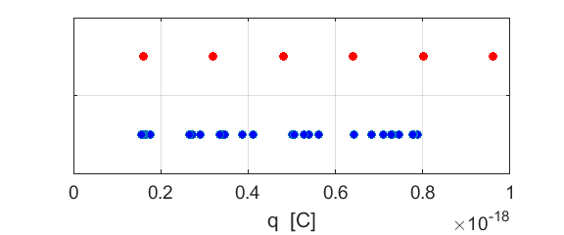

To see if charge is quantised it is better to plot *q / e* on a number line.

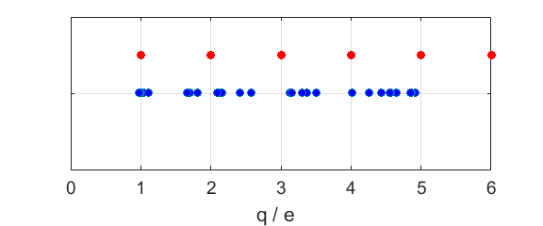

From the recorded measurements, an estimate of the elementary charge is 1.6x10-19 C. This value is in good agreement with the actual value of *e.*

From the graphs, you can conclude that the charge is quantised and that

(2) 

even though the results are not particular good. This is a very difficult experiment to perform and there is a lot of scatter in the measurements of *q.* You would need to take lots and lots of measurements to get stronger evidence to support equation 2.