[VISUAL PHYSICS ONLINE](http://www.physics.usyd.edu.au/teach_res/hsp/sp/spHome.htm)

**WORKSHOP**

**MILLIKAN’S OIL DROP EXPERIMENT #1**

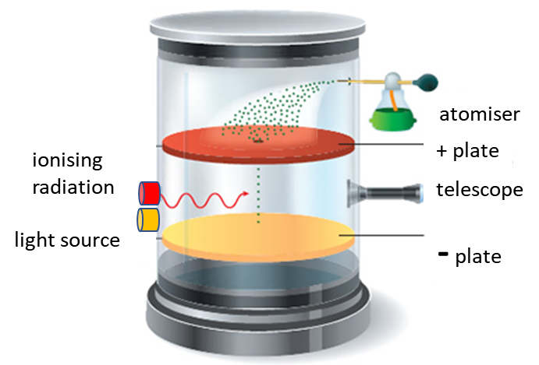

Before you start this Workshop / Experiment you should review the notes on Millikan’s Oil Drop Experiment

[Millikan’s Oil Drop Experiment](http://www.physics.usyd.edu.au/teach_res/hsp/sp/mod8/m8Millikan.pdf)

The values for the acceleration due to gravity, the density and viscosity of air are well known. The measurements for the distance between the capacitor plates, the voltage between the plates and the graticule spacing of the microscope easy to make. So, Millikan only had to measure the transit time intervals  and  to estimate the charge on a single oil drop.

But these time intervals are not so easy to make. This is a very difficult and tedious experiment to perform because of the challenge in timing a single oil drop as the voltage to the capacitor is switched on and off and the charge on the oil drop sometimes changes. Yet, Millikan was able to measure *q* for many thousand oil droplets.

You can use the following data to test the hypothesis that the charge on an object is quantized and estimate a value for the elementary charge *e.*

We start with known values for the density and viscosity of air

density of air 

viscosity of air at 15 oC 

However, Stokes’s law overestimates the resistive force acting on an oil drop. So, it is better to use a corrected value for the viscosity



We will use values from an actual experiment conducted with a teaching laboratory version of Millikan’s oil drop apparatus.

Acceleration due to gravity 

Density of oil 

Separation of capacitor plates 

Distance for time intervals measurements



The voltage between the capacitor was 

Table 1 shows a series of timings for a single droplet made with a commercial laboratory version of Millikan’s experiment. the parameters for the experiment are:

Distance travelled by drop *s* = 8.30x10-4 m

Density of oil  = 839 kg.m-3

Acceleration due to gravity *g* = 9.81 m.s-2

Viscosity of air (corrected for applying Stokes’s law)

 = 1.60x10-5 N.s.m-2

Electric field *E* = 1.21x105 N.C-1

Table 1. Measurements for the time intervals in seconds for a single drop to travel up (*tU)* and down (*tD)* a fixed distance *s.*

*tD* 

15.3 15.6 16.7 14.7 16.6 14.7 15.9 14.2 16.5 16.7

15.3 16.3 16.2 17.2 16.1 17.0 15.9 15.4 16.0 15.8

16.9 15.9 15.2 15.8 17.2 15.6 15.3 16.9 16.1 15.6

*tU* 

1.46 1.39 1.56 2.40 2.46 2.28 2.56 2.48 2.28 1.99

1.83 1.91 1.91 1.80 17.6 18.0 17.9 17.9 18.0 17.9

5.80 5.76 5.64 5.82 5.79 3.54 3.32 3.33 3.45 3.48

We now have all the required values to start the calculation to find the charges *q* on the oil drop.

Calculate the following in the order given:

Electric field 

Average value of *tD*

Terminal velocity of falling oil drop 

Radius of oil drop 

Volume of oil drop 

Mass of oil drop 

Gravitational acting on oil drop 

Terminal velocities of oil drop from the values of *tU* in Table 1 

Resistive force *FR* for each value of the terminal velocity



Ignore the buoyancy force since it is very small

Calculate all the values of the charge *q* on the oil drop.



Plot your values of *q* on a number line.

Is the charge *q* quantised?

What is your estimate of the elementary charge *e?*

**SAMPLE RESULTS**

The values for the charge *q* on the oil drops can be plotted along a number line. The blue crosses are the actual measurements for *q.* The red dots are the average *q* value for each cluster specify by an integer *N.*

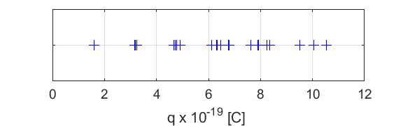

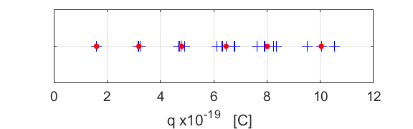

The line plot for the dimensionless quantity *q* / *e.*

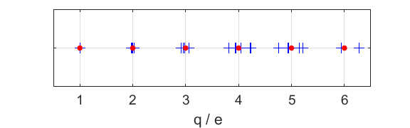

From the recorded measurements, an estimate of the elementary charge is 1.62x10-19 C. This value is in good agreement with the actual value of *e.*

From the graphs, you can conclude that the charge is quantised and that



even though the results are not particular good. This is a very difficult experiment to perform and there is a lot of scatter in the measurements of *q.* You would need to take lots and lots of measurements to get stronger evidence to support the quantisation of charge.

The analysis was done using the Matlab mscript **spMillikan2.m**

which can be download from the directory

<http://www.physics.usyd.edu.au/teach_res/mp/mscripts/>

[VISUAL PHYSICS ONLINE](http://www.physics.usyd.edu.au/teach_res/hsp/sp/spHome.htm)

If you have any feedback, comments, suggestions or corrections please email:

Ian Cooper School of Physics University of Sydney

ian.cooper@sydney.edu.au

*q* x1019 C values (average for each value of *N* and *N*e*)

10.05 10.54 9.52 (10.4 6*1.6 = 9.6)

6.48 6.33 6.76 6.12 6.30 6.79 (6.46 4*1.6 = 6.4)

7.62 8.24 7.90 7.92 8.36 (8.01 5*1.6 = 8.0)

1.61 1.60 1.60 1.60 1.59 1.61 (1.60 1*1.6 = 1.6)

3.18 3.20 3.24 3.17 3.18 (3.19 2*1.6 = 3.2)

4.67 4.91 4.91 4.77 4.73 (4.80 3*1.6 = 4.8)