[**VISUAL PHYSICS ONLINE**](http://www.physics.usyd.edu.au/teach_res/hsp/sp/spHome.htm)

**DEPTH STDIES: YEARS 11 AND 12**

**PHYSICS IS FUN, EXCITING, SIMPLE**

**MY SUGGESTIONED DEPTH STUDIES**

**Motion of Objects through a Resistive Medium** (Modules 1, 2, 5)

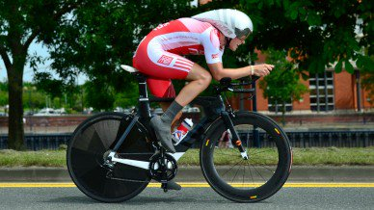

[Motion of falling objects with resistance](http://www.physics.usyd.edu.au/teach_res/mp/doc/mec_friction_2.pdf)

**Physics of Sports** (Modules 1, 2, 5)

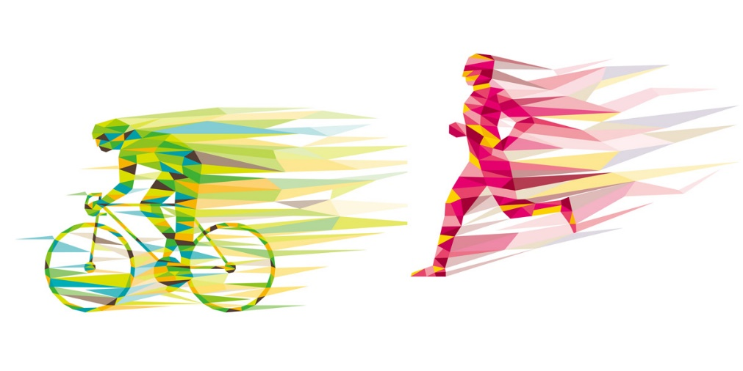

[The Physics of Sports](https://www.elsevier.com/connect/the-physics-of-sports)

**Physics of Musical Instruments** (Module 3.1)

[Standing Waves in air columns](http://www.physics.usyd.edu.au/teach_res/hsp/sp/mod31/pa31_tube_movie.pdf)

**Greenhouse Effect and Global Warming** (Modules 3.2, 7,8)

[Workshop Notes: Global Warming and Greenhouse Effect](http://www.physics.usyd.edu.au/teach_res/hsp/sp/mod32/m32_green_house.pdf)

**Rockets and Satellites** (Module 5)

[Rockets and Satellites](http://www.physics.usyd.edu.au/teach_res/hsp/sp/mod5/m5DSR.pdf)

**Physics of Natural Disasters: earthquakes, cyclones (hurricanes, typhoons), tornadoes** (Modules 1, 2, 3.1, 3.2, 5)

|  |  |
| --- | --- |
| Image result for images earthquakes | Image result for images hurricane irma |
| Image result for images hurricane irma | Image result for image tornado |

Northridge Earthquake

**Special Relativity, General Relativity, Cosmology, Black Holes**

(Module 7)

A depth study is any type of investigation/activity that a student completes individually or collaboratively that allows the further development of one or more concepts found within or inspired by the syllabus. It may be one investigation/activity or a series of investigations/activities.

Depth studies provide opportunities for students to pursue their interests in physics, acquire a depth of understanding, and take responsibility for their own learning. Depth studies promote differentiation and engagement, and support all forms of assessment, including assessment for, as and of learning. Depth studies allow for the demonstration of a range of Working Scientifically skills.

A depth study may be, but is not limited to:

* A practical investigation or series of practical investigations and/or a secondary-sourced investigation or series of secondary-sourced investigations
* Presentations, research assignments or fieldwork reports
* The extension of concepts found within the course, either qualitatively and/or quantitatively.

The length of time for any individual study and the pedagogies employed are not prescribed. The time for the depth studies may be allocated to a single study or spread over the year, and incorporate several studies depending on individual school and/or class requirements.

**Requirements for Depth Studies**

* A minimum of 15 hours of in-class time is allocated in both Year 11 and Year 12.
* At least one depth study must be included in both Year 11 and Year 12.
* The two Working Scientifically outcomes of Questioning and Predicting, and Communicating must be addressed in both Year 11 and Year 12.
* A minimum of two additional Working Scientifically skills outcomes, and further development of at least one Knowledge and Understanding outcome, are to be addressed in all depth studies.

**Ideas for Depth Studies**

* **Practical Investigations**: design and conduct experiments: Test a claim; Test a device.
* **Secondary-sourced Investigations**: Make a documentary or media report; Conduct a literature review; Develop an evidence-based argument; Write a journal article; Write an essay – historical or theoretical; Develop an environmental management plan; Analyse a work of fiction or film for scientific relevance; Create a visual presentation; Investigate emerging technologies.
* **Creating**: Design and invent; Create a working model; Create a portfolio.
* **Fieldwork** may be a starting point for a practical investigation or secondary-sourced study and could be initiated by the following stimuli: an excursion; engagement with community experts.
* **Data Analysis** may be incorporated into a practical investigation or secondary-sourced investigation. For example: construction and analysis of graphs/tables; data analysis from a variety of sources; research analysis, eg of longitudinal data, resource management data.

[VISUAL PHYSICS ONLINE](http://www.physics.usyd.edu.au/teach_res/hsp/sp/spHome.htm)

If you have any feedback, comments, suggestions or corrections please email:

Ian Cooper School of Physics University of Sydney

ian.cooper@sydney.edu.au