[**VISUAL PHYSICS ONLINE**](http://www.physics.usyd.edu.au/teach_res/hsp/sp/spHome.htm)

**WHY DO PHYSICS PROBLEMS**

**PHYSICS IS FUN, EXCITING, SIMPLE**

**Why do Physics problems?**

As you progress through your physics course, think of doing the exercise as a form of mental training whose purpose is to improve your confidence, knowledge, memory, understanding, interest, enjoyment, problem solving skills, critical thinking skill, and application of the principles of physics.

Exercise are often separated into two groups, qualitative (descriptive) and quantitative (numerical). Both types of exercises are design to make you think critically and to develop good problem-solving strategies.

In my answers, I often use **calculus** as an aid. The formal use of calculus is beyond what is expected in the Syllabus. However, having a simplified non-calculus approach leads to many misinterpretations and even incorrect physics. You should be able to use formal calculus based definitions and arguments, but you do not have to perform calculus based operations such as differentiation or integration. **Knowing the calculus notation is important.**

**Meaning of words**

Questions are often phased using ther terms, define, explain, discuss, discribe, compare, contrast. You need to distinguish between such terms.

**Define** means give ashort but exact formal statement. For example, the definition of a physical quantity such as velocity is best given by an equation

defintion of velocity 

However, terms such force and energy cannot be simply defined.



is not a definition of force. The number for the interaction (force) is simply equal to the number given by the product of mass and acceleration.

**Explain** (what is meant by … ?) requires more detail than giving an description.

Always take note of the wording of the question, so that you answer the question that was asked.

**Use of mathematics**

To improve your physics, it is necessary that you use a scientific approach when dealing with the mathematics in your answers to problems. You need to consider:

* Correct use of S.I. units and prefixes.
* Correct use of significant figures
* Correct use of symbols for physical quantities
* Correct mathematical statements and logic.
* Science approach to substitution of numbers into an equation
* Formatting of physical quantities:

physical quantity symbol = value unit

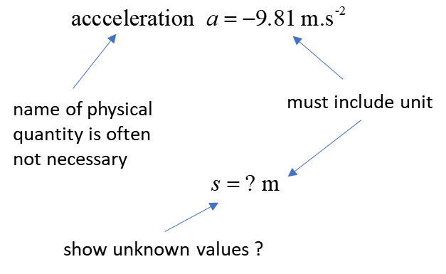

* Use ( ) extensively for multiplication of numbers and do not use x for multiplication

**Example**: a stone was thrown upwards with a speed of 20.456m.s-1 from the top of a cliff. 15.35 s later it hit the ground below the top of the cliff. How high is the top of the cliff above the ground? What speed did the stone hit the ground?

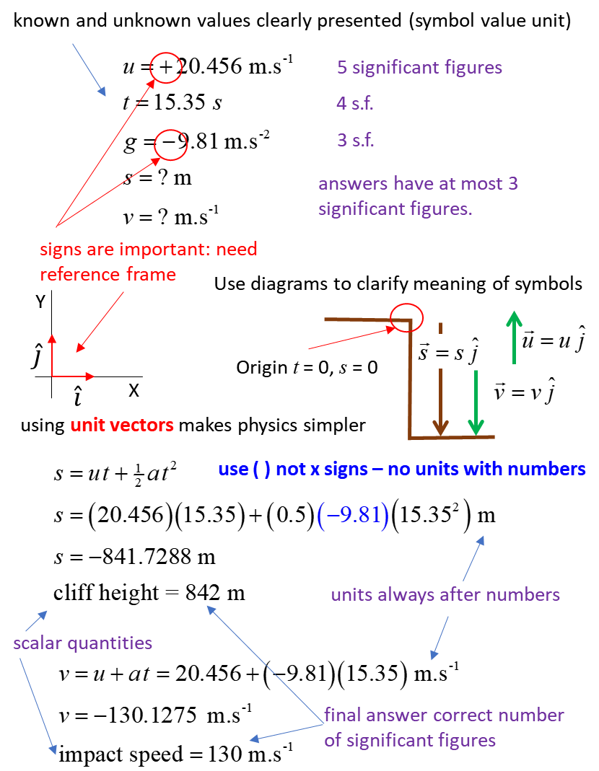

**HOW TO APPROACH A PROBLEM**

* Read through the question rapidly to focus your thoughts on the topic area concerned (conservation of energy or Newton’s Laws of Motion?).
* Visualise the physical situation – create your own mental images which helps stimulate the brain and making recall of information easier.
* Read the question again, this time in steps extracting the given information and establish exactly what must be answered. Write this information as you read through the question on a scientific annotated diagram.
* The next step is the most difficult one which requires creative thinking. There are no definite rules in this step. But you can ask yourself a set of questions, what do I know: what are the relevant physical principles; what concepts are applicable: what equations might be helpful; what approximations / simplifications have been made. You should add some of this information to your annotated diagram. The information is much more accessible when you view it on paper rather than kept enclosed in your brain.
* Finally, you put it all together by making association and linkages between all the information you have written to answer the posed questions.

In my notes, I often use exercise with solutions. Your ability to answer physics questions and problems can be enhanced by noting how I arrived at an answer. **The process of finding the answer is more important than the actual answer**. Also, some of my exercises have complete solutions which can you use to help build your problem-solving techniques and skills. My solutions are often presented as a learning tool and may contain more information than you would give an examination

Many (if not the majority) students in answering qualitative questions, simply rewrite the question. This is a waste of time, and not productive. What you need to do is extract from the question, the information presented and answer the question in terms of physical principles. So, in answering a question, it is most important to clearly state the relevant physical principles and equations, and how they are applied to answering the question.

**Some common mistakes**

* Not reading the question.
* Not using words in correct scientific sense.
* Using equations in situations to which they do not apply.
* Applying a physical principle that cannot be applied directly to the physical situation described.
* Using wrong units / Not converting units correctly / Not stating units.
* Inappropriate number of significant figures presented in final answers.
* Poor setting out of written answers.
* Not using scientific annotated diagrams

|  |
| --- |
| **Worked Example**  The purpose of this worked example is not so much to help you with particular physical concepts, but rather to illustrate the points made in the preceding paragraphs.  Two identical spherical lumps of iron of mass 6.45 kg lie with their centres 1.123 m apart. They are each given a charge *Q* (which maybe assumed to be distributed spherical symmetry) such that each sphere exerts a zero net force on each other.   1. What is their mutual gravitational attraction? 2. What is the value of *Q*? 3. How any electrons must be removed from each sphere to achieve the result of zero net force acting between the spheres?   **Solution**  The two objects because of their mass attract each other.  By removing electrons from each object, they acquire the same charge, so repel each other. The number of electrons removed is such the magnitude of the electric force is equal to the magnitude of the gravitational force. |

[VISUAL PHYSICS ONLINE](http://www.physics.usyd.edu.au/teach_res/hsp/sp/spHome.htm)

If you have any feedback, comments, suggestions or corrections please email:

Ian Cooper School of Physics University of Sydney

ian.cooper@sydney.edu.au