[**VISUAL PHYSICS ONLINE**](http://www.physics.usyd.edu.au/teach_res/hsp/sp/spHome.htm)

**Experiment PA41A**

**ELECTRIC CIRCUITS**

**Equipment (see Appendices)**

12V DC power supply (battery): multimeter (and/or milliammeter and voltmeter); electrical leads; alligator clips; fixed resistors 220 ohm, 1000 ohm, 1500 ohm, 4700 ohm.

# (Fixed resistors and alligator clips are inexpensive and can be brought from suppliers such as [Jaycar](https://www.jaycar.com.au/))

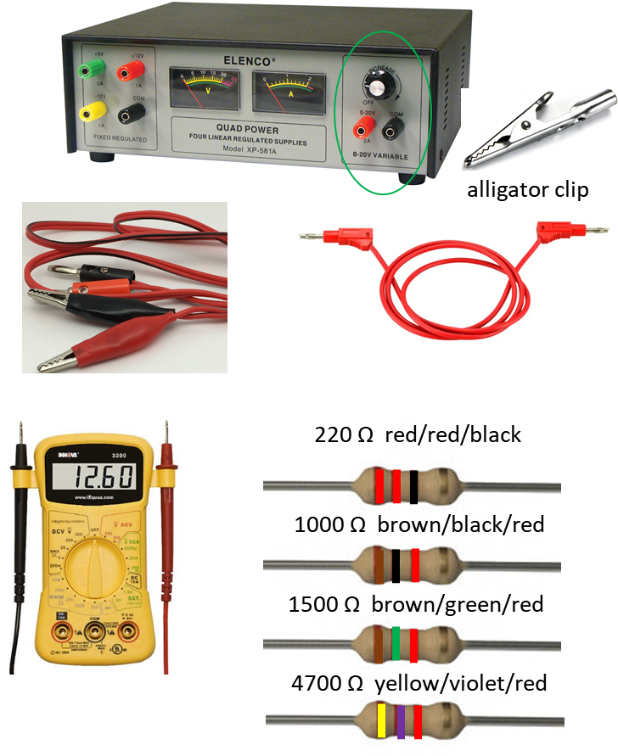

# Introduction

This experiment introduces the concept of an electrical circuit. The essential features of an electrical circuit are a source of electrical energy (such as a battery), a load (such as a resistor or a light bulb) and a switch. When the switch is closed the circuit is complete and electrical energy can flow to the load.

On completion of this experiment you should:

* Be familiar with the idea of a circuit as a means of transfer of energy from a source of electrical energy (such as a battery) to a load.
* Be able to apply the terms current, potential difference (potential drop, voltage) and resistance.
* Be able to measure values of current, potential difference and resistance using a digital multimeter.
* Be able to use Ohm's Law in simple electrical circuits.

The battery provides the electrical energy. The energy of the battery originates from the chemical reaction that goes on inside the battery. A resistance in the circuit transforms the electrical energy from the battery to thermal energy. A component where electrical energy is transformed to other forms is often called a l**oad**. When a complete circuit is made a current is setup in the **circuit**.

For our electrical circuits, the current is due to the movement of electrons from the negative to the positive terminal. However, by convention, the current is said to be in the direction from the positive battery terminal to the negative terminal. The S.I. unit for current is the current the**ampere *(***A). A meter which is used to measure current is called an **ammeter**. In the circuits we will investigate, most currents will be measured in milliamperes (mA 1mA = 10-3 A). To measure the current in a circuit, it is always necessary to break the circuit and complete the circuit with the ammeter. So, the ammeter is connected in **series** with the circuit components.

We need to introduce the more general concept of **potential difference** between two points in a circuit. When energy transfer occurs between two points in a circuit then there is a potential difference between the two points. A ***loss*** of electrical energy from the circuit, such as in a resistance, is associated with current flowing from a point of higher potential to one of lower potential, through the resistance. A ***gain*** in energy is associated with current flowing from a point of lower potential to one of higher potential as occurs at the battery. Electrical potential differences are measured in **volts** (symbol V). The term **voltage** is commonly used to describe potential differences in circuits. A potential difference is measured by a voltmeter which is placed in **parallel** across the circuit component.

An electrical circuit is represented by an electrical circuit diagram that show the logical rather than the actual layout of the circuit. The elements of the circuit are represented by standardised symbols.

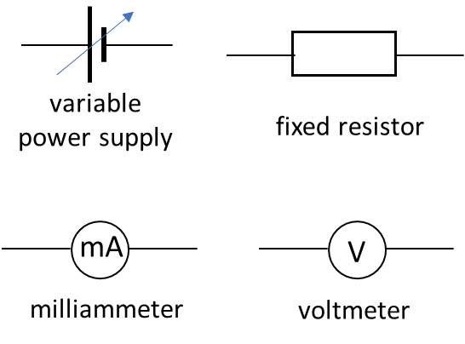

|  |
| --- |
| **Logbook 1**  State:  Ohm’s Law  Kirchhoff’s Current Law  Kirchhoff’s Voltage Law |

**Review**

[DC Circuits 1](http://www.physics.usyd.edu.au/teach_res/hsp/sp/mod41/m41DC1.pdf)

[DC Circuits 2](http://www.physics.usyd.edu.au/teach_res/hsp/sp/mod41/m41DC2.pdf)

**Activity 1**

The goal of this activity is to determine the connection between the potential difference *V* across a resistor *R* to the current *I* through it. Setup a circuit with the 1500 ohm resistor connected to the power supply (battery).

Use the multimeter to record the resistance of each resistor.

|  |
| --- |
| **Logbook 2**  Record the resistance measurements. |

By varying the voltage settings on the power supply measure at least 5 times the potential difference across the fixed resistor 1500 ohms and the current through it using a multimeter (can also use a voltmeter and milliammeter). Repeat your measurements using the 4700 ohm resistor.

|  |
| --- |
| **Logbook 3**  Record the potential differences and currents in a Table for both resistors. |

Step 1: Circuit with battery and resistor

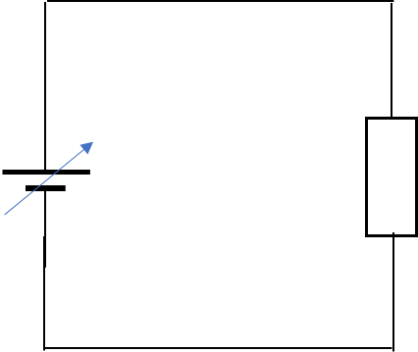

Step 2: Measurement of potential difference across resistor

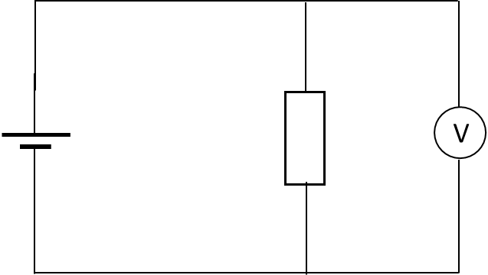

Step 3: Measurement of current through resistor

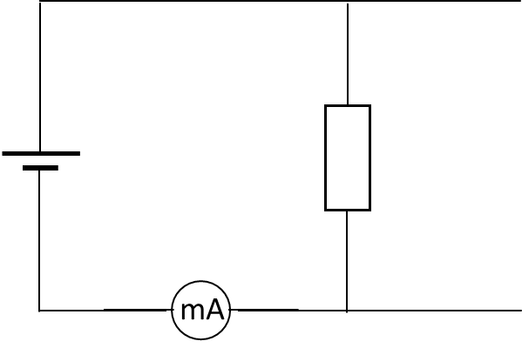

|  |
| --- |
| **Logbook 4**  On a single graph, plot your measurements for the potential difference (Y Axis) and current (X axis) for both resistor.  What conclusions can you make from your plots? What is Ohm’s Law. Do your results satisfy Ohm’s Law?  Estimate the resistance value for each resistor. Are the values what you expected? |

**Activity 2**

The goal of this activity is to investigate a circuit in which two resistors (1500 ohm and 4700 ohm) are connected in **series**.

Setup the circuit shown with the power supply set to about 10 V.

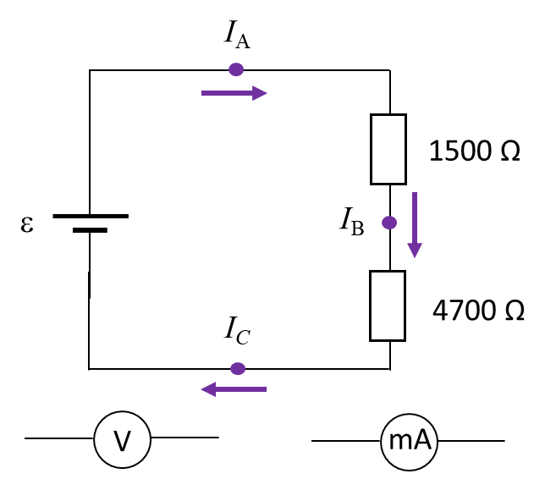

|  |
| --- |
| **Logbook 5: Predict Observe Explain**  Is the voltage across the 1500 Ω resistor the same or greater than or less than the potential drop across the 4700 Ω resistor?  Rank the three currents *I*A, *I*Band *I*C  in magnitude. |

Measure:

Battery emf

Currents at the point A, B and C

Potential difference across each resistor

|  |
| --- |
| **Logbook 6**  What is the relationship between the currents through each resistor?  What is the relationship between the battery emf and the potential drops across each resistor?  For your circuit with the set value of the emf, calculate the values for the currents and potential differences.  Were your predictions correct? If not, account for your discrepancies.  How well do your measurements agree with your calculations? |

**Activity 3**

The goal of this activity is to investigate a circuit in which two resistors (1500 ohm and 4700 ohm) are connected in **parallel**.

Setup the circuit shown with the power supply set to about 10 V.

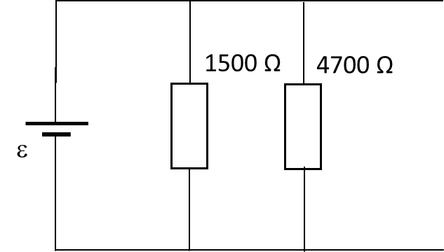

|  |
| --- |
| **Logbook 7 Predict Observe Explain**  Is the voltage across the 1500 Ω resistor the same or greater than or less than the potential drop across the 4700 Ω resistor?  Rank the three currents: current from battery, current through 1500 Ω resistor and current through the 4700 Ω resistor. |

Measure and record:

Battery emf.

Potential difference across each resistor.

Current through each resistor and from the battery.

What is the relationship between the current through each resistor and the current drawn from the battery?

What is the relationship between the battery emf and the potential drops across each resistor?

For your circuit with the set value of the emf, calculate the values for the currents and potential differences.

How well do your measurements agree with your calculations?

Were your predictions correct? If not, account for your discrepancies.

**Sample Results**

**Logbook 4**

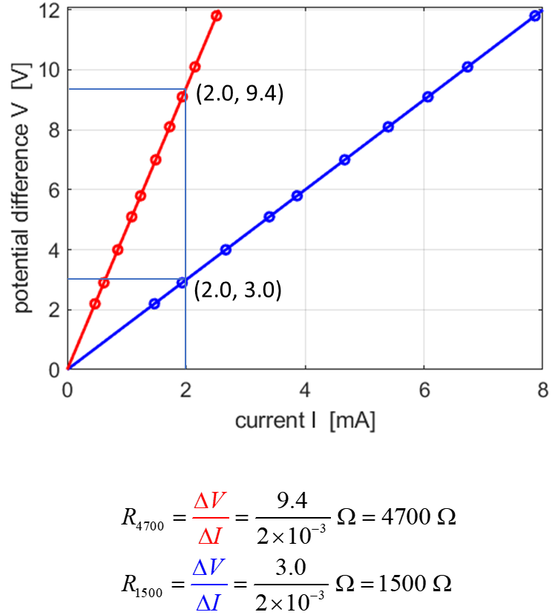

The plot of your measurements should be “perfect” straight lines through the Origin (0, 0). Hence, we can conclude that the potential difference and the current are proportional to each other and the constant of proportionality is the resistance. Our results verify **Ohm’s Law**  

Agree between theory and experimental measurements should be excellent.

**Logbook 6**

To analyse a circuit, all components should be labelled as shown in the figure below.

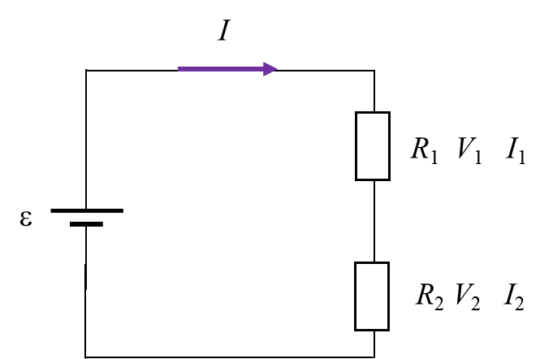



Kirchhoff’s Current Law implies that the same current flows around the circuit 

Kirchhoff’s Voltage Law implies 

Ohm’s Law implies 



**Your measurements and calculations should be very close to each other.**

**Logbook 7**

To analyse a circuit, all components should be labelled as shown in the figure below.

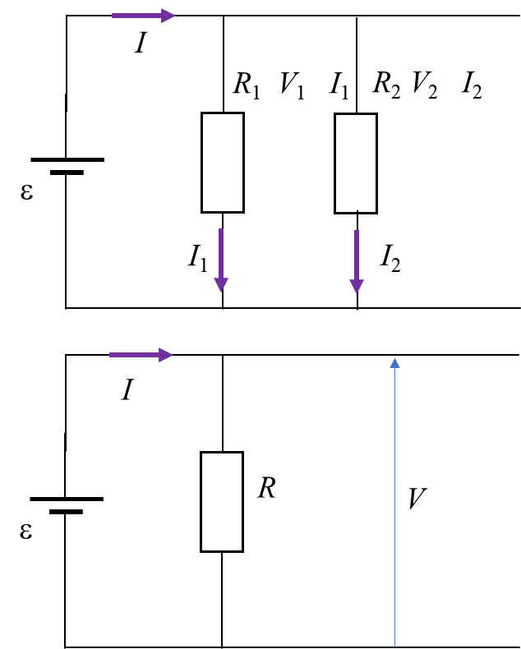



Kirchhoff’s Current Law implies 

Kirchhoff’s Voltage Law implies 

Ohm’s Law implies 



**Your measurements and calculations should be very close to each other.**

**Review**

* A sustained electric current can exist only in a closed conducting path - called a circuit.
* In a loop without any branches going off to the sides a steady current must have the same value at all places in the circuit.
* A battery causes a current in a complete circuit.
* A battery is a source of electrical energy.
* Energy and current are different things.
* In a circuit, energy is transferred from a source (eg. battery) to a load (eg. resistance).
* Electrical energy can be delivered into devices such as light globes, motors and heaters and then into the environment.
* The sum of potential rises equals the sum of potential drops i.e., the sum of potential differences around a circuit is zero.
* The current into a branch is equal to the current out of a branch.

**Appendix: Resistor colour code**

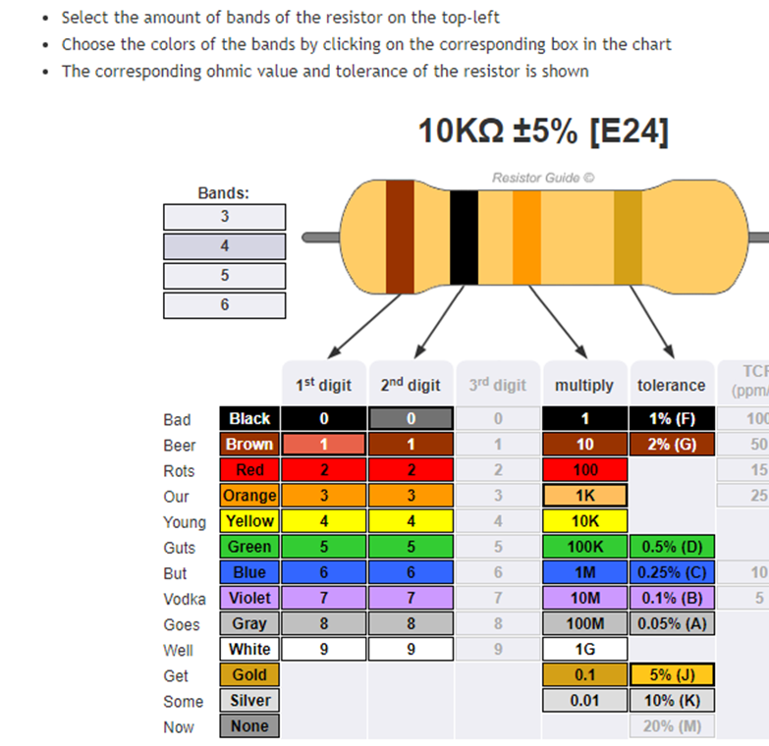

**Protecting your electrical meters**

Power supplies can often deliver currents greater than 5 A. Such large currents can permanently damage your meters. To prevent this a light globe can be placed in series with the battery to limited the current. The light globe because of its low resistance will have a negligible effect upon your measurements with the resistors used in this experiment.

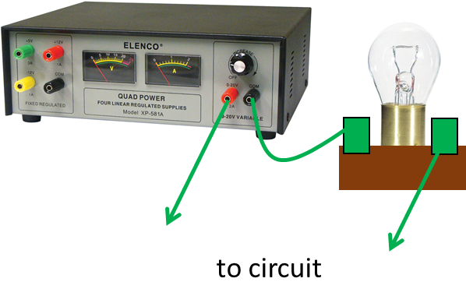

[Watch video on how to use a multimeter](https://www.youtube.com/watch?v=bF3OyQ3HwfU)

[VISUAL PHYSICS ONLINE](http://www.physics.usyd.edu.au/teach_res/hsp/sp/spHome.htm)

If you have any feedback, comments, suggestions or corrections please email:

Ian Cooper School of Physics University of Sydney

ian.cooper@sydney.edu.au